Voice recognition software allows users to transform their spoken words into written words through the use of a microphone.  
  
**Advantages**

1. Increases productivity
2. Can help with menial computer tasks, such as browsing and scrolling
3. Can help people who have trouble using their hands
4. Can help people who have cognitive disabilities
5. Has long term benefits for students

**Disadvantages**

1. Can be hacked with prerecorded verbal messages
2. Has an initial period of adjusting to each user's voice
3. Less accurate when there is background noise
4. Can be distracting in a cubicle environment
5. The company Nuance is one of the last companies producing the software and is essentially a monopoly

### Types of Algorithms

1. Dynamic Time Warping (DTW)

Dynamic time warping is a method that is most applicable to signals which are skewed or shifted in time relative to each other. For example if one signal is compared to another signal that is the same signal but shifted in the x (time) axis, a point to point Euclidian comparison with give a large error. However, if the shift is accounted for, as it is in DTW, the two signals will be recognised as being very similar, which they are. In this way, DTW is ideal for speech recognition, where one word spoken by two users is never exactly the same, but often said with differing speed or emphasis.

In the below figure, the input signal and template signal are compared. If the two signals were exactly the same, the minimum distance path would be a 45 degree angle between the two. However, any skew will cause the minimum distance maping to shift. DTW takes advantage of this fact and gives a distance which accounts for this shift.

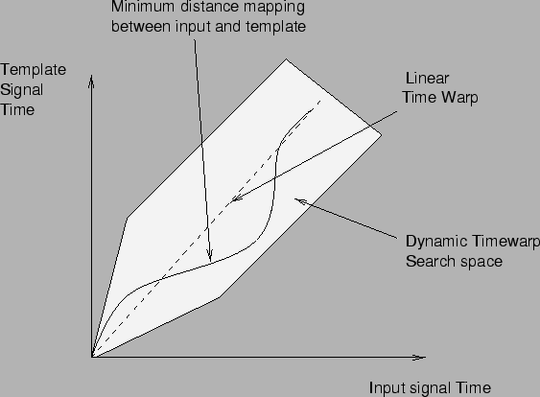

Figure 6 - Warping path

[Ref: <http://www.cse.unsw.edu.au/~waleed/phd/html/node38.html>]

Two signals warped in time:



Figure 7 - Two skewed signals

As shown above, the two signal are in fact, the same. However, a Euclidian comparison would give a large difference. DTW, skews the difference computed much like B above.

DTW skews the difference by computing the minimum distance between the two signals. Here, a minimum distance warping path is shown:



Figure 8 - Minimum distance warping path

[Ref for above two pics: http://www.cs.ucr.edu/~eamonn/sdm01.pdf]

1. Hidden Markov Model (HMM)

The HMM algorithm is a statistical model. The process is assumed to be a Markov process with hidden (unknown) parameters. The hidden parameters are deduced by analysing the known parameters. By computing these states, pattern recognition is possible, which is how HMM can be used for speech recognition. HMM is a complex algorithm which provides the most benefit for use with a large vocabulary system. In this project, five commands were recognised by the system.

1. Neural Networks (NN)

Neural networks use a network of “neurons” of acoustic phonemes which are compared to the input to find a match. NN is a highly mathematical system which is useful for computing larger words with many phonemes in them. In this project, words were kept short.