Physical AI Fleet Analytics
From Robot Telemetry to Operational Insights

Data Analytics Capstone Report

InGen Dynamics Inc.
Data Analyst Internship

Yi-Ting Hsiao
Data Analyst Intern

September 2026

Table of Contents
Executive Summary 3
Introduction 4
InGen Physical AI Landscape and PIC 2.0 5
Environmental Science and Physical AI Analytics Bridge 6
Telemetry Exploratory Data Analysis 6
Predictive Modelling 9
Time-Series Analysis 13
Anomaly Detection 15
Hypothesis Testing 18
Fleet Analytics Dashboard 19
Per-Platform Data Analytics Recommendations 22
Limitations and Future Work 23
References 25

Executive Summary
This capstone project demonstrates how data analytics can transform Physical AI telemetry into interpretable and operationally useful insights. Using synthetic telemetry representing a fleet of 30 Aido Rovers over a 21-day period, the project integrates exploratory data analysis, predictive modeling, time-series forecasting, anomaly detection, statistical hypothesis testing, and interactive dashboard development into an end-to-end fleet analytics workflow.
The predictive modeling analysis showed that Aido Rover operational states could be distinguished effectively within the synthetic dataset. Random Forest achieved a Macro-F1 of 0.9327, substantially outperforming Logistic Regression, while permutation importance identified wheel imbalance and wheel torque measurements as the most influential classification features. For battery forecasting, Holt exponential smoothing outperformed ARIMA(1,0,0) and achieved an out-of-sample RMSE of 0.1076. In the controlled anomaly-detection experiments, statistical detection achieved the highest observed AUROC of 1.000 for GPS disruption, LiDAR saturation, and IMU axis failure, although these results reflect predefined synthetic fault signatures and should not be interpreted as expected real-world detection performance.
The analyses also identified several important limitations to relying on individual models or telemetry signals. FAULT remained the most challenging operational state for classification, class weighting did not improve FAULT recall, and model performance declined substantially when the Aido Rover classifier was evaluated on shifted synthetic Sentinel Prime AI telemetry. Hypothesis testing further showed that statistically significant relationships between FAULT behavior and individual variables such as battery SoC or LiDAR saturation had very small effect sizes. Together, these findings support the use of multiple complementary telemetry signals rather than isolated indicators.
The Aido Rover Fleet Analytics Dashboard integrates these analytical outputs into a single monitoring interface covering fleet status, classification insights, battery forecasting, and anomaly alerts. The dashboard demonstrates how notebook-based analysis can be translated into a more accessible operational view for fleet monitoring and investigation. Across the broader InGen Physical AI portfolio, the project supports a strategy of shared analytical principles combined with platform-specific features, models, thresholds, and validation.
Overall, the capstone demonstrates the feasibility of applying methods from environmental science, transportation analytics, and data science to Physical AI telemetry. The results provide a foundation for fleet condition monitoring, predictive analytics, and anomaly detection, while also emphasizing the need for real operational data, platform-specific validation, and calibrated monitoring thresholds before production deployment.

Introduction
Project Background
Physical AI systems generate continuous streams of sensor data that describe both the internal condition of a robot and its interaction with the surrounding environment. For platforms such as the Aido Rover, these data may include battery state of charge (SoC), GPS information, LiDAR measurements, wheel torque, inertial measurement unit (IMU) readings, environmental conditions, and operational states. Analyzing these data can help identify operating patterns, monitor system conditions, detect abnormal behavior, and support fleet-level decision making.
This capstone project brings together the analytical work completed throughout the InGen Dynamics Data Analyst Internship. Using synthetic Aido Rover fleet telemetry, the project develops an end-to-end analytics workflow that includes exploratory data analysis, classification modeling, time-series analysis, anomaly detection, statistical hypothesis testing, and interactive dashboard development.
Project Objectives
The primary objective of this project is to demonstrate how data analytics can transform physical AI telemetry into interpretable and operationally useful insights. The analysis examines patterns and data-quality issues in robot telemetry, evaluates whether operational states can be classified from sensor measurements, identifies influential features, investigates temporal patterns in battery behavior, and compares approaches for detecting abnormal sensor conditions.
Another objective is to connect individual analytical methods into a practical fleet-monitoring workflow. Instead of treating exploratory analysis, predictive modeling, time-series analysis, and anomaly detection as separate tasks, their outputs are brought together in a fleet analytics dashboard to support the interpretation of robot status, model results, temporal behavior, and potential operational alerts.
Analytical Scope and Approach
The analysis is based on synthetic telemetry representing a fleet of 30 Aido Rovers over a 21-day operating period. The workflow begins with telemetry profiling and exploratory data analysis, followed by operational-state classification and model robustness analysis. Battery SoC is then examined using time-series methods, while controlled fault scenarios are used to evaluate anomaly-detection approaches. Statistical hypothesis tests provide additional evidence about operational patterns, and the final results are integrated into an interactive fleet analytics dashboard.
A central theme of the project is the transfer of analytical methods from environmental science to physical AI. Techniques used for multivariate environmental observations and atmospheric time-series data can also be applied to robot telemetry, while classification methods used in previous transportation-data analysis provide a foundation for operational-state modeling. This connection provides a consistent analytical framework while recognizing the different operational meaning of physical AI data.
All telemetry used in this project is synthetic. The work does not use InGen customer data, internal operational systems, or proprietary datasets, consistent with the scope defined in the internship plan.

InGen Physical AI Landscape and PIC 2.0
InGen Dynamics' Physical AI ecosystem includes platforms designed for a range of operational environments, including autonomous inspection, physical security, healthcare, education, logistics, and general-purpose robotics. Although these platforms serve different industries, they share a common analytical foundation through Origami AI and the PIC 2.0 architecture. From a data analytics perspective, the key differences among the platforms are the types of data they generate, their temporal characteristics, and the operational questions those data can help address.
Aido Rover generates continuous telemetry during autonomous patrol and inspection, including battery status, GPS location, vehicle speed, sensor measurements, and system-health information. Its multivariate and time-dependent data make it particularly suitable for exploratory analysis, operational-state classification, time-series analysis, anomaly detection, and fleet monitoring. For this reason, Rover telemetry serves as the primary analytical case study throughout this capstone project.
Sentinel focuses on physical security and produces more event-driven data, including detected activities, security alerts, timestamps, confidence scores, and supporting sensor information. These data create opportunities for event-frequency analysis, classification, anomaly detection, and performance monitoring.
Other platforms introduce different analytical contexts. Fari emphasizes longitudinal health and behavioral monitoring, while Senpai generates educational records related to learning progress, assessment, and engagement. Carry & Go combines operational measurements with delivery and logistics records, and Humanoid produces complex motion, perception, force, and task-execution data. Together, these platforms demonstrate how similar analytical methods can be adapted to different data structures and operational objectives.
Within this landscape, Origami AI and PIC 2.0 provide a shared foundation across the InGen ecosystem. From the perspective developed during this internship, this common framework is important because it allows data analytics concepts to remain transferable even when the underlying platforms and datasets differ. Exploratory data analysis can characterize distributions and operational patterns, time-series methods can monitor continuously changing measurements, classification can distinguish operational conditions or events, and dashboards can translate analytical results into information that supports decision-making.
This cross-platform perspective provides the context for the analytical workflow developed in the remainder of this report. Aido Rover is used as the primary case study because its telemetry supports the complete analytical pipeline, while the findings are later considered in relation to the different data characteristics and analytical opportunities of the broader InGen portfolio.

Environmental Science and Physical AI Analytics Bridge
Although Environmental Science and Physical AI focus on different systems, both rely on multivariate observations collected over time to understand changing conditions and support data-driven decisions. Environmental monitoring uses observations from sources such as weather stations, satellites, and transportation systems, while Physical AI platforms generate telemetry from sensors such as LiDAR, GPS, IMUs, and onboard system measurements. In both cases, raw observations must be validated, explored, modeled, and interpreted before they can provide meaningful insights.
Several analytical methods from my previous environmental and transportation data experience were transferred to the Aido Rover analysis. Multivariate environmental observations provided a foundation for exploring relationships among multiple robot telemetry variables. Experience with atmospheric time-series data was applied to battery SoC analysis, where temporal patterns and changes over time became important analytical considerations. Methods previously used to identify unusual environmental observations were adapted to detect abnormal robot sensor behavior and controlled fault conditions.
Classification also provided a connection between my previous work and Physical AI analytics. My experience analyzing transportation data, including traffic accident severity, provided a foundation for using machine learning to distinguish Aido Rover operational states such as PATROL, ALERT, CHARGING, and FAULT. Statistical methods were further used to evaluate operational patterns, while data visualization techniques were extended from communicating environmental observations to presenting fleet performance and analytical results through an interactive dashboard.
These connections are methodological rather than literal. Battery SoC is not equivalent to an atmospheric variable, and a robot fault is not equivalent to an environmental anomaly. Instead, the similarity lies in the analytical process. Both domains involve repeated observations, temporal behavior, relationships among multiple variables, abnormal conditions, and the need to transform complex measurements into interpretable information.
This analytical bridge provided a foundation for the capstone workflow. Rather than developing an entirely new analytical process for Physical AI, established techniques from environmental and transportation data analysis were adapted to the operational characteristics of Aido Rover telemetry. This demonstrates how core data analytics methods can remain transferable across application domains even when the meaning and source of the underlying data change.

Telemetry Exploratory Data Analysis
Exploratory data analysis was conducted on a 21-day synthetic telemetry dataset representing a fleet of 30 Aido Rovers. The analysis examined sensor distributions, missingness, cross-channel relationships, stationarity, temporal patterns, and spatial behavior. The objective was to establish an initial understanding of telemetry quality and sensor behavior before moving into predictive modeling and more advanced analytical methods.
The first important finding involved data completeness. Missing values were concentrated in the GPS channels, where latitude and longitude each contained approximately 2.0% missing observations. These gaps corresponded to the intentionally injected GPS dropout events. Because the dropout observations were randomly selected without conditioning on rover identity, time, operational mode, or other sensor measurements, the missingness was classified as Missing Completely At Random (MCAR). Although the overall missing rate was relatively small, GPS availability remains operationally important because temporary gaps can reduce localization and route-monitoring reliability. Fleet monitoring systems should therefore track GPS availability directly and provide complementary localization or short-term position estimation when GPS telemetry is unavailable.
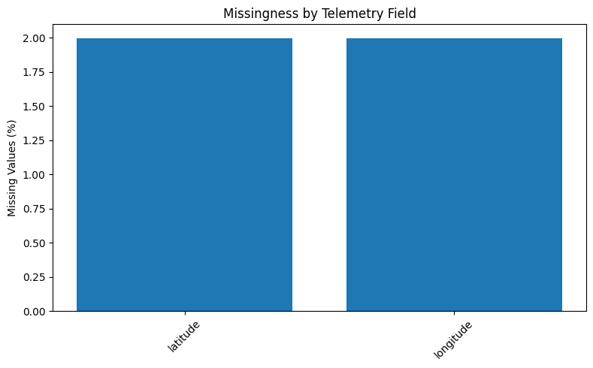
Figure 1. GPS Telemetry Missingness
Cross-channel correlation analysis provided additional insight into sensor consistency. The four wheel torque channels showed the strongest positive correlations in the dataset, with all six wheel-to-wheel correlations ranging from approximately 0.865 to 0.867. The strongest relationship was observed between front-left and rear-right wheel torque, with a correlation coefficient of r = 0.867. In comparison, correlations between LiDAR distance and wheel torque were much weaker, ranging from approximately 0.084 to 0.086. The strong agreement among wheel torque channels is expected because all four wheels respond to the same rover operational mode, but it also provides a useful baseline for drivetrain monitoring. Persistent divergence in one wheel relative to the others could indicate a motor, drivetrain, wheel, or sensor issue.
The correlation analysis also revealed that battery SoC and most IMU channels had relatively weak linear relationships with wheel torque. In a physical rover, sustained higher torque could contribute to greater energy consumption, so the weak relationship between battery behavior and wheel torque highlights a limitation of the synthetic telemetry model. This limitation is important when interpreting later predictive and time-series results because not all relationships in the dataset represent fully coupled physical behavior.

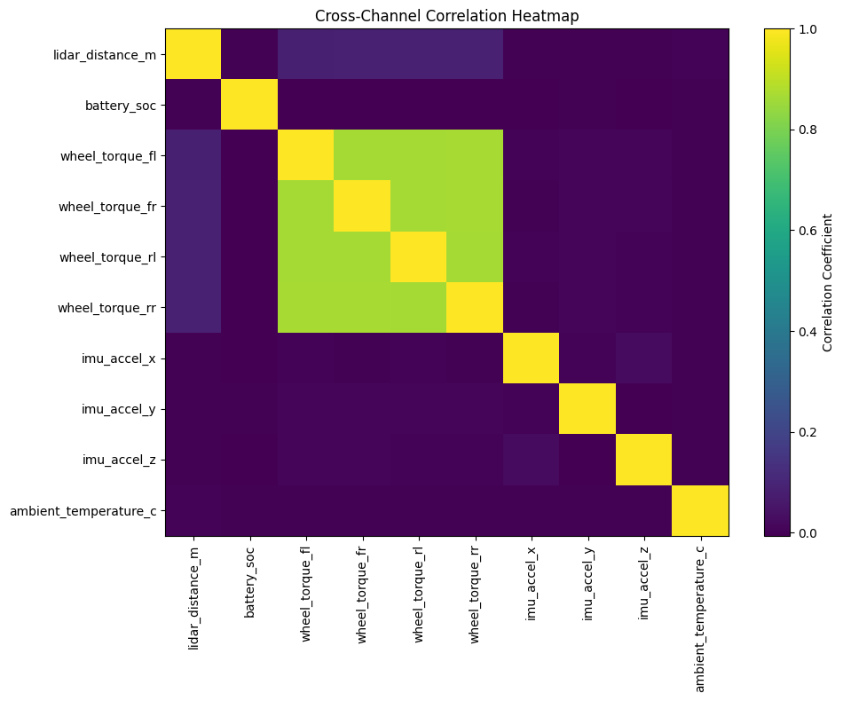
Figure 2. Cross-Channel Correlation Heatmap
Stationarity testing further demonstrated the importance of interpreting statistical results in their operational context. For AIDO_003, the Augmented Dickey-Fuller test produced an ADF statistic of −8.7546 with p < 0.001 for battery SoC and −79.6041 with p < 0.001 for front-left wheel torque. The unit-root null hypothesis was therefore rejected for both series. However, visual inspection of the time series showed that battery SoC declined from approximately 80% to near 0% by around July 6 and remained at a very low level afterward, while wheel torque continued to fluctuate around its typical operating range with occasional large spikes.
This result illustrates that statistical stationarity should not be interpreted as evidence of healthy operation. The low battery pattern reflects a limitation of the synthetic data generation process, where charging was assigned independently of battery SoC rather than being triggered by low battery levels. Because discharge modes occurred more frequently than charging, many observations remained near the lower battery boundary for much of the simulation. Operational monitoring should therefore combine statistical tests with visual inspection and domain-specific thresholds. A telemetry signal can satisfy a statistical stationarity test while still representing an undesirable operating condition.
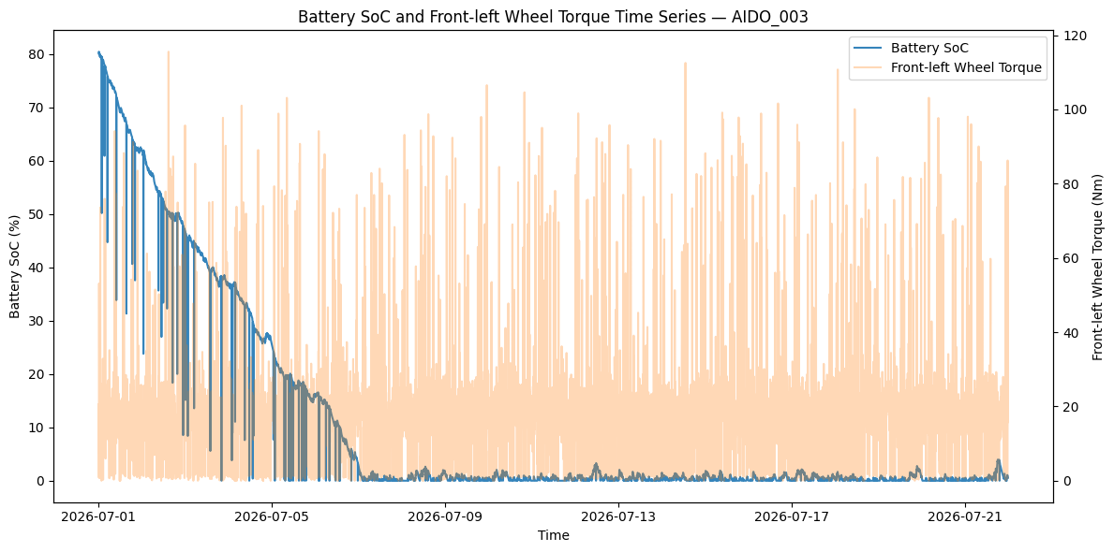
Figure 3. Battery SoC and Wheel Torque Time Series for AIDO_003
Overall, the exploratory analysis identified three important dimensions of fleet monitoring: data reliability, cross-sensor consistency, and temporal behavior. GPS missingness demonstrated the importance of monitoring telemetry availability, wheel torque correlations established a potential baseline for drivetrain consistency, and the stationarity analysis showed why statistical results must be interpreted together with operational conditions. These findings also identified limitations in the synthetic telemetry, particularly the weak physical coupling among some sensor channels, which should be considered when interpreting the predictive modeling and anomaly detection results presented in later sections.

Predictive Modelling
Predictive modeling was used to evaluate whether Aido Rover operational states could be identified from telemetry measurements. The target variable contained four operational modes: PATROL, CHARGING, ALERT, and FAULT. The dataset was imbalanced, with PATROL representing approximately 69.97% of observations, followed by CHARGING at 15.07%, ALERT at 10.01%, and FAULT at 4.94%. Because overall accuracy could therefore be influenced by the dominant PATROL class, Macro-F1 was used as a primary evaluation metric to provide a more balanced assessment of performance across all four operational states.
Two classification models were evaluated: Random Forest and Logistic Regression. On the held-out test set, Random Forest achieved an accuracy of 0.9672, Macro-F1 of 0.9327, and Macro ROC-AUC of 0.9880. Logistic Regression achieved an accuracy of 0.8839, Macro-F1 of 0.7384, and Macro ROC-AUC of 0.9388. Both models exceeded the simple baselines, but Random Forest provided substantially stronger performance across the four operational states. Based on these results, Random Forest was selected for more detailed class-level evaluation and feature importance analysis.
The Random Forest confusion matrix and class-level metrics show that the model performed particularly well for CHARGING and PATROL, with F1-scores of 0.9960 and 0.9778, respectively. ALERT achieved an F1-score of 0.8943, while FAULT had the lowest F1-score at 0.8627. FAULT recall was 0.7970, meaning that the model detected most fault observations but still missed a meaningful portion of the rarest operational class. In comparison, Logistic Regression showed greater difficulty separating the minority states, particularly ALERT, which had a recall of only 0.2064. These results indicate that nonlinear relationships in the telemetry were important for distinguishing operational conditions.
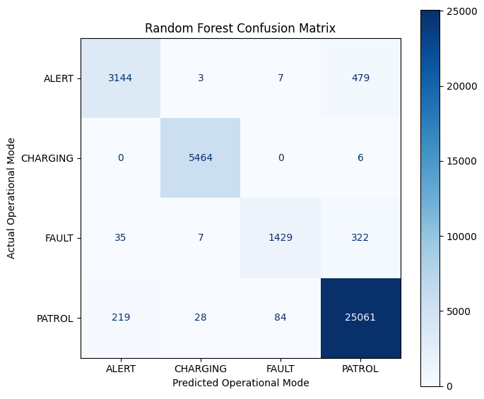
Figure 4. Random Forest Confusion Matrix
Feature importance analysis was then used to examine which telemetry variables contributed most strongly to the Random Forest predictions. Permutation importance identified wheel imbalance as the most influential feature, with an importance of approximately 0.296, followed by front-right wheel torque (0.201), front-left wheel torque (0.192), rear-right wheel torque (0.191), rear-left wheel torque (0.189), and LiDAR distance (0.151). Other variables, including battery SoC, IMU measurements, ambient temperature, and GPS speed, contributed relatively little to overall classification performance.
The importance of wheel imbalance and individual wheel torque measurements is consistent with the exploratory analysis, which showed strong relationships among drivetrain-related sensor channels. A separate FAULT-versus-PATROL analysis also identified wheel imbalance and wheel torque measurements as the dominant features, supporting their relevance for distinguishing normal patrol behavior from fault conditions. However, these relationships should be interpreted within the context of the synthetic telemetry generation process rather than as evidence that the same variables would necessarily dominate in real-world rover operations.
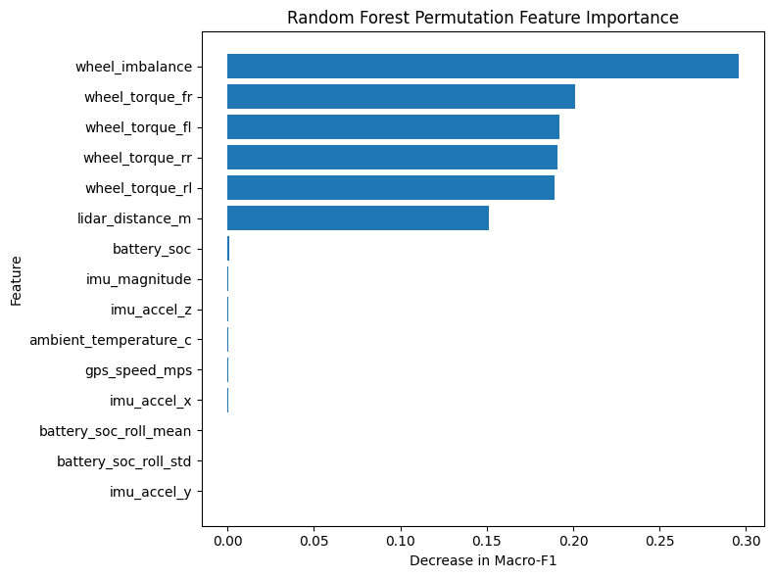
Figure 5. Random Forest Permutation Feature Importance
Model robustness was evaluated using five-fold stratified cross-validation. Random Forest produced a mean Macro-F1 of 0.9307 ± 0.0008, compared with 0.7376 ± 0.0023 for Logistic Regression. The low variation across folds suggests that the performance difference was stable across different subsets of the synthetic dataset rather than being driven by a single train-test split.
Because FAULT represented only 4.94% of the observations, a class-weighted Random Forest was also evaluated to determine whether additional weighting could improve minority-class detection. In the robustness analysis, the baseline Random Forest achieved a Macro-F1 of 0.9298 and FAULT recall of 0.7858, while the class-weighted model achieved a Macro-F1 of 0.9277 and FAULT recall of 0.7680. FAULT recall therefore decreased by 0.0178 rather than improving. This result demonstrates that class weighting does not automatically improve minority-class detection and should be evaluated empirically rather than assumed to be beneficial.
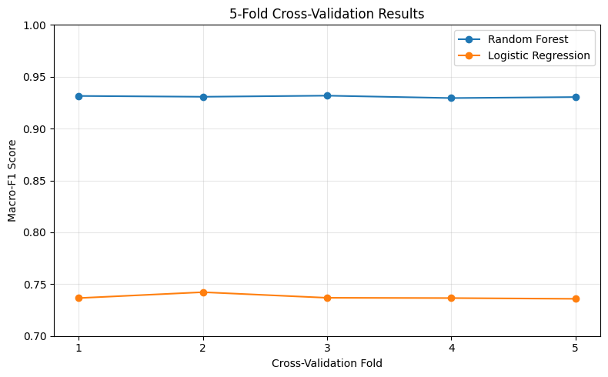
Figure 6. Five-Fold Cross-Validation Performance
Finally, model transferability was tested using a synthetic Sentinel Prime AI dataset with the same 15-feature structure but shifted sensor characteristics. The Aido Rover Random Forest achieved an accuracy of 0.7084 and Macro-F1 of 0.6387 on the transfer dataset, compared with 0.9662 accuracy and 0.9298 Macro-F1 on the Aido Rover held-out set used in the robustness analysis. This corresponds to decreases of approximately 0.2578 in accuracy and 0.2911 in Macro-F1, demonstrating substantial performance degradation under the simulated platform shift.
Dataset | Accuracy | Macro-F1 | Accuracy Change | Macro-F1 Change
Aido Rover Test Set | 0.9662 | 0.9298 | 0.0000 | 0.0000
Sentinel Prime AI Transfer Set | 0.7084 | 0.6387 | -0.2578 | -0.2911
Table 1. Aido Rover and Sentinel Prime AI Transfer Performance
The transfer experiment highlights an important limitation of applying a model trained on one Physical AI platform directly to another. Even when telemetry features have similar structures, differences in sensor behavior and operational characteristics can change the relationships learned by the model. Platform-specific calibration, validation, or retraining would therefore be necessary before using a classification model across different Physical AI systems.
Overall, the predictive modeling results demonstrate that Aido Rover operational states can be distinguished effectively within the synthetic dataset, with Random Forest providing stronger and more balanced performance than Logistic Regression. Drivetrain-related features were the primary contributors to classification, while the FAULT class remained the most challenging state because of its lower prevalence and weaker recall. The robustness and transfer experiments further show that strong within-dataset performance does not guarantee improved minority-class detection through weighting or reliable performance when the model is transferred to a different platform.

Time-Series Analysis
Time-series analysis was conducted to examine temporal patterns in Aido Rover battery State of Charge (SoC) and evaluate whether fleet-level battery behavior could be forecast from historical telemetry. The original 5-minute observations were aggregated into hourly mean battery SoC across the 30-unit fleet, producing 504 hourly observations over the 21-day study period. Aggregation reduced short-term unit-level variation and provided a fleet-level view of battery behavior suitable for temporal analysis.
The hourly battery SoC series showed a substantial decline over the observation period, followed by a prolonged period at relatively low SoC levels. STL decomposition was used to separate the series into trend, 24-hour seasonal, and residual components. The trend component confirmed the overall decline in fleet-average battery SoC, while the 24-hour seasonal component was relatively small. This indicates that daily seasonality was not the dominant source of variation in the synthetic fleet battery series.
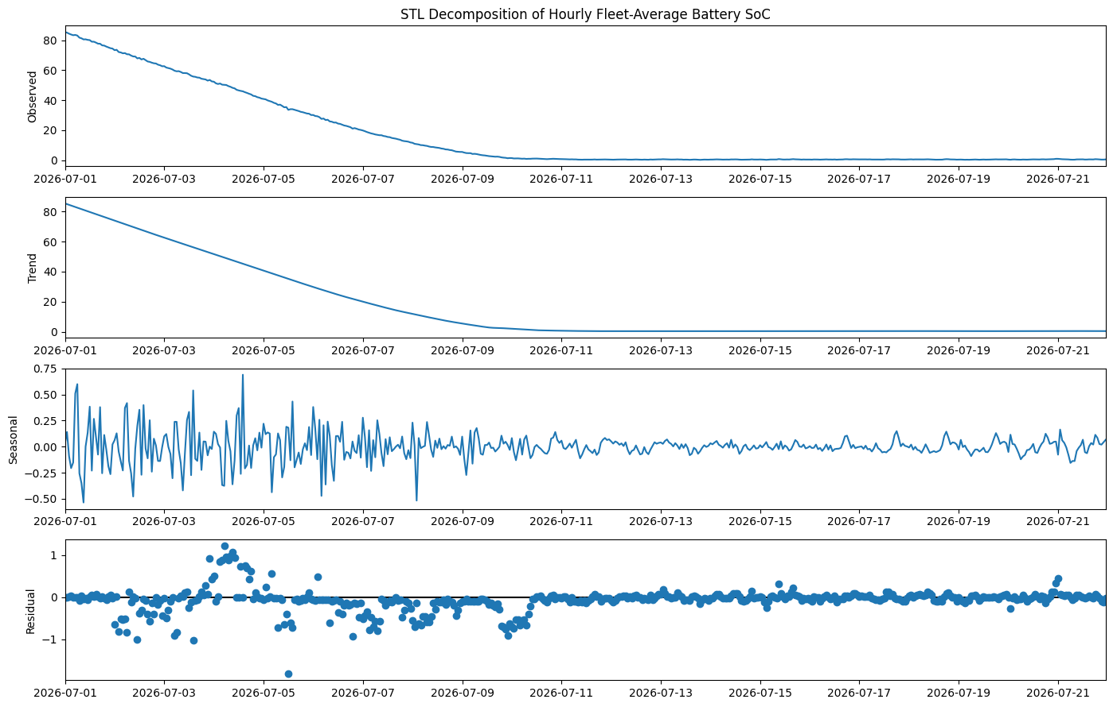
Figure 7. STL Decomposition of Hourly Fleet-Average Battery SoC
Stationarity was evaluated using the Augmented Dickey-Fuller test. The raw hourly battery SoC series produced an ADF statistic of −2.9809 with a p-value of 0.0367. At the 5% significance level, the unit-root null hypothesis was therefore rejected, providing evidence that the raw series was stationary. First-order differencing was also examined for comparison, but the differenced series produced an ADF statistic of −1.3447 with a p-value of 0.6085. Differencing therefore did not provide stronger evidence of stationarity and was not required based on the ADF results.
Autocorrelation and partial autocorrelation were then examined to characterize the temporal dependence structure and support forecasting model selection. The ACF declined gradually across successive lags, indicating strong temporal persistence. The PACF contained a dominant positive spike at lag 1 followed by substantially smaller values at later lags. This pattern suggested a first-order autoregressive structure and supported the use of an AR(1)-type model as an initial forecasting candidate.
The ADF and ACF/PACF results directly informed the initial forecasting model specification. Because the raw series rejected the unit-root null hypothesis, first-order differencing was not included, resulting in an ARIMA(1,0,0) model rather than a model with an integrated differencing component. The lag-1 structure identified in the PACF supported the autoregressive term. However, the fitted AR coefficient was approximately 1.00, indicating very strong persistence near the unit-root boundary. The stationarity result was therefore treated cautiously rather than as definitive evidence of a strongly stationary process.
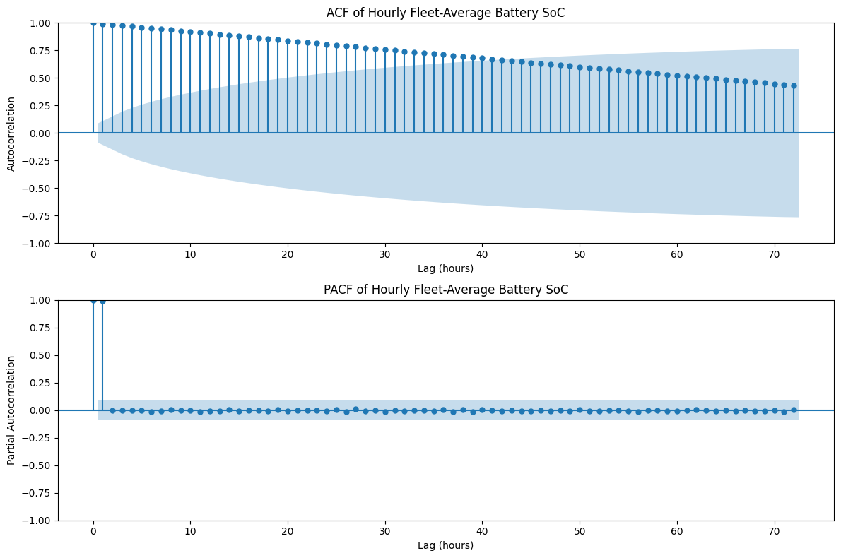
Figure 8. ACF and PACF of Hourly Fleet-Average Battery SoC
Forecast performance was evaluated using a chronological train-test split. The first 14 days, or 336 hourly observations, were used for model training, while the final 7 days, or 168 observations, were reserved for out-of-sample testing. ARIMA(1,0,0) achieved a Mean Absolute Error (MAE) of 0.0966 and a Root Mean Squared Error (RMSE) of 0.1231 during the test period.
Holt exponential smoothing was then evaluated as an alternative model because the series exhibited a changing underlying level and trend while showing limited evidence of strong daily seasonality. Holt achieved an MAE of 0.0818 and an RMSE of 0.1076, outperforming ARIMA(1,0,0) on both measures. Holt exponential smoothing was therefore selected as the final forecasting model.
To represent forecast uncertainty, a bootstrap-based 95% prediction interval was constructed by repeatedly resampling training residuals and adding them to the Holt point forecasts. Across the 168-hour test period, all observed battery SoC values fell within the resulting interval, corresponding to 100% empirical coverage. This result should not be interpreted as perfect uncertainty calibration, because the test period contained relatively little variation and the interval was generated from a residual-bootstrap approximation.
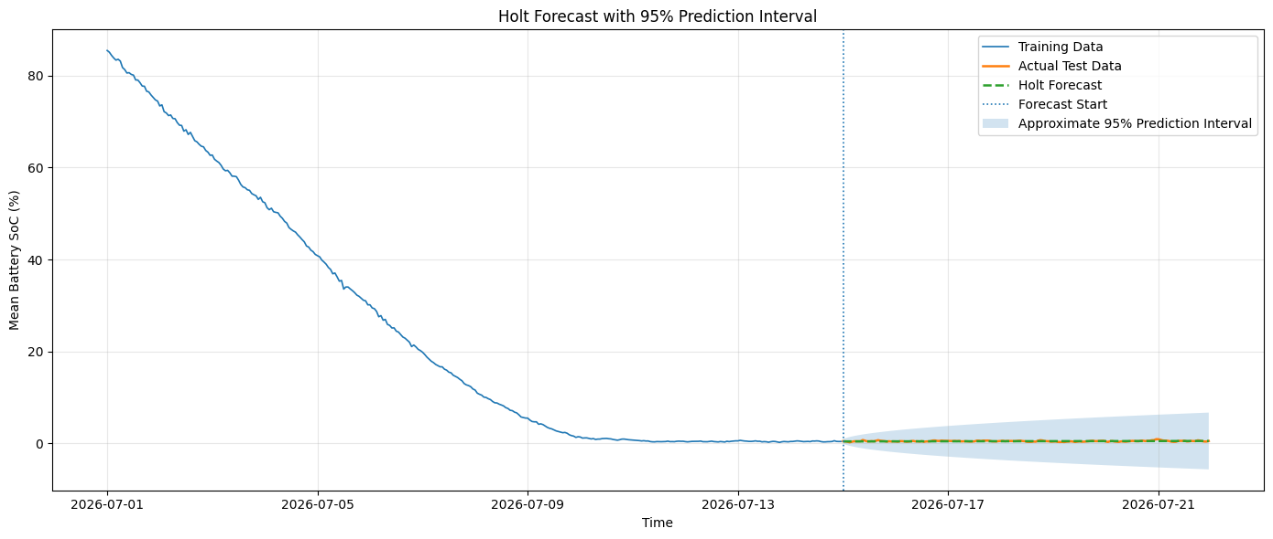
Figure 9. Holt Forecast with Bootstrap 95% Prediction Interval
Overall, the time-series analysis demonstrates that fleet-level battery telemetry contains strong temporal dependence that can support short-term forecasting. The ADF result influenced the initial ARIMA specification by indicating that differencing was unnecessary, while ACF and PACF analysis supported a first-order autoregressive structure. However, out-of-sample comparison showed that Holt exponential smoothing provided lower forecast error and was therefore selected as the final model. The low RMSE of 0.1076 should also be interpreted in the context of the synthetic dataset and the relatively stable, low-SoC test period rather than as evidence that the same level of forecasting accuracy would necessarily be achieved under real-world fleet conditions.

Anomaly Detection
Anomaly detection was used to evaluate whether abnormal Aido Rover sensor behavior could be identified from multivariate telemetry. Five controlled fault types were injected into the synthetic telemetry: motor stall, battery degradation, GPS disruption, LiDAR saturation, and IMU axis failure. These scenarios were designed to represent different forms of abnormal behavior, including sensor deviations, missing telemetry, and temporal changes that develop across multiple observations.
The controlled fault design provided known ground-truth labels for evaluating detection performance. Motor stall and battery degradation were also examined at the event level. The statistical detection approach identified 19 of 20 motor stall events and 20 of 20 battery degradation events, demonstrating that most injected events produced detectable deviations from recent rover-specific behavior.
Two anomaly detection approaches were evaluated. The first used statistical thresholds based on recent rover-specific telemetry behavior and fault-relevant diagnostic rules. The second used Isolation Forest, an unsupervised multivariate method trained only on telemetry observations without controlled faults and outside the original FAULT operational state. PATROL, ALERT, and CHARGING observations were therefore treated as normal operating conditions for model training.
Isolation Forest was trained on 160,744 normal observations using 14 telemetry features and evaluated on 162,184 observations, including 1,440 controlled-fault observations. Across ten random seeds, its overall mean AUROC was 0.631 ± 0.007, with mean precision of 0.015 and recall of 0.307. The low precision indicates that the default model threshold generated a large number of false-positive anomaly predictions, even though the continuous anomaly scores retained some ability to distinguish abnormal from normal observations.
Detection performance varied substantially across fault mechanisms. To evaluate this more robustly, the controlled fault experiment was repeated across ten random seeds, with Statistical Threshold and Isolation Forest evaluated on the same fault placements for each seed. Statistical detection achieved the higher mean AUROC for all five controlled fault types.
Statistical detection was particularly effective for GPS disruption, IMU axis failure, and LiDAR saturation, each achieving a mean AUROC of 1.000 across the ten paired experiments. Battery degradation produced a statistical AUROC of 0.676, while motor stall achieved 0.775. Isolation Forest performed most strongly on motor stall, with an AUROC of 0.688, followed by LiDAR saturation at 0.654 and battery degradation at 0.624. GPS disruption was particularly difficult for Isolation Forest, producing an AUROC of only 0.382.
Fault Type | Isolation Forest AUROC | Statistical AUROC | Higher AUROC
Battery Degradation | 0.624 ± 0.026 | 0.676 ± 0.009 | Statistical
GPS Disruption | 0.382 ± 0.043 | 1.000 ± 0.000 | Statistical
IMU Axis Failure | 0.540 ± 0.060 | 1.000 ± 0.000 | Statistical
LiDAR Saturation | 0.654 ± 0.024 | 1.000 ± 0.000 | Statistical
Motor Stall | 0.688 ± 0.032 | 0.775 ± 0.008 | Statistical
Table 2. Anomaly Detection Performance by Fault Type
The differences between methods reflect the characteristics of the controlled fault mechanisms. Statistical rules were especially effective when faults had explicit diagnostic signatures, such as missing GPS coordinates, saturated LiDAR measurements, or loss of variability in an IMU axis. Isolation Forest was better suited to identifying unusual multivariate numerical patterns, but its performance was weaker when a fault depended on missing values or temporal behavior that was not well represented by individual raw observations.
The results also demonstrate an important precision-recall trade-off. For battery degradation, Isolation Forest achieved a mean recall of 0.325, compared with 0.163 for statistical detection, despite the statistical method producing the higher AUROC. Similarly, for motor stall, Isolation Forest achieved a recall of 0.408, compared with 0.275 for statistical detection. However, Isolation Forest produced very low precision because its default threshold flagged many normal observations as anomalous. Operational anomaly detection should therefore consider not only AUROC but also the acceptable balance between missed faults and false alarms.
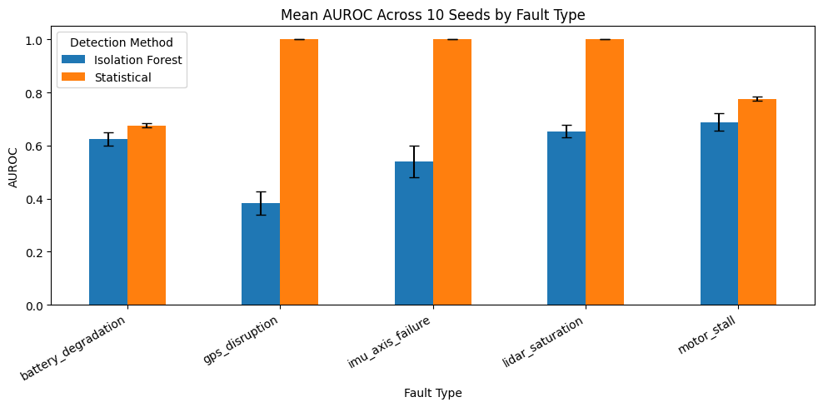
Figure 10. AUROC by Fault Type and Detection Method
These findings support a hybrid monitoring strategy rather than reliance on a single anomaly detection method. Explicit statistical or rule-based detectors can be used for faults with known sensor signatures, while multivariate anomaly detection can provide additional coverage for unusual patterns that are more difficult to define in advance. Threshold calibration and temporal feature engineering would be important next steps for reducing false alarms and improving detection of faults such as battery degradation.
The perfect statistical AUROC values for GPS disruption, LiDAR saturation, and IMU axis failure should be interpreted cautiously. These faults were injected into synthetic telemetry using predefined failure signatures that closely correspond to the statistical detection rules. Their 1.000 AUROC values therefore reflect the controlled experimental design and should not be interpreted as evidence of perfect detection under real-world operating conditions. Real sensor failures may develop more gradually, occur at different severities, or overlap with normal operating variability.
Overall, the anomaly detection analysis demonstrates that detection effectiveness depends strongly on the underlying fault mechanism. Statistical detection provided the strongest discrimination for the controlled faults evaluated in this experiment, while Isolation Forest showed greater sensitivity for some fault types but generated substantially more false positives. The results emphasize the value of combining interpretable fault-specific rules with multivariate anomaly detection and validating both approaches against real operational fault data before deployment.

Hypothesis Testing
Statistical hypothesis testing was conducted to determine whether selected telemetry characteristics were associated with Aido Rover FAULT behavior. Three questions were examined: whether battery State of Charge (SoC) differed between FAULT onset and normal PATROL operation, whether LiDAR saturation was associated with FAULT occurrence, and whether FAULT rates differed systematically across individual rover units. A significance level of α = 0.05 was used for all three tests.
The first test compared battery SoC at FAULT onset with battery SoC during PATROL operation. Because the battery distributions were strongly skewed, a two-sided Mann–Whitney U test was used rather than an independent-samples t-test. The analysis included 8,497 FAULT-onset observations and 126,960 PATROL observations. Median battery SoC was 0.557 for FAULT onset and 0.673 for PATROL operation.
The Mann–Whitney U test identified a statistically significant difference between the two groups (U = 518,211,418, p < 0.001). However, the rank-biserial correlation was only −0.0393, indicating a very small effect size. Although the null hypothesis was rejected statistically, battery SoC provided little practical separation between FAULT onset and normal PATROL conditions. Battery SoC alone should therefore not be interpreted as a strong indicator of imminent FAULT behavior.
The second test examined whether LiDAR saturation was associated with FAULT occurrence. Because both LiDAR saturation status and FAULT occurrence were categorical variables, a chi-square test of independence was used. FAULT observations represented approximately 4.93% of observations without LiDAR saturation and 6.17% of observations with LiDAR saturation.
The association was statistically significant (χ²(1) = 5.664, p = 0.017, n = 181,440). However, Cramér's V was only 0.0056, indicating a negligible association. LiDAR saturation was therefore associated with a slightly higher observed FAULT rate, but the magnitude of the relationship was too small for LiDAR saturation to serve as a strong standalone fault indicator.
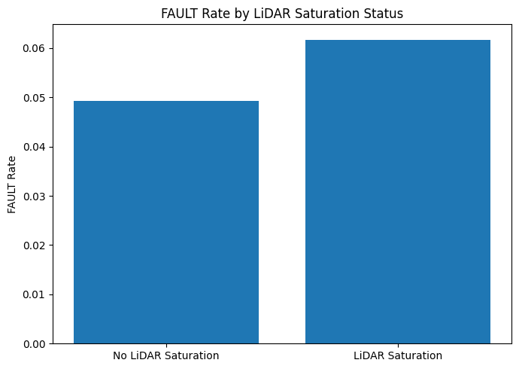
Figure 11. FAULT Rate by LiDAR Saturation Status
The third test evaluated whether FAULT occurrence differed systematically across the 30 individual rover units. A chi-square test of independence was again used because rover identity and FAULT status were categorical variables. Each rover contributed the same number of telemetry observations, allowing FAULT rates to be compared under equal observation exposure.
Observed FAULT rates ranged from 4.20% for AIDO_002 to 5.69% for AIDO_004 and AIDO_024. However, the chi-square test did not identify a statistically significant association between rover identity and FAULT occurrence at the predefined significance level (χ²(29) = 42.202, p = 0.054, n = 181,440). Cramér's V was 0.0153, indicating a negligible association. The null hypothesis was therefore not rejected, and the synthetic telemetry did not provide sufficient evidence that specific rover units were systematically more fault-prone than others.
Test | Method | p-value | Effect Size | Decision
Battery SoC: FAULT Onset vs. PATROL | Mann–Whitney U | 8.837e-10 | 0.0393 | Reject H₀
LiDAR Saturation vs. FAULT Occurrence | Chi-square | 0.0173 | 0.0056 | Reject H₀
FAULT Rate by Rover | Chi-square | 0.0539 | 0.0153 | Fail to Reject H₀
Table 3. Summary of Hypothesis Testing Results
Taken together, the hypothesis tests demonstrate the importance of distinguishing statistical significance from operational significance. Battery SoC and LiDAR saturation both produced statistically significant relationships with FAULT behavior, but their effect sizes were very small. Rover identity did not show a statistically significant association with FAULT occurrence at the α = 0.05 level. These findings suggest that no single variable examined in this analysis provides a sufficiently strong standalone indicator of FAULT behavior.
From an operational perspective, FAULT monitoring should therefore rely on combinations of telemetry and sensor-health signals rather than isolated measurements or rover-specific assumptions. Battery behavior may become more informative when evaluated as a temporal pattern rather than as a single SoC observation, while LiDAR saturation may provide supplementary evidence when combined with other abnormal sensor conditions. Similarly, maintenance decisions should be driven by observed telemetry behavior rather than assuming that particular rover units are inherently more fault-prone.
These results should be interpreted within the limitations of the synthetic dataset. The telemetry contains repeated five-minute observations from the same rover, which may introduce temporal dependence even though the statistical tests assume independent observations. In addition, FAULT status was evaluated at the observation level rather than as independent fault episodes, meaning that longer FAULT periods contribute more observations than shorter events. Future analysis could address these limitations using statistical methods designed for repeated measurements and rover-level temporal dependence.

Fleet Analytics Dashboard
The Aido Rover Fleet Analytics Dashboard was developed to integrate the analytical outputs from the previous stages of the project into a single monitoring environment. Rather than presenting exploratory analysis, classification, time-series forecasting, and anomaly detection as separate analytical tasks, the dashboard organizes their outputs into an operational view that supports fleet-level interpretation and monitoring.
The dashboard is organized into four main analytical areas: Fleet Overview, Classification Insights, Time-Series Monitor, and Anomaly Alert Summary. Together, these sections provide complementary perspectives on current fleet conditions, predictive model behavior, temporal battery patterns, and abnormal telemetry events.
The Fleet Overview section provides a high-level view of rover operations through Operational Mode Distribution, Current Fleet Status, and Current Battery SoC by Rover. These views allow users to examine how the fleet is distributed across operational states while also identifying differences in battery condition among individual rover units. This section serves as the primary operational entry point before users examine more detailed analytical results.
The Classification Insights section summarizes the Random Forest operational-state classification analysis. It includes the Random Forest confusion matrix, class-level F1 scores, and permutation feature importance. These views allow users to evaluate both model performance and the telemetry variables that contribute most strongly to operational-state predictions. In particular, the feature-importance view connects the dashboard to the earlier finding that drivetrain-related measurements played a major role in distinguishing rover operating conditions.
The Time-Series Monitor focuses on fleet battery behavior. The Battery SoC Prediction Interval view presents the forecasting results and associated uncertainty, while Battery Anomaly Events provides additional visibility into unusual battery behavior. Together, these views extend battery monitoring beyond a single current SoC measurement by incorporating temporal patterns and deviations that may require further investigation.
The Anomaly Alert Summary brings together the fault-monitoring results through Per-Fault AUROC, Alert Frequency by Hour and Unit, and Threshold Anomaly Flagging. The AUROC view allows users to compare detection performance across fault types and methods, while the alert-frequency and threshold views provide a more operational perspective on when and where abnormal telemetry is being identified. This section helps translate anomaly-detection results into information that could support further inspection or maintenance review.
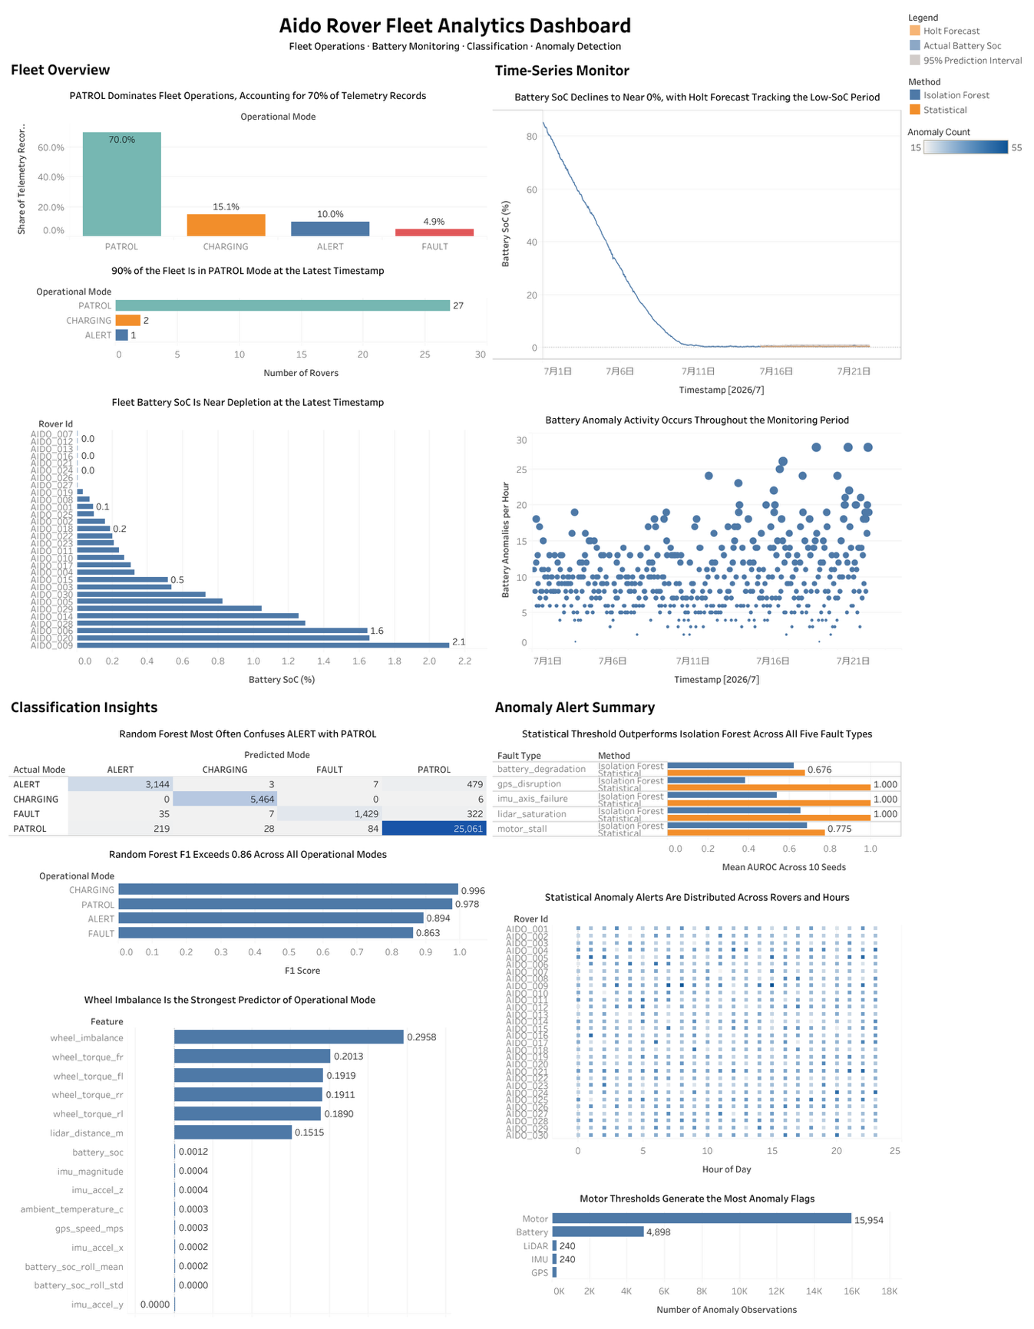
Figure 12. Aido Rover Fleet Analytics Dashboard
The dashboard therefore acts as the integration layer for the analytical workflow developed throughout the internship. Fleet status provides operational context, classification summarizes predicted operating conditions, time-series analysis adds a temporal view of battery behavior, and anomaly detection highlights observations that may require attention. Bringing these components together reduces the need to interpret analytical outputs independently and provides a more coherent view of fleet behavior.
From an operational perspective, the dashboard is intended to support monitoring and investigation rather than automated decision-making. An anomaly flag, low battery measurement, or model prediction should be treated as evidence for further review rather than as a definitive diagnosis. This distinction is particularly important because the dashboard is based on synthetic telemetry and analytical models developed under controlled assumptions.
Overall, the Aido Rover Fleet Analytics Dashboard demonstrates how telemetry analytics can be translated from notebook-based analysis into a more accessible fleet-monitoring interface. By combining operational status, classification performance, battery forecasting, and anomaly detection in a single dashboard, the project connects analytical methods with the types of information that could support practical Physical AI fleet monitoring.

Per-Platform Data Analytics Recommendations
The analytical workflow developed for Aido Rover demonstrates how telemetry can be transformed into operational insights through exploratory analysis, predictive modeling, time-series analysis, anomaly detection, statistical testing, and dashboard development. However, the same analytical approach should not be applied identically across all InGen Physical AI platforms. Each platform generates different types of data and supports different operational objectives, requiring platform-specific analytical priorities.
For Aido Rover, the primary recommendation is to continue developing fleet-level condition monitoring around battery behavior, drivetrain telemetry, and sensor health. The capstone analysis showed that wheel torque and wheel imbalance were particularly informative for operational-state classification, while battery behavior benefited from temporal analysis rather than interpretation of individual SoC measurements. A practical next step would therefore be to combine multivariate drivetrain monitoring, battery trend analysis, and hybrid anomaly detection into a unified fleet-health framework.
For Sentinel Prime AI, analytics should emphasize event-based security monitoring rather than directly transferring the Rover classification model. The synthetic transfer experiment demonstrated substantial degradation when the Aido Rover model was applied to shifted Sentinel-like telemetry, with Macro-F1 decreasing from 0.9298 to 0.6387. This result supports platform-specific model validation and retraining. Sentinel analytics could instead focus on event frequencies, alert patterns, confidence scores, and unusual changes in security-event activity.
For Fari, the most relevant analytical direction is longitudinal monitoring. Health and behavioral observations can be evaluated as changes over time rather than isolated measurements. Time-series methods, individual baseline comparisons, and trend-based anomaly detection could therefore be useful for identifying meaningful changes in behavior or monitored conditions. Because these data may represent individual users, interpretation should emphasize trends and contextual review rather than automatic conclusions from individual measurements.
For Senpai, analytics should focus on learning progress, assessment patterns, and engagement over time. Longitudinal analysis could be used to examine changes in learner performance, while classification or clustering methods could help identify different engagement or learning patterns. Dashboard views could summarize progress and highlight changes that may require additional review while preserving the educational context of the underlying data.
For Aido Humanoid, the analytical priority should be high-dimensional motion and system-health monitoring. Joint measurements, force signals, balance information, perception data, and task-execution telemetry create a substantially more complex multivariate environment than Rover telemetry. Anomaly detection and time-series analysis could be particularly useful for identifying deviations from normal motion or task patterns, while dimensionality reduction and feature engineering may be necessary to make high-dimensional telemetry more interpretable.
At the PIC 2.0 and cross-platform level, the primary recommendation is to establish a consistent analytics framework while preserving platform-specific models and thresholds. Common processes for telemetry validation, data-quality monitoring, feature documentation, model evaluation, anomaly reporting, and dashboard design could make analytics more consistent across the portfolio. However, the transferability experiment in this project demonstrates why shared infrastructure should not be interpreted as evidence that a model trained for one platform can be deployed directly to another.
Overall, the most useful cross-platform strategy is therefore a combination of shared analytical principles and platform-specific implementation. Exploratory analysis, temporal monitoring, predictive modeling, anomaly detection, and visualization can provide a common methodological foundation, while the features, thresholds, models, and operational interpretations should reflect the data characteristics and objectives of each Physical AI platform.

Limitations and Future Work
This capstone demonstrates an end-to-end analytics workflow for Physical AI telemetry, but several limitations should be considered when interpreting the results. The most important limitation is that the analysis was conducted using synthetic Aido Rover telemetry rather than real operational fleet data. The synthetic dataset made it possible to develop and evaluate the complete analytical workflow under controlled conditions, but it cannot fully represent the variability, sensor noise, environmental influences, hardware degradation, and unexpected operating conditions that may occur in real-world deployments. As a result, the reported model performance should be interpreted as evidence of analytical feasibility rather than expected production performance.
The controlled fault experiments introduce an additional limitation. Motor stall, battery degradation, GPS disruption, LiDAR saturation, and IMU axis failure were injected using predefined fault mechanisms. Some statistical detection rules therefore aligned closely with the signatures used to generate the faults, contributing to the perfect AUROC values observed for several fault types. Real failures may develop gradually, appear at different levels of severity, interact with other system conditions, or differ from predefined patterns. Future anomaly-detection evaluation should therefore incorporate real fault records when available and include a wider range of fault durations, severities, and overlapping conditions.
The predictive modeling results are also specific to the data-generating characteristics of the synthetic Aido Rover dataset. Random Forest achieved strong within-dataset classification performance, but the synthetic Sentinel Prime AI transfer experiment showed substantial degradation under shifted sensor characteristics. This demonstrates that strong performance on one platform does not establish cross-platform generalizability. Future work should validate models independently for each Physical AI platform and investigate platform-specific feature engineering, calibration, and retraining rather than assuming that a single model can be transferred directly across systems.
The time-series analysis has similar limitations. Fleet-average battery SoC was evaluated over a relatively short 21-day period, and the final seven-day test period contained relatively stable, low-SoC behavior. Holt exponential smoothing achieved a low RMSE under these conditions, while the bootstrap prediction interval covered all test observations. These results should not be interpreted as evidence that the same forecast accuracy or interval coverage would persist under more variable operating conditions. Longer observation periods containing realistic charging cycles, mission schedules, battery degradation, and environmental variation would provide a stronger basis for evaluating forecasting performance.
Statistical inference is also limited by the structure of the telemetry. Repeated five-minute observations from the same rover introduce temporal dependence, while several hypothesis tests treated observations as independent. In addition, FAULT status was analyzed at the observation level, meaning that longer fault episodes could contribute more observations than shorter events. Future analysis could use methods designed for repeated measurements, rover-level dependence, and event-level outcomes to provide stronger statistical inference.
The Fleet Analytics Dashboard should likewise be viewed as an analytical prototype rather than a production monitoring system. It integrates fleet status, classification results, battery forecasting, and anomaly information into a single interface, but the underlying results are derived from synthetic and offline data. Future development could connect the dashboard to validated operational telemetry, incorporate near-real-time data refresh, establish alert-priority rules, and evaluate whether the displayed information supports effective decisions for fleet operators.
Overall, the next stage of this work should focus on real-world validation and operational calibration. The analytical methods developed in this capstone provide a reusable framework for telemetry exploration, predictive modeling, temporal monitoring, anomaly detection, statistical testing, and visualization. Applying this framework to real Physical AI data would make it possible to evaluate how well the findings generalize beyond the controlled synthetic environment and determine which analytical components provide the greatest operational value.

References
- Cleveland, R. B., Cleveland, W. S., McRae, J. E., & Terpenning, I. (1990). STL: A seasonal-trend decomposition procedure based on loess. Journal of Official Statistics, 6(1), 3–73.
- Hyndman, R. J., & Athanasopoulos, G. (2021). Forecasting: Principles and practice (3rd ed.). OTexts.
- InGen Dynamics. (n.d.). InGen Dynamics. https://www.ingendynamics.com/
- Liu, F. T., Ting, K. M., & Zhou, Z.-H. (2008). Isolation forest. 2008 Eighth IEEE International Conference on Data Mining, 413–422.
- Pedregosa, F., Varoquaux, G., Gramfort, A., Michel, V., Thirion, B., Grisel, O., et al. (2011). Scikit-learn: Machine learning in Python. Journal of Machine Learning Research, 12, 2825–2830.

