Charts:

Histogram

Barchart

Bar in Bar

Dual Axis chart

Tree map

Heat map

Scatter plot

Box and Whiskers

Cross tabs

Highlight tables

Pareto Charts

Waterfall Charts

Funnel Charts

Type of files:

.twb

.twbx

.tds

.tde

Tableau – navigation

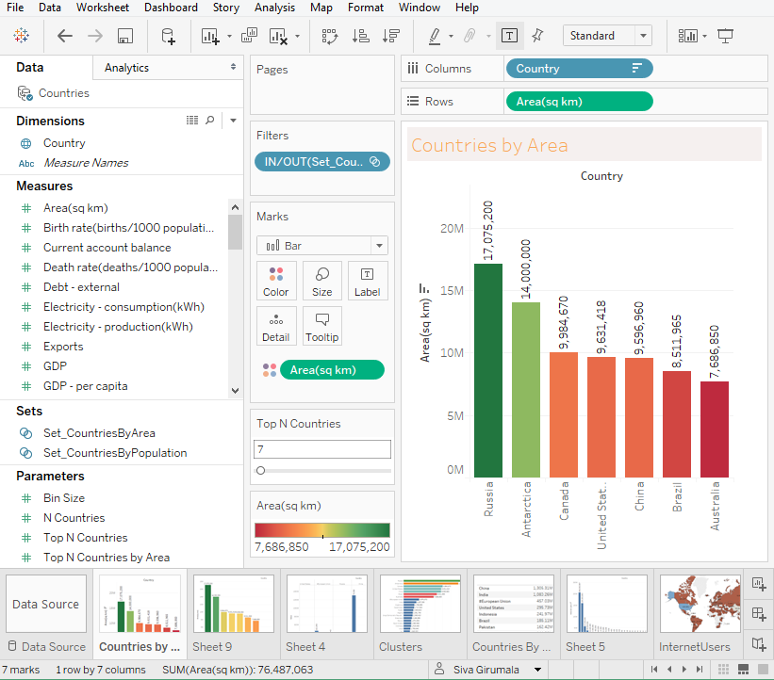

Panes

Pills

Filters

Workbook

Dashboards

Story

Pages

Difference between Discrete Vs Continuous

Parameters

Groups

Sets

Data Connections:

Various Datasoources

Live vs Data Extract

Data Interpreter

Joins

Union vs Blend

Source Data Files:

Connect to Sales.xlsx