PHPGRID3.0用户手册
目录

PHPGRID3.0用户手册 1
目录 1
1简介 1
2 PHPGRID3.0新特性 1
3概览/原理 2
3安装 3
4 PHPGRID的类型 4
5 定制Datagrid 4
6 简单的使用示例 5
6.1. 只需要指定一条SQL 5
6.2 只需要指定表名和字段名 6
6.3 查询 6
6.4 显示控制 6
6.5隐藏行功能 7
6.6使用表单 7
6.7权限控制 7
6.8启用缓存 8
7.复杂功能的例子 8
7.1指定表单字段类型 8
7.2指定表单显示几列 9
7.3给表单字段附加属性 10
7.4设置表单验证 11
7.5使用在线编辑器 12
7.6显示多个grid 13
7.7更换皮肤 15
8．高级应用 16
8.1实现字段值的替换 16
8.2重写表单 18
20

1简介
PHPGRID是一个用于快速开发MIS系统(如ERP,CRM,HR)，网站后台，演示程序的PHP类库，不仅具有数据
添加编辑删除的基本功能，还具有表单自动生成，排序，分页，查询，权限设定，缓存的功能，而且这些功能是可
定制的。对于特殊的需求，您只需编写少量的代码来继承于PHPGRID。 PHPGRID适合那些懒惰而又聪明的PHP
程序员，PHPGRID将使你从无味重复的工作中解放出来。

2 PHPGRID3.0新特性
- 代码简单，不依赖任何第3方类库(去掉以往版本中xajax,prototype pear库)
- 使用简单,一条SQL语句就可以完成所有功能示
- 灵活控制，可以很方便控制显示区域并内置了权限控制
- 同时支持PDO和MYSQL函数
- 支持多个grid同时显示
- 使用了缓存,只缓存表结构信息，但不会缓存数据
- 多语言支持
- 使用live validation做为前端验证
- 精简了HTML代码和CSS样式
- 高性能，使用测试工具：Loadruner进行了性能测试，能够承受大量用户同时访问

3概览/原理
PHPGRID由如下模块组成：
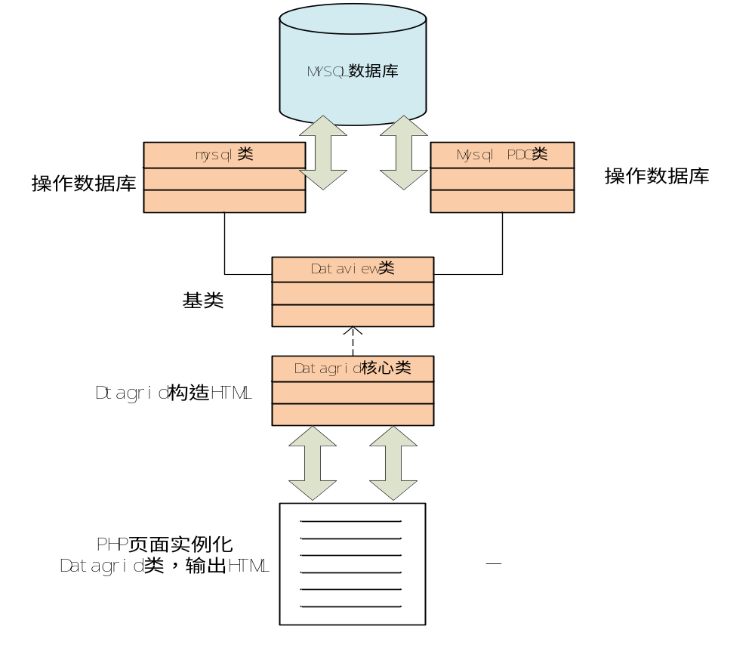

注意，上图并不是一个标准的UML图，该图只是为了大家明白PHPGRID的结构。其中Datagrid类是核心类，它
将根据提供的参数构造SQL并从数据库中取得数据，然后并接成类似如下的HTML，最后返回。
生成HTML的例子：

<form action="" method="get" name="grid_search"><input
type="hidden" name="datagrid_action" value="search" /> <input
type="hidden" name="datagrid_page" value="1" />

<table>
<tr>
<td colspan="3"><span>查询条件</span></td>
</tr>
<tr>
<td>武将名称</td>
<td><select name="ge_name_exp">
<option value="=">=</option>
<option value="!=">!=</option>
<option value="LIKE">LIKE</option>
<option value="LIKE %...%">LIKE %...%</option>
<option value="NOT LIKE">NOT LIKE</option>
<option value="IS NULL">IS NULL</option>
<option value="IS NOT NULL">IS NOT NULL</option>
</select></td>
<td><input type="text" name="ge_name_value" size="25"
class="textfield" id="ge_name_value" /></td>
</tr>

<tr>
<td colspan="6">
<div align="center"><input type="submit" name="Submit"
value="提交"> &nbsp;&nbsp;<input type="reset" name="Submit2"
value="重置"></div>
</td>
</tr>
</table>
<br>
</form>
<table summary=" table of Datagrid">
<caption>武将列表</caption>
<thead>
<tr>
<td scope="col"><a href="?datagrid_order=ge_userid">用户ID</a></td>
<td scope="col"><a href="?datagrid_order=ge_cityid">城市ID</a></td>
<td scope="col"><a href="?datagrid_order=ge_name">武将名称</a></td>
<td scope="col"><a href="?datagrid_order=ge_equipment">装备信息</a></td>
<td width="10%" align="center" scope="col"><a href=#>操作</a></td>
<tr>
</thead>
<tbody>
<tr>
<td>2</td>
<td>2222222222222</td>
<td>Name</td>
<td></td>
<td align="center"><a title="body_control"
href="?datagrid_action=edit&ge_id=1&">编辑</a> <a href="#"
title="body_control"
onClick="if(isconfirm()) window.location.href='?datagrid_action=delete&ge_id=1&'">删除</a></td>
</tr>
</tbody>
<tfoot>
<tr>
<td colspan="21">总数：30 &nbsp; 分页</td>
</tr>
</tfoot>
</table>

文件目录结构：

phpgrid3.0beta
|
|-...
|
+--cache 存放缓存目录
+--js Javascript目录
+--css Css样式目录，用于控制界面的皮肤
+--examples 一些典型的例子
+--images
+--lang 语言包，支持多国语言
+--uploadfiles 默认的文件上传目录，你可以在代码指定另外一个目录
|-...
|-config.inc.php 全局配置文件，主要设置数据库连接，时区和语言
|-Dataview.php Phpgrid3.0的基类文件，该类只是显示一个表格，类似ASP.NET的dataview
|-Datagrid.php Phpgrid3.0的核心文件，继承于Dataview，具有Dataview全部和附件特性
|-Mysql.php 连接MYSQL的类库，支持PDO和MYSQL函数，如果安装了PDO扩展那么将不使用MYSQL函数

3安装
将Phpgrid3.0压缩包释放到你的PHP程序目录，在你需要的地方引入Datagrid.php就可以使用了。
如何运行examples中例子?
步骤如下：
1.在MYSQL数据库中建立任意一个数据库，
2.然后在该数据库下执行example_sql.txt中的SQL语句，将数据导入到该库，
3.接着修改config.inc.php的数据库连接项，
4.最后在浏览器中访问example下的PHP文件。

4 PHPGRID的类型
选择类型
如果你想生成拥有添加删除修改甚至表单的页面，那么你需要实例化于Datagrid类，而如果你只想显示数据那么你只需要实例化于Dataview类
最简单的Dtagrid例子：

<?php

include_once('../Datagrid.php');
$expamle=new Datagrid();
$expamle->sql="SELECT * FROM `customer`";
$html=$expamle->display();
echo $html;
?>

也可以在这个页面中加入其他任意代码，如css样式表，菜单等。
示例：

<?php
include_once('../Datagrid.php');
$expamle=new Datagrid();
$expamle->sql="SELECT * FROM `customer`";
$html=$expamle->display();
?>
<!DOCTYPE html PUBLIC "-//W3C//DTD XHTML 1.0 Transitional//EN">
<html xmlns="http://www.w3.org/1999/xhtml">
<head>
<meta http-equiv="Content-Type" content="text/html; charset=utf-8" />
<link type="text/css" rel="stylesheet" href="../css/bluedream.css" />
<title>Customers</title>
<body >
<table >
<tr>
<td>
<a href="?" >back</a>,&nbsp;&nbsp;Add form:
<a href="?datagrid_action=new" >here</a>
</td>
</tr>
</table>
<?php
echo $html;
?>
</body>
</html>

5 定制Datagrid
你可以非常方便的设定Datagrid的显示，排序，权限，查询，缓存。有如下设定：

//基本参数
public $is_use_cache=false; //是否启用缓存，默认不启用
public $role="v,u,a,d"; //v,u,a,d分表表示具有查看,更新,添加,删除的权限
public $pageRow = 10; //每页显示几行

//显示设置 注意下面设置与前面的权限设置不同，下面只是显示的设置不是权限
public $displaySearch =true; //是否显示表标题的HTML
public $displayTableTitle =true; //是否显示表标题的HTML
public $displayTableHeader =true; //是否显示表头的HTML
public $displayTableBody =true; //是否显示表内容的HTML
public $displayTableFooter =true; //是否显示表底部的HTML
public $displayFooter =true; //是否显示底部的HTML
public $displayControl =true; //是否显示操作
public $displayOrder =true; //是否可以排序
public $displayHideField =false;//显示隐藏列

//数据设置
public $rows=array(); //Datagrid从数据库中得到数据,这里可以不设置
public $sql=""; //通过设置该值，取得特定数据
public $key=""; //SQL中主键字段,如果为空Datagrid自动取得主键值
public $tables=""; //SQL查询中表名称，可以是单表，多表，或者连接表，如果已经设置前面sql，这里可以不需要设置
public $where=""; //设置查询的条件，可以动态的构建条件，用于取得你所需要数据
public $fields =array();//要取得$tables字段格式类似如下：array(’id’,’name’,’pic as picture’),可以使用as 别名
public $fieldDisplays =array();//指定$fields中要显示的字段,格式如下：array(’name’=>’名称’,’ picture’=>’照片’)，数组键值为字段名，而数组值为显示的字符串
public $hideField =""; //设置隐藏列值的字段，如果显示设置允许显示，该项才会生效

//查询的字段,下标为字段名，值为显示的名称
public $searchFields =array();//设置查询的字段，格式类似如：array(’name’=>’名称’,’ picture’=>’照片’),与$fieldDisplays 相似

//表单设定
public $formTable =""; //设置表单对应的表名,只可以设置一个表，如果你要使用表单，必须给该项设置值
public $formFields =array();//设置表单的项，这些表单项为$formTable中的字段，格式如下：array(’name’=>’名称’,’ picture’=>’照片’),与$fieldDisplays 相似
public $formTypes =array();//为表单项指定类型，改项目是可选的，可以指定：label,input,date,text,textarea,select,list,hidden,simple_editor,fckeditor.格式如下：array(’name’=>’text’,
’pic’=>’file’,
’memo’=>’simple_editor’,
’sex’=>array(’select’,array(1,2)
);
public $formPrimkey =""; //指定$formTable中的主键，如果你要使用表单，必须给该项设置值
public $formDefaults =array();//指定表单项中对应的默认值，格式如下array(’name’=>’请输入姓名’);
public $formFieldsValidates =array();//设置表单项中的js验证，使用了livevalidation1.3 javascript库，格式如：array("name"=>"Presence","user_email"=>"Email","cus_phone"=>"Numericality, {minimum: 11}"), 关于livevalidation1的详细使用可以访问官方网站文档：http://livevalidation.com/
public $formColsNum =2;//表单将会显示几列
public $formAttributes =array();//自定义表单项中的HTML属性,格式举例：array("name"=>'style="background:#FFFF00" ',"user_email"=>'readonly="true" style="background:#CCCCCC"'),数组的键值为表单项的名称，数组元素值为其属性

public $formUploadDir ="uploadfiles/";//文件上传的默认存放路径，你可以更改此路径
public $formUploadFiloeType=array("jpg","gif","png","pdf","rar","zip","doc","xls");//允许上传文件的格式
public $formUploadMaxSize =1048576;//文件上传的大小限制

6 简单的使用示例

6.1. 只需要指定一条SQL

<?php

include_once('../Datagrid.php');
$expamle=new Datagrid();
$expamle->sql="SELECT * FROM `customer`";
$html=$expamle->display();
echo $html;
?>

6.2 只需要指定表名和字段名

<?php
include_once('../Datagrid.php');
$expamle=new Datagrid();
$expamle->tables="`customer`";
//aim to-> SELECT `cus_id` ,`cus_name`,`cus_address`,`cus_phone` FROM `customer`
$expamle->fields=array("cus_id","cus_name","cus_address","cus_phone");
$expamle->fieldDisplays=array("cus_name"=>"Customer's name","cus_address"=>"Address","cus_phone"=>"Phone");
$expamle->title="List of customer";
$html=$expamle->display();
echo $html;
?>

6.3 查询

<?php
include_once('../Datagrid.php');
$expamle=new Datagrid();
$expamle->tables="`customer`";
//aim to-> SELECT `cus_id` ,`cus_name`,`cus_address`,`cus_phone` FROM `customer`
$expamle->fields=array("cus_id","cus_name","cus_address","cus_phone");
$expamle->fieldDisplays=array("cus_name"=>"Customer's name","cus_address"=>"Address","cus_phone"=>"Phone");
$expamle->title="List of customer";

//define search fields
$expamle->searchFields=array("cus_name"=>"Customer's name", "cus_address"=>"Address");

$html=$expamle->display();
echo $html;
?>

6.4 显示控制

<?php

include_once('../Datagrid.php');
$expamle=new Datagrid();
$expamle->tables="`customer`";
$expamle->fields=array("cus_id","cus_name","cus_address","cus_phone");
$expamle->fieldDisplays=array("cus_name"=>"Customer's name","cus_address"=>"Address","cus_phone"=>"Phone");
$expamle->title="List of customer";

$expamle->displayTableTitle=false; //no display Table Title
$expamle->displayOrder=false; //no display order
$expamle->displayTableHeader=false; //no display Table Header
$expamle->displaySearch=false; //no display Search part
$expamle->displayControl=false; //no display Control colums
$expamle->displayTableFooter=false; //no display Footer

$html=$expamle->display();
echo $html;
?>

6.5隐藏行功能

<?php

include_once('../Datagrid.php');
$expamle=new Datagrid();
$expamle->tables="`customer`";
//aim to-> SELECT `cus_id` ,`cus_name`,`cus_address`,`cus_phone` FROM `customer`
$expamle->fields=array("cus_id","cus_name","cus_address","cus_phone","cus_memo");
$expamle->fieldDisplays=array("cus_name"=>"Customer's name","cus_address"=>"Address","cus_phone"=>"Phone");
$expamle->title="List of customer";
$expamle->displayHideField=true;//先设置显示隐藏行
$expamle->hideField="cus_memo";/指定隐藏行的字段

$html=$expamle->display();
echo $html;
?>

6.6使用表单

<?php

include_once('../Datagrid.php');
$expamle=new Datagrid();
$expamle->tables="`customer`";
//aim to-> SELECT `cus_id` ,`cus_name`,`cus_address`,`cus_phone` FROM `customer`
$expamle->fields=array("cus_id","cus_name","cus_address","cus_phone");
$expamle->fieldDisplays=array("cus_name"=>"Customer's name","cus_address"=>"Address","cus_phone"=>"Phone");
$expamle->title="List of customer";

// 设置表单属性
$expamle->formTable="`customer`";
$expamle->formFields=array("cus_name"=>"Customer's name","cus_address"=>"Address","cus_phone"=>"Phone");

$html=$expamle->display();
echo $html;
?>

6.7权限控制

<?php

include_once('../Datagrid.php');
$expamle=new Datagrid();
$expamle->tables="`customer`";
//aim to-> SELECT `cus_id` ,`cus_name`,`cus_address`,`cus_phone` FROM `customer`
$expamle->fields=array("cus_id","cus_name","cus_address","cus_phone");
$expamle->fieldDisplays=array("cus_name"=>"Customer's name","cus_address"=>"Address","cus_phone"=>"Phone");
$expamle->title="List of customer";
$expamle->role="v,d,a";//设置此属性来设定权限
// define form
$expamle->formTable="`customer`";
$expamle->formFields=array("cus_name"=>"Customer's name","cus_address"=>"Address","cus_phone"=>"Phone");

$html=$expamle->display();
echo $html;
?>

6.8启用缓存
启用缓存，需要对cache具有读写权限

<?php

include_once('../Datagrid.php');
$expamle=new Datagrid();
$expamle->is_use_cache=true; //启用缓存
$expamle->tables="`customer`";
//aim to-> SELECT `cus_id` ,`cus_name`,`cus_address`,`cus_phone` FROM `customer`
$expamle->fields=array("cus_id","cus_name","cus_address","cus_phone");
$expamle->fieldDisplays=array("cus_name"=>"Customer's name","cus_address"=>"Address","cus_phone"=>"Phone");
$expamle->title="List of customer";
$html=$expamle->display();
echo $html;
?>

7.复杂功能的例子

7.1指定表单字段类型

<?php

include_once('../Datagrid.php');
$expamle=new Datagrid();
$expamle->tables="`customer`";
//aim to-> SELECT `cus_id` ,`cus_name`,`cus_address`,`cus_phone` FROM `customer`
$expamle->fields=array("cus_id","cus_userid","cus_name","cus_email","cus_dept","cus_address","cus_phone","cus_pic");
$expamle->fieldDisplays=array("cus_name"=>"Customer's name","cus_userid"=>"User","cus_email"=>"Email","cus_dept"=>"Department","cus_address"=>"Address","cus_phone"=>"Phone","cus_pic"=>"Pictrue");
$expamle->title="List of customer";

$expamle->formTable="`customer`";
$expamle->formFields=$expamle->fieldDisplays;

$user_list=array(1=>"Mark",2=>"Jockson",3=>"Tom",4=>"Sun");
$expamle->formTypes=array('cus_name' =>'text',
'cus_email' => 'text',
'cus_address' => 'text',
'cus_pic'=>'file',
'cus_phone'=>'text',
'cus_userid' => array('select',$user_list),
'cus_dept' => array ('list',array (1=>'HR',2=>'Information',3=>'BI'))
);

//use livevalidation1.3 javascript libary
//how to use? See http://livevalidation.com/
$expamle->formFieldsValidates=array("cus_name"=>"Presence",
"cus_userid"=>"Presence",
"cus_email"=>"Email",
"cus_phone"=>"Numericality, {minimum: 11}");

$html=$expamle->display();
echo $html;
?>

结果如下：
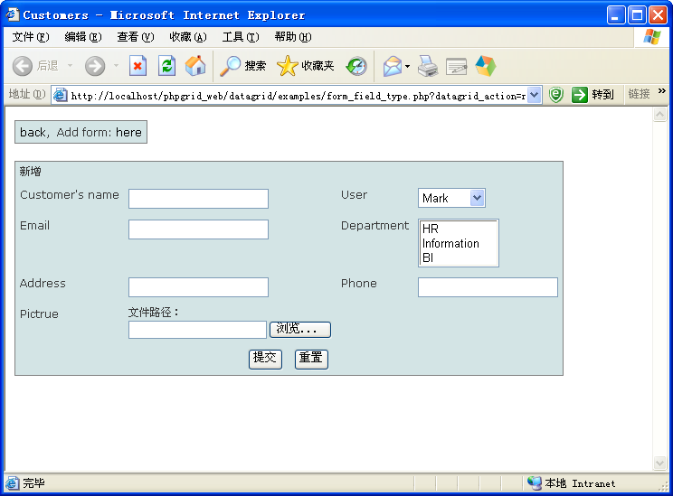

7.2指定表单显示几列

<?php
include_once('../Datagrid.php');
$expamle=new Datagrid();
$expamle->tables="`customer`";
//aim to-> SELECT `cus_id` ,`cus_name`,`cus_address`,`cus_phone` FROM `customer`
$expamle->fields=array("cus_id","cus_name","cus_address","cus_phone");
$expamle->fieldDisplays=array("cus_name"=>"Customer's name","cus_address"=>"Address","cus_phone"=>"Phone");
$expamle->title="List of customer";

$expamle->formTable="`customer`";
$expamle->formFields=$expamle->fieldDisplays;
$expamle->formColsNum=3;//指定表单显示3列
$html=$expamle->display();
?>
<!DOCTYPE html PUBLIC "-//W3C//DTD XHTML 1.0 Transitional//EN">
<html xmlns="http://www.w3.org/1999/xhtml">
<head>
<meta http-equiv="Content-Type" content="text/html; charset=utf-8" />
<link type="text/css" rel="stylesheet" href="../css/bluedream.css" />
<title>Customers</title>
<body >
<table >
<tr>
<td><a href="?" >back</a>,&nbsp;&nbsp;Add form: <a href="?datagrid_action=new" >here</a></td>
</tr>
</table>
<?php
echo $html;
?>

</body>
</html>

结果：
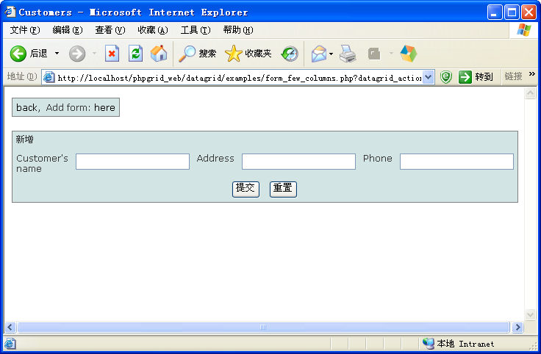

7.3给表单字段附加属性

<?php

include_once('../Datagrid.php');
$expamle=new Datagrid();
$expamle->tables="`customer`";
//aim to-> SELECT `cus_id` ,`cus_name`,`cus_address`,`cus_phone` FROM `customer`
$expamle->fields=array("cus_id","cus_name","cus_email","cus_address","cus_phone");
$expamle->fieldDisplays=array("cus_name"=>"Customer's name","cus_email"=>"Email","cus_address"=>"Address","cus_phone"=>"Phone");
$expamle->title="List of customer";

$expamle->formTable="`customer`";
$expamle->formFields=array("cus_name"=>"Customer's name",
"cus_email"=>"Email",
"cus_address"=>"Address",
"cus_phone"=>"Phone");

//此处设置了表单中一些字段的属性
$expamle->formAttributes=array("cus_name"=>'style="background:#FFFF00" ',
"cus_email"=>'readonly="true" style="background:#CCCCCC"');

$html=$expamle->display();
?>
<!DOCTYPE html PUBLIC "-//W3C//DTD XHTML 1.0 Transitional//EN">
<html xmlns="http://www.w3.org/1999/xhtml">
<head>
<meta http-equiv="Content-Type" content="text/html; charset=utf-8" />
<link type="text/css" rel="stylesheet" href="../css/bluedream.css" />
<title>Customers</title>
<body >
<table >
<tr>
<td><a href="?" >back</a>,&nbsp;&nbsp;Add form: <a href="?datagrid_action=new" >here</a></td>
</tr>
</table>
<?php
echo $html;
?>

</body>
</html>

结果，注意cus_name和cus_email表单字段的背景颜色改变了：
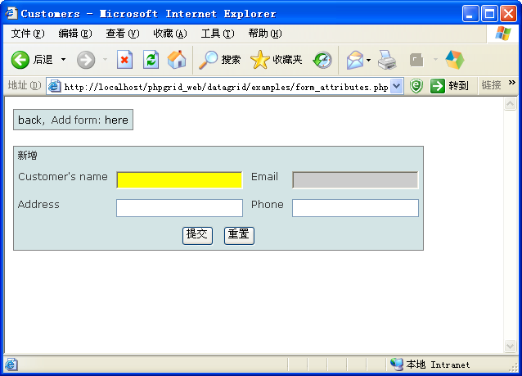

7.4设置表单验证
在Datagrid设置表单验证非常的简单

<?php

include_once('../Datagrid.php');
$expamle=new Datagrid();
$expamle->tables="`customer`";
//aim to-> SELECT `cus_id` ,`cus_name`,`cus_address`,`cus_phone` FROM `customer`
$expamle->fields=array("cus_id","cus_name","cus_email","cus_address","cus_phone");
$expamle->fieldDisplays=array("cus_name"=>"Customer's name","cus_email"=>"Email","cus_address"=>"Address","cus_phone"=>"Phone");
$expamle->title="List of customer";

$expamle->formTable="`customer`";
$expamle->formFields=array("cus_name"=>"Customer's name",
"cus_email"=>"Email",
"cus_address"=>"Address",
"cus_phone"=>"Phone");
//使用了 livevalidation1.3 javascript 验证类库
//详细使用请参考 http://livevalidation.com/
$expamle->formFieldsValidates=array("cus_name"=>"Presence",
"cus_email"=>"Email",
"cus_phone"=>"Numericality, {minimum: 11}");

$html=$expamle->display();
?>
<!DOCTYPE html PUBLIC "-//W3C//DTD XHTML 1.0 Transitional//EN">
<html xmlns="http://www.w3.org/1999/xhtml">
<head>
<meta http-equiv="Content-Type" content="text/html; charset=utf-8" />
<link type="text/css" rel="stylesheet" href="../css/bluedream.css" />
<title>Customers</title>
<body >
<table >
<tr>
<td><a href="?" >back</a>,&nbsp;&nbsp;Add form: <a href="?datagrid_action=new" >here</a></td>
</tr>
</table>
<?php
echo $html;
?>

</body>
</html>
结果
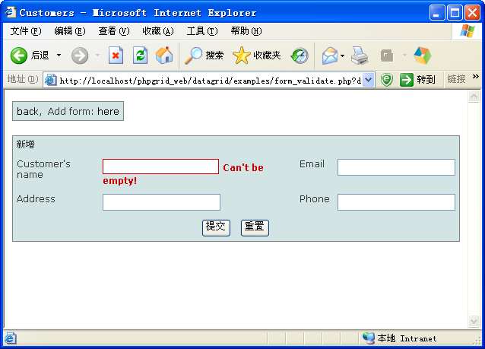

7.5使用在线编辑器

<?php

include_once('../Datagrid.php');
$expamle=new Datagrid();
$expamle->tables="`customer`";
//aim to-> SELECT `cus_id` ,`cus_name`,`cus_address`,`cus_phone` FROM `customer`
$expamle->fields=array("cus_id","cus_userid","cus_name","cus_email","cus_dept","cus_address","cus_phone","cus_pic","cus_memo");
$expamle->fieldDisplays=array("cus_name"=>"Customer's name",
"cus_userid"=>"User",
"cus_email"=>"Email",
"cus_dept"=>"Department",
"cus_address"=>"Address",
"cus_phone"=>"Phone",
"cus_pic"=>"Pictrue",
"cus_memo"=>"Memo");
$expamle->title="List of customer";

$expamle->formTable="`customer`";
$expamle->formFields=$expamle->fieldDisplays;
$expamle->formColsNum=1; //Set the form for a few columns

$user_list=array(1=>"Mark",2=>"Jockson",3=>"Tom",4=>"Sun");
$expamle->formTypes=array('cus_name' =>'text',
'cus_email' => 'text',
'cus_address' => 'simple_editor',
'cus_memo' => 'fckeditor',
'cus_pic'=>'file',
'cus_phone'=>'text',
'cus_userid' => array('select',$user_list),
'cus_dept' => array ('list',array (1=>'HR',2=>'Information',3=>'BI'))
);

//use livevalidation1.3 javascript libary
//how to use? See http://livevalidation.com/
$expamle->formFieldsValidates=array("cus_name"=>"Presence",
"cus_userid"=>"Presence",
"cus_email"=>"Email",
"cus_phone"=>"Numericality, {minimum: 11}");

$html=$expamle->display();
?>
<!DOCTYPE html PUBLIC "-//W3C//DTD XHTML 1.0 Transitional//EN">
<html xmlns="http://www.w3.org/1999/xhtml">
<head>
<meta http-equiv="Content-Type" content="text/html; charset=utf-8" />
<link type="text/css" rel="stylesheet" href="../css/bluedream.css" />
<title>Customers</title>
<body >
<table >
<tr>
<td><a href="?" >back</a>,&nbsp;&nbsp;Add form: <a href="?datagrid_action=new" >here</a></td>
</tr>
</table>
<?php
echo $html;
?>

</body>
</html>

结果：
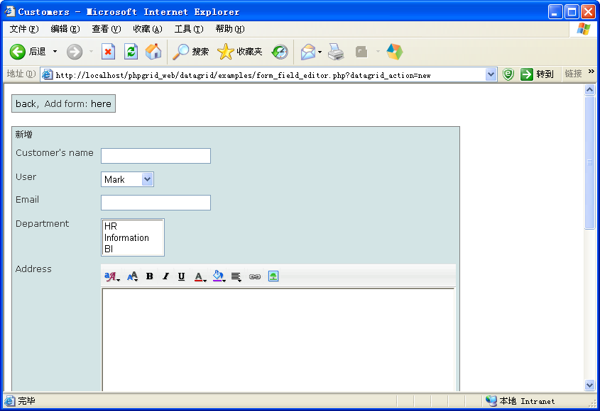

7.6显示多个grid

<?php
//first
include_once('../Datagrid.php');
$gridObj=new Datagrid();
$gridObj->tables="`customer`";
//aim to-> SELECT `cus_id` ,`cus_name`,`cus_address`,`cus_phone` FROM `customer`
$gridObj->fields=array("cus_id","cus_name","cus_address","cus_phone");
$gridObj->fieldDisplays=array("cus_name"=>"Customer's name","cus_address"=>"Address","cus_phone"=>"Phone");
$gridObj->title="List of customer";
$gridHtml=$gridObj->display();

//second
$viewObj=new Dataview();
$viewObj->sql="SELECT * FROM `customer` left join `user` on user_id=cus_userid";
$viewObj->fieldDisplays=array("cus_name"=>"Customer","user_name"=>"User","cus_pic"=>"Pictrue","cus_address"=>"Address","cus_phone"=>"Phone");
$viewHtml=$viewObj->display();

?>
<!DOCTYPE html PUBLIC "-//W3C//DTD XHTML 1.0 Transitional//EN">
<html xmlns="http://www.w3.org/1999/xhtml">
<head>
<meta http-equiv="Content-Type" content="text/html; charset=utf-8" />
<link type="text/css" rel="stylesheet" href="../css/bluedream.css" />
<title>Customers</title>
<body >
<?php
echo $gridHtml;
?>
<p><p>

<?php
echo $viewHtml;
?>
</body>
</html>
结果：
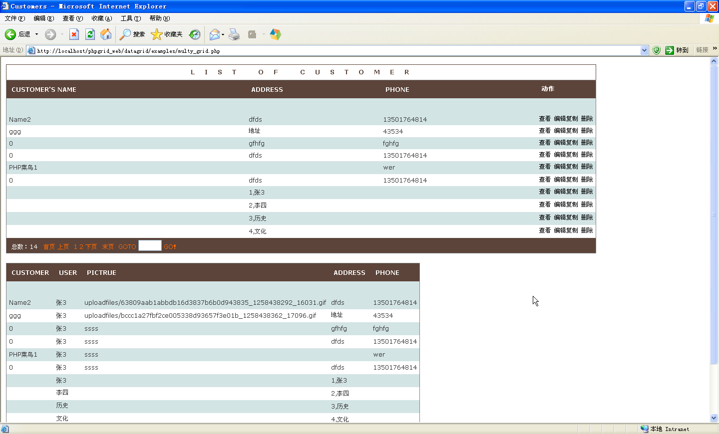

7.7更换皮肤
Datagrid内置了许多表格CSS样式通过更换这些样式可以更换你所需要的皮肤

<?php
//first
include_once('../Datagrid.php');
$gridObj=new Datagrid();
$gridObj->tables="`customer`";
//aim to-> SELECT `cus_id` ,`cus_name`,`cus_address`,`cus_phone` FROM `customer`
$gridObj->fields=array("cus_id","cus_name","cus_address","cus_phone");
$gridObj->fieldDisplays=array("cus_name"=>"Customer's name","cus_address"=>"Address","cus_phone"=>"Phone");
$gridObj->title="List of customer";
$gridHtml=$gridObj->display();

//second
$viewObj=new Dataview();
$viewObj->sql="SELECT * FROM `customer` left join `user` on user_id=cus_userid";
$viewObj->fieldDisplays=array("cus_name"=>"Customer","user_name"=>"User","cus_pic"=>"Pictrue","cus_address"=>"Address","cus_phone"=>"Phone");
$viewHtml=$viewObj->display();

?>
<!DOCTYPE html PUBLIC "-//W3C//DTD XHTML 1.0 Transitional//EN">
<html xmlns="http://www.w3.org/1999/xhtml">
<head>
<meta http-equiv="Content-Type" content="text/html; charset=utf-8" />
<title>Customers</title>
<script type="text/javascript">
if(getCookie('style_css')!=null){
document.write('<link type="text/css" rel="stylesheet" href="../css/'+getCookie('style_css')+'.css" />');
}else{
document.write('<link type="text/css" rel="stylesheet" href="../css/oranges-in-the-sky.css" />');
}
//写cookies函数
function SetCookie(name,value)
{
var Days = 30;
var exp = new Date(); //new Date("December 31, 9998");
exp.setTime(exp.getTime() + Days*24*60*60*1000);
document.cookie = name + "="+ escape (value) + ";expires=" + exp.toGMTString();
}
function getCookie(name)
{
var arr = document.cookie.match(new RegExp("(^| )"+name+"=([^;]*)(;|$)"));
if(arr != null) return unescape(arr[2]); return null;

}
</script>

<body >

<table >
<tr>
<td>当前位置：<a href="?" >数据列表</a>,&nbsp;&nbsp;添加请点 <a href="?datagrid_action=new" >这里</a>&nbsp;&nbsp;&nbsp;更换皮肤
<select name="style_cass" id="style_css" onChange="SetCookie('style_css',this.value);window.location.reload();" >
<option >请选择</option>
<option value="oranges-in-the-sky">oranges-in-the-sky.css</option>
<option value="bluedream">bluedream.css</option>
<option value="classic_somehow">classic_somehow.css</option>
<option value="itunes">itunes.css</option>
<option value="mintgreen">mintgreen.css</option>
<option value="seaglass">seaglass.css</option>
<option value="pure_blue">pure_blue.css</option>
<option value="dartblue">dartblue.css</option>
</select>
</td>
</tr>
</table>
<?php
echo $gridHtml;
?>
<p><p>

<?php
echo $viewHtml;
?>
</body>
</html>
结果：
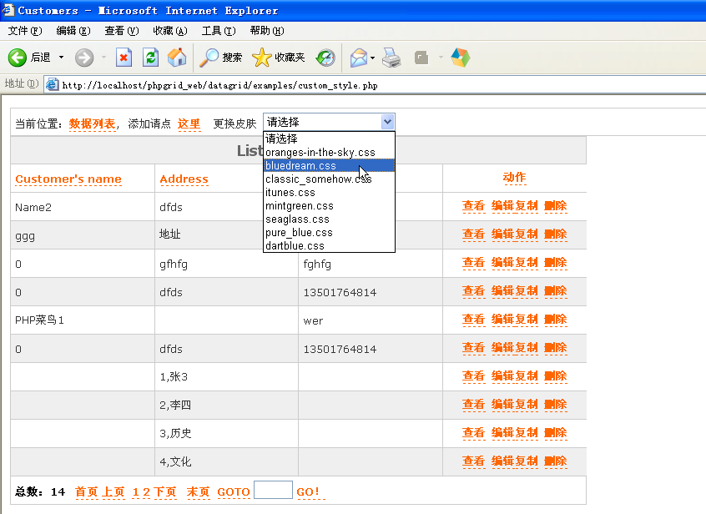

8．高级应用
在遇到比较复杂的业务需求时，基本设置里已经不能满足运行的需要了 ，由于Phpgrid 采用面向对象技术，因此可以对Datagrid和Dataview类进行继承和扩展重写.
使用这种方法，可以满足任何特殊的需求，而且这样无需要修改基类的代码。
当你继承于Datagrid和Dataview类后你可以重写其中任意public方法。
下面是一些扩展的示例。

8.1实现字段值的替换
通过重写Datagrid类的repalceValue函数可以对每一个字段值进行替换，例如加上 颜色或者超链接，代码：

<?php

include_once('../Datagrid.php');

$GLOBALS['user_list']=array(1=>"Mark",2=>"Jockson",3=>"Tom",4=>"Sun");

/**
* 继承了 Datagrid类 并重写了repalceValue函数
*
* @author cdwei
*
*/
class myclass extends Datagrid{

//rewrite this function to custom table body
function repalceValue($row,$field,$value) {
if($field=="cus_userid"){
return $GLOBALS['user_list'][$value];
}
if($field=="cus_pic"){
return '<img src="../'.$value.'" width="30%" height="30%" />';
}
return $value;
}
}
//实例化继承后的myclass类
$expamle=new myclass();
$expamle->tables="`customer`";
//aim to-> SELECT `cus_id` ,`cus_name`,`cus_address`,`cus_phone` FROM `customer`
$expamle->fields=array("cus_id","cus_name","cus_userid","cus_pic","cus_address","cus_phone");
$expamle->fieldDisplays=array("cus_name"=>"Customer's name","cus_userid"=>"User","cus_pic"=>"Pictrue","cus_address"=>"Address","cus_phone"=>"Phone");
$expamle->title="List of customer";

$expamle->formTable="`customer`";
$expamle->formFields=$expamle->fieldDisplays;

$expamle->formTypes=array('cus_name' =>'text',
'cus_email' => 'text',
'cus_address' => 'text',
'cus_pic'=>'file',
'cus_phone'=>'text',
'cus_userid' => array('select',$GLOBALS['user_list'])
);

$html=$expamle->display();
?>
<!DOCTYPE html PUBLIC "-//W3C//DTD XHTML 1.0 Transitional//EN">
<html xmlns="http://www.w3.org/1999/xhtml">
<head>
<meta http-equiv="Content-Type" content="text/html; charset=utf-8" />
<link type="text/css" rel="stylesheet" href="../css/bluedream.css" />
<title>Customers</title>
<body >
<table >
<tr>
<td><a href="?" >back</a>,&nbsp;&nbsp;Add form: <a href="?datagrid_action=new" >here</a></td>
</tr>
</table>
<?php
echo $html;
?>

</body>
</html>

replaceValue函数的$row为数据中每一行的值，$field为当前的字段名，$value为当前值
结果：
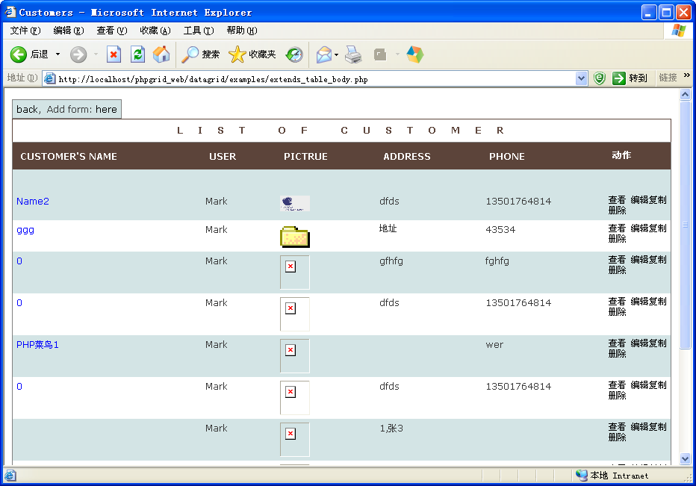

8.2重写表单
当您需要更复杂的表单时， 需要扩展Datagrid类的formAdd ，formEdit函数，例如：

<?php

include_once('../Datagrid.php');

$GLOBALS['user_list']=array(1=>"Mark",2=>"Jockson",3=>"Tom",4=>"Sun");

/**
* extend Datagrid ,rewrite the public of function
*
* @author cdwei
*
*/
class myclass extends Datagrid{

/**
*重写生成新增表单
*/
public function setNewFormHtml() {
$html='
<table id="formHtml" >
<tr>
<td colspan="4" ><span >自己定义添加表单</span></td>
</tr>

<td >Customer name</td>
<td ><input type="text" id="cus_name" name="cus_name" value="" > </td>

<td >User</td>
<td ><select name="cus_userid" id="cus_userid">
<option value=1>Mark</option>
<option value=2>Jockson</option>
<option value=3>Tom</option>
<option value=4>Sun</option>
</select> </td>
</tr>
<td >Pictrue</td>
<td >文件路径：<a href="../" target="_blank"></a><br>
<input name="cus_pic" id="cus_pic" type="file" /> </td>

<td >Address</td>
<td ><input type="text" id="cus_address" name="cus_address" value="" > </td>
</tr>
<td >Phone</td>
<td ><input type="text" id="cus_phone" name="cus_phone" value="" > </td>

<td ></td>
<td > </td>
</tr><tr >
<td colspan="4">
<div align="center">
<input type="submit" name="Submit" value="提交">
&nbsp;&nbsp;<input type="reset" name="Submit2" value="重置">
</div></td>
</tr> </table>
';

return $html;
}

/**
*重写生成编辑表单
*/
public function setEditFormHtml() {
return $this->makeFormHtml('edit');
}

}
//实例化继承后的myclass类
$expamle=new myclass();
$expamle->tables="`customer`";
//aim to-> SELECT `cus_id` ,`cus_name`,`cus_address`,`cus_phone` FROM `customer`
$expamle->fields=array("cus_id","cus_name","cus_userid","cus_pic","cus_address","cus_phone");
$expamle->fieldDisplays=array("cus_name"=>"Customer's name","cus_userid"=>"User","cus_pic"=>"Pictrue","cus_address"=>"Address","cus_phone"=>"Phone");
$expamle->title="List of customer";

$expamle->formTable="`customer`";
$expamle->formFields=$expamle->fieldDisplays;

$html=$expamle->display();
?>
<!DOCTYPE html PUBLIC "-//W3C//DTD XHTML 1.0 Transitional//EN">
<html xmlns="http://www.w3.org/1999/xhtml">
<head>
<meta http-equiv="Content-Type" content="text/html; charset=utf-8" />
<link type="text/css" rel="stylesheet" href="../css/bluedream.css" />
<title>Customers</title>
<body >
<table >
<tr>
<td><a href="?" >back</a>,&nbsp;&nbsp;Add form: <a href="?datagrid_action=new" >here</a></td>
</tr>
</table>
<?php
echo $html;
?>

</body>
</html>

运行结果：

