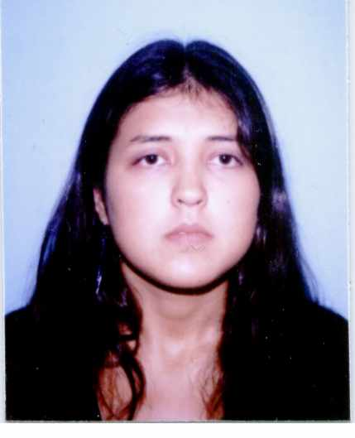
PERSONAL DETAILS
- Date of birth: June 3rd, 1982
- Nº Passport: 29506398N
- Marital Status: single
- Nationality: Argentinean
- US VISA B1

EDUCATION
2000- 2006. Universidad Tecnológica Nacional – Facultad Regional Buenos Aires
System Engineering degree

OBJECTIVE
I consider myself a person with analytical, problem solving, good communication skills and easily adaptable to changes and my objectives are:
To find a challenging position to utilize my skills and abilities as Functional Analyst and Project Leader, to be able to interact to clients and team groups from different cultures and in diverse countries. My goal is to lead and manage project (Project Management)

SKILLS
Junior level in: Corel Draw, DB2, Dreamweaver, Firework, Hubs & Switches, Illustrator, J#, JavaScript, JSP / Servlet / JavaBeans, Linux, Modems, MS Access, Oracle, Reparación PC, SAP, TCP/IP, VPN, Windows ME, Windows NT, Windows 9x, Eclipse, Netbeans, Hibernate, Struts, Spring, Nhibernate, Spring.Net, Design Patterns, Websphere 5.1 , Tomcat, Ruby
Semi senior level in: ASP, C#, C/C++, HTML, Java, MS SQL Server, Pascal, Prolog, SmallTalk, MySQL, Visual Basic .NET, Web Servers, XML, SOA, usability, user experience, Drupal, ecommerce business , PMBOK Guide (PMI), Object Oriented Programming, SQL Server 2000/2005
Senior level in: requirements elicitation, creating use cases/user stories, managing project status as a Project Leader level, SQL, UML, Agile methodology, MS Project

Applications/ Tools:
- Tools for modeling and documenting software systems: Enterprise Architect, Rational. (Advance level in modeling using UML)
- Tool for issue tracking, task tracking, and project management: Bugzilla, JIRA.
- Tool for sharing information: Confluence.
- Internet: Mail configuration, etc.
- Ms Office
Languages
- Native Language: Spanish
- Language written and spoken fluently: English (FCE). I lived and worked abroad.
- Language read and understood basic: French (U.B.A)

ACTIVITIES/ INTERESTS
Member of Scouts de Argentina: leader responsible for the planning of activities.

WORK EXPERIENCE
DIRECTV 02/2011 to Present
- I am working as: Business Analyst Sr and Project Leader
- I am working in the Regional IT team and my responsibility is to understand the new processes in order to implement them in all Panamericana region from Directv.

FREELANCER 10/2010 to 01/2011
- I have worked as: Functional Analyst Sr
- I have worked for a customer from UK as Functional Analyst. I am in charge of all functional documentation and change requests.
- Update meetings

GLOBANT 03/2010 to 10/2010
- I worked as: Functional Analyst Sr
- Member of Globant’s Functional Analyst team
- I have worked as Functional Analyst abroad for 6 months (in Prague, Czech Republic) and I was in charge of the functional analyst team. The development team was spread all over the world (India, Argentina, UK and Prague)
- My responsibility was to elicitate requirements and offer different solutions and approaches to solve the business need.
- Pre sales support: I had to create Functional Specification and I have participated in estimations

INTELLIGENX 08/2009 to 02/2010
- I worked as: Functional Analyst Sr and Project Leader
- Methodology: Agile
- Writing user stories
- Document systems functionalities in APT format in the project
- Pre sales tasks: I had to create Functional Specification and I have helped in estimations

GLOBANT 01/2008 to 07/2009
- I worked as: Functional Analyst SSr Advanced
- Member of Globant’s Functional Analyst team
- Methodology: Agile
- Extracting requirements and documenting those definitions
- Wrote user stories for the projects: GLOW and DNA (both internal projects)
- Wrote user manuals
- I was the only Functional Analyst in a team of 30 developers (20 in Buenos Aires, 5 in Tandil and 5 in US) and 5 QC Analysts.
- The system we built was developed in Java and .Net using an object oriented design
- GLOW and DNA Trainings
- Pre sales support: I had to create Functional Specification and I have helped in estimations
- In charge of the planning and development of a UML Training Course

PATAGONIA TECHNOLOGIES 06/2005 to 12/2007
- I worked as: Java and .Net Developer, Functional Analyst SSr and Project Leader.
- Extracting of requirements and Functional analysis
- Use Case specifications and design of sequence and activity diagrams
- User Interface prototype specification and development
- Estimating resources
- Follow up meeting and minutes
- Development in Java and C#
- Testing

Projects in Patagonia Technologies:

2006/2007 – Telecom
I was involved in four projects: Gestión de Emprendimientos, Portal de Autogestión, Estadísticas 0800 y Mi Cuenta.
My responsibilities as Functional Analyst are extracting requirements, defining and documenting those business requirements; design use cases using UML; user Interface prototype specification. Also, as a Project Leader I am responsible for monitoring progress in all project simultaneously.

2006 – La Caja de Ahorro y Seguro
I was involved in one project: HDLC
My main responsibility was to develop in Java an internal tool for the company. (Eclipse 3.1, Hibernate, Struts)

2005 – Telecom
I was involved in one project: Comisiones
My responsibilities were to extract the requirements, research and prioritize user requirements; Use Case specification and User Interface prototype specification and development.

2005 – INSA
I was involved in one project: Gestor de Residuos
My responsibilities were to analyze user needs to determine functional requirements, functional analisys and design use cases and sequence diagrams.

2005 – Solis System
I was involved in one project: NEP
My responsibilities were to analyze requirements, use case specification and design of activity and sequence diagrams.
Development in Java (win application using Netbeans).
Development in C# Visual Studio 2003 .NET
Note: It was necessary to communicate in english ( call conferences , emails,etc)

E.D.S ARGENTINA 03/2004 to 05/2005
- I worked as Data center Analyst
- Audit tape process (Data center)
- Monitoring bank processes (mainframe, TSO (ispf))
- Coordination of technical services
- Inventory of modems and crypt devices

LATINGRAFICA S.R.L 06/2003 to 02/2004
- Calculate budget (magazines, books, etc)
- Negotiate with suppliers

