

MODULE 3.2 ASSIGNMENT: GITHUB PAGES

ELVIA GISELLA ADAIR
STUDENT

CHRISTINE MAZHATA
TEACHER

JANUARY 25, 2026

ASSIGNMENT: GITHUB PAGES

- Validate the HTML by using the W3C HTML validator and correct any errors. There must be 0 errors

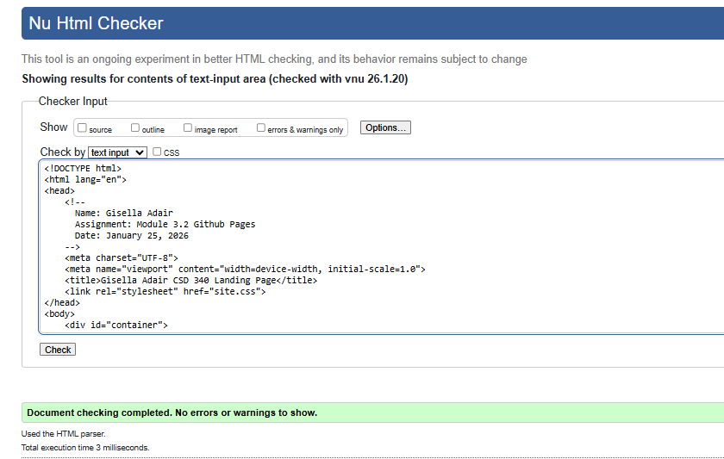

- Validate the CSS by using the W3C CSS validator. There must be 0 errors
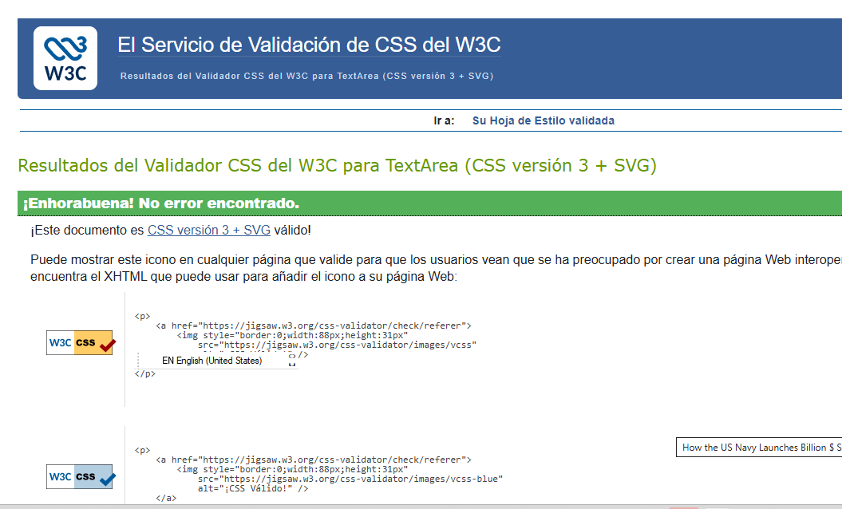
- Open your index page in a browser and take a screenshot of the results.

