Name: Elvia Gisella Adair
Date: November 30, 2025
Assignment: Movies: Update & Deletes
GitHub link: https://github.com/gisellaadair/csd-310.git

- Python package installed
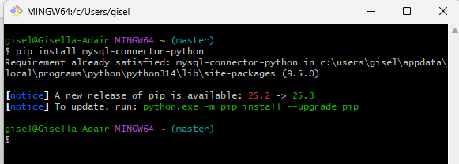

- Create a new python file containing all the queries under the module-8 directory and name it movies_update_and_delete.py.

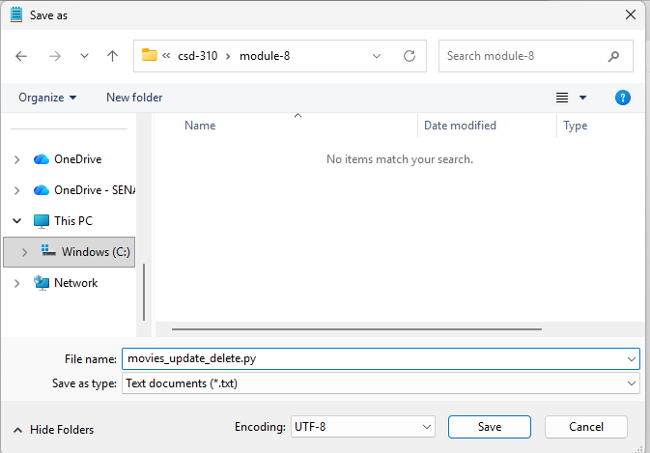

- Insert a new record into the Movies table using a film of your choice. Do not use 'Star Wars'. (Easier if you use a studio already in use..)
- Python code to update and delete movies

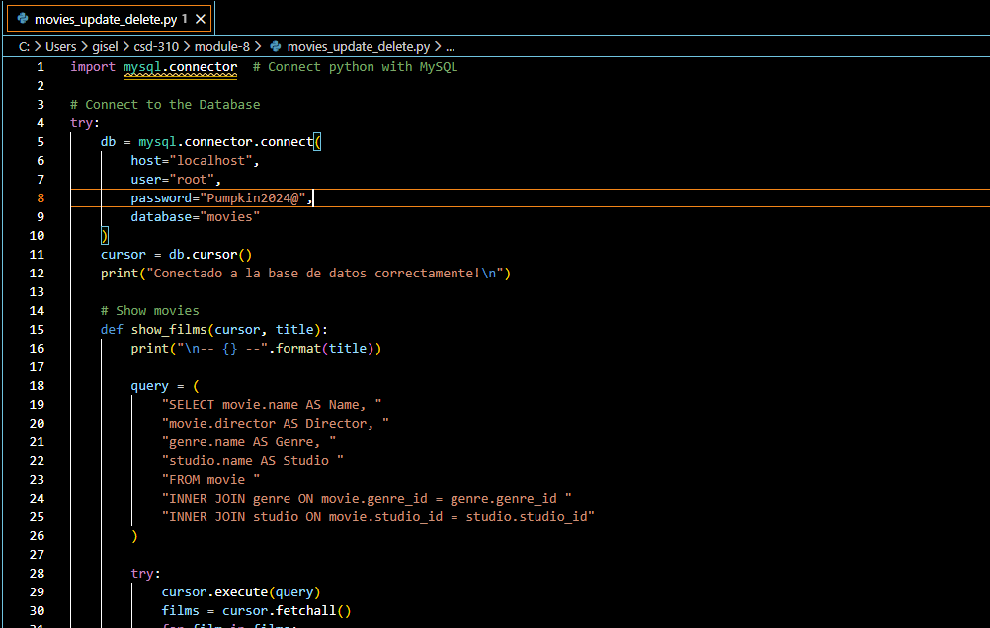
- Install python in command bash
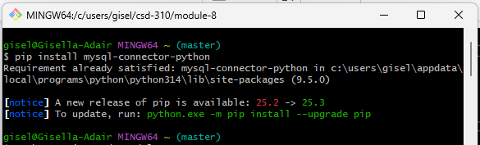

- Find folder and make sure is connected to the Database
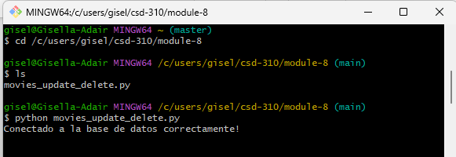

- Final Output
