Name: Elvia Gisella Adair
Assignment: Assignment: Movies: Setup

GitHub link: https://github.com/gisellaadair/csd-310.git

- Start MySQL Command Line Terminal, and Log in
- Database Movies
- Run SQL Script
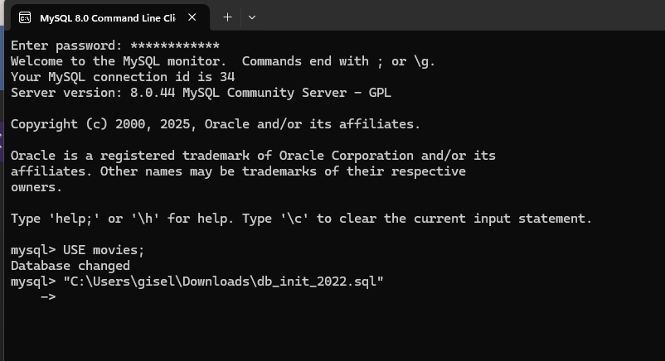

- Database Table list
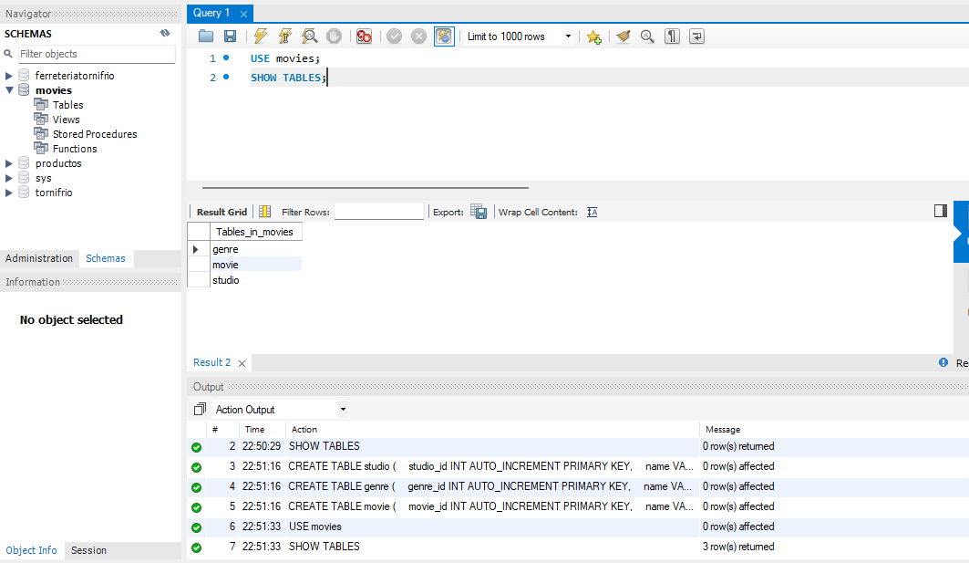
- Show tables
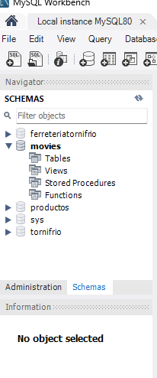
- MySql_test.py connection test code

