Name: Elvia Gisella Adair
Date: 11/16/2025
Assignment: MySQL Functions
Funtion 1:
CURRENT_TIME()
The CURRENT_TIME() funtion retrives the current system time. It can be used in logs, reports, or monitoring tables to record when events occur during database operations.
Sql
SELECT CURRENT_TIME() AS ‘Current Time’;
Current Time
10:00 am

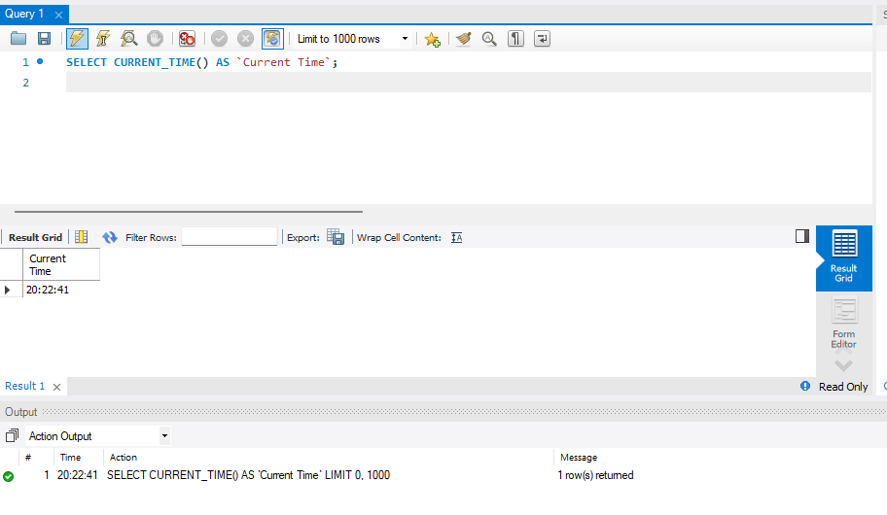
Funtion 2:
The DAYNAME() function returns the name of the weekday for a specific date. It’s useful for analyzing sales or events that depend on the day of the week.
Sql
SELECT DAYNAME(‘2025-11-16’) AS ‘Day of week’;
Day of week
2025-16-2025
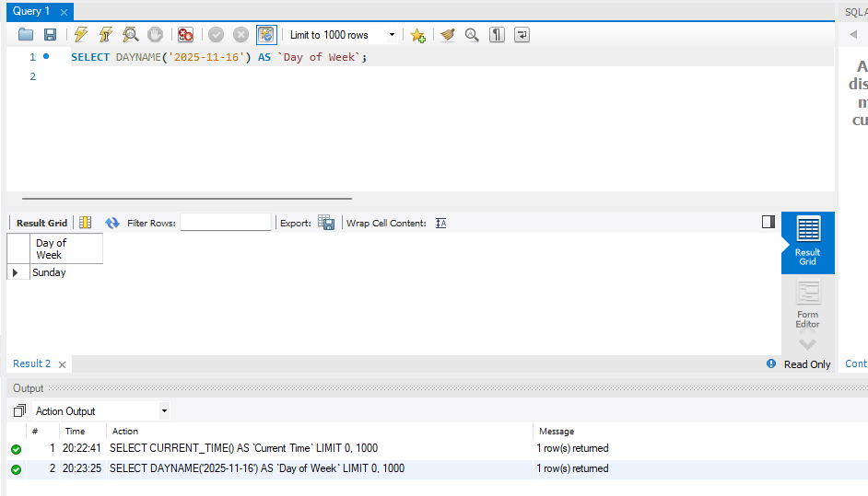
Funtion 3:
The ROUND() function is used to round numeric values to a given number of decimal places, making it useful in financial or statistical queries.
Sql
SELECT ROUND(125.4525, 2) AS ‘Rounded Value’;
Rounded Value
1.5 = 2
