

MODULE 2.3 ASSIGNMENT: DATA MODELS

ELVIA GISELLA ADAIR
STUDENT

CHRISTINE MAZHATA
TEACHER

NOVEMBER 2, 2025

ASSIGNMENT: DATA MODELS

- Translate the following business rules into one Entity relationship diagram (ERD) using Visual Paradigm.
  - a USER has many ROLES.
  - a USER has one BIRTHDATE.
  - a USER can have many DEPENDENTS.
- Convert the translated diagram into one NoSQL data structure
GITHUB: https://github.com/gisellaadair/csd-310.git

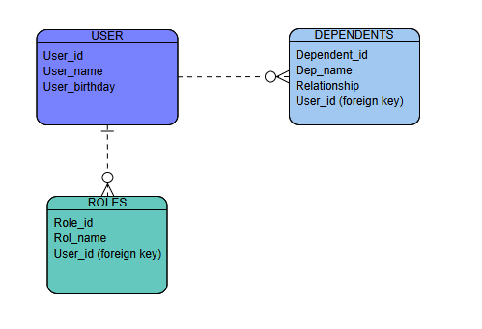

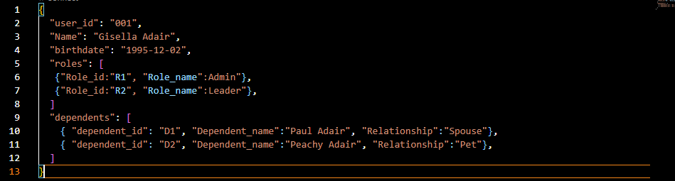

REFERENCES
- Document PDF, Module 2 “Everything You Wanted To Know About ERDs”
- https://www.mongodb.com/docs/manual/data-modeling/
- https://www.mongodb.com/docs/manual/tutorial/model-embedded-one-to-many-relationships-between-documents/
- https://online.visual-paradigm.com/es/diagrams/features/erd-tool/

