

MODULE 9: ASSIGNMENT: APIS

ELVIA GISELLA ADAIR
STUDENT

LATONYA LEWIS
TEACHER

NOVEMBER 30, 2025

ASSIGNMENT: APIs

- Open the API tutorial listed in the Reading List.
- Create a Python program to use for the tutorial. Use the correct URL listed above in the Reading List to test the connection, run the program, take a screenshot of the results and paste into the Word document.
- Making sure I have the library installed, before started
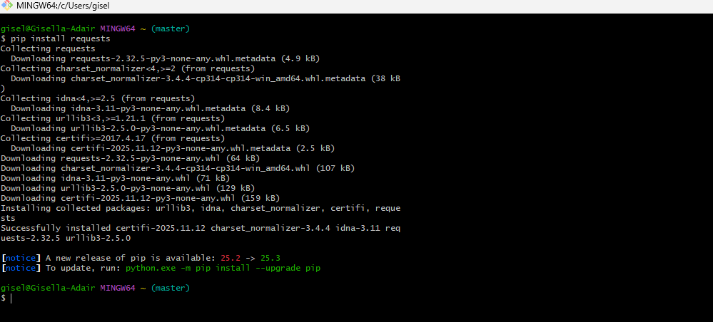

- Tutorial “Retrieving current Astronauts”, Add the program
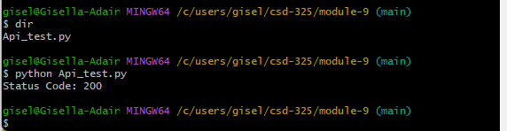

- Run the program

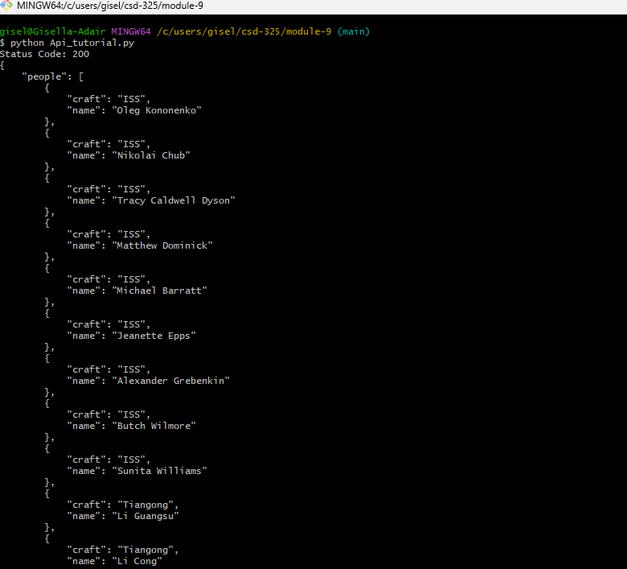
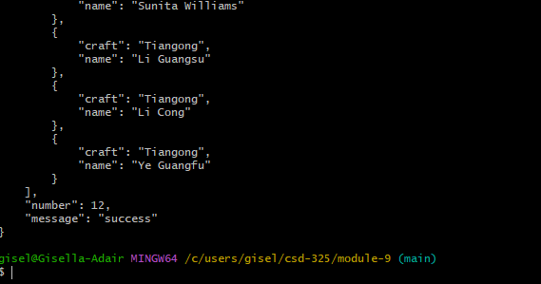

Apy My choice Exercise
