

MODULE 5.2 ASSIGNMENT: FOREST FIRE SIMULATION: FLOWCHART

ELVIA GISELLA ADAIR
CHRISTOPHER VILLARREAL
STUDENTS

LATONYA LEWIS
TEACHER

NOVEMBER 16, 2025
- Add a lake roughly in the center of the display. You might want to take a look at the video above titled Mod5 Cartesian for a brief explanation of how elements are placed in a display.
  - new constant with the WATER name
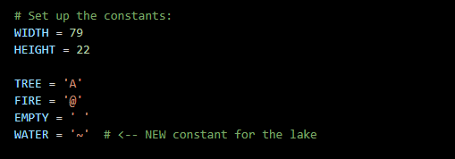
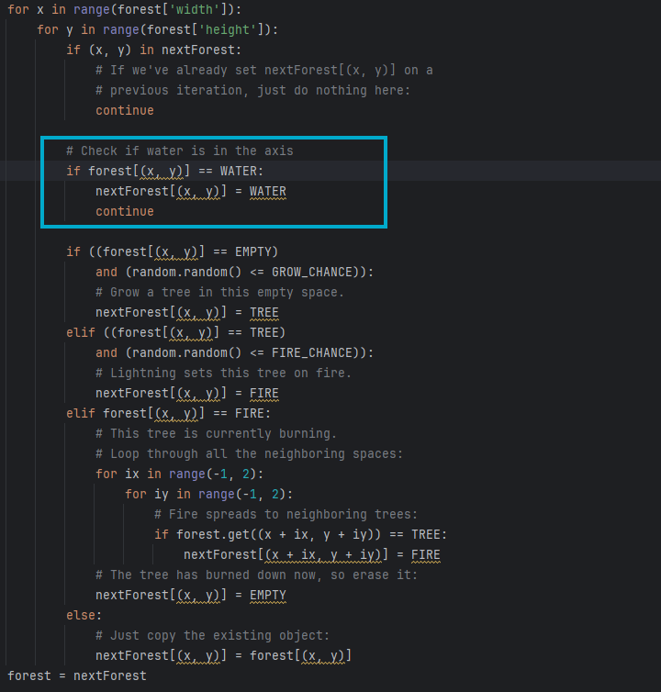
- The water feature should use a different character (not A or @) and be blue.
  - If the current cell is WATER (~), leave it as it is, and if does not grow trees, catch fire or turn into anything else

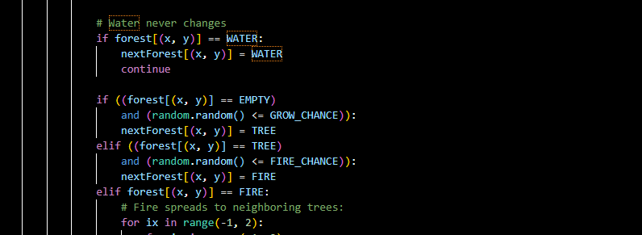
- The water feature cannot be modified once it is in place, the water feature acts as a firebreak that flames cannot cross. Here's an example of before and after adding water feature.
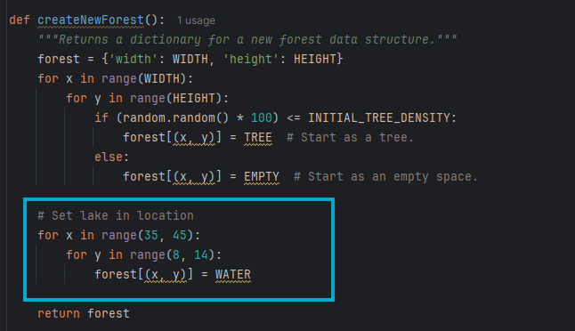
Then, of course, just add the else statement to write down the symbol (W) as the color blue, along with the global variable.

- Replace whatever was there with the water symbol ~
