Elvia Gisella Adair
Module 10.2 Assignment: GUI ToDo

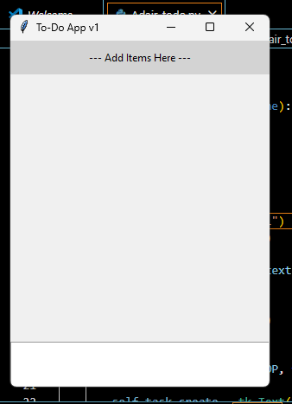

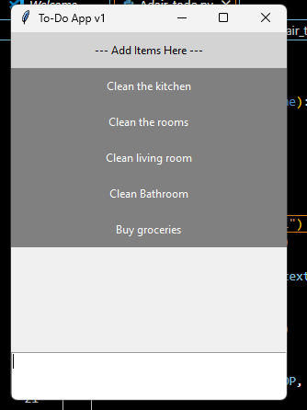

Using the other items in the reading list, complete the following modifications:
- Change the Title of the window to your last name-ToDo. Ex. Sampson-ToDo
- Change the color of the menu items, two (2) complementary colors work best.
- Currently, the user clicks the left mouse button to delete a task.. change that to the right mouse button.
- Provide instructions in the label on how to delete a task.
- We want the user to exit correctly, so add a menu item of File -> Exit. When clicked, Exit will end the program.
- Run the program, add a few tasks and take a screenshot. Paste that screenshot into your Word document.
- As the program is running, delete a task, then take a screenshot. Paste that screenshot into your Word document.

New Window tittle
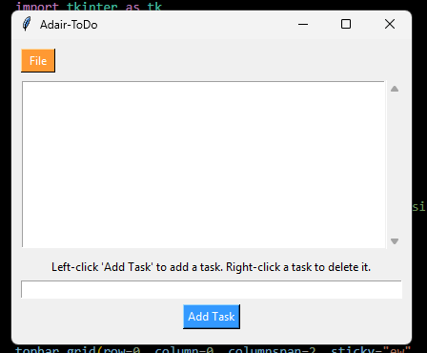
Create list of Task to do
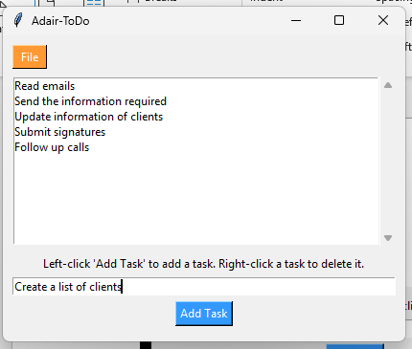

Delete a Task
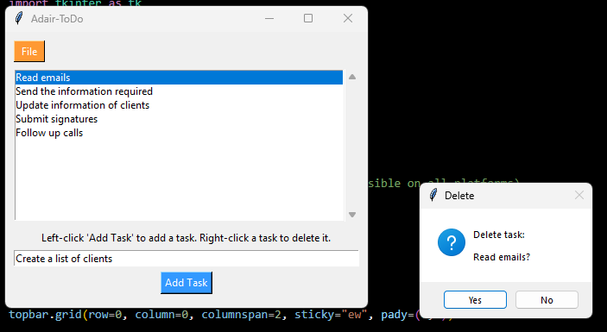
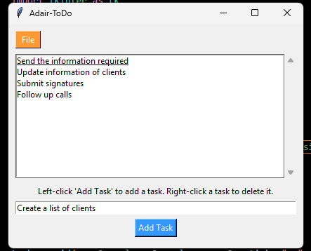
Exit button
