An Embedded System for Real-Time Vehicle Driving Safety

Senior Project (Work in Progress)

In Partial Fulfillment of Bachelor of Science in Computer Engineering

Giselle Razo

Supervisor: Fitratullah Khan

September 5, 2018
Table of Contents
- Deliverables, Timeline and Status for the Project
- Abstract
- Sensors
- System Implementation
- CMS
- Database Design, Data Collection and Transfer
- Website
- Notifications
- Access to CMS and Maintenance
- Appendix

- Deliverables, Timeline and Status for the Project
# | Deliverable | Expected Date of Completion
1 | Website design | Sep 5
2 | Motion Sensor circuitry and interfacing | Sep 12
3 | Camera circuitry and interfacing | Sep 19
4 | Camera image captures | Sep 26
5 | Uploads to database | Oct 3
6 | Image analysis | Oct 10
7 | Coinciding sensor with image analysis outcome | Oct 17
8 | Real-time priorities | Oct 24
9 | Notification implementation | Oct 31
10 | Implementation of website profiling tools | Nov 7
11 | Testing and bug squishing | Nov 14
12 | Testing and bug squishing (… continued) | Nov 21
13 | Work on presentation | Nov 28
14 | Demo | Dec 5
II. Abstract
This project uses a Raspberry Pi equipped with a camera, a motion sensor, and a speaker, to design and implement an embedded system for vehicle driving safety. The camera is focused on driver’s face to detect information on the level of fatigue based on the state of the eyes. Motion sensor provides the information if the vehicle is moving. The speaker is used to deliver appropriate notifications. The data collected is transmitted to a server on the Internet at a specified interval. The server populates a backend database with the data received from the Raspberry Pi. A website on the server shows the recent history of the state of driving. The website is updated in real-time.

The website provides profiling tools as well, such as driving history at a certain time or in a certain interval.

Deliverables are in the form of a developed system around a Raspberry Pi which may be mounted in a vehicle to monitor the state of the driver, thereby providing notifications in real-time to keep the driver alert in order to avoid accidents. Besides Raspberry Pi's native GPIO instructions, Linux is used as an operating system with Python as the primary programming language. JSONRequest and FTP are used for transferring data between the client (Raspberry Pi) and the server site. PHP and SQL are used as primary tools for website development and database manipulation.

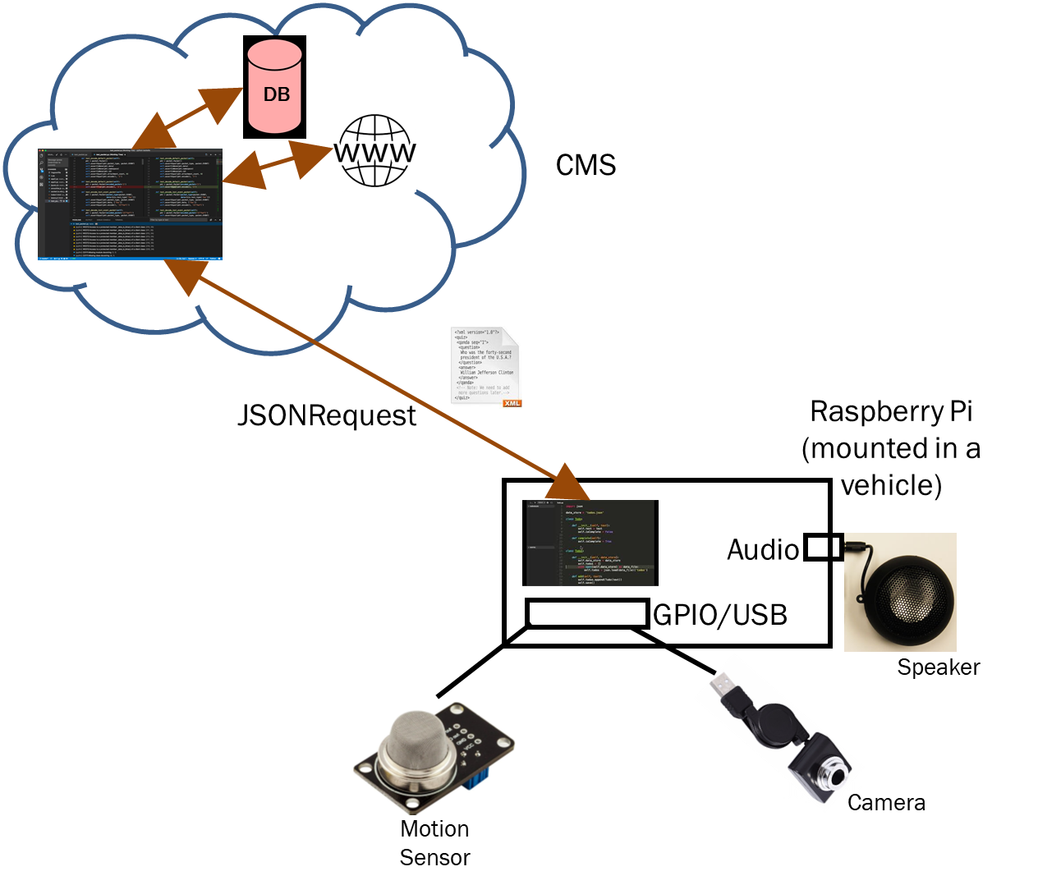
The figure below shows different components involved in the project.

Figure 1:
Figure 1.1: System Diagram of the Driving Safety System

- Sensors
A). Motion sensor
b). Camera
c).Speaker
- System Implementation
Before the motion sensor, camera, and speaker were purchased a prototype was built centered around the server, the database , and simulated input and output signals on the Raspberry pi in the form of two LEDs and two Switches. A python program on the RaspberryPi is executed and it triggers a PHP file on the server in the form of a JSONRequest. The JSONRequest sent to the server is sent every delay seconds and send the status of the LEDS and the switches connected on the RaspberryPi. The RaspberryPi expects the server to update the backend database if any changes are made. In addition, the status of each signal is displayed on the protected page on the server to show that the appropriate changes are made. After this prototype was successfully implemented the camera, speaker, and motion sensor were connected to create the embedded system.
The web application must go to the RaspberryPi and exchange data in order to update the information stored in the database. For this task, JSON was used. JSON is a data interchange format based on Javascript. JSON cannot be used to represent functions or expression, it will be explicitly to carry data. JSONRequest is a global object with three methods. For this project the JSONRequestPost will be used. The URL parameter contains the URL to post to. The data field sends the username & password fields of the user for verifications. The status of the LEDs and switches are also sent within the JSONRequest.
On the RaspberryPi side of the application, Python is utilized because it is a highly level language that is easy to use and learn since it consists of recognizable English.
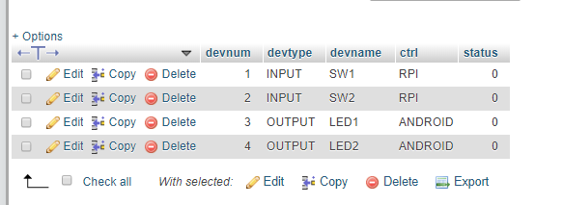
Figure 4.1:
Figure 4.1: Prototype database with two switches and two LED signals to simulate output and input signals

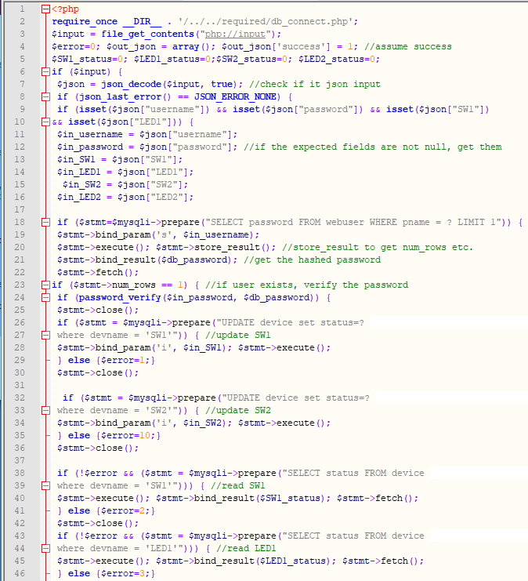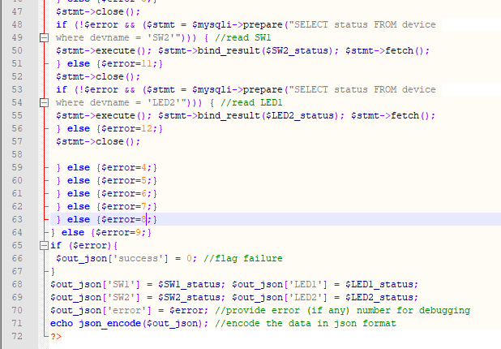
Figure 4.2:
Script on the server that updates the server website and backend database

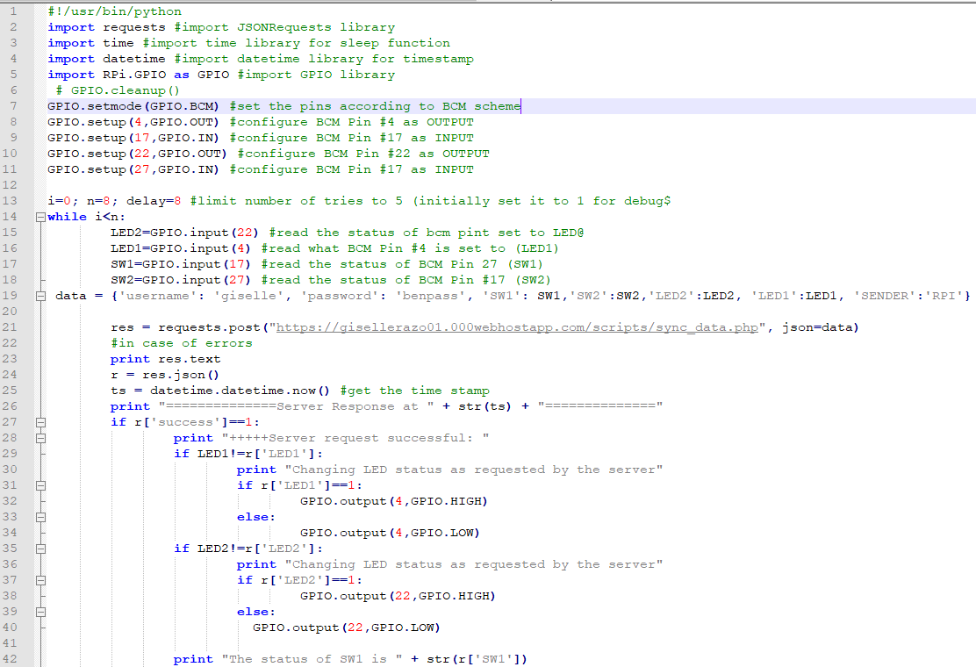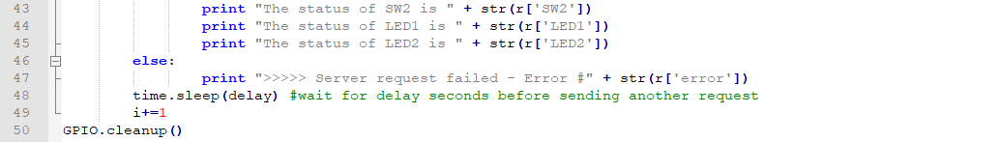
Figure 4.3:
Script on the RaspberriPi side that carries the status of the input and output signals.

- CMS
- Database Design, Data Collection and Transfer

A relational database will be implemented for the project in order to keep track of the users and to keep the status of the sensors connected to the RPi(Raspberry Pi). The database of records (DBOR) is secured as a backend to a well secured server. SQL ( Structured Query Language) is at the heart of maintaining all the data because it allows for the easy access of many records at a single command. SQL allows for the creation and modification of the data. Data was inserted and retrieved with simple commands such as ‘create’, ‘update’, and ‘alter’. One table, named webusers, stores the personal username and password of any user when the user creates an account in our site. For security purposes the password was stored using a hashing function.

Add picture of database

- Website
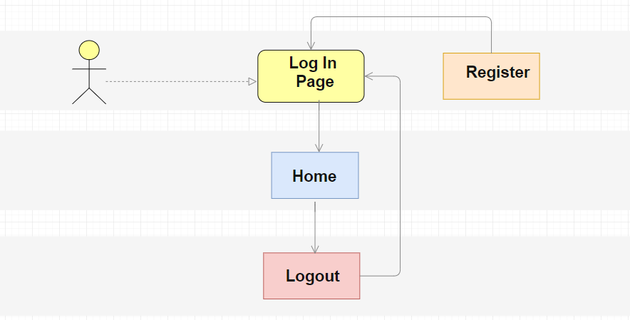
Figure 6.1

The first part of this project consists of designing a functional and user-friendly website for users of the system to log into to see the profiling tools. To develop the web application on a personal computer WampServer was installed. Wamp is a web server stack that holds the specific set of applications to perform a particular task. Wamp will be used for testing the web page without publishing it live in the internet. Wamp is an acronym that stands for Windows, Apache, MySQL, and Hypertext Preprocessor (PHP). These four tools together allow the ability to host a dynamic website that was connected to a database. All Hypertext Preprocessor(PHP) files are stored under a www folder processed by the Apache server. WampServer also includes a graphical tool called phpMyAdmin which aids in the development of relational databases. PhpMyAdmin aids in the creation of databases and tables and in the modification of data within the database. After editing the website on a personal computer, the website was maintained, stored, and edited in a website called 000webhost.com. The website provided with free webhosting with other services such as Hypertext Preprocessor(PHP) and MySQL.

Figure 6.1 above shows the pages the user would be redirected to depending on the use of the website. The layout of the website itself is simple. The user has access to a log in page. If the user does not have an account, the user has the option to register. Once the user registers, their records are stored in the database, so they can safely log in. Once the user enters the correct credentials into the website the user is then redirected to a protected page where the user can see the profiling tools. The user then has the option to logout of the site and is redirected to the log in page. Figure 6.2 summarizes the files located on the online server. Together these files provide for the insertion, modification, and displaying of data.

Hypertext Preprocessor (PHP) files on ‘public_html’ folder
Index.php | The main page of the website. Provides users with the ability to log in and register
Protected_page.php
Hypertext Preprocessor (PHP) files in the ‘scripts’ folder
process_logout.php: | Processes when the user logs out by destroying the session
protected_page.php | Displays data from the database utilized for profiling tools
Update_db.php
Sync_data.php
Hypertext Preprocessor (PHP) files in the ‘required’ folder
db_config.php | Connection information for DBOR.
db_connect.php,
functions.php | Functions here are utilized to create a secure session to login and check if the user is logged in. Writing support functions for a login session
Hypertext Preprocessor (PHP) files in the ‘css’ folder
Style.css | Controls the layout of multiple webpages with the help of HTML tags.
Hypertext Preprocessor (PHP) files in the ‘img’ folder
utrgv.png | Picture in the site
Fondo2.jpg | Picture in the site

To retrieve information and connect to the database MySQLi is used throughout the HTML source code. MySQLi is improved MySQL API used by PHP to interact with MySQL database.

Hypertext Preprocessor(PHP) ,Hypertext Markup Language (HTML),and Cascading Style Sheets (CSS) was studied before anything else as they are the basic building blocks web pages and web applications. Hypertext Preprocessor(PHP) is a server side language used to connect to the database and retrieve information to display it into the website. Manipulation of the database is done through Hypertext Preprocessor (PHP) code embedded in the Hypertext Markup Language (HTML) files. Prepare statements were used to access the database to prevent and malicious input. Hypertext Markup Language (HTML) describes the structure of the page and denotes them as heading, paragraphs, links or unordered lists to name a few. The elements are utilized in the Hypertext Markup Language (HTML) as tags. Once an intermediate understanding of Hypertext Markup Language HTML was learned it would be easy to enhance the page with the other two languages. Hypertext Preprocessor (PHP) was embedded in the HTML code to access the Database of Records (DBOR). Cascading Style Sheets (CSS) is used for describing the presentation of the page that was written in the Hypertext Markup Language (HTML). The separation from structure and layout allowed for more flexibility. The section (<section> )and defines sections of the website. Similarly, the class attribute specifies one or more class names. The class and section tags were used in the style.css to add color and design to the website. For this page, the content of the pages was simplified by style.css by having a header and footer for the site. This way, the control and layout of multiple web pages was edited all at once
Images were added to make the site more aesthetically pleasing. Figure 6.3 shows the progress done throughout the week for the webpage. The first day (Day 1) doing research was done for designing pages. The main page was later (Day 2-4) modified by adding sections and classes to add background colors and add a background pictures. The forms and buttons were also modified. The last effort to perfect the site (Days 5-7) consisted of centering everything so it flowed. In addition, a register form was added so the user could make an account on the main site.

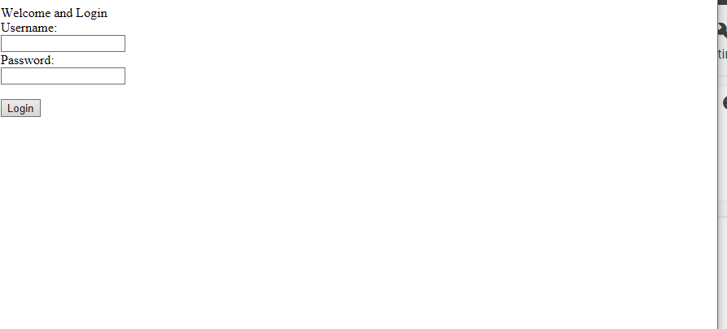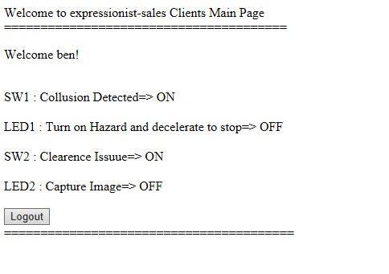
Day 1
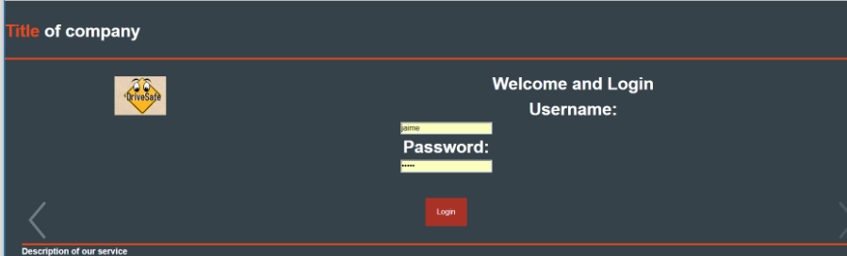

Day 2-4

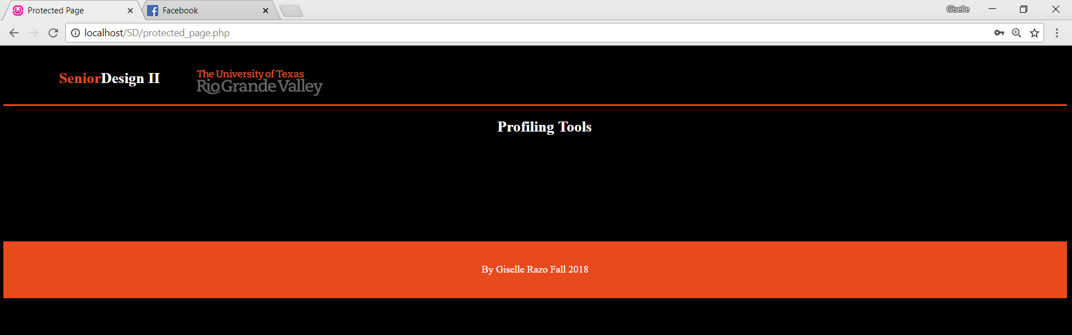
Day 5-7

Figure 6.3
Progress on the design of the website

The website has the task of providing profiling tools to the user. For this, the person monitoring the driver via the site has access to a protected_page.php that shows the status of the user every x seconds. Since the driver will be updated constantly over his status, the database with information will be lengthy in size. For this reason, code using Asynchronous JavaScript and XML(AJAX) was created to retrieve information from the database 10 items at a time as a start. This code was later added to site.
Asynchronous JavaScript and XML(AJAX) was used to so asynchronous things such as updating the page without having to reload the entire content of the site. The data in the web application was able to retrieve data form the server in the background without changing the display and behavior of the existing page. Code in JQuery, a JavaScript library, was embedded within the Hypertext Markup Language (HTML) and Hypertext Preprocessor (PHP) code to provide methods for Asynchronous JavaScript and XML (AJAX)functionality.
Figure 6.4 shows the coded that retrieves information from the database x amount of times. This code was later implemented to retrieve the status of the sensor attached to the raspberry pi.

- Notifications
Figure 6.4:
Snippet of script implemented with AJAX

- Access to CMS and Maintenance
- Appendix

