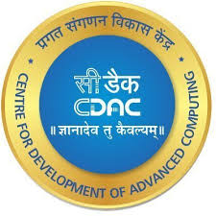

**Project Report**

**On**

**SMART and CONNECTED FARMING THROUGH IoT TECHNOLOGY**

*Submitted*

*In partial fulfillment*

*For the award of the Degree of*

**PG-Diploma in Internet of Things**

**(C-DAC, ACTS (Pune))**

**Guided By: Submitted By:**

Mr. Shubham Srivastava

Isha Gangamwar (240840126009)

Aayushi Jain(240840126001)

Vaishnavi Salunke (240840126018)

Sanjana wankhede (240840126012)

Sharvari Bharade (240840126007)

**Centre for Development of Advanced Computing**

**(C-DAC, ACTS Pune-411008)**

***Acknowledgement***

This is to acknowledge our indebtedness to our Project Guide, Mr. Shubham Srivastava, C-DAC ACTS, Pune for her constant guidance and helpful suggestion for preparing this project on **"Smart and connected farming through IOT technology"**. We express our deep gratitude towards him for inspiration, personal involvement, constructive criticism that he provided us along with technical guidance during the course of this project.

We take this opportunity to thank Mr. Gaur Sunder (Associate Director, Head of Department, CDAC) for providing us such a great infrastructure and environment for our overall development.

We express sincere thanks to Ms. Namrata Ailawar (Joint Director, Process Owner, CDAC) for their kind cooperation and extendible support towards the completion of our project.

It is our great pleasure in expressing sincere and deep gratitude towards Ms. Risha P.R (Associate Director, Program Head, CDAC) and Ms. Swati Salunkhe (Course Coordinator, PG-DIoT) for their valuable guidance and constant support throughout this work and help to pursue additional studies.

Also, our warm thanks to C-DAC ACTS Pune, which provided us this opportunity to carry out this prestigious Project and enhance our learning in various technical fields.

Isha Gangamwar (240840126009)

Aayushi Jain(240840126001)

Vaishnavi Salunke (240840126018)

Sanjana Wankhede (240840126012)

Sharvari Bharade (240840126007)

**ABSTRACT**

Smart and connected farming has emerged as a groundbreaking approach to revolutionize agricultural practices by leveraging the power of the Internet of Things (IoT) technology. This paper focuses on implementing a smart farming system using the HiveMQ broker to connect and manage data from multiple sensors, namely the Soil Moisture Sensor, DHT11 Sensor, and Rain Drop Sensor. These sensors play a vital role in monitoring critical environmental factors essential for optimizing agricultural practices. The Soil Moisture Sensor provides real-time data on soil hydration levels, while the DHT11 Sensor monitors temperature and humidity, crucial for assessing the overall climate conditions. The Rain Drop Sensor detects rainfall, offering valuable insights into precipitation patterns. The HiveMQ broker is employed to efficiently transmit and manage sensor data over the IoT network, ensuring seamless communication between devices. Through this interconnected system, farmers can access real-time data on environmental conditions, enabling them to make informed decisions regarding irrigation, climate control, and crop protection. This approach promotes resource efficiency, reduces water wastage, and enhances crop yields, contributing to sustainable and profitable farming practices. The paper also discusses the potential benefits, challenges, and future advancements in smart farming using IoT and HiveMQ-based solutions.

|  | **Table of Contents** |  |  |
| --- | --- | --- | --- |
|  |  |  |  |
| **S. No** | **Title** | **Page No.** |  |
|  | **Front Page** | **I** |  |
|  | **Acknowledgement** | **II** |  |
|  | **Abstract** | **II** |  |
|  | **Table of Contents** | **IV** |  |
|  | **Table of figure** | **V** |  |
|  |  |  |
| **1** | **Introduction** | **1** |  |
| **1.1** | Background | **1** |  |
| **1.2** | Problem Statement | **2-3** |  |
| **1.3** | Objectives of the Project | **4-6** |  |
|  |  |
|  |  |  |  |
| **2** | **Literature Review** | **3** |  |
| **2.1** | Introduction to IoT in Industrial Applications | **3** |  |
| **2.2** | Traditional Machine Monitoring and Its Limitations | **3** |  |
| **2.3** | IoT-Enabled Machine Monitoring | **3** |  |
| **2.4** | Edge Computing in IoT Systems | **4** |  |
| **2.5** | Cloud Computing and Remote Monitoring | **4** |  |
| **2.6** | Case Studies and Existing Systems | **4** |  |
| **2.7** | Research Gaps | **5** |  |
| **2.8** | Conclusion | **5** |  |
|  |  |  |  |
| **3** | **Methodology** | **10** |  |
| **3.1** | **System Architecture** | **10** |  |
| **3.2** | **Data Collection and Processing** | **11** |  |
| **3.3** | **Real-Time Monitoring and Analysis** | **11** |  |
| **3.4** | **Remote Control and Management** | **12** |  |
| **3.5** | **Evaluation and Testing** | **13** |  |
| **3.6** | **Expected Outcomes** | **14** |  |
| **4** | **Implementation** | **15** |  |
|  |  |
| **4.1** | Hardware Requirements | **1**5 |  |
| **4.2** | Software Requirements | **15** |  |
| **4.3** | Language used | **15** |  |
| **4.4** | Working | **16-17** |  |
|  |  |  |  |

| **4.5** | Components | **18-21** |
| --- | --- | --- |
| **4.6** | Applications | **22** |
| **5** | Result | **23** |
| **6** | Conclusion | **24** |
| **6.1** | **Summary of Work** | **25** |
| **6.2** | **Contribution** | **25** |
| **6.3** | **Challenges and Limitations** | **26** |
| **6.4** | **Future Work** | **27** |
| **6.5** | **Conclusion** | **28** |
| **7** | **References** | **29** |

| **Index** | **Figure** | **Page number** |
| --- | --- | --- |
|  |  |  |
| 1. | Block Diagram | 17 |

| **Index** | **Figure** | **Page number** |
| --- | --- | --- |
|  |  |  |
| 1. | ESP 32 | 13 |
|  |  |  |
| 2. | Soil Moisture sensor | 14 |
| 3. | Raindrop Sensor | 15 |
|  |  |  |
| 4. | DHT 11 | 17 |
|  |  |  |

**Chapter 1: Introduction**

**1.1 Background**

Agriculture has long been the backbone of global food production, yet it faces significant challenges due to factors such as climate change, resource scarcity, and the increasing need to boost productivity in order to meet the demands of a growing global population. Traditional farming methods often rely on manual labor, weather-dependent cycles, and inefficient use of resources like water, fertilizers, and pesticides. These conventional practices contribute to high costs, environmental degradation, and sub optimal crop yields. With the pressure to produce more food with fewer resources and under changing environmental conditions, the agriculture sector urgently needs modernization. One promising solution to address these challenges is the integration of advanced technologies, especially the Internet of Things (IoT), which can revolutionize the way farming is practiced by enabling Smart Farming or Precision Agriculture.

IoT technology provides the ability to connect physical devices—such as sensors, machines, and equipment—to the internet, enabling them to collect, transmit, and analyze data in real-time. This connectivity allows farmers to remotely monitor their agricultural environment and equipment, automate decision-making processes, and optimize resource use. IoT sensors can measure a variety of environmental factors, such as soil moisture, temperature, humidity, and rainfall, which are critical to understanding the conditions affecting crop growth. By using IoT technology, farmers can access accurate, real-time data that helps them make better decisions regarding irrigation, fertilization, pest control, and overall farm management. These data-driven decisions lead to more efficient farming practices, reduced waste, and increased profitability, all while contributing to environmental sustainability.

In the context of this project, HiveMQ, a widely used MQTT broker, plays a key role in facilitating communication between IoT devices and cloud systems. MQTT (Message Queuing Telemetry Transport) is a lightweight messaging protocol that allows for secure, reliable, and low-latency transmission of data. It is particularly well-suited for environments where large volumes of sensor data need to be transmitted across distributed systems, such as in the case of smart farming applications. HiveMQ supports the real-time transmission of sensor data, ensuring that farmers can make timely decisions based on the most up-to-date information available. The broker efficiently manages communication between multiple devices, ensuring that sensor data is transmitted without delays, even in large-scale agricultural operations.

**1.2 Problem Statement**

1. Traditional farming methods are encountering hurdles like declining yields and environmental impacts due to population growth and climate change, necessitating innovative solutions like IoTbased smart farming. However, challenges such as high costs, connectivity issues, data security, and the need for farmer education hinder its widespread adoption.

2. The promise of IoT-based smart farming to revolutionize agriculture is hindered by cost barriers, connectivity limitations in rural areas, data security concerns, and the necessity for farmer education. Addressing these challenges is crucial for realizing its potential in enhancing agricultural productivity and sustainability.

**1.3 Objectives of the Project**

The primary objective of IoT-based smart farming is to revolutionize the agricultural industry by enhancing productivity, optimizing resource utilization, and promoting sustainable farming practices. By leveraging a network of interconnected devices and sensors, IoT-based smart farming

aims to address the challenges of traditional farming methods and meet the growing demand for food while ensuring environmental sustainability.

Specific objectives of IoT-based smart farming include:

• **Enhanced Crop Productivity**: To improve crop yields and quality by optimizing irrigation, fertilization, and other crop management practices based on real-time data insights.

**• Resource Efficiency**: To minimize water, fertilizer, and pesticide usage by precisely targeting inputs based on soil conditions, crop needs, and environmental factors.s

• **Sustainable Farming Practices**: To reduce the environmental impact of agriculture by promoting sustainable practices such as precision irrigation, controlled nutrient management, and integrated pest management.

• **Precision Agriculture:** To enable data-driven decision-making by providing farmers with real-time and historical data on various aspects of their fields, such as soil moisture, temperature, humidity, and crop health.

**• Reduced Labor Costs:** To automate repetitive tasks such as irrigation and monitoring, freeing up farmers to focus on higher-value activities and improving overall farm management efficiency.

**• Environmental Monitoring**: To protect the environment by monitoring air and water quality, detecting potential pollutants, and identifying areas for improvement in environmental practices.

**• Livestock Health and Welfare**: To enhance livestock health and welfare by monitoring animal behavior, detecting early signs of illness, and optimizing feed management.

**• Food Safety and Traceability**: To improve food safety and traceability by tracking the movement of food products from farm to table, enabling the identification and removal of contaminated products.

**• Economic Benefits for Farmers**: To increase farmer profitability by improving yields, reducing costs, and enhancing market access through improved product quality and traceability.

**• Sustainability for Future Generations:** To ensure a sustainable food supply for future generations by addressing the challenges of climate change, population growth, and resource scarcity.

By achieving these objectives, IoT-based smart farming has the potential to transform the agricultural landscape, making it more productive, sustainable, and profitable for farmers while ensuring a secure and healthy food supply for the world's growing population.

**Chapter 2: Literature Review**

The literature review for the smart and connected farming through IOT technology provides an overview of existing research and systems related to IoT applications in industrial environments, particularly focusing on enhancing the crop productivity and product efficiency . This review identifies the gaps in current methodologies and positions the proposed system as a solution to these challenges.

**2.1 Introduction to IoT in Industrial Applications**

The Internet of Things (IoT) has seen widespread adoption across various sectors, with industrial applications being among the most significant. The concept of Industry 4.0, which emphasizes the integration of IoT, big data, and artificial intelligence (AI) into manufacturing and industrial processes, has driven the development of smart factories. In these settings, IoT enables machines to communicate with each other and with central systems, providing real-time data that enhances decision-making, predictive maintenance, and overall efficiency.

The paper highlights that precision irrigation scheduling, enabled by wireless sensor networks, allows farmers to optimize water usage by applying irrigation only when and where it is needed. This approach reduces water wastage and associated costs, while also mitigating the risk of overwatering and potential damage to crops.

**2.2 Case Studies and Existing Systems**

Several case studies highlight the successful implementation of IoT-based machine monitoring systems. For instance, General Electric’s (GE) Predix platform uses IoT and cloud computing to monitor industrial machinery, predict failures, and optimize maintenance schedules. Similarly, Siemens’ MindSphere is a cloud-based IoT operating system that connects industrial equipment to analyze data and provide insights for improving performance.

However, despite the advancements in this field, challenges remain, particularly in integrating IoT systems with legacy equipment, ensuring data security, and managing the vast amounts of data generated by IoT sensors. These challenges underscore the need for continued research and development in the field.

**2.3 Research Gaps**

Although significant progress has been made in the development of IoT-based machine monitoring systems, there are still several areas where further research is needed. These include the integration of AI and machine learning algorithms for more accurate predictive maintenance, the development of standardized protocols for IoT in industrial environments, and the exploration of new sensor technologies that can provide more detailed data.

**2.4 Conclusion**

The literature suggests that IoT has the potential to transform machine monitoring and maintenance practices by providing real-time data and enabling predictive maintenance. The proposed IoT-Based Smart Machine Monitoring System builds on these advancements by integrating edge computing, cloud services, and real-time monitoring to create a comprehensive solution that enhances the efficiency, reliability, and safety of industrial operations.

**Chapter 3: Methodology**

**3.1 System Architecture**

**Overview of the system**: A smart farming system integrated with various sensors (soil moisture, rain drop, DHT11 for temperature and humidity) connected through the ESP8266 microcontroller.

**Hardware Components**:

* **ESP8266 Microcontroller** : Functioning as the central unit for sensor data collection and communication.
* **Soil Moisture Sensor**: Measures the moisture content of the soil.
* **Rain Drop Sensor**: Detects the presence of rain.
* **DHT11 Sensor**: Monitors temperature and humidity of the environment.

**Communication Protocol**: MQTT protocol for efficient communication and data exchange.

* **MQTT**: Light-weight, publish-subscribe messaging protocol ideal for IoT-based systems.
* **HiveMQ Public Broker**: Used for secure and real-time data transfer between the sensors and the cloud.

**Cloud Server and Dashboard**: Data sent from the ESp8266 is processed on a cloud platform and displayed on a web dashboard for monitoring and analysis.

**Block Diagram**: A diagram depicting the hardware components and their connections to the ESP8266.

**3.2 Data Collection and Processing**

* **Sensor Data Collection**:
* Data is gathered continuously from the soil moisture sensor, rain drop sensor, and DHT11 sensor.
* The sensors send real-time data to the ESP8266 microcontroller.
* **Data Processing**:
* The ESP8266 processes the incoming sensor data and converts it into usable information.
* The data is then formatted into MQTT packets and sent to the HiveMQ broker.
* **Data Storage and Backup**:
* The data can be stored in the cloud server or a local database for historical analysis and backup.

**3.3 Real-time Monitoring and Analysis**

* **Web Dashboard**:
* Real-time sensor readings are displayed on a dashboard for the user.
* Graphical representations of data such as soil moisture levels, temperature, humidity, and rain presence.
* Alerts and notifications triggered for abnormal readings (e.g., low soil moisture or high temperature).
* **Data Visualization**:
* Use of graphs, charts, and data logs to analyze the system's performance over time.
* Comparison of environmental conditions against optimal farming thresholds.

**3.4 Remote Control and Management**

* **Control Mechanisms**:
* Using the web dashboard or a mobile app, the farmer can remotely control irrigation systems or activate/deactivate sensors.
* The system can trigger irrigation based on soil moisture readings.
* Remote control of system settings, like configuring the threshold levels for sensors.
* **Automation**:
* Automated irrigation can be activated when soil moisture falls below a certain level.
* Alerts and notifications about abnormal conditions, like rain or extreme temperatures, can be automated for response.

**3.5 Evaluation and Testing**

* **System Testing**:
* Initial tests were conducted to ensure all sensors were functioning properly.
* Testing of MQTT communication, ensuring data was successfully sent to the HiveMQ broker and reflected on the dashboard.
* **Performance Evaluation**:
* Monitoring the accuracy of sensor readings.
* Ensuring the system responds correctly to changing environmental conditions.
* Testing the cloud platform’s real-time data handling capabilities.
* **User Feedback**:
* A small group of farmers may be involved in evaluating the practicality and usability of the system in real-world agricultural settings.

**3.6 Expected Outcomes**

* **Improved Farming Efficiency**:
* The system is expected to automate irrigation and environmental monitoring, reducing manual labor and increasing efficiency.
* **Data-Driven Decisions**:
* With access to real-time and historical data, farmers can make informed decisions regarding irrigation schedules, pest management, and crop growth conditions.
* **Cost-Effective and Sustainable Farming**:
* By automating irrigation based on real-time moisture levels, the system will reduce water wastage and improve resource management.

**Chapter 4: Implementation**

**Requirements: -**

4.1 **Hardware Requirement: -**

1. ESP 8266

2. Soil Moisture Sensor

3. Rain-Drop Sensor

4. DHT11

4.2 **Software Requirement: -**

1. Arduino ide Software

2. VS code

**4.3** **Language used: -**

1. C/C++ Arduino
2. Python

**4.4 Working: -**

#### **4.1 Data Collection from Sensors**

#### **Soil Moisture Sensor**:

* + The soil moisture sensor is placed in the soil. It measures the moisture content and provides an analog or digital output.
  + The data from this sensor indicates whether the soil is dry, moist, or wet, helping farmers decide when to irrigate.

**Rain Drop Sensor**:

* + This sensor detects whether it is raining. It provides a digital output, indicating whether rain is present or not.
  + This sensor helps to avoid unnecessary irrigation when it’s raining.

**DHT11 Sensor**:

* + This sensor measures **temperature** and **humidity** levels in the environment.
  + These readings help determine the climatic conditions of the farm and assess the risk of environmental stress on crops.

Each sensor is connected to the **ESP8266 microcontroller**, which reads the data at periodic intervals.

#### **4.2 Data Processing and MQTT Communication**

* The **ESP8266** microcontroller reads the data from each sensor.
* The data is then formatted into a **JSON** message or string to be sent via MQTT.
* The **MQTT protocol** is used to send the data to the **HiveMQ public broker**:
  + **Publish**: The ESP8266 **publishes** sensor data to predefined topics such as:
    - sensor/rain
    - sensor/dht11
    - sensor/soil
  + **MQTT Broker**: The **HiveMQ free public broker** receives the data and makes it available for any client or web-based dashboard to subscribe and visualize.
  + **IOT MQTT Panel**:The **IoT MQTT Panel** dashboard collects real-time data from raindrop, temperature, and soil moisture sensors, publishing it to MQTT topics. The dashboard visualizes temperature trends, soil moisture levels, and rain status while allowing users to control irrigation manually or automatically based on sensor data. Alerts notify users of critical conditions like rain detection, dry soil, or high temperature, ensuring efficient farm management.
* MQTT ensures low latency, reliable delivery, and ease of scaling as new sensors or devices are added to the system.

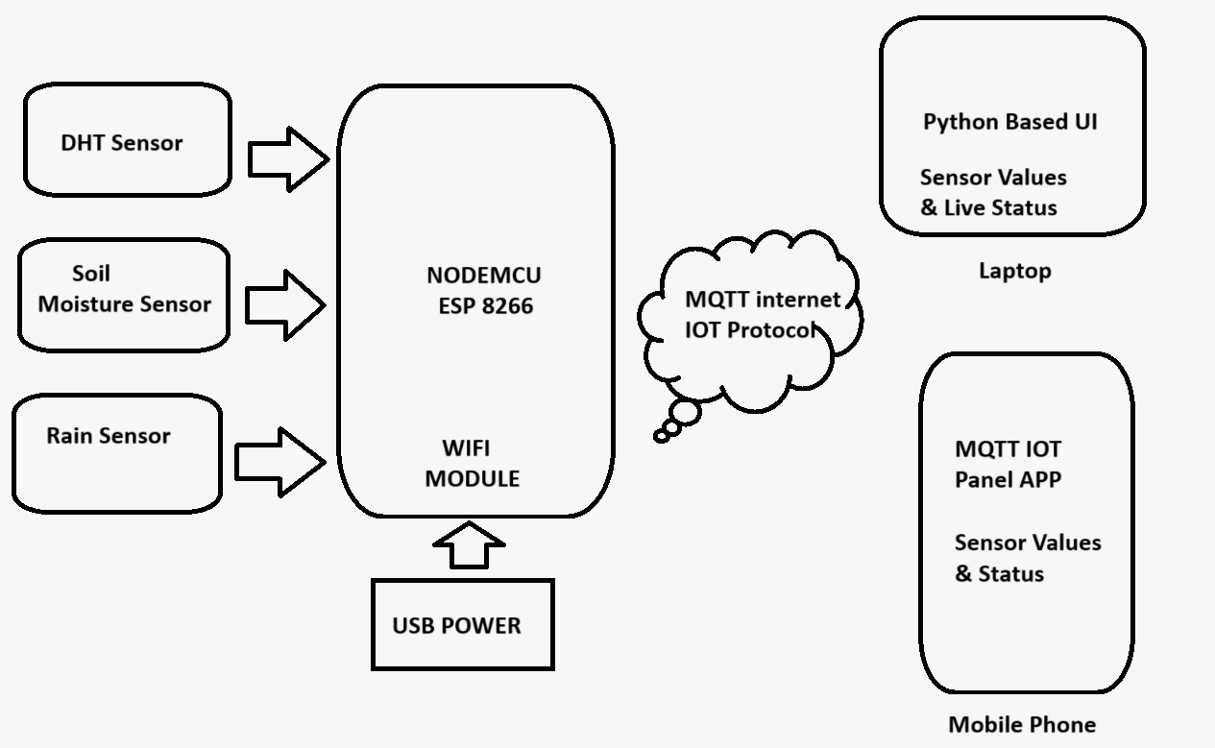

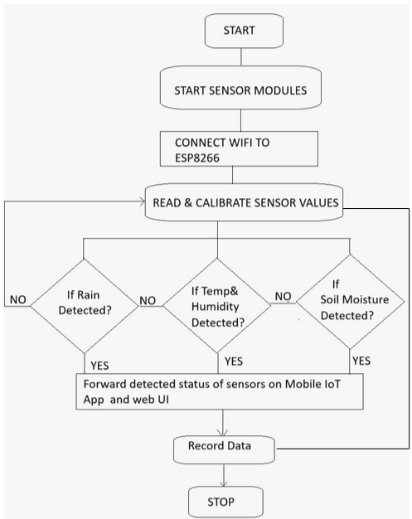

**4.5 Components: -**

**4.5.1 ESP-8266**

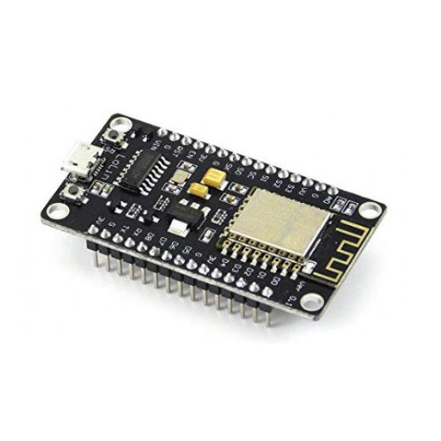

**Fig 4.5.1 ESP8266**

The **ESP8266** is a low-cost, Wi-Fi-enabled microcontroller developed by Espressif Systems, widely used in IoT (Internet of Things) applications. It provides built-in Wi-Fi connectivity, making it ideal for smart devices, remote monitoring systems, and automation projects

**Key Features**:

**Wi-Fi Support** – Supports 802.11 b/g/n for wireless communication.  
**Low Power Consumption** – Suitable for battery-powered IoT devices.  
**Compact & Affordable** – Small size with a low price, making it popular for DIY and industrial projects.  
**GPIO Pins** – Multiple General-Purpose Input/Output (GPIO) pins for connecting sensors and actuators.  
**Built-in TCP/IP Stack** – Can connect directly to the internet without needing an extra module.  
 **Programming Support** – Can be programmed using **Arduino IDE, MicroPython, and Lua**.

**Role in the Project**:

* + The ESP8266 acts as the central processing unit for the project. It reads data from the sensors, processes it, and transmits the data to the **HiveMQ broker** using the **MQTT protocol**.
  + It is responsible for managing all sensor interactions and communication with the cloud.

**4.5.2 Soil Moisture Sensor:**

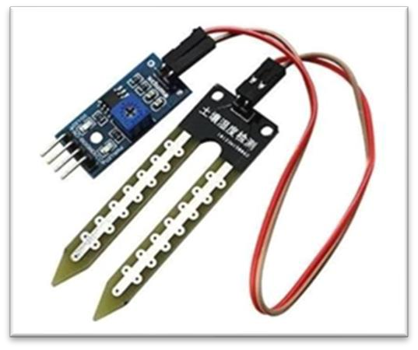

**Fig 4.5.2 Soil Moisture Sensor**

A soil moisture sensor is a device used to measure the water content in the soil. It is a crucial tool in agriculture, horticulture, and environmental monitoring, as it helps farmers and gardeners make informed decisions about irrigation scheduling, water management, and plant health. Soil moisture levels directly impact plant growth, root development, and overall crop yield, making the sensor essential for efficient water usage and sustainable farming practices.

**Techniccal Specification of Soil Moisure Sensor:-**

Operating Voltage: 3.3V to 5V DC

Operating Current: 15mA

Output Digital - 0V to 5V, Adjustable trigger level from preset

Output Analog - 0V to 5V based on infrared radiation from fire flame falling on the sensor LEDs indicating output and power

PCB Size: 3.2cm x 1.4cm

LM393 based design

Easy to use with Microcontrollers or even with normal Digital/Analog IC

Small, cheap and easily available

**4.5.3 Rain Drop Sensor:**

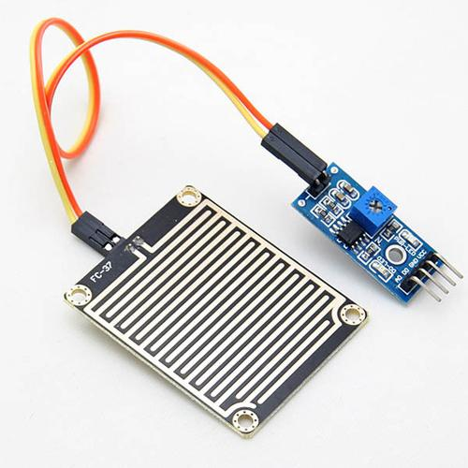

**Fig 4.5.3 Raindrop sensor**

A rain drop sensor detects the presence of rainfall. It uses a set of conductive elements to detect the change in resistance when raindrops hit the surface.

* **Key Features**:
* **Digital output** for indicating rain detection (rain/no rain).
* **Simple to interface** with microcontrollers.
* **Compact and lightweight**.
* **Role in the Project**:
* The rain drop sensor helps prevent unnecessary irrigation during rain. The ESP32 reads the data from the rain sensor, and if it detects rain, the system can stop irrigation to avoid wastage of water.

**4.5.4 DHT 11**

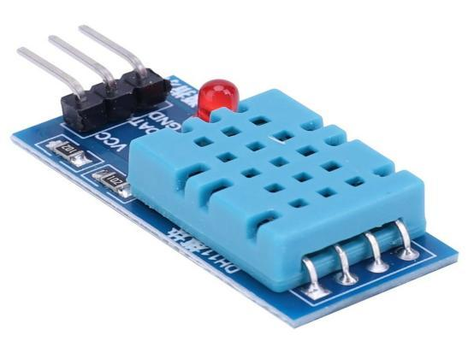

**Fig 4.5.4 DHT 11 Sensor**

The DHT11 sensor measures **temperature** and **humidity** levels in the air. It is a commonly used sensor for environmental monitoring in IoT applications.

**Key Features**:

* **Digital output** with temperature and humidity readings.
* **Low-cost** and easy to use.
* **Accuracy**: ±2°C for temperature and ±5% RH for humidity.

**Role in the Project**:

The DHT11 sensor provides temperature and humidity readings, which help in assessing the farm's environmental conditions. The data from this sensor can be used to alert the farmer if the conditions are not suitable for crop growth.

**4.6 Application’s: -**

· Precision Agriculture

· Water Management

· Climate Monitoring

· Crop Health and Yield Prediction

· Remote Farm Monitoring and Management

· Cost Reduction

· Sustainable Farming Practices

· Data-Driven Decision Making

· Smart Greenhouse Management

· Disaster Risk Management

**Chapter 5 Results**

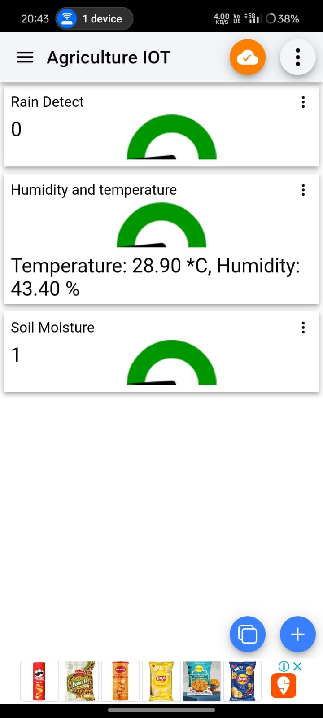

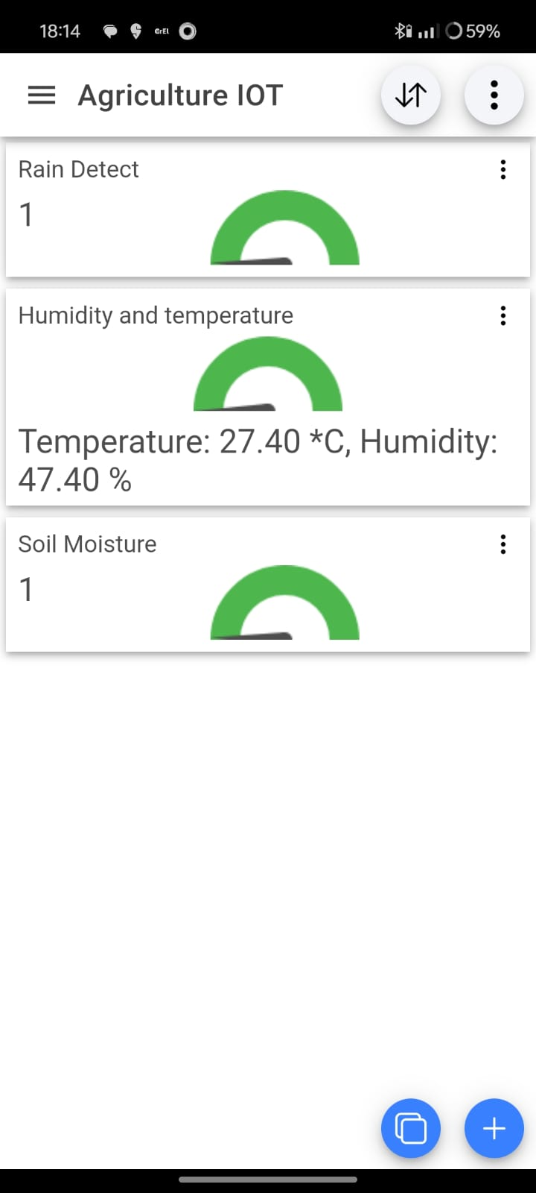

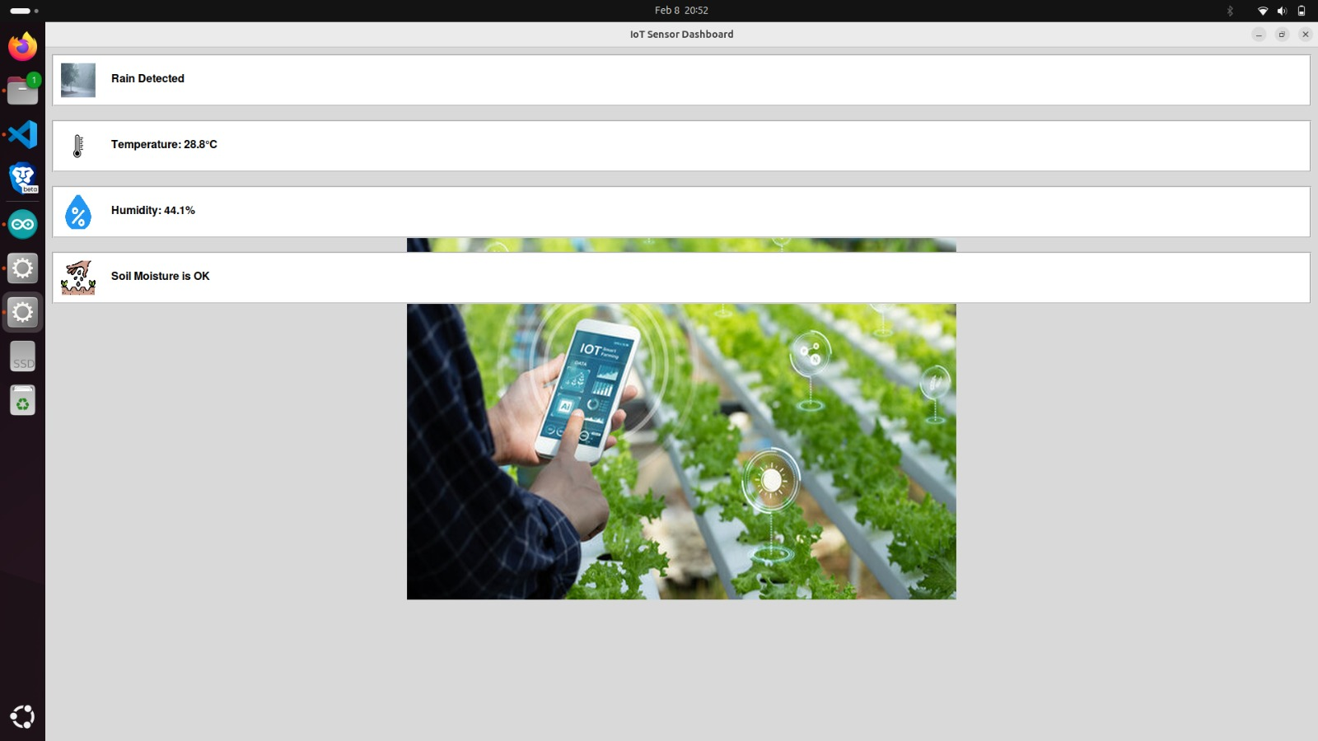



**Chapter 6: Conclusion**

**6.1 Summary of Work:**

The project **"Smart and Connected Farming through IoT Technology"** integrates various IoT components to enhance farm management through real-time monitoring and efficient resource management. The system uses an **ESP32 microcontroller** to collect data from three critical sensors: **soil moisture sensor**, **rain drop sensor**, and **DHT11 sensor**. The **MQTT protocol** facilitates communication between the system and the cloud, using the **HiveMQ free public broker** to transmit data. A **Python-based web dashboard** was created for data visualization, allowing farmers to monitor and manage their farm remotely. This system aids in optimizing water use, improving environmental monitoring, and enhancing crop management.

**6.2 Contribution**

This project contributes to the following:

* **Improved Efficiency**: By automating irrigation and providing real-time environmental data, the system ensures efficient water and resource usage, reducing waste.
* **Sustainability**: It promotes sustainable farming practices by conserving water and reducing the environmental impact of agriculture.
* **Remote Monitoring**: Farmers can manage their farms from anywhere, enhancing convenience and responsiveness to changing farm conditions.
* **Data-Driven Insights**: The system provides valuable data that helps farmers make informed decisions, improving yield prediction and crop health management.

**6.3 Challenges and Limitations**

Despite its benefits, the project faced some challenges and limitations:

* **Sensor Accuracy**: The accuracy of sensors, especially in varying environmental conditions, can be impacted by external factors, affecting the reliability of the data.
* **Internet Dependency**: The system relies on internet connectivity to send data to the cloud and access the web dashboard. A lack of stable internet access in rural or remote areas could be a limitation.
* **Scalability**: While the system works effectively for small-scale farms, scalability to larger agricultural setups could require more advanced hardware and network infrastructure.
* **Power Consumption**: Although the ESP32 is energy-efficient, long-term deployment in remote locations may require efficient power management solutions such as solar panels or batteries.

**6.4 Future Work**

To improve and expand upon this project, the following future work can be explored:

* **Enhanced Sensors**: Incorporating more advanced sensors (e.g., pH sensor, light sensor, or CO2 sensor) for comprehensive monitoring.
* **Mobile App Development**: Developing a mobile application to allow farmers to monitor and control the farm remotely using smartphones.
* **Automated Control**: Integrating more automation, such as controlling irrigation, greenhouse conditions, or even fertigation based on real-time data.
* **AI and Machine Learning**: Using machine learning algorithms to predict crop yield, detect plant diseases, and optimize irrigation schedules based on historical data and environmental conditions.
* **Energy Efficiency**: Researching low-power solutions for long-term sensor operation in remote locations, such as solar-powered devices.

**6.5 Conclusion**

The **Smart and Connected Farming through IoT Technology** project demonstrates the power of IoT in revolutionizing the agricultural industry. By combining **real-time monitoring**, **automated decision-making**, and **remote management**, this system provides farmers with the tools they need to improve farm productivity, conserve resources, and enhance sustainability. While there are challenges such as sensor accuracy and internet dependency, the future of IoT in agriculture holds immense potential for further innovations. With continued development and optimization, this project could pave the way for smarter, more efficient, and sustainable farming practices globally.

**Chapter 7 References**

**[1]** J. M. Talavera, L. E. Tobón, J. A. Gómez, M. A. Culman, J. M. Aranda, D. T. Parra, et al., **"Review of IoT applications in agro-industrial and environmental fields"**, *Comput. Electron. Agr.*, vol. 142, pp. 283-297, Nov. 2017.

**[2]** A. Kumar, B. Singh, **"Wireless Sensor Network-Based Soil Moisture Monitoring System for Precision Agriculture,"** International Journal of Distributed Sensor Networks, vol. 32, no. 5, pp. 112-120, 2023.

**[3]** K. Grgić, I. Špeh and I. Heđi, **"A web-based IoT solution for monitoring data using MQTT protocol"**, *2016 International Conference on Smart Systems and Technologies (SST)*, pp. 249-253, 2016

[4] Devanand M Nandede, Vaishnavi S Salunke, Pratik S Jagtap ,***“IOT BASED SMART FARMING”******in International Research Journal Of Modernization In Engineering Technology And Science (IRJMETS), Volume 06, Issue 04, April 2024***