Projects

GISiK – Visually Impaired Learners

GISiK – Online Learning

GISiK – Language & Literacy

GISiK – Text & Talk

**GISiK - Text & Talk**

Text Analytics: GIKS

We have developed a text visual analytic system, [Graphical Interface of Knowledge Structure (GIKS)](https://giks.herokuapp.com/), that can automatically capture, visually represent, and statistically compare the knowledge structure inherent in texts.

* Funding Agency: The Center for Online Innovation in Learning (COIL), Penn State University
* Award: 2018 Outstanding Development Award, AECT
* Reference: Kim, K. (2017). Graphical Interface of Knowledge Structure: A web-based research tool for representing knowledge structure in text. *Technology, Knowledge and Learning* ([link](https://files.acrobat.com/a/preview/60343b8d-d3c5-4c29-ac4b-061953614006))

Conversation Analytics: AICAS

We are working to develop an Automated Intelligent Conversation Analytic System (AICAS) that can automatically capture, visually represent, and statistically compare the knowledge structure inherent in verbal conversation.

* Funding Agency: The Center for Cross-disciplinary Research on Engaging Advanced Technology for Education (CREATE), Northern Illinois University

**GISiK – STEM Literacy**

We are working to develop a computational visual analytics system to represent and analyze the correspondence (or lack of thereof) between *what is read* and *what is written* in order to understand how readers' visual behaviors in reading relate to their knowledge structure in their writings, so ultimately to detect individuals with difficulty in reading and writing such as dyslexics

* Funding Agency: IBM Watson

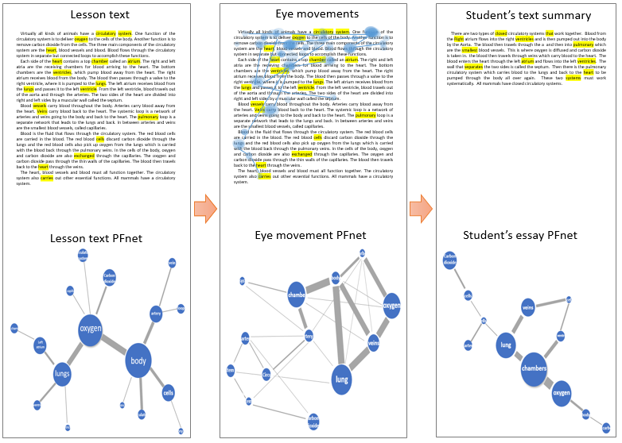

An example of a lesson text that a student read (*left*), eye movement of where the student looked (*middle*), and text projection of what the student wrote (*right*), converted into Pathfinder Networks.

We also conduct research to examine the role of knowledge visualization in helping linguistically diverse learners, particularly English Language Learners, understand complex scientific conceptual knowledge and providing instructional advice for those students who must learn science in English.

* Selected Publications:

**Kim, K**., & Clariana, R. (2018). Applications of Pathfinder Network scaling for identifying an optimal use of first language for second language science reading comprehension. Educational Technology Research and Development. (Online First)

Kim, K. (2018). An automatic measure of cross-language text structures. *Technology, Knowledge and Learning. 28*(2), 301-314

Kim, K. (2017). Visualizing first and second language interactions in science reading: A knowledge structure network approach. *Language Assessment Quarterly. 14*(4), 328-345

Kim, K., & Clariana, R. (2017). Text signals influence second language science text comprehension: Knowledge structure analysis. *Educational Technology Research and Development. 65*(4), 909-930

Kim, K., & Clariana, R. (2015). Knowledge structure measures of reader’s situation models across languages: Translation engenders richer structure. *Technology, Knowledge and Learning. 20*(2), 249-268

Clariana, R., Wolfe, M., & Kim, K. (2014). The influence of narrative and expository lesson text structures on knowledge structure: Alternate measure of knowledge structure. *Educational Technology Research and Development*, *62*(5), 601-616

GISiK – Online Learning

We conduct research to promote students’ active engagement in the development of their knowledge structure during learning online by providing individualized knowledge structure visual feedback, and also benefit instructors’ understanding of individual students’ understanding and thinking, thereby leading to using improved pedagogy and individualized instructional strategies.

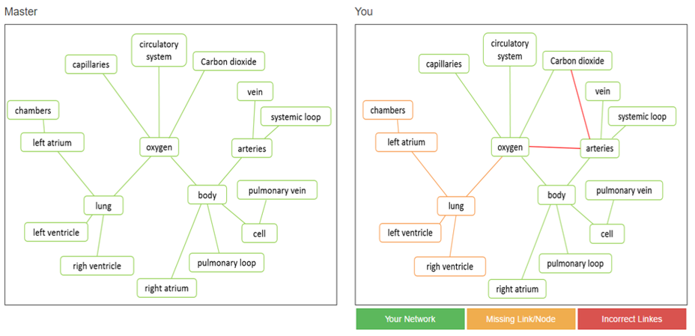

An example of a knowledge structure network graph from a lesson text (left) and a student written response (right). Yellow indicates “missing” links/concepts (perhaps due to a lack of understanding of the specific relationships between the yellow key concepts in the lesson text) and red indicates “incorrect” links/concepts (perhaps due to a misunderstanding of the relationships between the red key concepts in the lesson text)

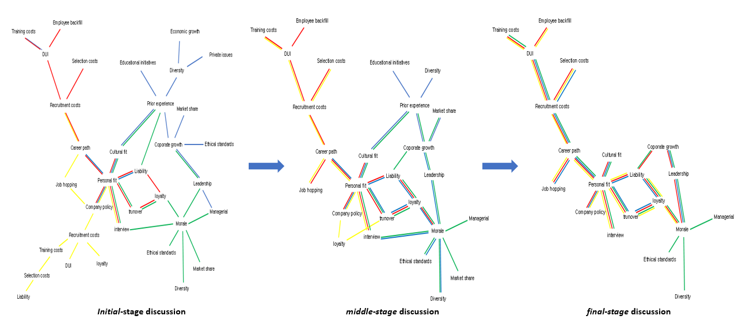

Visualizing the changes in knowledge structures of team members during online discussion over three time snapshots (initial, middle, final); each color indicates each individual knowledge structure network. * the member in red has a strong knowledge impact on this group knowledge structure.

* Selected Publications:

Tawfik, A., **Kim, K.**, Hogan, M., & Msilu, F. (2018). How success vs. failure cases support knowledge construction in collaborative problem solving.  Journal of Educational Computing Research. (Online First)

**Kim, K**., Clariana, R., & Kim, Y. (2018). Automatic representation of knowledge structure: Enhancing science learning through knowledge structure reflection in an online course. Educational Technology Research & Development. (Online First)

Smithwick, E., Baxter, E., Kim, K., Edel-Malizia, S., Rocco, S., & Blackstock, D. (2018). Interactive Videos enhance learning about socio-ecological systems. *Journal of Geography. 117*(1), 40-49

Tawfik, A., Law, V., Ge, X., Wanli, X., & Kim, K. (2018). The Effect of sustained vs. faded scaffolding on students' argumentation in ill-structured problem solving. *Computers in Human Behavior. 87,* 436-449

Zimmerman, W.A., Kang, H.B., Kim, K., Johnson, G., Clariana, R., & Zhang, F. (2018). Computer-automated approach for scoring short essays in an introductory statistics course. *Journal of Statistics Education. 26*(1), 40-47

GISiK – Blind Learners

We are working to develop an assistive visual technology to enable visually impaired learners to touch-navigate their knowledge structure graphical feedback and/or any types of 2-dimensional graphical data (e.g., statistical data, geographical map) on their touchscreen or on swell touch paper.

* Funding Agency: The Center for Online Innovation in Learning (COIL), Penn State University

