Documentation

# Qgis-Plugin: EasyTemplatePrint

## Version: 1.0

## Developer: Jesper Jøker Eg, GISkonsulenten

# Scope

This plugin for Qgis gives the user an easy way to input text data into a print-composer, handles numerous composers and rotating maps.

The plugin is based on existing plugin “Instant Print” by SOURCEPOLE from Zurich but is then added functionality to rotate plot and an easy input method for label-variables.

# How to use

Initial functions:

* Reads active composer from project file into list ”Composer:” sorted alphabetically.
* Sets scale to current map-scale in composer map item.
* Creates list of possible export formats
* Sets rotation to ”0”.
* Reads labels with expressions and adds them to up to 5 input fields. If no expression or less than 5 is found, input fields are left empty. Labelitems in dialog follows the order of labels in composer.

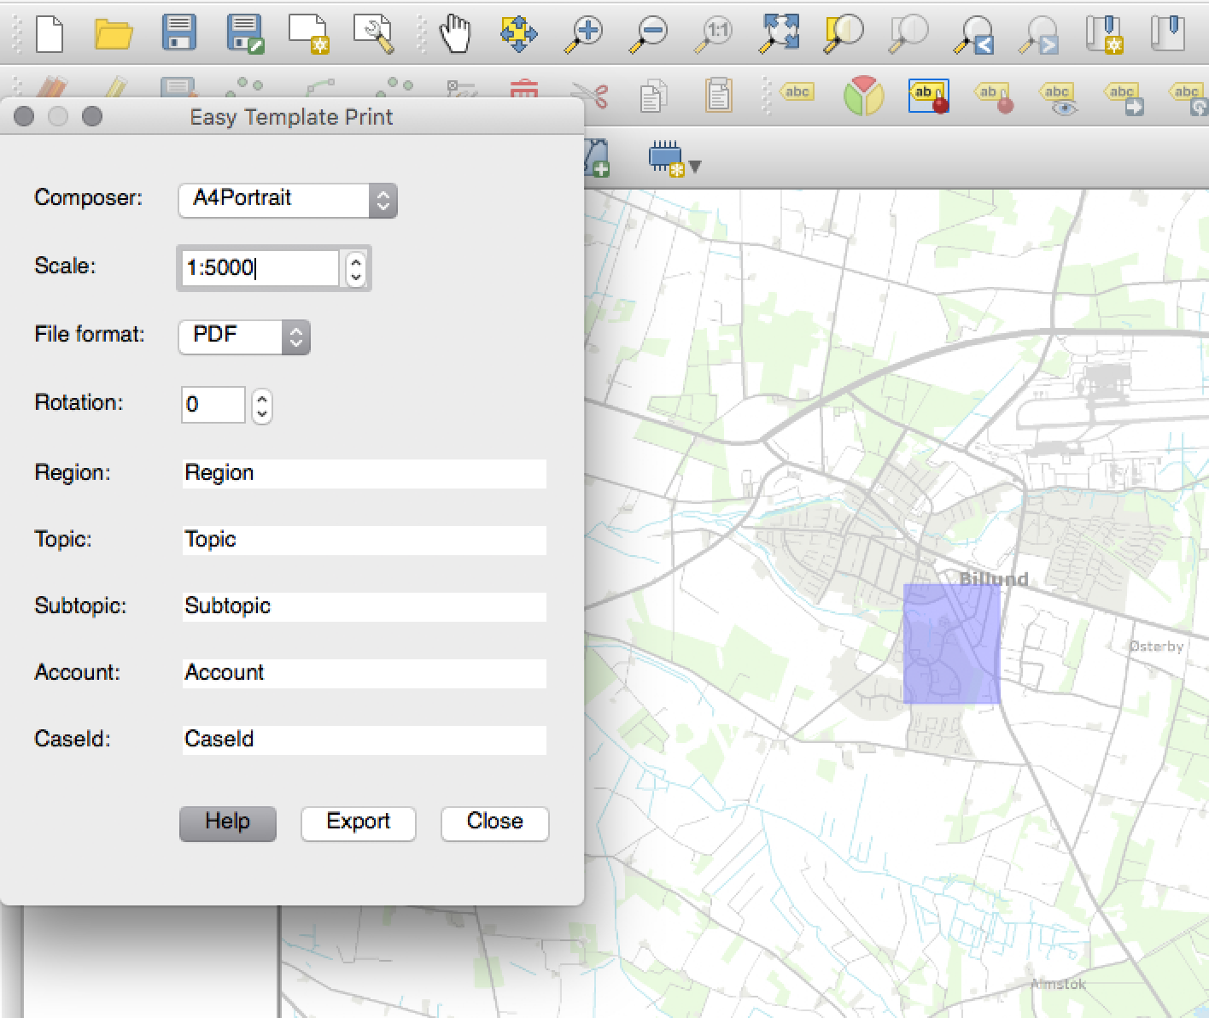

User functions in dialog:

* Select another composer from list.
* Change scale.
* Select file format.
* Change rotation. This affects all items related/locked to map rotation in composer.
* Input user defined texts
* Export to file

When export is finished, the user gets this information dialog:

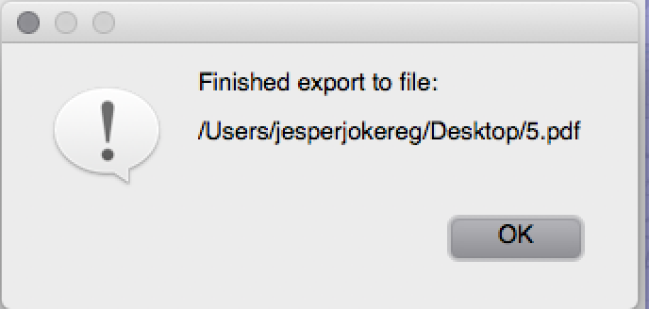

User functions in map:

* Move map extend by drag and drop

# Bindings in Composers

No template variables can have the same name as a Label-variable.

Label-variable must be in the format: [% @Region %]

The plugin searches all labels items in composer. If label-item includes the characters “[%@ ]” this label is used to setup an input-field in dialog.

The input data is stored in project variables to further use with other composer.

# Extras

The Help-folder in the plugin directory contains composer templates and project file set up for proper use of the plugin.