Postprocessing UAV Footage

This documents provides a basic workflow of the georeferencing process of Solo/Pixhawk flight data as well as the optimized workflow for deriving high quality point clouds 3D models and orthoimages. In detail it covers the topics:
- data acquisition constraints
- geotagging of the images
- high quality image alignment
- high quality point cloud generation
- high quality orthoimages generation
- high quality dense point clouds
- importing and exporting data from photoscan
- Agisoft Photoscan scripting
- interaction with the uavRst package

This is a preliminary draft. Please note that significant changes can still be expected

Constraints of data acquisition
The base for good micro-remote sensing products are the images takes by the drone. They will pass through a post processing workflow where the original picture quality determines the quality in every further step. It is pretty simple and successful if one keep in mind some very basic constraints during data acquisition.
Actually you should take care of two requirements:
- sufficient overlap, provide photos where at least 70% of the photo is on focus while avoiding scale leaps (surface following flight paths). Consider on which footprint the overlap is calculated. If you have different structure layers in different distances to the camera, the overlap differs for every of this layers as they have all their own footprint dimensions.
- diffuse but bright light, best is at noon with kind of high thin cirrus clouds scattering the light perfectly and reduce shadows....

Prerequisites
The following workflow requires some tools: You need the mapillary_tools which is a very useful bunch of python scripts dealing with image placement on web maps. To run them you also need to install gpxpy, pillow, exifread, pyexiv2 . If running windows please install first a pip installer derivate, running Linux you can install pip with sudo apt-get install pip. Then you may install the dependencies like following:
pip install git+https://github.com/mapillary/mapillary_tools.git
pip install gpxpy
pip install exifread
pip install Pillow
sudo apt-get install python-pyexiv2 (Linux)
windows pyexif2 (windows)
Next (if not already installed) you need to install the gpsbabel binaries.
sudo apt-get install gpsbabel
For the visualization of the gpx data you may use QGIS or mapview and plotRGB in R.

Adding geotags to the images
Almost no standalone camera has a GPS or an aGPS onboard. As a result no image will have a spatial reference at all. Georeferenced images can be aligned better and faster and, as a side effect, one will have a fairly good georeference (~1-5 meters). So even if this task is a bit cumbersome it will help a lot.
The most prominent way to apply a spatial position is to add geotags to the images. This needs a semi-automated post processing. The best software doing so is geosetter, which is unfortunately not running very stable under Linux and OSX (besides some other shortcomings).
Actually, while adding geotags you have to deal with three effects:
- time shift between logger and camera time
- automatic timezone adaption of the data
- identification of a start and stop image within the time series
For our needs we want to align the images along the flight track within a accuracy of 2-5 seconds (according to lapse rate). It seems to be kind of senseless to automate this process due to the fact that you always have to start and stop the cameras manually and you always will take pictures on the ascending, descending going to and coming back from the core task.

Note: You have to find out when the timestamp of the image is created. Shooting the picture or saving the file (what might be a few seconds later, e.g. for Mapir-cameras the timestamp is created in that moment the file is saved).

Preparation of the data
If not done you need to organize some basic things. It is more than helpful to separate each partial flight an the corresponding gpx file in a subdirectory. Very straightforward it may look like below.
- separate all image files according to the corresponding flight (log file)
- copy the GPX-log file into the same directory
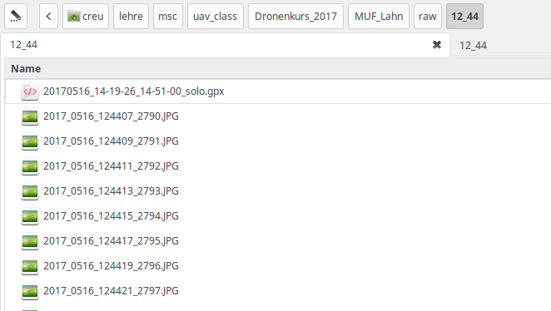

The basic concept
You have to find the start and stop image of the partial task. Load the task in QGIS open the Bing aerial map and the first and last image. In most cases you can easily identify the rough position of the camera. It is by no means necessary to get an extremely exact result. You just need to to generate a correct sequence according to the gpx track points as described below.
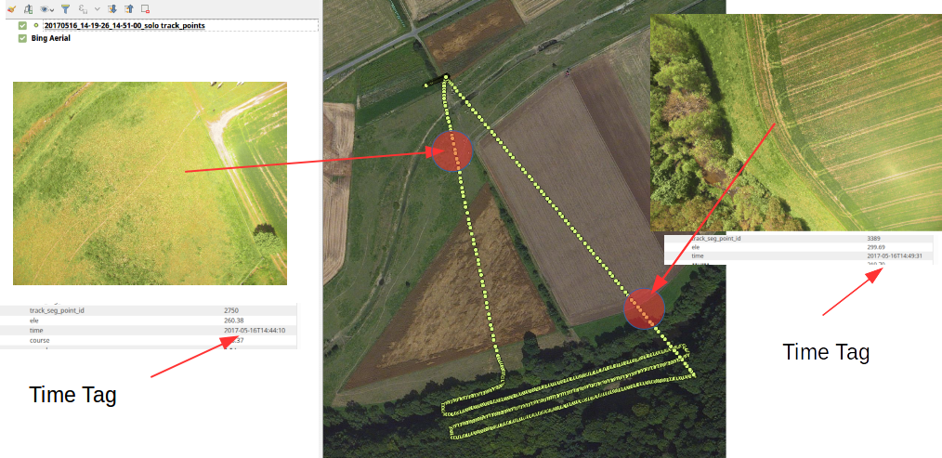

The workflow
Open a terminal and navigate to the image/gpx folder.
Write fake exif date and time tag
python ~/dev/R/uavRst/inst/python/add_fix_dates.py . '2017-05-16 16:44:12' 2

Please note:
- the location of the scripts is arbitrary
- you start with the best fitting track point according to your first image
- the dot is obligatory to point to the actual directory
- the 2 is the time increment of the cameras lapse rate in seconds
- take the time of the GPX-time-tag (red 16)real GPS time is 14

Cut the gpx log file.
gpsbabel -t -i gpx -f current_solo.gpx track, start=20170516144408 ,stop=20170516144930 -o gpx -F clean_task.gpx
Please note:
- gpsbabel may re-interpret the time tag to GPS time so usually you have to set the time shifted by the time zone and summertime
- just add for convenience two lapse rate steps in the beginning and end

Write the derived geotags to each image file
python ~/dev/R/uavRst/inst/python/geotag_from_gpx.py . clean_task.gpx

You are done with the preparation now. Time to start Photoscan.

Add the photos to photoscan
Loading the images into Agisofts Photoscan the aerial images are lining up along the track as you can see below.
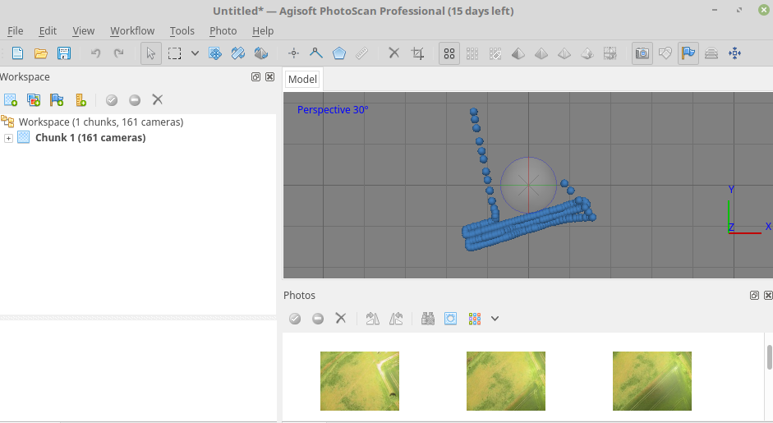

Agisoft Photoscan basic workflow
Agisofts Photoscan is a great tool for deriving point clouds and all kind of surface models. It has a incredible straightforward GUI and is well balanced. However one should know how to deal with it for more specialised goals.

Alignment

Note: The quality of the alignment is crucial for all follow up products - especially 3D model dense point cloud and orthoimage.

The Align Images process is somehow explorative. It is a good practice to use for a first general run the following settings:
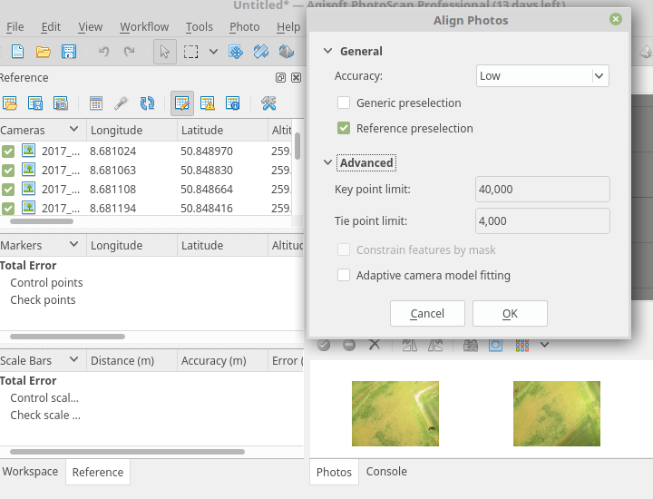
It will give you an good estimate how the general alignment process will perform.
Note: we did choose reference preselection due to the georeferenced images.

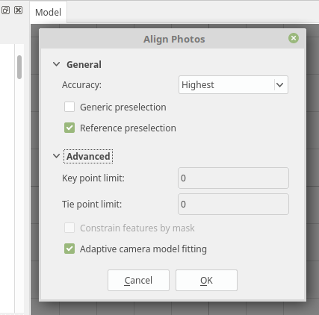
However there are a lot of different requirements depending on sensor, light and surface characteristics. For high quality images there is obviously no significant quality improvement if increasing the number of keypoints behind 240000. You may calculate as a rule of thumb (same post) the maximum number of keypoint according to
megapixels x 6400
For the Mapir or DJI this will results in roughly 77000 keypoints. Nevertheless setting the params to zero will be interpreted as maximum which seems to be reliable if one is filtering the point clouds and 3D models in a second step. So a reasonable highest quality approach may look like:

Please keep in mind that it will take a really long time to align the images in a high quality process.

Creating high quality sparse (tie) point clouds
The trick to derive a high quality sparse point clouds is to avoid spurious information and to retrieve a good spatial positioning of the images. In other words you need a optimal alignment with as less as possible “spurious” tie points. You can reach itin most cases with a highest quality alignment and posterior filtering and camera optimization process. If still the result is not satisfying your needs, you additionally may also use ground control points GCPs.
We made fairly good experiences following jhutan who suggest the this workflow for generating high quality point clouds. Usually we need only one recursion of gradual selection:

- Remove sparse points by gradual selection (see below)
- Optimize cameras (after each removal)
- Optionally repeat steps 1-2 until the reconstruction error is minimized

Ad 1: this removes spurious points from the point cloud e.g. it will smooth the surface
Ad 2: all cameras will be re-optimized for the new geometry
Gradual Selection Process
Before starting the gradual selection process right-click your current chunk in the Workspace window and select “Duplicate chunk”, then proceed with the copy.
- Choose “Reconstruction uncertainty“. Type something like “10” and see the as a result all points in the sparse cloud selected Clicking “OK” and “DEL” will delete the selected points. If the DEL key doesn’t work, you need to click once into the model window to activate it, and press DEL again.
- Next choose the “Reprojection Error” option. Set it to < 1 and again delete the selected points then click that wizard’s wand icon again.
- Finally check the “Projection Accuracy” try to delete the poorest 10 % of the points
For more details have a look at e.g. dinosaurpaleo.

It is recommended to keep in line with this process if you want to reconstruct high quality point clouds and surfaces like textures or orthoimages. Even if it seems to be an annoying manual approach, you will soon notice that the time you have spent pays itself several times…
For a first automatic retrieval you may use the script makeSparseCloud.py.

Build 3D model (mesh)
Now you may use the derived sparse point cloud to build a 3D model. the process is straightforward. For an maximum number of faces in the mesh choose the following settings:
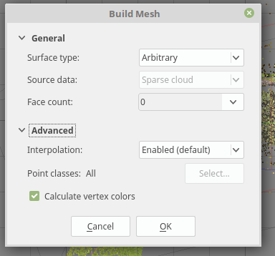

Generate Orthophoto
Creating an orthoimage is a very straightforward approach and it differs slightly from deriving a high density point cloud. Just follow the below outlined Workflow.

- load the prepared images
- check image quality
- align images according as proposed before
- build mesh on an optimized sparse point cloud
- create orthoimage on the mesh
Using a mesh (3D model) will give in most cases better results for the orthoimage generation of low AGL flight level altitude imagery. Nevertheless you have to check what kind of cloud is more sufficient the dense or sparse point cloud. It depends on the structure. You will get often more satisfactory results using a well preprocessed sparse point cloud.
So the recommended settings are:
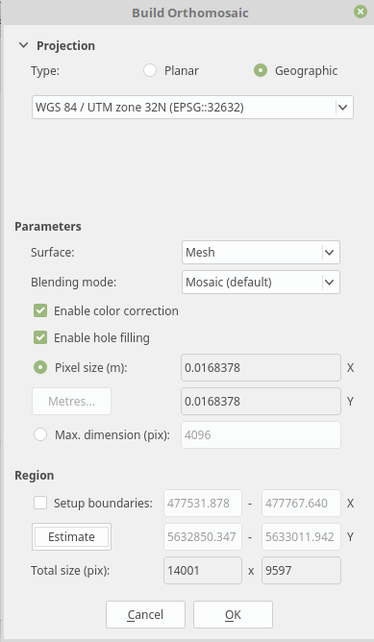
Et voila - Finally you derive an orthoimage of fairly high quality

Creating high quality dense point clouds
Hence micro-remote sensing is usually restricted to a single (visible) layer the temporal scale this layer can be observed by drones is the advantage compared to high-cost and temporal limited LIDAR data sets. Using photoscan the dense point cloud might still be classified in different layers depending of the structure of the observed area and structure (i.e a deciduous forest can be observed in winter for ground models and tree structure while summer flights will deliver good surface models).
Additionally dense clouds can be exported in several formats to be used in further processing in QGIS, SAGa or 3D modelbuilder software. So it is easy to benefit from already existing and established workflows which were developed for LIDAR oder 3D modeling data.
The settings of the dense point cloud calculation determines quality and necessary calculation time. Hereby a higher quality results in longer calculation time. Aggressive filtering ignores small structures and runs fastest while moderate and mild filtering consider smaller structures on the cost of longer calculation time.
The dense point cloud can be calculated as soon the pictures are aligned. Even if the dense cloud comes second in the workflow dropdown menu in Photoscan it should be considered to calculate the orthoimage first as the dense point cloud will take the longest time of all processes.

Photoscan import/export
Interaction with the uavRst package

