ONLINE MAPPING PROPOSAL

**Note**: The objective of this document is to provide a high level description for *Canada 150: Mining History Mapping Project*.

**Keywords**: CANADA 150, mining, outreach, WebGIS, history, visualization, analysis

# 1. Introduction

Canada is rich in natural resources and is a world leader in mining. Mining not only plays significant role in Canada’s economy, but also brings broad benefits to our society. We are richly endowed with valuable natural resources and we are proud to have a long history in mining. The field of mining has always been the focus of researchers from many diverse disciplines due to its complex nature.

However, there are some challenges regarding knowledge dissemination and exchange between academia and industry / public, sometimes within academia itself. This proposed online mapping platform is an effort of answering these challenges.

Here are the expected outcomes of this project:

* Presenting fascinating mining stories in rich and captivating multimedia format of interactive maps, images, animations and videos to stakeholders (researchers, students, policy-makers, practitioners, and general public)
* Serving as a research platform with a wealth of dataset and analysis tools to facilitate knowledge discovery, dissemination and exchange across research communities from diverse disciplines
* Serving as a knowledge mobilization tool to raise public awareness of our exciting mining resources and mining industry, especially the effects of mining industry on various aspects of our society, including indigenous communities
* Advocating current academic researches on mining by University of Saskatchewan, to potentially lead to future scholarly research opportunities (funding, initiatives)

Knowledge dissemination and exchange has always been a challenge for most researches with a spatial context, including geographic studies such as minding. This is one of the reasons why GIS is still used in academics and professional industry practitioners instead of the general public. Google Map changed the landscape of GIS to unleash the power of GIS from the desktop workstation to the browsers. Since then WebGIS has been booming and served itself as a perfect answer for knowledge mobilization tool in the field of mining. However, WebGIS today is still in its infancy, with its own challenges. In this proposal we are going to analyze the current WebGIS industry, so that the best implementation framework can be selected in our *mining history mapping project* to achieve the pre-defined outcomes.

# 2. Comparison of WebGIS Frameworks

The landscape of WebGIS today is still evolving, with a large amount of frameworks available. However, they are developed to suit different research needs. The large quantity of them simply testifies the truth that not one of them is the panacea for all, or even most, of the research needs. Even though the landscape of desktop GIS industry is much simpler.

A WebGIS may require a back-end server to serve the web content, but always has a front-end framework to visualize spatial data as well as some data analysis. Be definition, all WebGIS frameworks supports viewing spatial data at the front-end. However, capacity of service maintaining (back-end) and analysis functionalities (back-end, and/or front-end) varies. In this section a brief review of all WebGIS models are reviewed for comparison. Then starting with Section 3 the proposed model for this project will be described in detail.

## 2.1 Back-end

The back-end refers to the server-side where data and services are hosted for the browsers to consume. In a WebGIS, the back-end involves a Web Server to serve regular web services, and may also have a dedicated GIS Server to publish spatial data and services. An effective WebGIS should have a robust back-end. This is especially the case if sophisticated analysis (GIS spatial analysis) are intended in the WebGIS application. The types of GIS Servers can be categorized into 2 groups: commercial products (usually with all-purpose and more integrated functionalities) and open source solutions (usually with specific-purpose and less integrated functionalities). Here some popular products are listed for comparison in order to find the best model for our project.

### 2.1.1 ArcGIS Server

ESRI’s ArcGIS product family is the leader in the Desktop GIS industry. It’s not surprising to find ESRI as one of the earliest pioneers to tap into the WebGIS industry. It has its own all-purpose WebGIS solution: “ArcGIS Server[1]”. This is by far the most advanced model in the industry, will well-rounded functionalities from data publishing to sophisticated analyses powered by its Desktop GIS engine. The drawback of using ArcGIS Server include:

* Maintaining an ArcGIS Server. ArcGIS Server is powerful with lots of features and capabilities. But there is a high cost in staff training and server deployment and maintaining. Although ESRI conforms to most web standards, it will not be surprising to find ESRI implements its own standards alien and difficult to most developers, bringing up the cost in deploying and tailoring ArcGIS Server to specific needs.
* ArcGIS Server is proprietary. ArcGIS Server is too expensive for most WebGIS applications, as most WebGIS intends to be simple and front-end oriented.

We find large amount of WebGIS examples powered by ArcGIS Server in WebGIS applications authored by Government of Canada, such as

* The Atlas of Canada - Minerals and Mining[2]
* The Atlas of Canada - Indigenous Mining Agreements[3]
* First Nation Profiles Interactive Map[4]

### 2.1.2 Other Commercial Server-side Packages

Since most WebGIS applications are focused on visualizing spatial data, there exist lots of software packages to convert GIS data into resources (files, or end-point services) that can be consumed for browsers. Some of them are tools and technically not qualified as GIS servers.

The most popular product is an online platform Mapbox Studio[5], with the ability to publish GIS layers of various formats into front-end consumable resources. Mapbox also has a free desktop version called Mapbox Studio Classic[6]. The most appealing feature is its ability to prepare vector services that makes the final map presentation responsive, interactive and visually attractive.

There exist other commercial solutions in the WebGIS market such as Carto[7], CartoVista[8] and 21st Century Geomatics[9], with either proprietary or customized open-source frameworks.

The major drawbacks of these commercial solutions are

* Data may have to be uploaded to these third-party’s private servers
* Limited or no analysis functionalities, especially support of custom scientific models often used in mining research and industry
* Cost in purchase, training and maintenance

### 2.1.3 Mapping Services

Commercial mapping service providers, such as Google Maps and Microsoft Bing Maps, provide general mapping services, which can be used to build custom WebGIS through mashup (see Section 2.3.1). They don’t allow users to publish spatial data on their servers[10], but instead offer front-end tools to visualize user’s spatial data. This model works for simple WebGIS mashup, but its limitations are obvious due to its lack of server-side support:

* Ineffective in case of massive data to be published
* Impossible to publish any spatial services
* Vendor lock-ins if mapping service quota is exceeded. Mapping service providers always set limit (quota) on the number of request of their mapping resources. This is not a problem if a WebGIS application has a few end-users, thus making only a few request on the commercial mapping resources. But this is not practical if the end user base grows large enough to reach the quota when the WebGIS will stop functioning and commercial licenses are need to be purchased.

Since our mining project targets at large audience, and probably requires publishing massive GIS and non-GIS data, as well as sophisticated services, this model cannot be used in this project.

### 2.1.2 Open-source GIS Servers

It is exciting to witness the rise and popularity of open source solutions in the field of WebGIS, with some of commercial product custom-built on top of powerful open source packages. Some popular open source GIS Server examples include: GeoServer[11], MapServer[12], CartoDB[13], GeoNode[14], Maknik libraries[15]. The strengths of open source GIS servers are: free of charge, free support, open standards, better security/transparency, and also avoids vendor lock-ins. Major disadvantage of using open-source GIS servers are:

* Cost in staff training and server deployment and maintaining. Initial cost is high due to open source tools often require highly skilled staff teams to configure, trouble-shoot and set up. But the cost becomes much lower later on.
* Tailoring the server to meet the project requirement. This initial cost is similar as above. However, this process of tailoring gives us the power over the entire software, thus allowing us to build the optimal product for our project.

## 2.2 Front-end

### 2.2.1 ESRI’s ArcGIS Tools

ESRI offers frontend tools (API) for building WebGIS. Needlessly to say the entire framework is focused on consuming GIS services published using ArcGIS Server. The strength of this framework is its well-rounded functionality. However its limitation is as prominent as its strength:

* Mainly designed to be used with ArcGIS Server
* Large and cumbersome libraries required, of which few are relevant for our project. This explains the reason why WebGIS applications authored by Government of Canada uses other front-end frameworks even though ArcGIS Servers are used the back-end.

### 2.2.2 Tools by Commercial Map Providers

Commercial mapping service providers, such as Google Maps and Microsoft Bing Maps, have made their front-end development tools (API) available to the public at free of cost. This allows us to build WebGIS applications using their mapping services. Main limitation of such tools include:

* Designed to work with their own mapping services
* Hard to customize to meet the project needs. Though the front-end API is free, it is not open source and thus making it impossible to modify (from both legal and technical perspectives), which are often the case for professional WebGIS such as our project.

### 2.2.3 Open Source Tools

Meanwhile, there exist a plethora of open source tools available for building custom WebGIS. There are some popular general-purpose Mapping APIs: OpenLayers[16], Leaflet[17], MapBox[18] and custom-purpose Mapping APIs: GeoNode, CartoDB. These tools have benefits from their open source nature. Meanwhile, the above-mentioned examples are well-built with enterprise level quality.

It’s worth-noting that Government of Canada has developed its own open-source front-end frameworks:

* GeoCanViz Viewer [19] by Natural Resources Canada Canadian Center Mapping and Earth Observation group
* Web Experience Toolkit[20] by the Government of Canada

These government-endorsed frameworks are developed on top of other general-purpose open source tools, in order to meet the specific needs of the government — publishing massive GIS data layers to the general public and optionally allowing data extraction, but with weak capabilities in data analysis.

## 2.3 Related WebGIS applications

Based on the previously mentioned back-end (Section 2.1) and front-end (Section 2.2) models, a WebGIS can be possibly built with all the combinations of a back-end and a front-end from the 2 lists. Here are some notable implementations of such models in WebGIS applications.

### 2.3.1 Map Mashups (Front-end only)

The simplest model of building a WebGIS is a ‘mashup’. In this model, web contents of interest, which can be from different sources, are overlaid on top of a mapping service layer (such as Google Maps) to produce spatial-enabled rich browsing experience. This model is simple to implement, but the limitation is obvious:

* Lacking control of data sources. This is due to the simple fact that there is no back-end support at all. All web contents are from different sources hosted by third-parties which the model itself has no control. Slightest changes on the data format will break this model.
* Low data quality for the intended research goal. Since data are produced and published by their-parties with little or no customization support, the model often fails to serve its pre-defined research goal.
* No support for scientific analysis models. Our project needs to publish scientific models as services that can be used at the front-end. This will not be possible using a simple mashup.

It’s worth to mention ESRI’s Story Maps[21], which is a highly customized front-end framework to allow non-GIS and non-technical people to use their services. It is intended for non-professionals to publish some of their spatial and non-spatial data in an engaging and interactive story-style presentation. However its limitations outweigh its simple of use in our project:

* Data are uploaded to ESRI’s private server
* Though there are templates to choose from, it is hard to meet our specific project’s needs
* Lack any analysis functions, even no support for querying or filtering data. This is due to its design as a presentation tool instead of a functioning data visualization / analysis WebGIS

### 2.3.2 Integrated Framework

As can be seen from Section 2.1 and Section 2.2, there exist pre-built WebGIS frameworks with support for both back-end and front-end. An example of such commercial WebGIS framework is ESRI’s ArcGIS Server + ArcGI Mapping API, whereas an open-source framework is GeoNode. From the technical point of view, the strength of using such frameworks is its full-fledged GIS features. However, this also means they can become cumbersome to be highly tailored to suit the needs of a specialized WebGIS such as our mining project.

### 2.3.3 WebGIS by Government of Canada

Section 2.1.1 mentioned some WebGIS examples developed by Government of Canada. As far as we know, all these WebGIS applications employ ArcGIS Server at the back-end to publish GIS data layers. However, at the front-end, there are several options: including commercial API[22], as well as open-source APIs[23] developed by the government on top of other general-purpose mapping APIs.

# 3. The proposed Framework

The proposed framework will fully take the advantage of open-source tools to build an effective customized solutions for this project:

* At the back-end, an open-source GIS server will be adopted and customized to support GIS functionalities: publishing spatial data and services
* At the front-end, open-source mapping APIs and JavaScript framework libraries will be used to build a customized solution that perfectly suits the need of this project, with the best performance on visualization as well as data analysis according to our needs.

Specifically, the proposed framework can be illustrated as below:

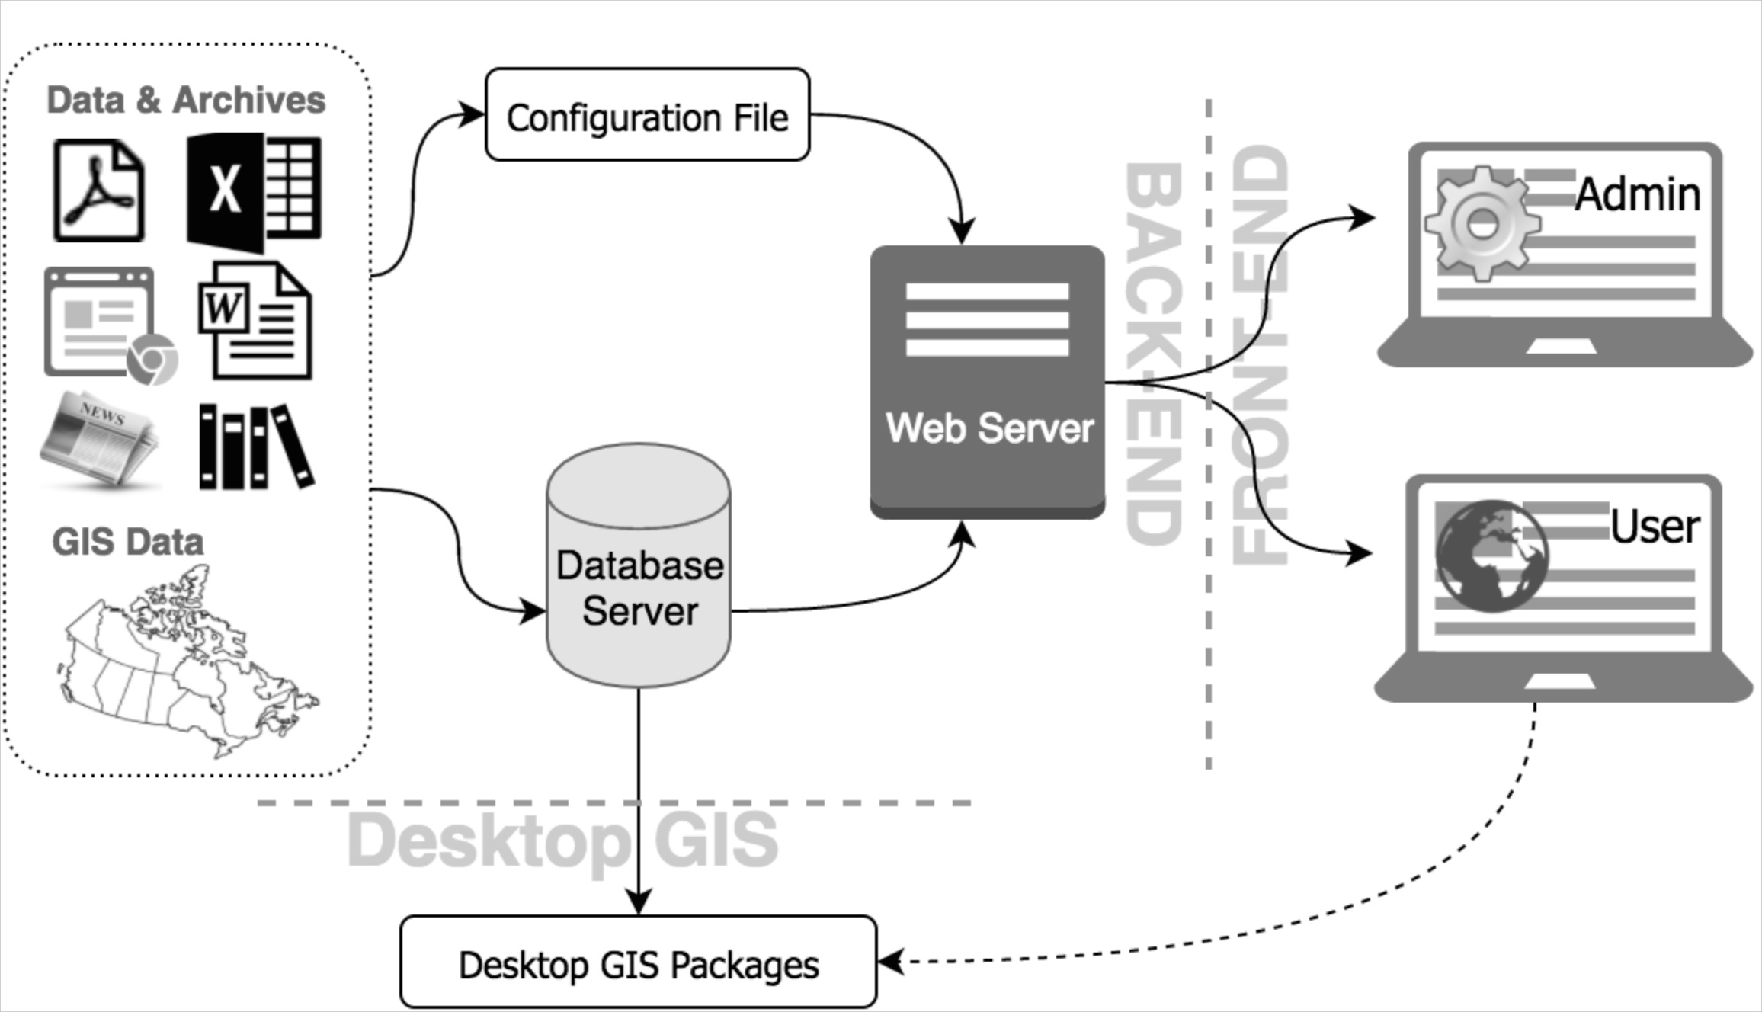

This project involves a large amount of data layers from diverse sources. Here is a list of major data layers (more layers will be possibly incorporated into this project):

* Basemap layers:
  + - topography and other physical features (rivers)
* Operational layers:
  + Spatial layers with temporal dimension
    - towns
    - road networks, railroads, airbases and airports
    - mine locations
    - mining innovations
  + Spatial layers without temporal dimension
    - mining province
    - national historic sites,
    - national parks
    - indigenous lands
    - mining museums
    - mineral collections
  + Non-spatial layers
    - story narratives
    - other resources such as images, videos etc.

Data for all these layers will be collected from multiple sources such as books, newspapers, journals, government, historical gazetteers etc.

These data will be cleaned, organized, geocoded, and finally imported into the spatial-enabled database server, which can be used in Desktop GIS environment such as QGIS for powerful desktop data analysis.

Meanwhile these data will be registered in the configuration file with their meta-data and style definition, to be used in the WebGIS.

For the WebGIS architecture, we have:

* back-end framework: a web server, a database server (spatial-enabled) and a GIS server
* front-end framework: two interfaces will be implemented
  + ‘Admin Page’ is for site administrators to manage this WebGIS, with functionalities include
    - access control and authorization
    - view the schema of entire database
    - monitor published data / layers
    - debug configuration problems
    - update project's data, configuration
    - other administering services
  + ‘User Page’ is for regular end users to use the WebGIS through the responsive user interface, with functionalities include
    - custom layer visualization (catalog control, time control, layer control, legend control, attribute control, tooltip control)
    - download data (GIS formats, raster / vector formats)
    - print maps
    - search data by keywords (meta-data)
    - filter by location (spatial context, town)
    - filter by time (decades)
    - filter by keywords (mining sites, mineral)
    - other analysis functions (models from geologists)

For more information about the proposed framework and demos, please contact Dr. Weiping (Winston) Zeng, Associate Director, The Spatial Initiative, SAFIHR Laboratory Manager, SSRL, University of Saskatchewan, Phone: (306) 966-5133, Email: [Winston.Zeng@usask.ca](mailto:Winston.Zeng@usask.ca)

1. http://www.esri.com/software/arcgis/arcgisserver
2. http://atlas.gc.ca/mins/en/index.html
3. http://atlas.gc.ca/imaema/en/index.html
4. http://fnpim-cippn.aandc-aadnc.gc.ca/index-eng.html
5. https://www.mapbox.com/studio/
6. https://www.mapbox.com/help/define-mapbox-studio-classic/
7. https://carto.com/
8. https://cartovista.com/products
9. http://21geo.com/index.html
10. However, Google has Google Cloud SQL for clients to store spatial and non-spatial data on their cloud server. But this can be problematic for a WebGIS project with strict data confidentiality policy such as ours.
11. http://geoserver.org/
12. http://www.mapserver.org/
13. https://carto.com/
14. http://geonode.org/
15. http://mapnik.org/
16. http://openlayers.org/
17. http://leafletjs.com/
18. https://www.mapbox.com/api-documentation/
19. https://github.com/GeoCanViz/GeoCanViz
20. http://wet-boew.github.io/wet-boew/index-en.html
21. https://storymaps.arcgis.com/en/
22. Such as *First Nation Profiles Interactive Map* *http://fnpim-cippn.aandc-aadnc.gc.ca/index-eng.html*
23. Such as

    *The Atlas of Canada - Minerals and Mining http://atlas.gc.ca/mins/en/index.html*

    *Geospatial Data Extraction http://geogratis.gc.ca/site/eng/extraction*