K-means clustering

Definition and Purpose

K-means is a method to **partition $n$ observations into $k$ clusters** in which each observation belongs to the cluster with the nearest **mean (cluster centers or cluster centroid), serving as a prototype of the cluster**. It minimizes with-cluster variances (squared Euclidean distance), but not regular Euclidean distance (can be solved using k-medians or k-medoids).

In the mathematic expression, given a set of observations ($x_{1},x_{2},…,x_{n}$), where each observation is d-dimensional real vector, it aims to partition the $n$ observations into $k$ cluster $S=\{S_{1},S_{2},…,S_{k}\}$

$$\arg_{S}{\min{\sum_{i=1}^{k}{\sum_{X∈S_{i}}{{\left|\left|X-μ_{i}\right|\right|}^{2}}}}}=\arg_{S}{\min{\sum_{i=1}^{k}{|S_{i}|}}}VarS_{i}$$

$μ_{i}$ is the mean of points in $S_{i}$,

## Algorithms

Given an initial set of k-means $m_{1}^{(1)},…,m_{k}^{(1)}$, the algorithm proceeds by alternating between two steps:

1. **Assignment step:** Assign each observation to the cluster with the nearest mean: with the squared Euclidean distance (Mathematically, this means **partitioning the observations according to the** **Voronoi diagram** centered by the means).
2. Update Step: Recalculate means (centroids) for observations assigned to each cluster.

The algorithm has converged when the assignments no longer change. **The algorithm is not guaranteed to find the optimum**. Various modifications of k-means such as spherical k-means and k-medoids have been proposed to allow using other distance measures.

## Properties

Three key features of *k*-means that make it efficient are **often regarded as its biggest drawbacks**:

1. The number of clusters k is an input parameter: **an inappropriate choice of k may yield poor results**. That is why, when performing k-means, it is important to run diagnostic checks for determining the number of clusters in the data set.
2. Convergence to a **local minimum may produce counterintuitive ("wrong") results** (**wrong initial position**)

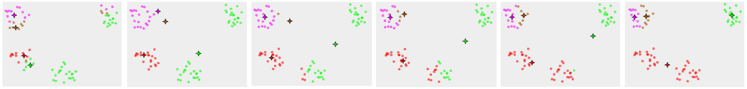

1. Euclidean distance is used as a metric and variance is used as a measure of cluster scatter.

