1. **Prerequisite**

Please make sure you already installed python 3.5x or 3.6x, if you installed another version python, please uninstall it. (Tips: If you install python to your C drive, it may cause access problem when you install TensorFlow. If so, please uninstall it at first)

* Check your python version

1. Open the Command Prompt

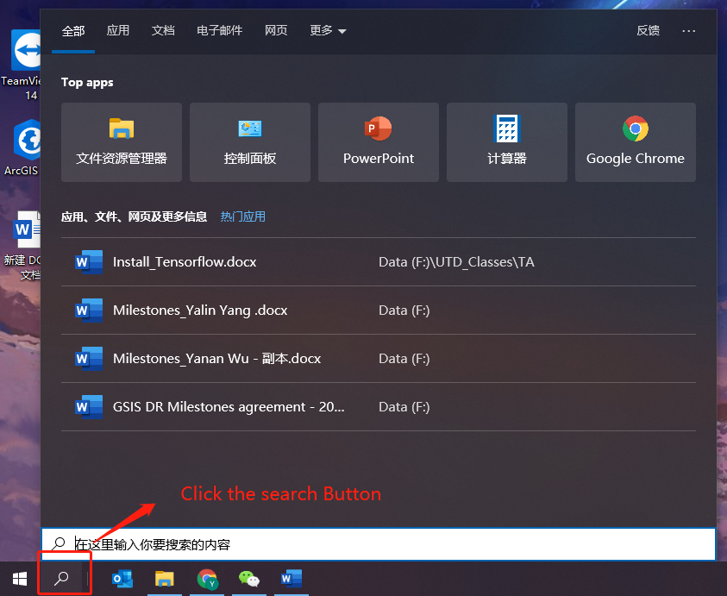

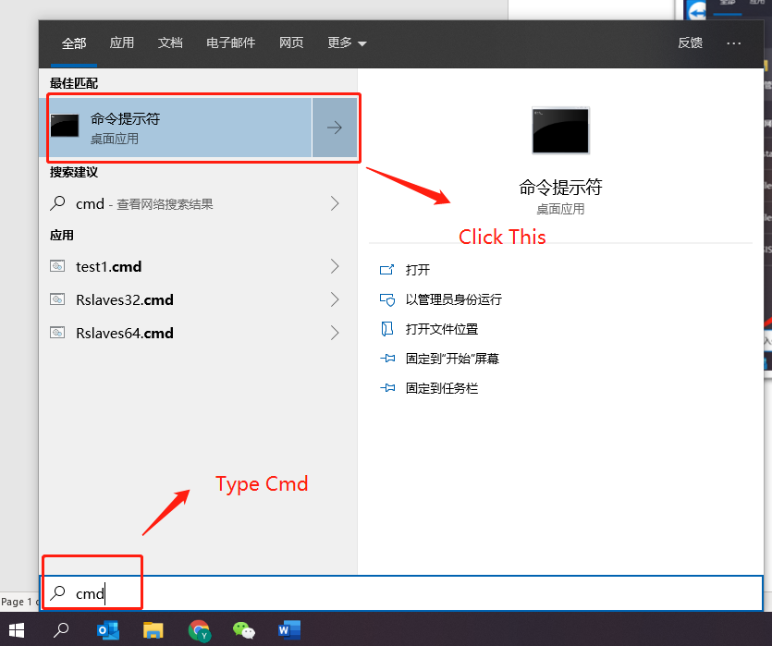

1. Type “python“ in command Prompt to check your Python Version

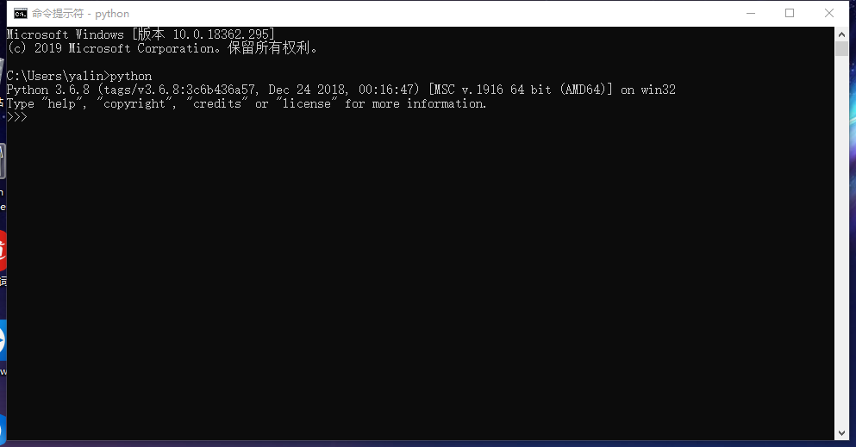

1. **Install TensorFlow**
2. Go to the folder where you put python and then press “shift” plus right click to open the power shell

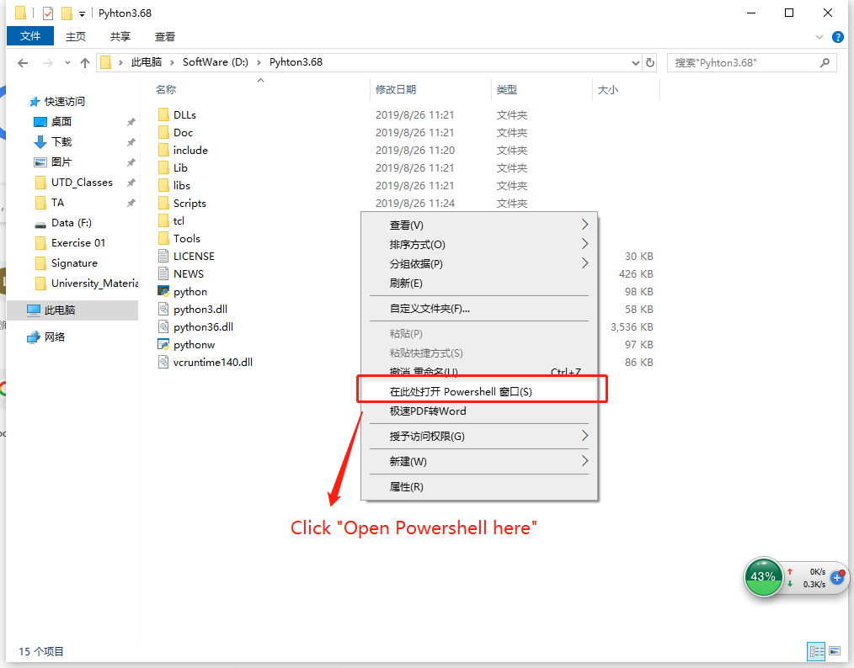

1. Type “pip install tensorflow” in the Powershell, you could also specify the version of the tensorflow you want to install (e.g. pip install tensorflow==2.0.0-rc0).

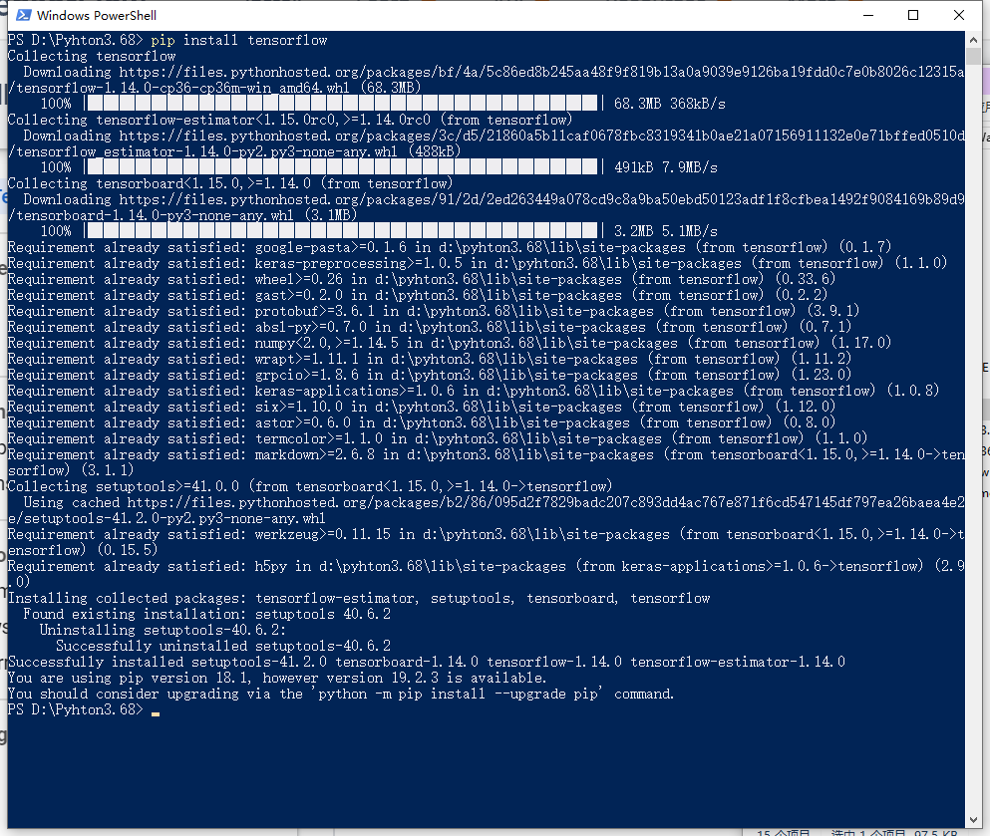

1. Check the device support your TensorFlow

Run the test script (Test(CPU_or_GPU).py) to see what device support for Tensorflow right now.

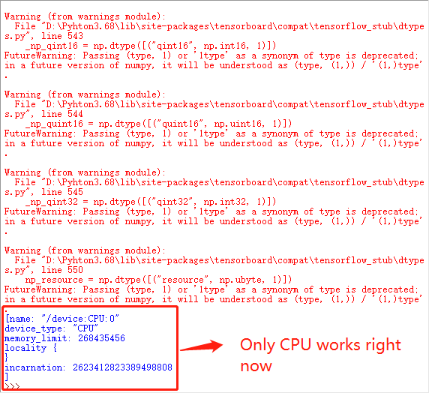

You may get some warning as the picture shows. You could just ignore it. It caused by the latest version of “NumPy” you installed. Because TensorFlow build by old version NumPy, right now some classes build-in NumPy has been changed. But you could still run it. If you want to remove those warnings, you could uninstall your NumPy, and use ‘pip install “numpy < 1.17” ‘ to get the old version.