# **Lab02: Data Transformations and Bivariate Regression Analysis**

**Handed out:** Thursday, September 17, 2020

**Return date:** Thursday, October 1, 2020, by midnight at eLearning’s **SubmitLab02**.

**Grading:** This lab counts 8 % towards your final grade

**Objectives:** This lab focuses on a review of basic bivariate regression analysis, confidence intervals, the Box-Coxtransformation and bivariate regression to estimate the elasticity.

## Task 1: Confidence Intervals (2 points)

Open the **Concord1.sav** file for this task as data-frame. To simplify things do not perform variable transformations.

Task 1.1: Run a bivariate regression model of **income** (dependent variable) on **education** (independent variable) and statistically interpret the model estimates for the intercept and slope as well as the $R^{2}$. (0.5 points)

library(foreign)

Concord <- read.spss('Concord1.sav', to.data.frame=TRUE)

summary(lm(income~educat, data=Concord))

lm(formula = income ~ educat, data = Concord)

Residuals:

Min 1Q Median 3Q Max

-26.848 -8.182 -0.997 6.471 74.003

Coefficients:

Estimate Std. Error t value Pr(>|t|)

(Intercept) 2.5893 2.5574 1.012 0.312

educat 1.4630 0.1783 8.203 2.04e-15 ***

---

Signif. codes: 0 ‘***’ 0.001 ‘**’ 0.01 ‘*’ 0.05 ‘.’ 0.1 ‘ ’ 1

Residual standard error: 12.26 on 494 degrees of freedom

Multiple R-squared: 0.1199, Adjusted R-squared: 0.1181

F-statistic: 67.29 on 1 and 494 DF, p-value: 2.04e-15

Comment: The 𝑅2 is only 0.1199 which means only about 11.9% of the variation in the dependent  
variable **Income** can be explained by the independent variable **education**. The statistically significant slope(𝐻0: 𝛽1 = 0 ) is positive meaning with each additional year of education the income will increase the income by $1.463 . While the intercept is not statistically different from zero, it should be keep in  
the model because [a] there is no logical reason why a person without education may have zero income, and [b] because otherwise some statistics of the OLS model, such as the 𝑅2 lose their properties.

Task 1.2: Calculate the 99 % confidence intervals around the estimated regression parameters. Can you draw the same conclusions as you did using the *t*-test in the **summary** output from task 1.1? (0.5 points)

reg <- lm(income~educat, data=Concord)

cbind("Coef"=coef(reg), confint(reg, level=0.99))

Coef 0.5 % 99.5 %

(Intercept) 2.589322 -4.023659 9.202304

educat 1.462957 1.001811 1.924102

Comments: The *t*-test investigates the null hypotheses that the estimated regression parameters are  
zero. That is, 𝐻0: 𝛽0 = 0 for the intercept and 𝐻0: 𝛽1 = 0 for the slope. As long as the 1 - 𝛼 confidence  
intervals cover the values under the null hypothesis, that is 𝛽0 = 0 and 𝛽1 = 0, the null hypothesis  
cannot be rejected with an error probability of 𝛼.

*Intercept:* 0 is inside the confidence interval so we fail to reject the null hypothesis. *P* value for the *t*-test  
in task 1.1 is larger than 𝛼 = 0.01 so we fail to reject the null hypothesis. Both methods lead to the  
identical conclusions: intercept is not different from 0.

*Slope:* 0 is outside the confidence so we can reject the null hypothesis. *P* value for the *t*-test in task 1.1 is  
smaller than 𝛼 = 0.01 so we can reject the null hypothesis. Both methods lead to identical conclusions  
that income is significantly influenced by education.

Task 1.3: Scatterplot both variables and add the predicted regression line as well as the lower and upper 90% confidence interval lines around the ***point predictions***.(as known as prediction interval in Hamilton and **interval="prediction"** parameter in the **predict** function).

You should enhance your plot by adding lines for the means of education and income as well as adding a title. (1 point)

regPred <- predict(reg, interval="prediction", level = 0.90)

ConcordPred <- data.frame(Concord,regPred)

plot(income~educat,data=ConcordPred, main = "Point Prediction and Confidence Interval")

lines(ConcordPred$educat,ConcordPred$fit,col="red")

lines(ConcordPred$educat,ConcordPred$lwr,col="green")

lines(ConcordPred$educat,ConcordPred$upr,col="green")

abline(h=mean(ConcordPred$income), lty=3)

abline(v=mean(ConcordPred$educat), lty=3)

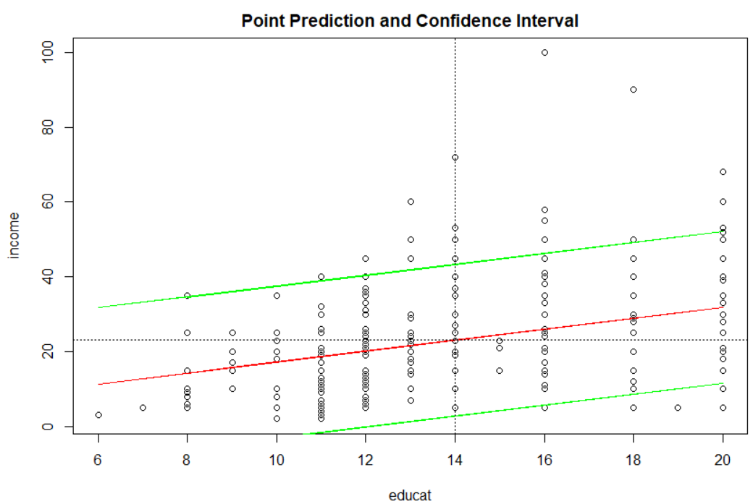

## Task 2. Univariate Variable Exploration and Transformations (3 points)

Use the **CPS1985** dataset in the library **AER** to explore the distribution of the respondents’ **wage**.   
Use the syntax **data(CPS1985, package="AER")** to read the dataframe.

Task 2.1: Find the best $λ^{best}$-value (see **summary(car::powerTransform(lm(*varName*~1)))**) for the Box-Cox transformation. Interpret the test whether the *log*-transformation (i.e., $λ=0.0$) instead of $λ^{best}$ could be used? Justify your answer. (1 point)

library(AER);library(car);library(e1071)data(CPS1985)summary(powerTransform(CPS1985$wage~1))bcPower Transformation to Normality  
Est Power Rounded Pwr Wald Lwr Bnd Wald Upr Bnd  
CPS1985$wage -0.0658 0 -0.1997 0.068Likelihood ratio test that transformation parameter is equal to 0  
(log transformation)  
LRT df pvalLR test, lambda = (0) 0.9245 1 0.33628Likelihood ratio test that no transformation is needed  
LRT df pvalLR test, lambda = (1) 232.5055 1 < 2.22e-16Comment: The estimated transformation power (𝜆 = -0.0658), which is very close to 0. The p-value of  
the likelihood ratio test (𝐻0: 𝜆 = 0 ) is larger than 0.05, so we fail to reject the null hypothesis. Instead of  
using (𝜆 = -0.0658), the log-transformation should be used in this case.

Task 2.2: For the untransformed ($λ=1)$, optimal ($λ=λ^{best}$) and over-adjusted ( $λ=-1)$ Box-Cox transformed **wage** variable repeat the following tasks and ***comparatively interpret*** the results. (2 points)

[a] Draw properly constructed histograms including a kernel density curve of all three transformed variables **wage**,

|  |  |  |  |
| --- | --- | --- | --- |
|  | $$λ=1$$ | $$λ^{best}=-0.0658$$ | $$λ=-1.51$$ |
| Histograms |  |  |  |
| Skewness | 1.687762 | 0.001027028 | -7.310307 |
| Shapiro test | > shapiro.test(wage) Shapiro-Wilk normality test data: wage W = 0.8673, p-value < 2.2e-16 | > shapiro.test(wage.bc) Shapiro-Wilk normality test data: wage.bc W = 0.98923, p-value = 0.000586 | > shapiro.test(wage.bc.over) Shapiro-Wilk normality test data: wage.bc.over W = 0.59422, p-value = 2.2e-16 |

[b] evaluate the sknewness (see **e1071::skewness( )**), and test whether the variables are approximately normal distributed (see **shapiro.test( )**).

[c] Address the questions: Which transformed variable comes closest to the normal distribution? Is the transformation with $λ=-1$ over-compensating the inherent positive skewness in the **wage** variable?

Comments: The untransformed **wage** variable has positive skewness with an outlier $44500. The  
optimal transformation makes the transformed distribution almost symmetric with a tiny skewness  
value. However, the positive skewness is over-compensated when using (𝜆 = -1.5). This leads to  
substantial negative skewness.  
The *p*-values of Shapiro-Wilk normality tests with 𝐻0: 𝑋~𝑁(𝜇̂, 𝜎̂2) for the properly Box-Cox transformed  
data is much smaller than 0.05, therefore transformed **wage** still deviates from the normal distribution.  
However, this *p*-value is the largest one among all three scenarios. Therefore, we can conclude the optimal transformed variable becomes closest to the normal distribution.

## Task 3: Calibration and Prediction of a Bivariate Regression Model with Skewed Variables (3 points)

The **Stata** file **HPRICE2.DTA** has among other variables the **price** (home price in neighborhoods) and **dist** (weighted distance from 5 major employment centers).

Note: To import **Stata** files use the  function **foreign::read.dta( )**.

Task 3.1: Plot **price** in dependence of **dist** including their box-plots along the margins. By visual inspection of the marginal box-plots and the loess curve is a data transformation advisable? (0. 5 points)

HPRICE2 <- foreign::read.dta('HPRICE2.DTA')

scatterplot(price ~ dist , data = HPRICE2,pch=1, smooth=list(span = 0.35,lty.smooth=1, col.smooth="red", col.var="red"),regLine=list(col="green"))

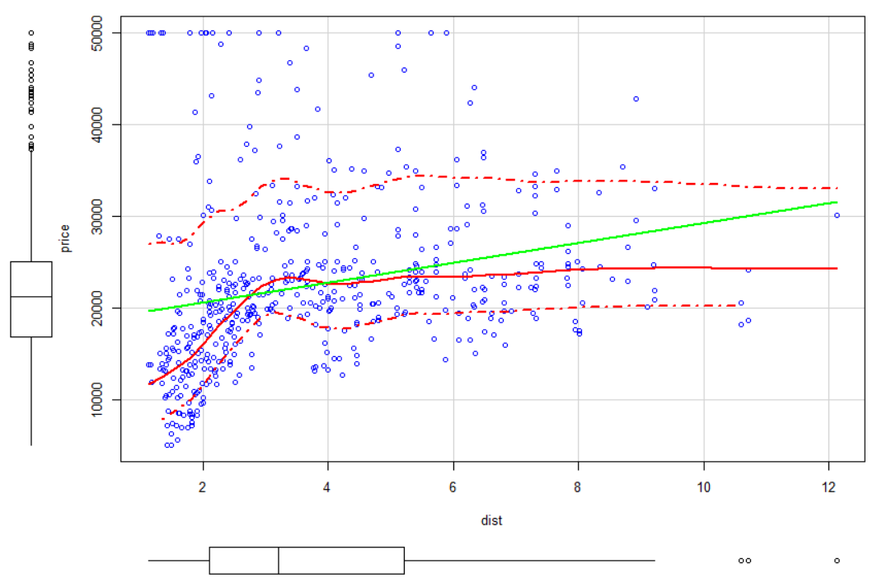

Comments: The dependent variable **dist** should be transformed because it is positively skewed. Furthermore, the residuals of the linear regression model are also positively skewed. To make sure the residuals satisfy the assumption of ordinary least squares, it is advisable that both variables are transformed.

Task 3.2: Find a proper transformation of both variables in a way that the independent variable **dist** is approximately symmetrically distributed and that the transformation of the dependent variable **price** leads to approximately symmetrically distributed regression residuals. (0.5 points)

## Transformation of independent variable

summary(powerTransform(lm(dist~1, data=HPRICE2)))

bcPower Transformation to Normality

Est Power Rounded Pwr Wald Lwr Bnd Wald Upr Bnd

Y1 -0.156 0 -0.3261 0.0141

Likelihood ratio test that transformation parameter is equal to 0

(log transformation)

LRT df pval

LR test, lambda = (0) 3.242834 1 0.071736

Likelihood ratio test that no transformation is needed

LRT df pval

LR test, lambda = (1) 179.0603 1 < 2.22e-16

## Transformation of dependent variable so residuals become approx. symmetric

summary(powerTransform((lm(price~log(dist), data=HPRICE2))))

bcPower Transformation to Normality

Est Power Rounded Pwr Wald Lwr Bnd Wald Upr Bnd

Y1 0.0692 0 -0.0822 0.2206

Likelihood ratio test that transformation parameter is equal to 0

(log transformation)

LRT df pval

LR test, lambda = (0) 0.8093437 1 0.36831

Likelihood ratio test that no transformation is needed

LRT df pval

LR test, lambda = (1) 127.4888 1 < 2.22e-16

The suggested lambda parameters are 𝜆 = -0.156 for the independent variable and 𝜆 = 0.0692 for the regression model lm(price~log(dist) so that the residuals are approximately normal or at least symmetrically distributed.

Task 3.3: Test whether a ***log***-transformation (i.e., $λ=0$) is appropriate for the dependent variable and the independent variable. If the ***log***-transformation is appropriate then ***use it*** because their relationship can be interpreted in terms of an elasticity. (0.5 points)

Comments: The likelihood ratio tests in task 3.2 suggests that the estimated lambda coefficients are not  
significantly different from zero. Therefore, both crime and police can be log-transformed

Task 3.4: Estimate the model in the transformed system and interpret the estimates. Also ***test*** if the elasticity (i.e., slope parameter) differs significantly from the neutral elasticity of 1, i.e., $H_{0}:β_{1}=1$. This could be done manually by using the $β_{1}$ standard error from the regression output. (1 point)

Task 3.5: Perform a prediction in the original data units and plot the ***median*** and ***expectation*** curves. Why is the expected predicted value in this case larger than the median predicted value? (0.5 points)