Sample Answer Lab 01:

**Handout date:** Wednesday, August 26, 2020

**Due date:** Wednesday, September 2, 2020 submitted as Word document to eLearning’s

Task 1: Equation Editor Exercise (1 pt)

Typeset the derivation of the definitional equation of the variance equation in line (1) from its computational counterpart in line (7). That is, your sequence of equations needs to be in the opposite order starting with equation (7) $s_{x}^{2}=\frac{1}{n-1}∙\left(\sum_{i=1}^{n}{x_{i}^{2}}-n∙{\overline{x}}^{2}\right) \text{with} \overline{x}=\frac{1}{n}∙\sum_{i=1}^{n}{x_{i}}$ and ending at equation (1)

Make sure that your equation formatting follows exactly the one given in the screen shot below. In particular, focus on [a] the change from the *italics* equation mode to the upright text mode now in your first equation, [b] proper nesting of the employed mathematical templates, [c] the alignment of all equation at the “ $=$”-sign, and [d] the use of underbraces $\underset{bottom}{\underbrace{top}}$ in equations (3) and (4). You do not need to replicate the *explanations* and *line numbers* in red. Deviations from the formatting in the screen shot below will lead to a loss of partial points.

$$S_{x}^{2}= \frac{1}{n-1}∙\sum_{i=1}^{n}{{\left(x_{i}-\overline{x}\right)}^{2} with }\overline{x}= \frac{1}{n}∙\sum_{i=1}^{n}{x_{i}} \\ =\frac{1}{n-1}∙\sum_{i=1}^{n}{\left(x_{i}^{2}-2∙x_{i}∙\overline{x}+{\overline{x}}^{2}\right) } \\ =\frac{1}{n-1}∙\sum_{i=1}^{n}{x_{i}^{2}- \frac{1}{n-1}∙ } \sum_{i=1}^{n}{2∙x_{i}∙\overline{x}+\frac{1}{n-1}∙ \underset{=n∙{\overline{x}}^{2}}{\underbrace{\sum_{i=1}^{n}{{\overline{x}}^{2}}}} } \\ =\frac{1}{n-1}∙\sum_{i=1}^{n}{x_{i}^{2}- \frac{1}{n-1}∙ }2∙\overline{x}∙\underset{=n∙{\overline{x}}^{2}}{\underbrace{\sum_{i=1}^{n}{x_{i}}}}+ \frac{n}{n-1}∙{\overline{x}}^{2} \\ = \frac{1}{n-1}∙\sum_{i=1}^{n}{x_{i}^{2}- \frac{n}{n-1}∙ 2∙{\overline{x}}^{2}}+\frac{n}{n-1}∙{\overline{x}}^{2} \\ = \frac{1}{n-1}∙\sum_{i=1}^{n}{x_{i}^{2}- \frac{n}{n-1}∙{\overline{x}}^{2}} \\ = \frac{1}{n-1}\left(\sum_{i=1}^{n}{x_{i}^{2}- n∙{\overline{x}}^{2}}\right)$$

# Task 2: Importing Data (0.5 pts)

Setup an  working directory and save the files **MyPower.RData** , **Concord1.sav** and **CPS1985.dbf**. into this directory.

1. Explore the **load( )** function and import **MyPower.RData** .

load('MyPower.RData')

1. Use a function from the library **foreign** to import **Concord1.sav** and save it under the name **Concord**.

library(foreign)

Concord <- read.spss('Concord1.sav')

1. Use a function from the library **foreign** to import **CPS1985.dbf** and save it under the name **CPS1985**.

CPS1985 <- read.dbf('CPS1985.dbf')

1. Explore the documentation of the data-frame **Mroz** in the library **carData** and link the data-frame to your  session with the **data( )** function.

library(carData)

data(Mroz)

1. To demonstrate that everything worked as intended show a screenshot of **Global Environment**, which displays all 4 data-frames.

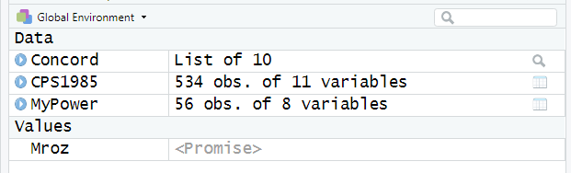

# Task 3: Data-frame Basics (1.5 pts)

1. For the data-frame **MyPower** calculate the average daily power consumption by using the variables **kWhBill** and **DaysBill** and add the new variable to the data-frame **MyPower** with the variable name **DailykWh**. Show your  code for this calculation. (0.2 pts)

MyPower$DailykWh <- MyPower$kWhBill / MyPower$DaysBill

1. Apply the statements   
    **MyPowerNames <- names(MyPower)⑴  
    length(MyPowerNames)⑵  
    MyPowerNames[4:6] ⑶**  
   What are these statements doing? (0.2 pts)

⑴ get columns’ name  
⑵ get the number of columns’ name

⑶ get the column name from 4th to 6th

1. Apply the statement **sapply(***data-frame***, is.factor)** on the data-frame **MyPower** to evaluate the which variables are factors. What is this statement doing? Show a copy of the Console with the output of this investigation. (0.1 pts)

sapply(MyPower, is.factor)

SeqID Year Month MinTemp AveTemp MaxTemp kWhBill DaysBill DailykWh

FALSE FALSE TRUE FALSE FALSE FALSE FALSE FALSE FALSE

C

1. Apply the **str( )** on the data-frame **MyPower**. What information about the data-frame does the **str( )** provide to you? (0.1 pts)

str(MyPower);

str() provides the internal structure of MyPower (shows the data type of each column)

1. What are the following statements doing? Show the plot and elaborate on the syntax of the statements. Is the power consumption over time decreasing? (0.3 pts)  
    **plot(DailykWh~SeqID, data=MyPower)  
    abline( lm(DailykWh~SeqID, data=MyPower) )**

Scatterplot the Daily KWH (as y) across seqID(as x), then add the fitted line from the linear regression to it. (it decreased)

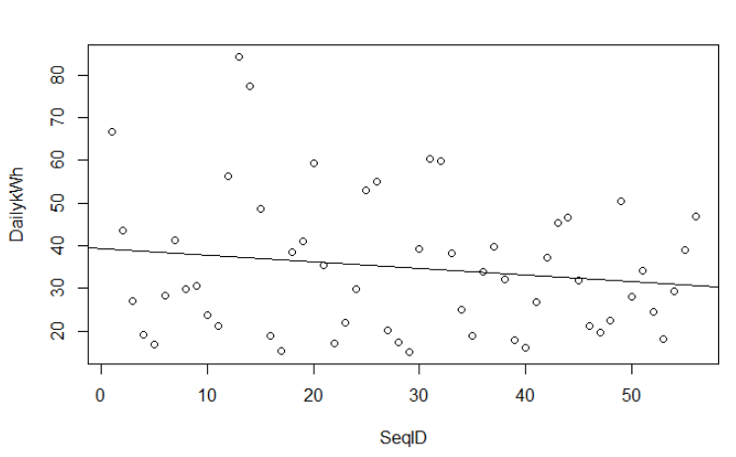

1. What is the following statement doing? Show the plot and elaborate on the syntax of the statements. Why does the power consumption fluctuate over the seasons? (0.2 pts)  
    **plot(DailykWh~Month, data=MyPower)**

Since we need heater in the winter and cooler in the summer.

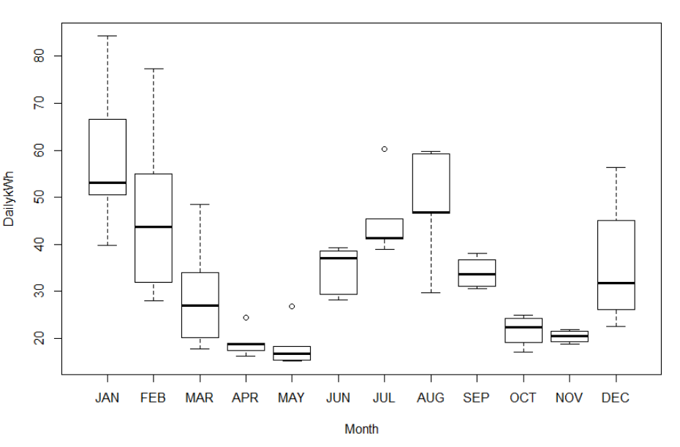

1. Use the syntax **MyPower[***rows***,** *cols***]** to select all records with the three variables **c("MinTemp","AveTemp","MaxTemp")** (alternatively you could use **MyPowerNames[4:6]**) in the month of **MyPower$Month=="JAN"**. Show the code and its output. (0.2 pts)

subset(MyPower[,4:6],MyPower$Month=="JAN")

1. Look and show at the header and the tail of the data-frame **MyPower** with the functions **head( )** and **tail( )**. (0.1 pts)

head(MyPower)

tail(MyPower)

1. What class is the output **MetricPower** of the operation below? (0.1 pts)  
   **MetricPower <- MyPower[ , c("MinTemp","AveTemp","MaxTemp", "DailykWh")**

Data frame

# Task 4: R Basics (1 pt)

1. Depending on the input object class type  functions behave differently. To see the different class-specific implementations of the generic **summary( )** function try the command **methods(summary)**.  
   Discuss the difference in the behavior of the **summary( )** function when applied to a **data.frame** or a **lm** object. (0.4 pts) (0.2 pts)
2. Data frame: get the statistical information(mean, quantile, NA…) about each column of a data frame
3. Linear model: get the statistical information (residuals, coefficients, R-squared….) about this linear model
4. Explore the online help for  
    **?summary.lm  
    ?summary.data.frame**and discuss the optional parameters (0.2 pts)

?summary.lm

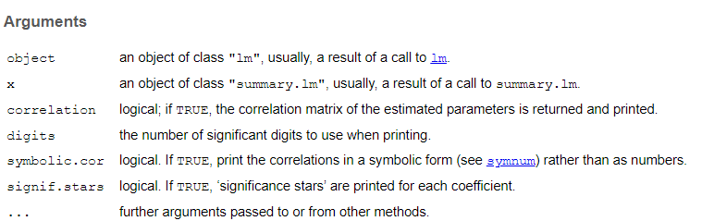

?summary.data.frame

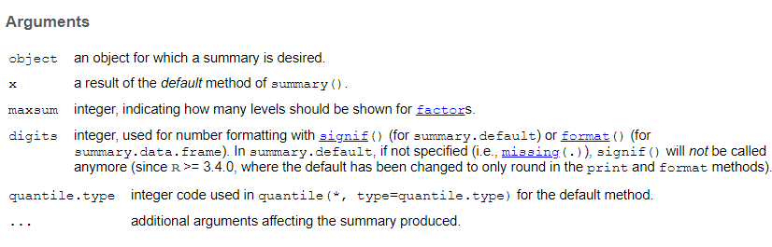

1. What are the following statements below doing when processing the vector x of length 6? (0.3 pts)  
    **x <- c(1,3,5,7,9,NA)**  
    **x * 2; x + 2 (1)**  
    **y <- seq(0,2, by=1); x * y (2)**  
    **z <- rep(c(1,2),3); x * z (3)**

(1) Scalar multiplication: x[i] * 2 or x[i] + 2 (i from 1 to 6)

(2) extended multiplication extends y to the same length with x by repeating, then y[i] * x[i] (i from 1 to 6)

(3) element-wise multiplication: z[i] * x[i] (i from 1 to 6)Note, the semicolon **;** allows to place several independent  commands into one line. Look the online help up for the functions **seq( )** and **rep( )**.

1. Define the function **myMean( )** and apply it on **x**  
    **myMean <- function(x){  
    x <- na.omit(x)  
    sum(x)/length(x)  
    }  
    myMean(x)**Compare its output to that of the standard  function **base::mean( )**. Look up the help for the functions **na.omit( )** and **mean( )**. (0.2 pts)

myMean(x) mean(x) mean(na.omit(x))

5 NA 5

1. How does the statement **x[c(T,T,T,T,T,F)]** work? (0.1 pts)

Get rid of the last element(T stands for True and F stands for False)