Lab10: Estimation and Confidence Intervals

**Handout date:** Wednesday, November 4, 2020

**Due date:** Friday, November 13, 2020 by midnight in the **SubmitLab10** link of eLearning.

*This lab counts 4 % toward your total grade*

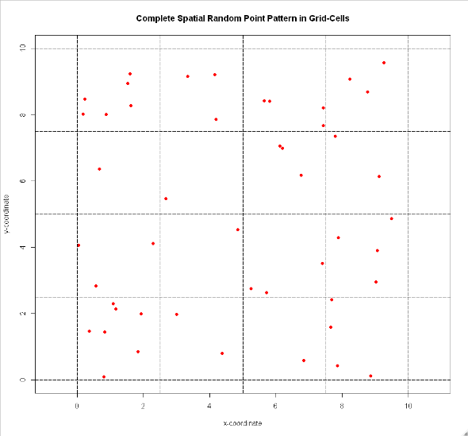

**Task 1:** Study example 14-1 on pages 539-540 in BBR (0.5 points). Based on the observed spatial point pattern in Figure 1: For each grid cell count the number of observed points.

[b] Estimate the ***mean*** number of points per grid cell (i.e., the average intensity). (0.25 points)

[c] Estimate the ***variance*** based on the observed number of the points per grid cell. (0.25 points)

Figure : Random Point Pattern

**Task 2:** Confidence intervals (0.75 points)

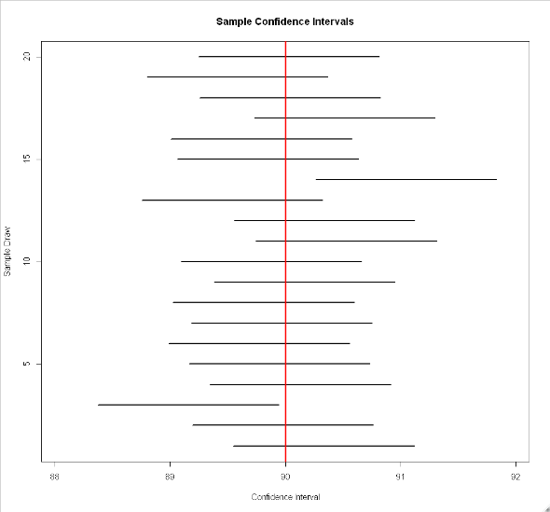[a] Show how a confidence interval around an unknown population expectation $μ$ for an observed sample mean $\overline{x}=100$ based on $n=100$ sample observations from a normal distributed population with a standard deviation of $σ=4$ at a given confidence level of 95% (or $α=0.05$) is calculate? Use the equation editor. (0.25 points)

[b] A set of 20 confidence intervals from 20 samples of size $n=100$ with a population distribution of $X\sim N(μ=90,σ^{2}=16)$ has been calculated with an error probability of $α=0.1$. How many confidence intervals do you expect to ***not*** cover the population expectation $μ=90$ and ***explain*** why? (0.25 points)

[c] Does your sample from task 2 [a] support the assumption with 95 % probability that it was drawn from a population with $\sim N(μ=90,σ^{2}=16)$? (0.25 points)

Figure : Confidence Intervals

**Task 3:** A sample has been drawn from a normal distributed population. The estimated population mean is $\overline{x}=8$ and the ***a priori known*** population variance is $σ^{2}=16$. (1 point)

Calculate the $1-α$ confidence intervals based on the parameters given in the table below. Insert the confidence intervals into the table below.

|  |  |  |
| --- | --- | --- |
|  | $$α=0.10$$ | $$α=0.01$$ |
| $$n=16$$ |  |  |
| $$n=64$$ |  |  |

**Task 4:** What trend with regards to the width of confidence intervals do you observe for decreasing error probabilities? (0.25 points)

**Task 5:** What trend with regards to the width of confidence intervals do you observe for increasing sample sizes $n$? (0.25 points)

**Task 6:** You need to sample from a binomial distributed population to estimate the underlying population success probability $π$. You would like to be 95% confident that your estimation error is not larger than 0.1. How large does your sample need to be? Show your calculations typeset in a professional way. (0.25 points)

**Task 7:** The  script **BinomToNorm.r** plots the distribution of binomially distributed random counts $X$ given the number of trials $n$ and probability of success $π$. The density of normal distribution with an expectation $E\left[X\right]=n∙π$ and a variance $V\left[X\right]=π∙\left(1-π\right)∙n$ is superimposed onto the binomial distribution to visually compare whether it is approximately normal distributed. (0.6 points)

[a] Describe the shape of the binomial distribution for $n=50$ (line 3) and $π=0.15$ (line 4) and show the plot. Pay attention to the value range shown in the plot. (0.2 points)

[b] Increase the number of trials $n$ to 1,000 (line 3) for an underlying probability of success $π=0.15$ (line 4) and plot it. (0.2 points)

[c] ***In your judgment***, did binomial distribution sufficiently approach the normal distribution for the increased sample size? Perhaps argue in terms of the skewness (line 7) of both distributions. (0.2 points)

**Task 8:** Discuss the confidence intervals of the calculated regression parameter (0.4 points).

Use the model:

**data(Cars93, package="MASS")**

**Cars93$MPG <- 0.7*Cars93$MPG.city+0.3*Cars93$MPG.highway**

**lm.cars <- lm(MPG~Fuel.tank.capacity+Weight+Passengers, data=Cars93)**

**summary(lm.cars)**

[a] Evaluate the confidence intervals at a confidence level of 0.95 ($α=0.05$).

[b] Evaluate the confidence intervals at a confidence level of 0.99 ($α=0.01$).

Why does the interpretation for the regression coefficient of the variable **Fuel.tank.capacity** change?