## Stratified Sampling

* Stratified sampling is a type of sampling method in which the total population is divided into smaller groups or strata to complete the sampling process.
* The strata is formed based on some common characteristics in the population data.
* After dividing the population into strata, the researcher randomly selects the sample proportionally.

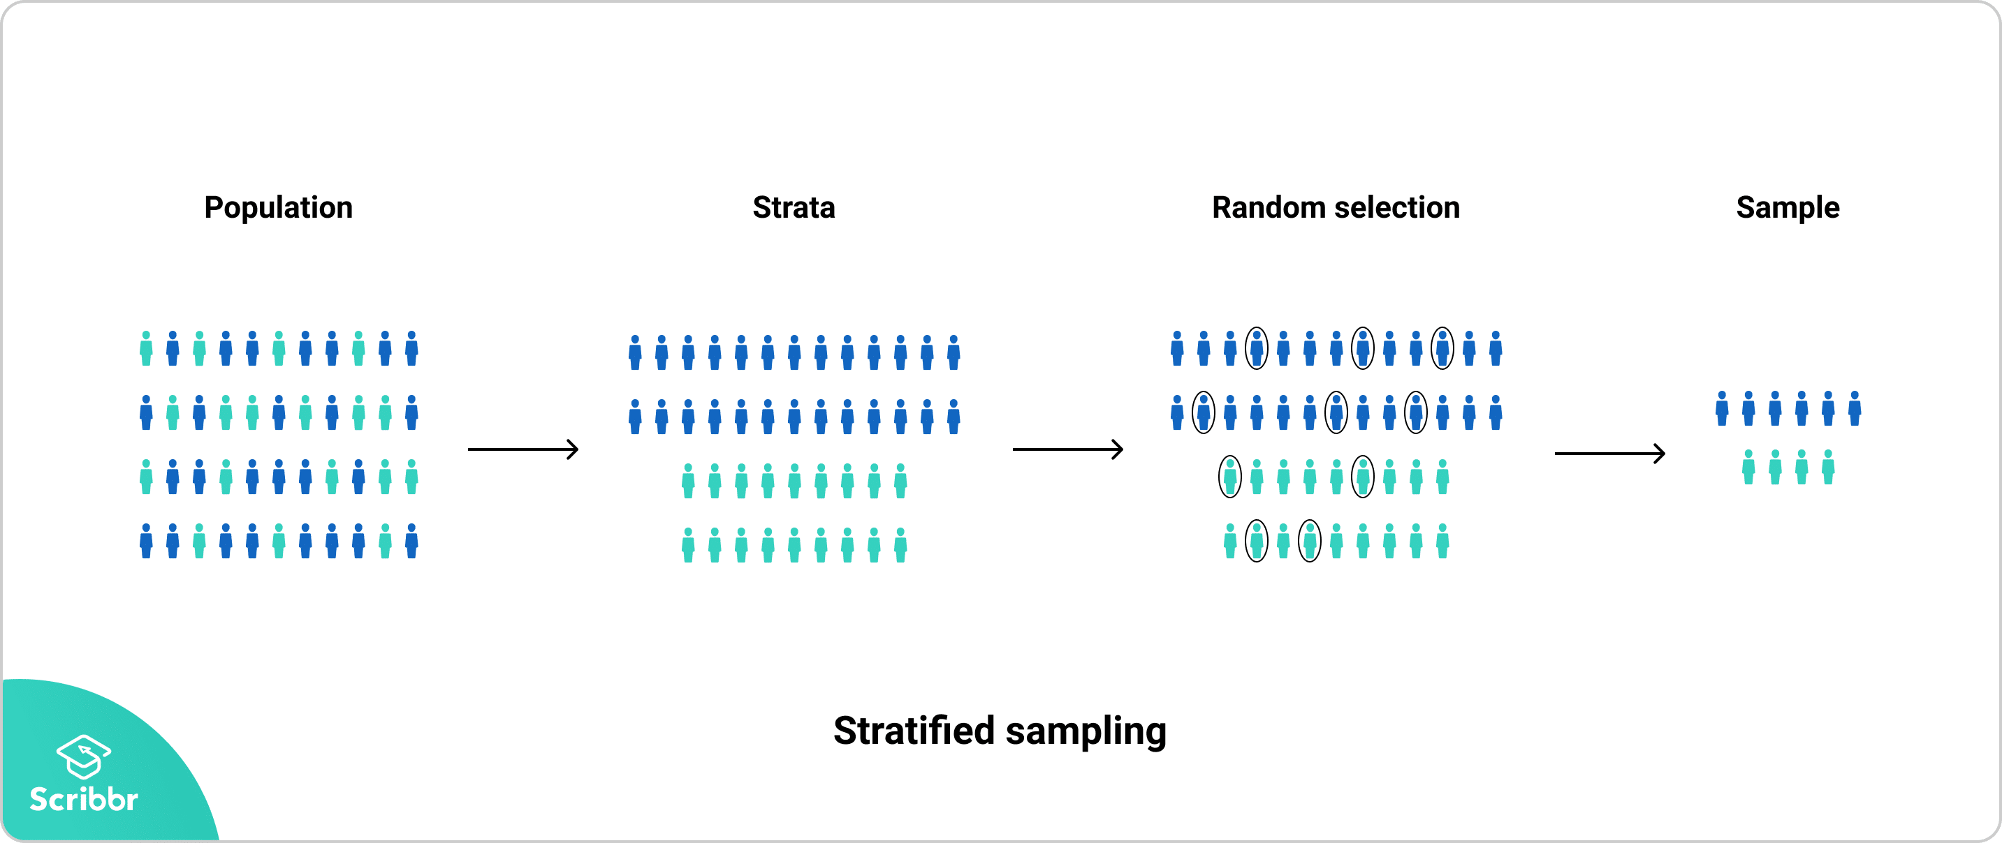

### When to use it

* Ensuring the diversity of your sample
* Ensuring similar variance
* Lowering the overall variance in the population
* Allowing for a variety of data collection methods

### Error estimation

* The normal distribution often describes the actual distribution of the random errors in real-world processes reasonably well