# Sample Answer Lab02: Multiple Regression Analysis, Factors and Interaction Effects

**Handed out:** Monday, March 1, 2021

**Return date:** Friday, March 12, 2021, at eLearning’s **Lab02Submit** link.

**Grading:** This lab counts 13 % towards your final grade

## Task 1. Partial Regression Coefficient [3 points]

Use the **Concord1.sav** file for this task. You will demonstrate that in multiple regression the partial effect of an independent variable is free from any linear effects of the remaining independent variables in a regression model.

**Task 1.1:** Run the multiple model **water81~income+water80+educat** and *interpret* its regression coefficients. [0.5 points]

model.1 <- lm(water81~income+water80+educat,data = concord)

summary(model.1)

Coefficients:

Estimate Std. Error t value Pr(>|t|)

(Intercept) 811.18243 196.29879 4.132 4.22e-05 ***

income 24.71652 3.54917 6.964 1.06e-11 ***

water80 0.59130 0.02477 23.872 < 2e-16 ***

educat -49.88881 14.18671 -3.517 0.000478 ***

---

Signif. codes: 0 ‘***’ 0.001 ‘**’ 0.01 ‘*’ 0.05 ‘.’ 0.1 ‘ ’ 1

Residual standard error: 914.9 on 492 degrees of freedom

Multiple R-squared: 0.6233, Adjusted R-squared: 0.621

F-statistic: 271.3 on 3 and 492 DF, p-value: < 2.2e-16

Comment: The intercept and all regression coefficients are significant in this model. **Income** and **water80** have positive effects on **water81**, however **educat** has a negative influence on **water81**. When income increases one thousand dollars, the **water81** consumption increases 24.7 $ft^{3}$ units because affluent people have more money to support high water consumption. When **water80** increases one $ft^{3}$, **water81** increases by **0.59 $ft^{3}$** . In other words, water consumption in 1981 is positively correlated the water consumption in the previous year. The water consumption in the previous year can be considered as the baseline demand not captured by the other variable in the model. Higher educated people tend to consume less water because they are concerned with saving water either because of environmental considerations or because they are better informed about saving water and, therefore, reduce their water bills. Thus, if the household head has one more year of education, the water consumption in 1981 decreases 49.9 $ft^{3}$, Overall, 62% of the variation in **water81** is explained by the independent variables.

**Task 1.2:** Calculate the residuals of the two models [a] **water81~income+water80** and [b] **educat~income+water80**. *What are these residuals specifically measuring*? [1 point]

[a] **water81~income+water80**

lm2 <- lm(water81~income+water80, data=concord)

summary(lm2)

Call:

lm(formula = water81 ~ income + water80, data = concord)

Residuals:

Min 1Q Median 3Q Max

-4861.1 -439.5 -67.5 382.5 4984.0

Coefficients:

Estimate Std. Error t value Pr(>|t|)

(Intercept) 203.82169 94.36129 2.160 0.0313 *

**income 20.54504 3.38341 6.072 2.52e-09 \*\*\***

water80 0.59313 0.02505 23.679 < 2e-16 ***

---

Signif. codes: 0 ‘***’ 0.001 ‘**’ 0.01 ‘*’ 0.05 ‘.’ 0.1 ‘ ’ 1

Residual standard error: 925.4 on 493 degrees of freedom

Multiple R-squared: 0.6138, Adjusted R-squared: 0.6122

F-statistic: 391.8 on 2 and 493 DF, p-value: < 2.2e-16

[b] **educat~income+water80**

lm3 <- lm(educat~income+water80, data=concord)

summary(lm3)

Call:

lm(formula = educat ~ income + water80, data = concord)

Residuals:

Min 1Q Median 3Q Max

-7.0278 -1.9509 -0.5896 1.7503 7.4588

Coefficients:

Estimate Std. Error t value Pr(>|t|)

(Intercept) 1.217e+01 2.962e-01 41.106 < 2e-16 ***

**income 8.362e-02 1.062e-02 7.874 2.21e-14 \*\*\***

water80 -3.654e-05 7.862e-05 -0.465 0.642

---

Signif. codes: 0 ‘***’ 0.001 ‘**’ 0.01 ‘*’ 0.05 ‘.’ 0.1 ‘ ’ 1

Residual standard error: 2.905 on 493 degrees of freedom

Multiple R-squared: 0.1203, Adjusted R-squared: 0.1167

F-statistic: 33.7 on 2 and 493 DF, p-value: 1.911e-14

Comment: Residuals of model [a] and model [b] measure the unexplained variations of **water81** and **educat**, respectively, after controlling for the influence from **income** and **water80**. We can observe the regression coefficients of income have significant positive effects in both the model [a] and the model [b]. This positive ***confounding correlation*** between **educat** and **income** causes **educat** in a bivariate model having a positive effect on **water81** compared to the multiple model. To solve this problem, we need to control for the effect of the confounding variable **income** to get the pure negative effect of **educat**

**Task 1.3:** Generate the partial regression leverage scatterplot of the water residuals against the education residuals. Make sure to use properly labeled axes. *Briefly interpret the scatterplot*. [0.5 points]

library(car)

scatterplot(resid(lm2)~resid(lm3), xlab="Education Residuals",

ylab="Water Residuals", main="Partial Regression Leverage Scatterplot",

pch=1, smooth=list(span = 0.35,lty.smooth=1, col.smooth="red", col.var="red"),regLine=list(col="green"))

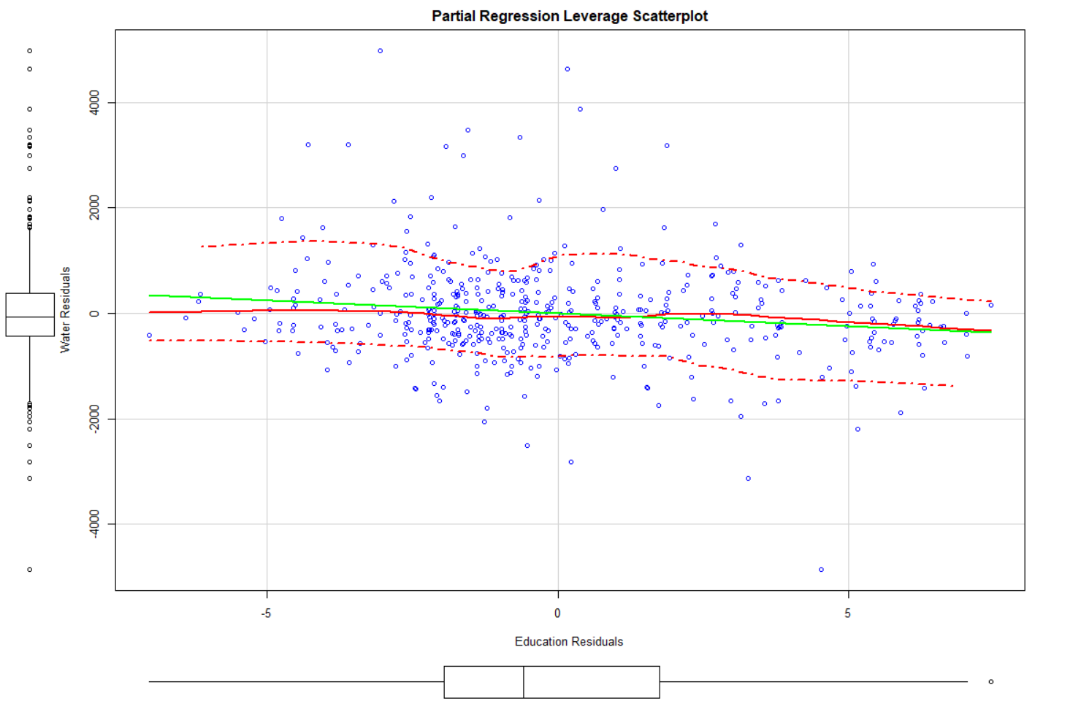

Comment: The water residuals and education residuals have a negative relationship. When education residuals increase, the water residuals decrease.

**Task 1.4:** Estimate a regression model of the *water residuals* on the *education residuals* and *compare* its estimate slope coefficient against the slope coefficient for **educat** of the multiple model from task 1.1. *Why are you allowed to suppress the intercept in this model*? [1 point]

lm4 <- lm(resid(lm2)~resid(lm3))

summary(lm4)

Call:

lm(formula = resid(lm2) ~ resid(lm3))

Residuals:

Min 1Q Median 3Q Max

-4635.2 -473.4 -65.0 405.6 4831.1

Coefficients:

Estimate Std. Error t value Pr(>|t|)

(Intercept) -1.757e-14 4.100e+01 0.000 **1.000000**

resid(lm3) **-4.989e+01** 1.416e+01 -3.524 0.000465 ***

---

Signif. codes: 0 ‘***’ 0.001 ‘**’ 0.01 ‘*’ 0.05 ‘.’ 0.1 ‘ ’ 1

Residual standard error: 913.1 on 494 degrees of freedom

Multiple R-squared: 0.02452, Adjusted R-squared: 0.02254

F-statistic: 12.42 on 1 and 494 DF, p-value: 0.0004651

Comment: The estimate slope coefficient in this model and the slope coefficient for **educat** of the multiple model from task 1.1 are identical because both models control the confounding effect of **income**. The intercept can be suppressed **because the mean of both residual vectors is zero**, i.e., they are centered around zero. Therefore, the origin point **(0,0)** is on the regression line.

## Task 2: A Multiple Regression Model with Factors and Partial *F*-test [7 points]

**Task 2.1:** Use common sense arguments ***how*** these four metric variables will influence the provincial fertility rates. Use one or two sentences per explanation, and formulate preferably *one* sided null and alternative hypotheses based on your explanation. The statistical hypotheses should be *type-set* properly, for instance, as $H_{0}:β_{VarXYZ}≤0$ against $H_{1}:β_{VarXYZ}>0$. Format everything in the table shown below. [1 point]

|  |  |  |
| --- | --- | --- |
| Variable | Common Sense Arguments | Statistical Hypotheses |
| ILLITERRAT | A higher illiteracy rate leads to higher fertility rate due to lack of education. | $$H_{0}:β≤0 \\ H_{1}:β>0$$ |
| FEMMARAGE | The latter a woman marries the lower will be her likelihood to have many children. | $$H_{0}:β≥0 \\ H_{1}:β<0$$ |
| DIVORCERAT | A higher divorce rate leads to lower chance of having many children. | $$H_{0}:β≥0 \\ H_{1}:β<0$$ |
| TELEPERFAM | An increased number of televisions will lead to more distractions and decreased fertility rate. | $$H_{0}:β≥0 \\ H_{1}:β<0$$ |

**Task 2.2:** Generate a scatterplot matrix showing the dependent variable and the four metric independent variables. Also generate a boxplot of the fertility rate against the regions. *Briefly interpret the scatterplot matrix.* [1 point]

provItaly <- foreign::read.dbf("provinces.dbf")

car::scatterplotMatrix(~TOTFERTRAT+ILLITERRAT+FEMMARAGE+DIVORCERAT+TELEPERFAM, data=provItaly,

main="Relationship between total fertility rate and a set of exogenous variables",

pch=1, smooth=list(span = 0.35,lty.smooth=1, col.smooth="red", col.var="red"),

regLine=list(col="green"))

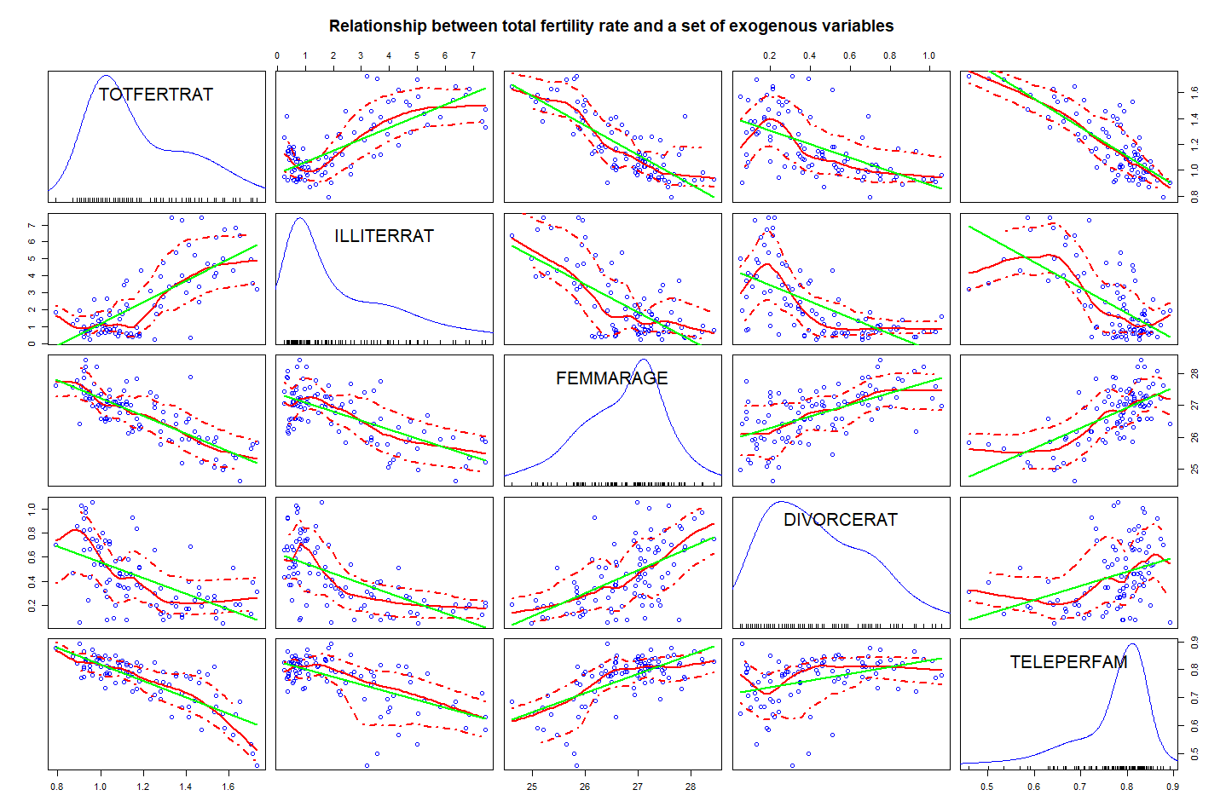

Comment:

[a] Distributional characteristics: The distributions of the dependent variable and the four independent variables are unimodal. **TOTFERTRAT**, **DIVORCERAT**, and **ILLITERRAT** are positively skewed, and **FEMMARAGE** and **TELEPERFAM** are negatively skewed.

[b] Y-X relationships: **FEMMARAGE**, **DIVORCERAT**, and **TELEPERFAM** have strong negative effects on **TOTFERTRAT**. However, **ILLITERRAT** has a positive relationship with **TOTFERTRAT**.

[c] Positive X-X relationships: **FEMMARAGE-DIVORCERAT**, **FEMMARAGE-TELEPERFAM**, and **DIVORCERAT-TELEPERFAM** have positive relationships.

[d] Negative X-X relationships: **FEMMARAGE-ILLITERRAT**, **DIVORCERAT-ILLITERRAT**, and **ILLITERRAT-TELEPERFAM** have negative relationships.

**Task 2.3:** Run a base model multiple regression with the four metric variables to explain the variation of the fertility rates. Interpret this model [a] in the light of your earlier stated hypotheses in task 2.1, [b] the significances of the estimate regression coefficients and [c] the goodness of fit. [1 point]

lm1<- lm(TOTFERTRAT~ ILLITERRAT+ FEMMARAGE+ DIVORCERAT+ TELEPERFAM, data=provItaly)

summary(lm1)

Call:

lm(formula = TOTFERTRAT ~ ILLITERRAT + FEMMARAGE + DIVORCERAT +

TELEPERFAM, data = provItaly)

Residuals:

Min 1Q Median 3Q Max

-0.21906 -0.06267 -0.00966 0.05425 0.41272

Coefficients:

Estimate Std. Error t value Pr(>|t|)

(Intercept) 4.496337 0.513726 8.752 1.13e-13 ***

ILLITERRAT 0.020377 0.008735 2.333 0.0219 *

FEMMARAGE -0.088837 0.020771 -4.277 4.71e-05 ***

DIVORCERAT -0.112265 0.055648 -2.017 0.0466 *

TELEPERFAM -1.226364 0.183037 -6.700 1.76e-09 ***

---

Signif. codes: 0 ‘***’ 0.001 ‘**’ 0.01 ‘*’ 0.05 ‘.’ 0.1 ‘ ’ 1

Residual standard error: 0.1035 on 90 degrees of freedom

Multiple R-squared: 0.8096, Adjusted R-squared: **0.8012**

F-statistic: 95.69 on 4 and 90 DF, p-value: < 2.2e-16

Comment: All independent variables exhibit a relationship with the dependent variable as stated by the one-sided alternative hypotheses in task 2.1.All regression coefficients are significantly different from zero at an error probability of $α=0.05$. Since the reported error probabilities are associated with two-sided tests; for one-sided tests they need to be divided by 2.The overall goodness of fit of this model is high $R_{adj}^{2}=0.8012$

**Task 2.4:** Calculate the standardized *beta-coefficients* for the multiple model in task 2.3. Rank the independent variables *according to the absolute strength* *of their effects* on the fertility rates and plot the beta coefficients with the **coefplot( )** function. Use proper options for the **coefplot( )** function. [1 point]

prov <- foreign::read.dbf("provinces.dbf")

prov <- prov[,13:17]

prov <- as.data.frame(scale(prov))

beta.lm <- lm(TOTFERTRAT~., data=prov)

summary(beta.lm)

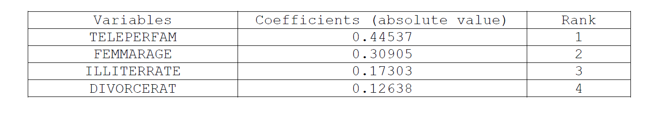

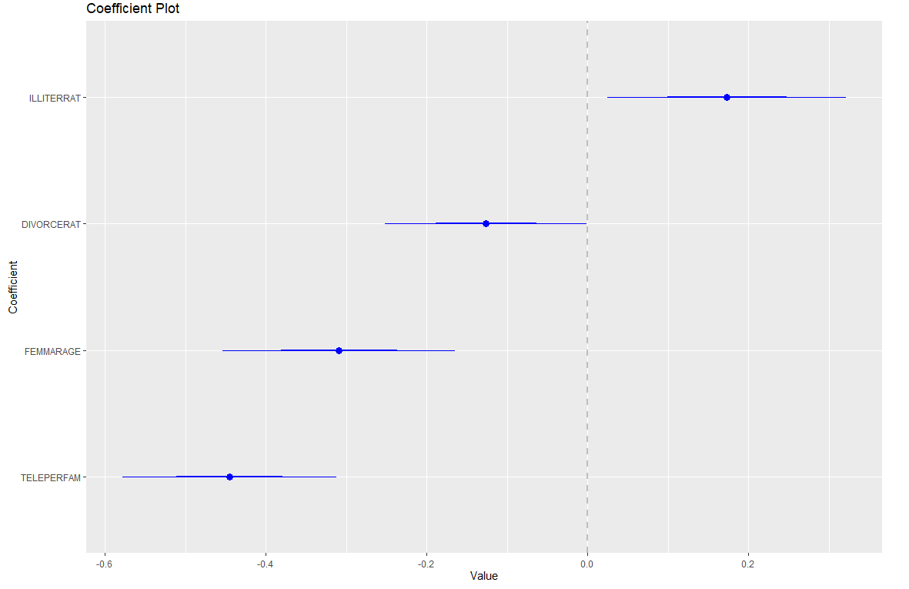

Comment: The influence strengths of the independent variables on the variation of the dependent variable are: **DIVORCERAT < ILLITERRAT < FEMMARAGE < TELEPERFAM**.

**Task 2.5:** Run five separate regressions on the [a] independent variables as well as [b] the dependent fertility rate using the factor **REGION** as independent variable.   
Does the **REGION** factor *explain variation* of the four independent variables as well as the fertility rate, i.e., what are the factor’s $R^{2}$’s? [1 point]

Hint: To calibrate all five models with one function call you can use the regression formula syntax **cbind(TOTFERTRAT,ILLITERRAT,FEMMARAGE,DIVORCERAT,TELEPERFAM)~REGION**.  
The **summary** function gives you the results for all five models.

lm2 <-lm(cbind(TOTFERTRAT,ILLITERRAT,FEMMARAGE,DIVORCERAT,TELEPERFAM)~REGION,data=provItaly)

summary(lm2)

**Response TOTFERTRAT :**

Call:

lm(formula = TOTFERTRAT ~ REGION, data = provItaly)

Residuals:

Min 1Q Median 3Q Max

-0.23300 -0.09275 -0.01300 0.07167 0.36333

Coefficients:

Estimate Std. Error t value Pr(>|t|)

(Intercept) 1.02300 0.02205 46.405 <2e-16 ***

REGIONNorth 0.03367 0.03118 1.080 0.283

REGIONSardinia 0.09950 0.06427 1.548 0.125

REGIONSicily 0.53700 0.04589 11.702 <2e-16 ***

REGIONSouth 0.39473 0.03389 11.647 <2e-16 ***

---

Signif. codes: 0 ‘***’ 0.001 ‘**’ 0.01 ‘*’ 0.05 ‘.’ 0.1 ‘ ’ 1

Residual standard error: 0.1207 on 90 degrees of freedom

**Multiple R-squared: 0.7409**, Adjusted R-squared: 0.7294

F-statistic: 64.34 on 4 and 90 DF, p-value: < 2.2e-16

**Response ILLITERRAT :**

Call:

lm(formula = ILLITERRAT ~ REGION, data = provItaly)

Residuals:

Min 1Q Median 3Q Max

-2.82455 -0.50394 -0.07267 0.34756 2.83545

Coefficients:

Estimate Std. Error t value Pr(>|t|)

(Intercept) 1.4157 0.1844 7.676 1.89e-11 ***

REGIONNorth -0.7630 0.2608 -2.925 0.00435 **

REGIONSardinia 1.8068 0.5377 3.360 0.00114 **

REGIONSicily 3.2466 0.3839 8.457 4.64e-13 ***

REGIONSouth 3.1689 0.2835 11.176 < 2e-16 ***

---

Signif. codes: 0 ‘***’ 0.001 ‘**’ 0.01 ‘*’ 0.05 ‘.’ 0.1 ‘ ’ 1

Residual standard error: 1.01 on 90 degrees of freedom

**Multiple R-squared: 0.7485**, Adjusted R-squared: 0.7373

F-statistic: 66.97 on 4 and 90 DF, p-value: < 2.2e-16

**Response FEMMARAGE :**

Call:

lm(formula = FEMMARAGE ~ REGION, data = provItaly)

Residuals:

Min 1Q Median 3Q Max

-0.96636 -0.31017 -0.04033 0.29057 1.21000

Coefficients:

Estimate Std. Error t value Pr(>|t|)

(Intercept) 27.25033 0.09179 296.888 < 2e-16 ***

REGIONNorth -0.27333 0.12981 -2.106 0.038 *

REGIONSardinia 0.18217 0.26760 0.681 0.498

REGIONSicily -1.88033 0.19107 -9.841 6.11e-16 ***

REGIONSouth -1.19397 0.14111 -8.461 4.54e-13 ***

---

Signif. codes: 0 ‘***’ 0.001 ‘**’ 0.01 ‘*’ 0.05 ‘.’ 0.1 ‘ ’ 1

Residual standard error: 0.5027 on 90 degrees of freedom

**Multiple R-squared: 0.6288**, Adjusted R-squared: 0.6124

F-statistic: 38.12 on 4 and 90 DF, p-value: < 2.2e-16

**Response DIVORCERAT :**

Call:

lm(formula = DIVORCERAT ~ REGION, data = provItaly)

Residuals:

Min 1Q Median 3Q Max

-0.51233 -0.10767 -0.01267 0.13591 0.46767

Coefficients:

Estimate Std. Error t value Pr(>|t|)

(Intercept) 0.59233 0.03703 15.994 < 2e-16 ***

REGIONNorth -0.04967 0.05237 -0.948 0.346

REGIONSardinia -0.36733 0.10797 -3.402 0.001 ***

REGIONSicily -0.34789 0.07709 -4.513 1.93e-05 ***

REGIONSouth -0.38324 0.05694 -6.731 1.53e-09 ***

---

Signif. codes: 0 ‘***’ 0.001 ‘**’ 0.01 ‘*’ 0.05 ‘.’ 0.1 ‘ ’ 1

Residual standard error: 0.2028 on 90 degrees of freedom

**Multiple R-squared: 0.423**, Adjusted R-squared: 0.3973

F-statistic: 16.49 on 4 and 90 DF, p-value: 3.596e-10

**Response TELEPERFAM :**

Call:

lm(formula = TELEPERFAM ~ REGION, data = provItaly)

Residuals:

Min 1Q Median 3Q Max

-0.247360 -0.025351 0.008611 0.033786 0.106420

Coefficients:

Estimate Std. Error t value Pr(>|t|)

(Intercept) 0.812704 0.010775 75.422 < 2e-16 ***

REGIONNorth -0.006805 0.015239 -0.447 0.656

REGIONSardinia -0.049512 0.031416 -1.576 0.119

REGIONSicily -0.180715 0.022431 -8.057 3.12e-12 ***

REGIONSouth -0.106844 0.016566 -6.449 5.48e-09 ***

---

Signif. codes: 0 ‘***’ 0.001 ‘**’ 0.01 ‘*’ 0.05 ‘.’ 0.1 ‘ ’ 1

Residual standard error: 0.05902 on 90 degrees of freedom

**Multiple R-squared: 0.5306,** Adjusted R-squared: 0.5098

F-statistic: 25.43 on 4 and 90 DF, p-value: 4.118e-14

Comment: **Region** is a significant variable in all five models. It can explain the 42.3% variation of **DIVORCERAT**, 74.85% variation of **ILLITERRAT**, 62.88% variation of **FEMMARAGE**, 53.06% variation of **TELEPERFAM**, and 74.09% variation of **TOTFERTRAT**. In other words, **Region** is highly correlated with the dependent variable and all four independent variables.

**Task 2.6:** Run the multiple regression model with the four metric variables plus the **REGION** factor to explain the variation of the fertility rates.   
*Speculate* in an informed way why some independent metric variables are no longer significant? [1 point]

lm3 <- lm(TOTFERTRAT~FEMMARAGE+DIVORCERAT+ILLITERRAT+TELEPERFAM+REGION,data=provItaly)

summary(lm3)

Call:

lm(formula = TOTFERTRAT ~ FEMMARAGE + DIVORCERAT + ILLITERRAT +

TELEPERFAM + REGION, data = provItaly)

Residuals:

Min 1Q Median 3Q Max

-0.17487 -0.06724 0.00231 0.04516 0.39168

Coefficients:

Estimate Std. Error t value Pr(>|t|)

(Intercept) 3.538560 0.609124 5.809 1.03e-07 ***

FEMMARAGE -0.060186 0.023278 -2.585 0.011409 *

DIVORCERAT -0.086453 0.055473 -1.558 0.122795

ILLITERRAT -0.001634 0.010915 -0.150 0.881362

TELEPERFAM -1.011377 0.182312 -5.547 3.14e-07 ***

REGIONNorth 0.004793 0.027447 0.175 0.861794

REGIONSardinia 0.031584 0.059267 0.533 0.595473

REGIONSicily 0.216287 0.060134 3.597 0.000537 ***

REGIONSouth 0.186853 0.046051 4.057 0.000109 ***

---

Signif. codes: 0 ‘***’ 0.001 ‘**’ 0.01 ‘*’ 0.05 ‘.’ 0.1 ‘ ’ 1

Residual standard error: 0.09589 on 86 degrees of freedom

**Multiple R-squared: 0.8438**, Adjusted R-squared: 0.8293

F-statistic: 58.09 on 8 and 86 DF, p-value: < 2.2e-16

**DIVORCERAT**, **ILLITERRAT**, and **TELEPERFAM** are no longer significant in this model. And the significance of **FEMMARAGE** also decreases dramatically. This drop in the significance is induced by the high correlation of these variables with the factor **REGION** which now also captures most of the variability in the dependent variable **TOTFERTRAT**. A high degree of multicollineary is present in the independent variables.

**Task 2.7:** Use a partial *F*-test to check whether the model in task 2.6 has improved the model fit of the base model in task 2.3 significantly. [1 point]   
That is, test the null hypothesis: $H_{0}:β_{Region 1}=β_{Region 2}=…=β_{Region J}=0$ against the alternative hypothesis is $H_{0}:β_{Region j}≠0$*for at least one $j∈\left\{1,2,…,J\right\}$* .

anova(lm3, lm1)

Analysis of Variance Table

Model 1: TOTFERTRAT ~ FEMMARAGE + DIVORCERAT + ILLITERRAT + TELEPERFAM +

REGION

Model 2: TOTFERTRAT ~ ILLITERRAT + FEMMARAGE + DIVORCERAT + TELEPERFAM

Res.Df RSS Df Sum of Sq F Pr(>F)

1 86 0.79079

2 90 0.96406 -4 -0.17327 4.7107 0.001743 **

---

Signif. codes: 0 ‘***’ 0.001 ‘**’ 0.01 ‘*’ 0.05 ‘.’ 0.1 ‘ ’ 1

The p-value (0.001743) is substantially smaller than 0.05, thus the null hypothesis can be rejected. We can conclude that the effect of the factor **REGION** is a significantly different from zero and the model in task 2.6 has improved the model fit of the base model in task 2.3 significantly.

## Task 3. Identification of the Underlying Model Structure [3 points]

Use the workspace **ModelSpecs.RData** for this task. It contains the six data-frames **mod1** to **mod6**. Each data-frame is comprised of three variables: **y** for the dependent variables, **g** for a binary ***factor***, and **x** for a ***metric*** variable. Each of these data-frames is best ***statistically*** described by one of these competing models:

|  |  |
| --- | --- |
| Name | Models Structure |
| Full interaction model | **lm(y~g+x+g:x, data=mod?) $⇔$ lm(y~g*x, data=mod?)** |
| Intercept model | **lm(y~g+x, data=mod?)** |
| Slope model | **lm(y~g:x, data=mod?)** |
| Means model | **lm(y~g, data=mod?)** |
| Plain regression model | **lm(y~x, data=mod?)** |

For each of the data-frame generate an informative scatterplot showing the regression regimes for both groups of observations. You can employ the syntax:

**car::scatterplot(y~x|g,smoother=F,boxplots="xy",data=mod???,main="Model???")**

Then identify, which of the competing model structures best describes the given data-frame. By visual inspection extend one of the regression lines to $x=0$ to check if both lines share an identical intercept. If several competing model structures seem to be reasonably relevant, then try to eliminate inferior models by looking at their $R_{adjusted}^{2}$ or the $t$-values of the most elaborated model **lm(y~g*x, data=mod?)**.

**Task 3.1:** Identify the underlying model structure for **mod1**. [0.5 points]

|  |  |
| --- | --- |
|  | **Plain regression model**  lm(formula = y ~ x, data = mod)  Residuals:  Min 1Q Median 3Q Max  -3.0288 -0.9416 0.0601 0.8972 3.3632  Coefficients:  Estimate Std. Error t value Pr(>|t|)  (Intercept) 1.82815 0.19726 9.268 <2e-16 ***  x 0.62359 0.03476 17.941 <2e-16 ***  ---  Signif. codes: 0 ‘***’ 0.001 ‘**’ 0.01 ‘*’ 0.05 ‘.’ 0.1 ‘ ’ 1  Residual standard error: 1.237 on 198 degrees of freedom  **Multiple R-squared: 0.6192, Adjusted R-squared: 0.6172**  F-statistic: 321.9 on 1 and 198 DF, p-value: < 2.2e-16 |
| **Means model**  lm(formula = y ~ g, data = mod)  Residuals:  Min 1Q Median 3Q Max  -4.2071 -1.3745 0.0404 1.3072 5.1967  Coefficients:  Estimate Std. Error t value Pr(>|t|)  (Intercept) 4.4710 0.1685 26.534 < 2e-16 ***  gB 1.4107 0.2752 5.127 6.99e-07 ***  ---  Signif. codes: 0 ‘***’ 0.001 ‘**’ 0.01 ‘*’ 0.05 ‘.’ 0.1 ‘ ’ 1  Residual standard error: 1.884 on 198 degrees of freedom  **Multiple R-squared: 0.1172, Adjusted R-squared: 0.1127**  F-statistic: 26.28 on 1 and 198 DF, p-value: 6.992e-07 | **Intercept model**  lm(formula = y ~ g + x, data = mod)  Residuals:  Min 1Q Median 3Q Max  -3.0335 -0.9385 0.0567 0.9010 3.3602  Coefficients:  Estimate Std. Error t value Pr(>|t|)  (Intercept) 1.82866 0.19799 9.236 <2e-16 ***  gB 0.01061 0.20094 0.053 0.958  x 0.62270 0.03864 16.114 <2e-16 ***  ---  Signif. codes: 0 ‘***’ 0.001 ‘**’ 0.01 ‘*’ 0.05 ‘.’ 0.1 ‘ ’ 1  Residual standard error: 1.24 on 197 degrees of freedom  **Multiple R-squared: 0.6192, Adjusted R-squared: 0.6153**  F-statistic: 160.1 on 2 and 197 DF, p-value: < 2.2e-16 |
| **Full interaction model**  lm(formula = y ~ g * x, data = mod)  Residuals:  Min 1Q Median 3Q Max  -2.9930 -0.9452 0.0734 0.9012 3.4968  Coefficients:  Estimate Std. Error t value Pr(>|t|)  (Intercept) 1.68697 0.23808 7.086 2.43e-11 ***  gB 0.48488 0.48637 0.997 0.320  x 0.65609 0.04965 13.215 < 2e-16 ***  gB:x -0.08462 0.07904 -1.071 0.286  ---  Signif. codes: 0 ‘***’ 0.001 ‘**’ 0.01 ‘*’ 0.05 ‘.’ 0.1 ‘ ’ 1  Residual standard error: 1.24 on 196 degrees of freedom  **Multiple R-squared: 0.6214, Adjusted R-squared: 0.6156**  F-statistic: 107.2 on 3 and 196 DF, p-value: < 2.2e-16 | **Slope model**  lm(formula = y ~ g:x, data = mod)  Residuals:  Min 1Q Median 3Q Max  -2.9907 -0.9422 0.0874 0.8856 3.4047  Coefficients:  Estimate Std. Error t value Pr(>|t|)  (Intercept) 1.80316 0.20760 8.686 1.44e-15 ***  gA:x 0.63466 0.04475 14.183 < 2e-16 ***  gB:x 0.62179 0.03513 17.701 < 2e-16 ***  ---  Signif. codes: 0 ‘***’ 0.001 ‘**’ 0.01 ‘*’ 0.05 ‘.’ 0.1 ‘ ’ 1  Residual standard error: 1.24 on 197 degrees of freedom  **Multiple R-squared: 0.6195, Adjusted R-squared: 0.6156**  F-statistic: 160.3 on 2 and 197 DF, p-value: < 2.2e-16 |

Except the mean model, the relatively $R_{adj}^{2}$ values of the rest four models are very close. After conducting the nested partial *F*-test, we can conclude the plain regression model is not significantly different from the other three models due to such large *p*-value. Based on the parsimony rule, we should choose the ***plain regression*** model for mod1.

**Task 3.2:** Identify the underlying model structure for **mod2**. [0.5 points]

|  |  |
| --- | --- |
|  | **Plain regression model**  lm(formula = y ~ x, data = mod)  Residuals:  Min 1Q Median 3Q Max  -2.8549 -0.8909 -0.1586 0.6597 3.2390  Coefficients:  Estimate Std. Error t value Pr(>|t|)  (Intercept) 1.78315 0.19262 9.257 <2e-16 ***  x 0.63243 0.03394 18.634 <2e-16 ***  ---  Signif. codes: 0 ‘***’ 0.001 ‘**’ 0.01 ‘*’ 0.05 ‘.’ 0.1 ‘ ’ 1  Residual standard error: 1.208 on 198 degrees of freedom  **Multiple R-squared: 0.6368, Adjusted R-squared: 0.635**  F-statistic: 347.2 on 1 and 198 DF, p-value: < 2.2e-16 |
| **Means model**  lm(formula = y ~ g, data = mod)  Residuals:  Min 1Q Median 3Q Max  -3.4098 -1.1140 0.0327 1.0594 4.2119  Coefficients:  Estimate Std. Error t value Pr(>|t|)  (Intercept) 3.9984 0.1366 29.28 <2e-16 ***  gB 2.6709 0.2230 11.98 <2e-16 ***  ---  Signif. codes: 0 ‘***’ 0.001 ‘**’ 0.01 ‘*’ 0.05 ‘.’ 0.1 ‘ ’ 1  Residual standard error: 1.527 on 198 degrees of freedom  **Multiple R-squared: 0.4201, Adjusted R-squared: 0.**4172  F-statistic: 143.4 on 1 and 198 DF, p-value: < 2.2e-16 | **Intercept model**  lm(formula = y ~ g + x, data = mod)  Residuals:  Min 1Q Median 3Q Max  -2.45860 -0.76067 0.04597 0.73026 2.72341  Coefficients:  Estimate Std. Error t value Pr(>|t|)  (Intercept) 1.85683 0.16047 11.571 <2e-16 ***  gB 1.53614 0.16286 9.432 <2e-16 ***  x 0.50470 0.03132 16.114 <2e-16 ***  ---  Signif. codes: 0 ‘***’ 0.001 ‘**’ 0.01 ‘*’ 0.05 ‘.’ 0.1 ‘ ’ 1  Residual standard error: 1.005 on 197 degrees of freedom  **Multiple R-squared: 0.7498, Adjusted R-squared: 0.7473**  F-statistic: 295.2 on 2 and 197 DF, p-value: < 2.2e-16 |
| **Full interaction model**  lm(formula = y ~ g * x, data = mod)  Residuals:  Min 1Q Median 3Q Max  -2.42583 -0.76610 0.05948 0.73039 2.83412  Coefficients:  Estimate Std. Error t value Pr(>|t|)  (Intercept) 1.74199 0.19296 9.028 < 2e-16 ***  gB 1.92054 0.39420 4.872 2.27e-06 ***  x 0.53176 0.04024 13.215 < 2e-16 ***  gB:x -0.06859 0.06406 -1.071 0.286  ---  Signif. codes: 0 ‘***’ 0.001 ‘**’ 0.01 ‘*’ 0.05 ‘.’ 0.1 ‘ ’ 1  Residual standard error: 1.005 on 196 degrees of freedom  **Multiple R-squared: 0.7513, Adjusted R-squared: 0.7475**  F-statistic: 197.3 on 3 and 196 DF, p-value: < 2.2e-16 | **Slope model**  lm(formula = y ~ g:x, data = mod)  Residuals:  Min 1Q Median 3Q Max  -2.4167 -0.7978 -0.0585 0.7776 2.6942  Coefficients:  Estimate Std. Error t value Pr(>|t|)  (Intercept) 2.20217 0.17771 12.39 <2e-16 ***  gA:x 0.44685 0.03830 11.67 <2e-16 ***  gB:x 0.66249 0.03007 22.03 <2e-16 ***  ---  Signif. codes: 0 ‘***’ 0.001 ‘**’ 0.01 ‘*’ 0.05 ‘.’ 0.1 ‘ ’ 1  Residual standard error: 1.061 on 197 degrees of freedom  **Multiple R-squared: 0.7212, Adjusted R-squared: 0.7183**  F-statistic: 254.8 on 2 and 197 DF, p-value: < 2.2e-16 |

The intercept and full interaction models have relatively the highest $R_{adj}^{2}$ values among all models. After conducting the nested partial *F*-test, we can conclude the intercept model is not significantly different from the full interaction model. Based on the parsimony rule, we should choose the ***intercept model*** for mod2.

**Task 3.3:** Identify the underlying model structure for **mod3**. [0.5 points]

|  |  |
| --- | --- |
|  | **Plain regression model**  lm(formula = y ~ x, data = mod)  Residuals:  Min 1Q Median 3Q Max  -4.8010 -1.5912 -0.1239 1.2518 5.4102  Coefficients:  Estimate Std. Error t value Pr(>|t|)  (Intercept) 4.26213 0.31423 13.56 < 2e-16 ***  x 0.14507 0.05537 2.62 0.00947 **  ---  Signif. codes: 0 ‘***’ 0.001 ‘**’ 0.01 ‘*’ 0.05 ‘.’ 0.1 ‘ ’ 1  Residual standard error: 1.971 on 198 degrees of freedom  **Multiple R-squared: 0.03351, Adjusted R-squared: 0.02863**  F-statistic: 6.864 on 1 and 198 DF, p-value: 0.009475 |
| **Means model**  lm(formula = y ~ g, data = mod)  Residuals:  Min 1Q Median 3Q Max  -4.4144 -1.3540 0.0893 1.2991 4.8614  Coefficients:  Estimate Std. Error t value Pr(>|t|)  (Intercept) 4.3163 0.1608 26.838 < 2e-16 ***  gB 1.8232 0.2626 6.942 5.41e-11 ***  ---  Signif. codes: 0 ‘***’ 0.001 ‘**’ 0.01 ‘*’ 0.05 ‘.’ 0.1 ‘ ’ 1  Residual standard error: 1.798 on 198 degrees of freedom  **Multiple R-squared: 0.1957, Adjusted R-squared: 0.1917**  F-statistic: 48.19 on 1 and 198 DF, p-value: 5.407e-11 | **Intercept model**  lm(formula = y ~ g + x, data = mod)  Residuals:  Min 1Q Median 3Q Max  -4.4080 -1.3638 0.0824 1.3093 4.8828  Coefficients:  Estimate Std. Error t value Pr(>|t|)  (Intercept) 4.350440 0.287703 15.121 < 2e-16 ***  gB 1.841244 0.291993 6.306 1.85e-09 ***  x -0.008042 0.056154 -0.143 0.886  ---  Signif. codes: 0 ‘***’ 0.001 ‘**’ 0.01 ‘*’ 0.05 ‘.’ 0.1 ‘ ’ 1  Residual standard error: 1.803 on 197 degrees of freedom  **Multiple R-squared: 0.1958, Adjusted R-squared: 0.1877**  F-statistic: 23.99 on 2 and 197 DF, p-value: 4.755e-10 |
| **Full interaction model**  lm(formula = y ~ g * x, data = mod)  Residuals:  Min 1Q Median 3Q Max  -4.3493 -1.3736 0.1066 1.3095 5.0813  Coefficients:  Estimate Std. Error t value Pr(>|t|)  (Intercept) 4.14455 0.34596 11.980 < 2e-16 ***  gB 2.53043 0.70676 3.580 0.000433 ***  x 0.04048 0.07214 0.561 0.575380  gB:x -0.12297 0.11485 -1.071 0.285622  ---  Signif. codes: 0 ‘***’ 0.001 ‘**’ 0.01 ‘*’ 0.05 ‘.’ 0.1 ‘ ’ 1  Residual standard error: 1.802 on 196 degrees of freedom  **Multiple R-squared: 0.2005, Adjusted R-squared: 0.1883**  F-statistic: 16.38 on 3 and 196 DF, p-value: 1.533e-09 | **Slope model**  lm(formula = y ~ g:x, data = mod)  Residuals:  Min 1Q Median 3Q Max  -4.3372 -1.4391 -0.0118 1.3361 4.6391  Coefficients:  Estimate Std. Error t value Pr(>|t|)  (Intercept) 4.75086 0.31060 15.296 < 2e-16 ***  gA:x -0.07140 0.06695 -1.066 0.287507  gB:x 0.18012 0.05255 3.427 0.000742 ***  ---  Signif. codes: 0 ‘***’ 0.001 ‘**’ 0.01 ‘*’ 0.05 ‘.’ 0.1 ‘ ’ 1  Residual standard error: 1.855 on 197 degrees of freedom  **Multiple R-squared: 0.1482, Adjusted R-squared: 0.1396**  F-statistic: 17.14 on 2 and 197 DF, p-value: 1.373e-07 |

The mean and full interaction models have relatively the highest $R_{adj}^{2}$-values among all models. Furthermore, the mean and the intercept model have similar 𝑅𝑎𝑑𝑗2-values, however, the slope coefficient of the intercept model is not significant. After conducting the nested partial *F*-test, we can conclude the mean model is not significantly different from the full interaction model. Based on the parsimony rule, we should choose the ***mean*** model for mod3.

**Task 3.4:** Identify the underlying model structure for **mod4**. [0.5 points]

|  |  |
| --- | --- |
|  | **Plain regression model**  lm(formula = y ~ x, data = mod)  Residuals:  Min 1Q Median 3Q Max  -4.2000 -1.4723 0.0146 1.5496 4.7610  Coefficients:  Estimate Std. Error t value Pr(>|t|)  (Intercept) 4.07158 0.31104 13.09 < 2e-16 ***  x 0.18253 0.05481 3.33 0.00103 **  ---  Signif. codes: 0 ‘***’ 0.001 ‘**’ 0.01 ‘*’ 0.05 ‘.’ 0.1 ‘ ’ 1  Residual standard error: 1.951 on 198 degrees of freedom  **Multiple R-squared: 0.05305, Adjusted R-squared: 0.04826**  F-statistic: 11.09 on 1 and 198 DF, p-value: 0.001034 |
| **Means model**  lm(formula = y ~ g, data = mod)  Residuals:  Min 1Q Median 3Q Max  -3.5374 -1.2077 -0.0586 1.4302 4.1353  Coefficients:  Estimate Std. Error t value Pr(>|t|)  (Intercept) 4.1388 0.1489 27.794 <2e-16 ***  gB 2.2964 0.2432 9.444 <2e-16 ***  ---  Signif. codes: 0 ‘***’ 0.001 ‘**’ 0.01 ‘*’ 0.05 ‘.’ 0.1 ‘ ’ 1  Residual standard error: 1.665 on 198 degrees of freedom  **Multiple R-squared: 0.3105, Adjusted R-squared: 0.3071**  F-statistic: 89.18 on 1 and 198 DF, p-value: < 2.2e-16 | **Intercept model**  lm(formula = y ~ g + x, data = mod)  Residuals:  Min 1Q Median 3Q Max  -3.5825 -1.1893 -0.0542 1.4131 4.1667  Coefficients:  Estimate Std. Error t value Pr(>|t|)  (Intercept) 4.18284 0.26636 15.703 < 2e-16 ***  gB 2.31972 0.27034 8.581 2.8e-15 ***  x -0.01037 0.05199 -0.199 0.842  ---  Signif. codes: 0 ‘***’ 0.001 ‘**’ 0.01 ‘*’ 0.05 ‘.’ 0.1 ‘ ’ 1  Residual standard error: 1.669 on 197 degrees of freedom  **Multiple R-squared: 0.3107, Adjusted R-squared: 0.3037**  F-statistic: 44.4 on 2 and 197 DF, p-value: < 2.2e-16 |
| **Full interaction model**  lm(formula = y ~ g * x, data = mod)  Residuals:  Min 1Q Median 3Q Max  -1.37465 -0.43413 0.03371 0.41389 1.60602  Coefficients:  Estimate Std. Error t value Pr(>|t|)  (Intercept) 6.5333 0.1094 59.75 <2e-16 ***  gB -5.5481 0.2234 -24.84 <2e-16 ***  x -0.5643 0.0228 -24.75 <2e-16 ***  gB:x 1.4038 0.0363 38.67 <2e-16 ***  ---  Signif. codes: 0 ‘***’ 0.001 ‘**’ 0.01 ‘*’ 0.05 ‘.’ 0.1 ‘ ’ 1  Residual standard error: 0.5695 on 196 degrees of freedom  **Multiple R-squared: 0.9201, Adjusted R-squared: 0.9189**  F-statistic: 752.7 on 3 and 196 DF, p-value: < 2.2e-16 | **Slope model**  lm(formula = y ~ g:x, data = mod)  Residuals:  Min 1Q Median 3Q Max  -3.2603 -0.5942 0.0696 0.7969 2.8553  Coefficients:  Estimate Std. Error t value Pr(>|t|)  (Intercept) 5.20392 0.19368 26.868 < 2e-16 ***  gA:x -0.31899 0.04175 -7.641 9.20e-13 ***  gB:x 0.26375 0.03277 8.048 7.77e-14 ***  ---  Signif. codes: 0 ‘***’ 0.001 ‘**’ 0.01 ‘*’ 0.05 ‘.’ 0.1 ‘ ’ 1  Residual standard error: 1.157 on 197 degrees of freedom  **Multiple R-squared: 0.6688, Adjusted R-squared: 0.6654**  F-statistic: 198.9 on 2 and 197 DF, p-value: < 2.2e-16F-statistic: 13.82 on 1 and 98 DF, p-value: 0.0003357 |

The $R_{adj}^{2}$ of the full interaction model is much higher than the other models, so we should choose the **full interaction model** for mod4.

**Task 3.5:** Identify the underlying model structure for **mod5**. [0.5 points]

|  |  |
| --- | --- |
|  | **Plain regression model**  lm(formula = y ~ x, data = mod)  Residuals:  Min 1Q Median 3Q Max  -3.0119 -1.4703 -0.2183 1.6869 3.7961  Coefficients:  Estimate Std. Error t value Pr(>|t|)  (Intercept) 3.42187 0.29412 11.634 < 2e-16 ***  x 0.31026 0.05182 5.987 9.9e-09 ***  ---  Signif. codes: 0 ‘***’ 0.001 ‘**’ 0.01 ‘*’ 0.05 ‘.’ 0.1 ‘ ’ 1  Residual standard error: 1.845 on 198 degrees of freedom  **Multiple R-squared: 0.1533, Adjusted R-squared: 0.149**  F-statistic: 35.84 on 1 and 198 DF, p-value: 9.904e-09F-statistic: 1853 on 1 and 98 DF, p-value: < 2.2e-16 |
| **Means model**  lm(formula = y ~ g, data = mod)  Residuals:  Min 1Q Median 3Q Max  -3.723 -0.950 0.028 1.012 3.797  Coefficients:  Estimate Std. Error t value Pr(>|t|)  (Intercept) 5.8647 0.1486 39.46 <2e-16 ***  gB -2.3058 0.2427 -9.50 <2e-16 ***  ---  Signif. codes: 0 ‘***’ 0.001 ‘**’ 0.01 ‘*’ 0.05 ‘.’ 0.1 ‘ ’ 1  Residual standard error: 1.662 on 198 degrees of freedom  **Multiple R-squared: 0.3131, Adjusted R-squared: 0.3096**  F-statistic: 90.25 on 1 and 198 DF, p-value: < 2.2e-16 | **Intercept model**  lm(formula = y ~ g + x, data = mod)  Residuals:  Min 1Q Median 3Q Max  -1.7420 -0.7779 0.0354 0.6191 2.5462  Coefficients:  Estimate Std. Error t value Pr(>|t|)  (Intercept) 3.24470 0.14108 23.00 <2e-16 ***  gB -3.69405 0.14319 -25.80 <2e-16 ***  x 0.61744 0.02754 22.42 <2e-16 ***  ---  Signif. codes: 0 ‘***’ 0.001 ‘**’ 0.01 ‘*’ 0.05 ‘.’ 0.1 ‘ ’ 1  Residual standard error: 0.884 on 197 degrees of freedom  **Multiple R-squared: 0.8066, Adjusted R-squared: 0.8047**  F-statistic: 410.9 on 2 and 197 DF, p-value: < 2.2e-16 |
| **Full interaction model**  lm(formula = y ~ g * x, data = mod)  Residuals:  Min 1Q Median 3Q Max  -1.04777 -0.33090 0.02569 0.31547 1.22412  Coefficients:  Estimate Std. Error t value Pr(>|t|)  (Intercept) 2.09042 0.08334 25.082 <2e-16 ***  gB 0.16974 0.17026 0.997 0.32  x 0.88946 0.01738 51.178 <2e-16 ***  gB:x -0.68941 0.02767 -24.917 <2e-16 ***  ---  Signif. codes: 0 ‘***’ 0.001 ‘**’ 0.01 ‘*’ 0.05 ‘.’ 0.1 ‘ ’ 1  Residual standard error: 0.4341 on 196 degrees of freedom  **Multiple R-squared: 0.9536, Adjusted R-squared: 0.9529**  F-statistic: 1343 on 3 and 196 DF, p-value: < 2.2e-16 | **Slope model**  lm(formula = y ~ g:x, data = mod)  Residuals:  Min 1Q Median 3Q Max  -1.04696 -0.32982 0.03061 0.31001 1.19186  Coefficients:  Estimate Std. Error t value Pr(>|t|)  (Intercept) 2.13109 0.07268 29.32 <2e-16 ***  gA:x 0.88196 0.01566 56.30 <2e-16 ***  gB:x 0.21767 0.01230 17.70 <2e-16 ***  ---  Signif. codes: 0 ‘***’ 0.001 ‘**’ 0.01 ‘*’ 0.05 ‘.’ 0.1 ‘ ’ 1  Residual standard error: 0.4341 on 197 degrees of freedom  **Multiple R-squared: 0.9534, Adjusted R-squared: 0.9529**  F-statistic: 2014 on 2 and 197 DF, p-value: < 2.2e-16 |

The slope and full interaction models have relatively the highest $R_{adj}^{2}$-values among all models. The g variable is not significant in the full interaction model. Based on the parsimony rule, we should choose the **slope model** for mod5.

**Task 3.6:** Identify the underlying model structure for **mod6**. [0.5 points]

|  |  |
| --- | --- |
|  | **Plain regression model**  lm(formula = y ~ x, data = mod)  Residuals:  Min 1Q Median 3Q Max  -2.766 -1.109 0.190 1.155 2.433  Coefficients:  Estimate Std. Error t value Pr(>|t|)  (Intercept) 2.04497 0.21740 9.407 <2e-16 ***  x 0.58096 0.03831 15.166 <2e-16 ***  ---  Signif. codes: 0 ‘***’ 0.001 ‘**’ 0.01 ‘*’ 0.05 ‘.’ 0.1 ‘ ’ 1  Residual standard error: 1.364 on 198 degrees of freedom  **Multiple R-squared: 0.5374, Adjusted R-squared: 0.5351**  F-statistic: 230 on 1 and 198 DF, p-value: < 2.2e-16 |
| **Means model**  lm(formula = y ~ g, data = mod)  Residuals:  Min 1Q Median 3Q Max  -3.06502 -0.41165 0.02258 0.39965 2.83671  Coefficients:  Estimate Std. Error t value Pr(>|t|)  (Intercept) 3.69633 0.09629 38.39 <2e-16 ***  gB 3.47647 0.15724 22.11 <2e-16 ***  ---  Signif. codes: 0 ‘***’ 0.001 ‘**’ 0.01 ‘*’ 0.05 ‘.’ 0.1 ‘ ’ 1  Residual standard error: 1.077 on 198 degrees of freedom  **Multiple R-squared: 0.7117, Adjusted R-squared: 0.7103**  F-statistic: 488.8 on 1 and 198 DF, p-value: < 2.2e-16 | **Intercept model**  lm(formula = y ~ g + x, data = mod)  Residuals:  Min 1Q Median 3Q Max  -1.50376 -0.49922 -0.02274 0.59316 1.74898  Coefficients:  Estimate Std. Error t value Pr(>|t|)  (Intercept) 2.17300 0.11181 19.43 <2e-16 ***  gB 2.66932 0.11347 23.52 <2e-16 ***  x 0.35899 0.02182 16.45 <2e-16 ***  ---  Signif. codes: 0 ‘***’ 0.001 ‘**’ 0.01 ‘*’ 0.05 ‘.’ 0.1 ‘ ’ 1  Residual standard error: 0.7005 on 197 degrees of freedom  **Multiple R-squared: 0.8785, Adjusted R-squared: 0.8773**  F-statistic: 712.5 on 2 and 197 DF, p-value: < 2.2e-16 |
| **Full interaction model**  lm(formula = y ~ g * x, data = mod)  Residuals:  Min 1Q Median 3Q Max  -0.57701 -0.18223 0.01415 0.17373 0.67413  Coefficients:  Estimate Std. Error t value Pr(>|t|)  (Intercept) 3.159606 0.045898 68.840 < 2e-16 ***  gB -0.633212 0.093766 -6.753 1.6e-10 ***  x 0.126485 0.009571 13.215 < 2e-16 ***  gB:x 0.589262 0.015237 38.673 < 2e-16 ***  ---  Signif. codes: 0 ‘***’ 0.001 ‘**’ 0.01 ‘*’ 0.05 ‘.’ 0.1 ‘ ’ 1  Residual standard error: 0.2391 on 196 degrees of freedom  **Multiple R-squared: 0.9859, Adjusted R-squared: 0.9857**  F-statistic: 4577 on 3 and 196 DF, p-value: < 2.2e-16 | **Slope model**  lm(formula = y ~ g:x, data = mod)  Residuals:  Min 1Q Median 3Q Max  -0.74575 -0.16762 -0.01297 0.18221 0.81227  Coefficients:  Estimate Std. Error t value Pr(>|t|)  (Intercept) 3.007883 0.044323 67.86 <2e-16 ***  gA:x 0.154481 0.009554 16.17 <2e-16 ***  gB:x 0.650031 0.007500 86.67 <2e-16 ***  ---  Signif. codes: 0 ‘***’ 0.001 ‘**’ 0.01 ‘*’ 0.05 ‘.’ 0.1 ‘ ’ 1  Residual standard error: 0.2647 on 197 degrees of freedom  **Multiple R-squared: 0.9827, Adjusted R-squared: 0.9825**  F-statistic: 5580 on 2 and 197 DF, p-value: < 2.2e-16 |

The slope and full interaction models have relatively the highest $R_{adj}^{2}$-values among all models. All the variables are significant in the full interaction model, and its $R_{adj}^{2}$ is slightly higher than that of the slope model, so we should choose the **full interaction** model for mod6.