# Database Keys and Indexes in PostgreSQL

## Automatic increment variable

In PostgreSQL, if you want to create an automatic increment variable, you could simply use “SERIAL” command.

“PRIMARY KEY” is using for building index for the given field, which allow database quickly to search for it.

“UNIQUE” is using for logical key.

## INDEX

Index is basically the shortcuts for every record, there are two types of indexes for common use, **Trees and hashes.**

### B-Trees

The basic idea about B-tree is, sort all data, and use tree index to represent different block of data range. When we look for specific data, we first look at where is the range contains that data.

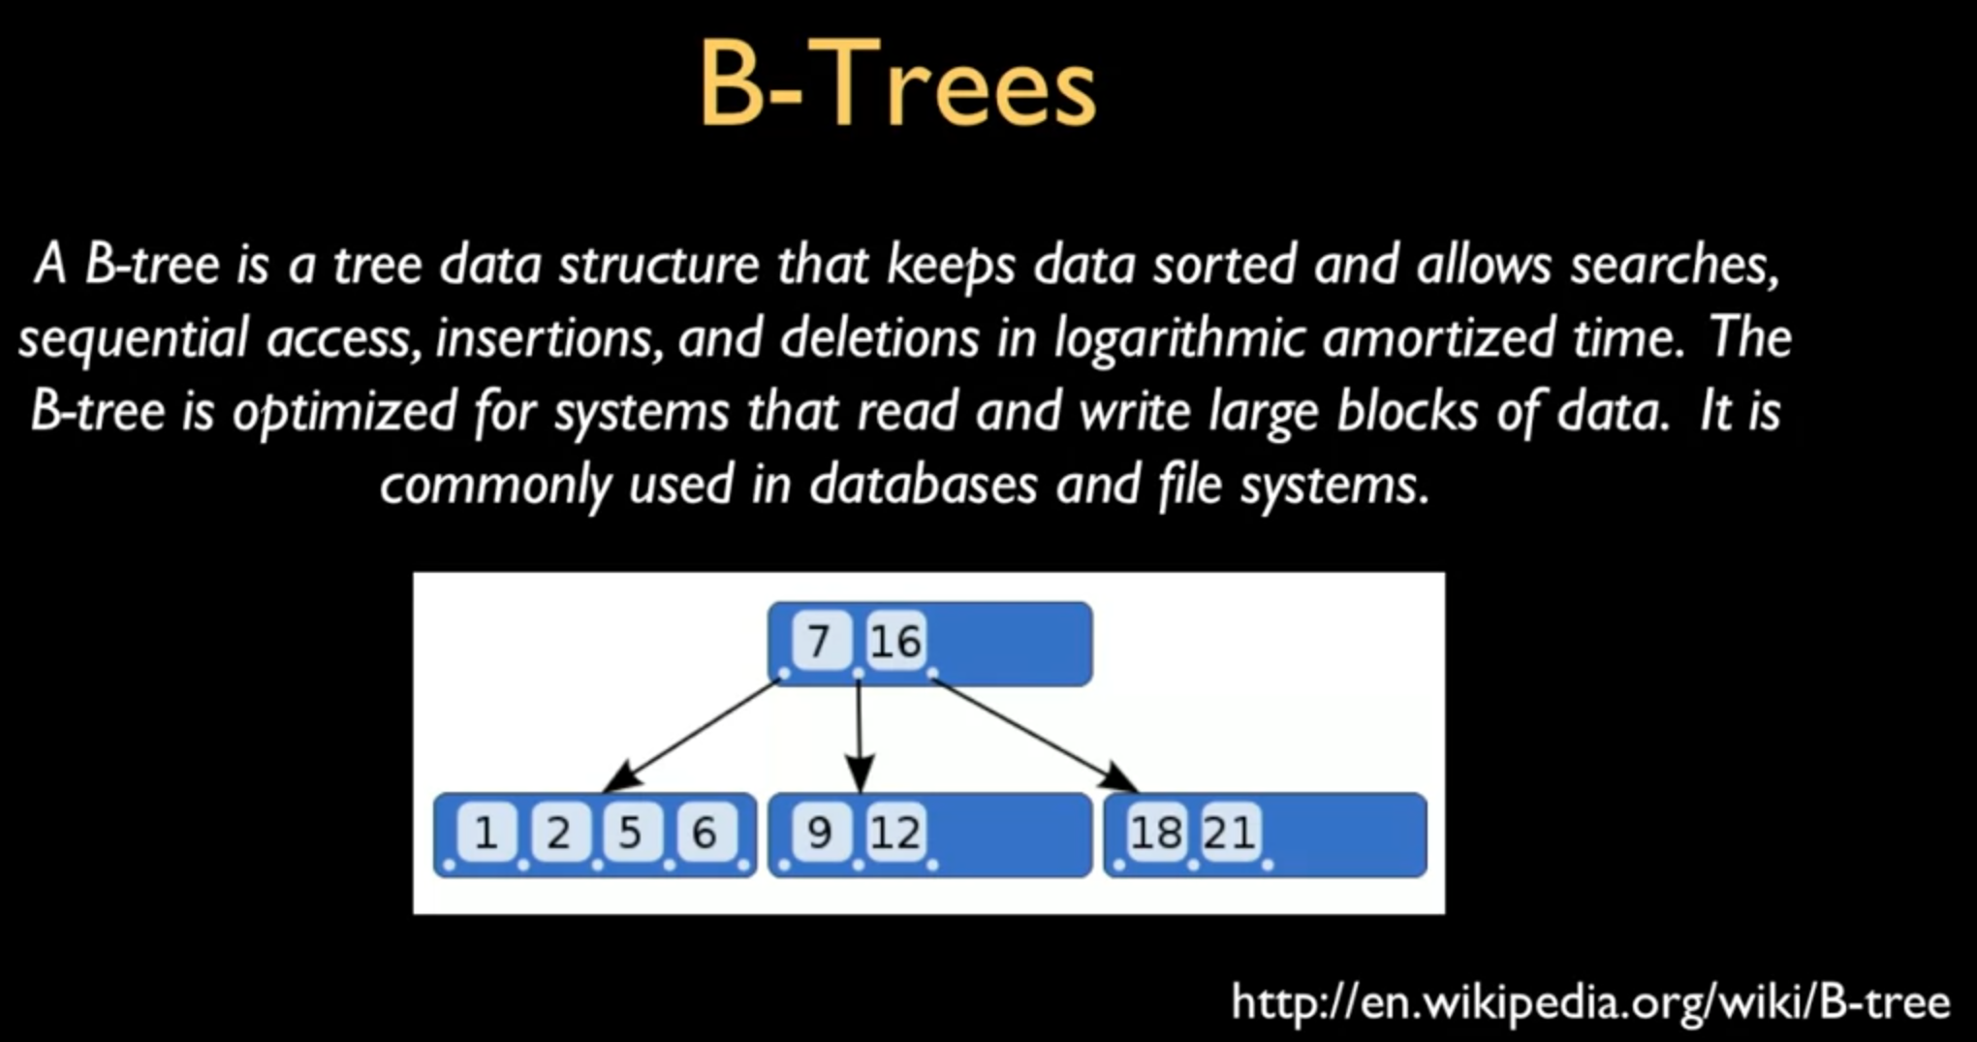

### Hashes

Hashes are calculation. In the following example, every letter are represented by numbers, and then do the calculation (MD5, SHA1 algorithm) to find the corresponded index.

**Hashes is only good for exact match** (e.g., Primary keys, unique columns), if we want to do prefix matching, do use it.

## Summary

