Lab 01: Introduction to ArcGIS Online
Due date: Noon (12:00 p.m.) on Wednesday, Sep 9, 2026, submitted as a Word document to the Brightspace Lab01 link.
This lab counts 6.25% (50 points out of 800 points) toward your total grade.
Objectives: In this lab, you will use ArcGIS Online Map Viewer to create and share a web map for hurricane evacuation planning in Houston, Texas. You will explore authoritative demographic data, map styling, basemaps, filters, attribute tables, visual effects, and sharing settings. The exercise is adapted for this course from the Esri Learn tutorial “Get started with ArcGIS Online.”
Official tutorial: Get started with ArcGIS Online
Topics covered in this exercise include:
1. How to create and navigate a web map in ArcGIS Online
2. How to add authoritative data from ArcGIS Living Atlas of the World
3. How to style demographic data using graduated colors
4. How to change a basemap to improve geographic context
5. How to filter a national dataset to a local study area
6. How to explore and sort an attribute table
7. How to emphasize priority areas using map effects
8. How to save and share a web map
Scenario: Hurricane evacuation can be difficult for households without access to a vehicle. You will create a map that helps identify census tracts in the Houston area where a relatively high percentage of households have no vehicle available.

Step 1. Sign In and Begin a Web Map
ArcGIS Online is a cloud-based GIS platform for creating, analyzing, and sharing geographic information. Web maps created in ArcGIS Online can be opened in a browser and shared with other users.
✓ Open ArcGIS Online and sign in with your UCA ArcGIS organizational account.
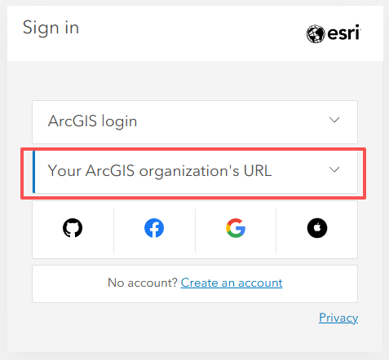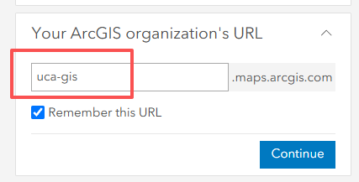
✓ On the main ribbon, select Map to open Map Viewer.
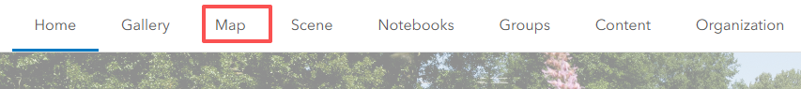
✓ Review the default web map. At this point, the basemap is the primary map layer providing geographic context.
✓ Use Search (right-lower corner in the map view) to locate Houston, Texas, and close the location pop-up after the map zooms to the city.
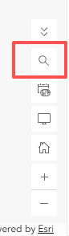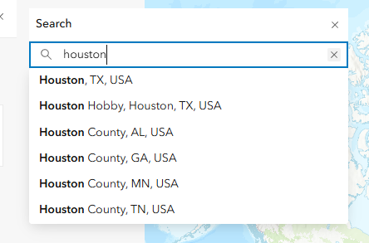
Question 1. What is the purpose of a basemap in a web map? (5 Points)
Answer 1:

Step 2. Add Demographic Data from ArcGIS Living Atlas
Layers contain geographic features and their associated attributes. ArcGIS Living Atlas of the World provides ready-to-use geographic content from Esri and other authoritative organizations.
✓ In the Layers pane, click Add.
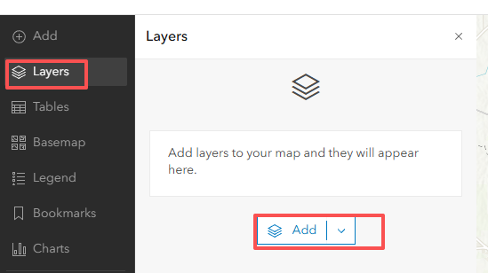
✓ Change the data source from My content to Living Atlas.
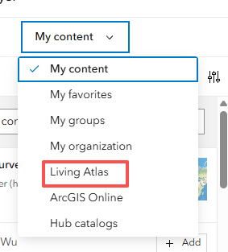
✓ Search for ACS Vehicle Availability (Latest).
✓ Open the item details and read the description of the layer.
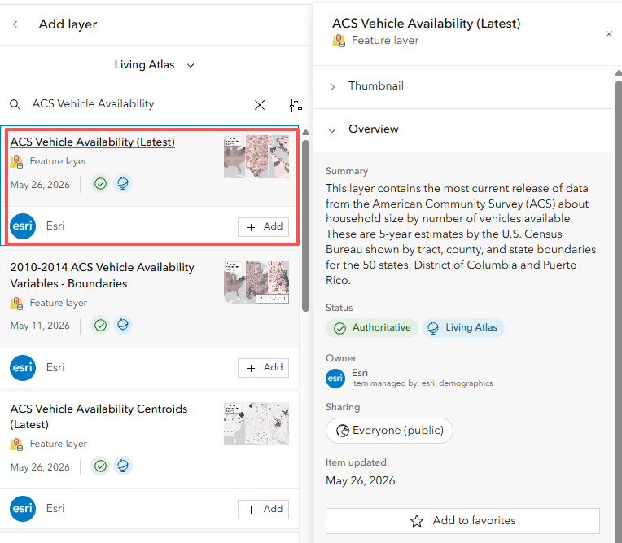
✓ Add ACS Vehicle Availability (Latest) to the map.
✓ Expand the group layer. The dataset contains related layers at multiple geographic scales.
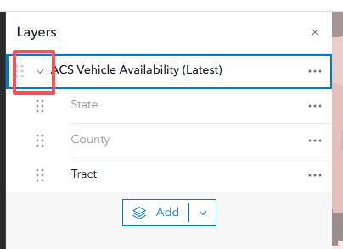
✓ Move the Tract layer outside the group so that it can be managed independently, and remove the remaining group layer.
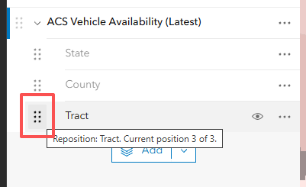
GIS concept: A feature layer combines geography with attributes. In this exercise, each census tract is a polygon feature with demographic attributes describing household vehicle availability.

Question 2. What organization or program provides the vehicle-availability data used in this exercise? (5 Points)
Answer 2:

Question 3. Why is the census tract layer more appropriate than the state or county layer for examining patterns within Houston? (5 Points)
Answer 3:

Step 3. Style the Demographic Layer
The layer is already mapped using the percentage of households with no vehicle available. You will modify the color scheme so that areas with high percentages are visually prominent.
✓ Select the Tract layer and open Styles on the Settings toolbar.
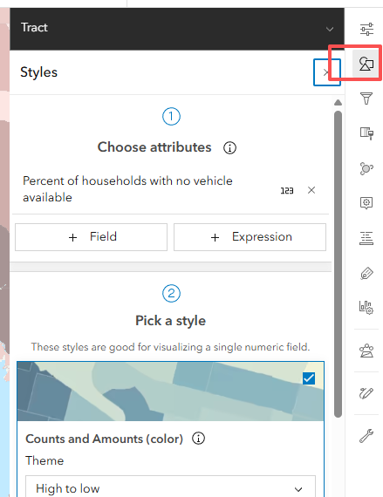
✓ Confirm that the mapped attribute is Percent of households with no vehicle available.
✓ Open Style options for Counts and Amounts (color).
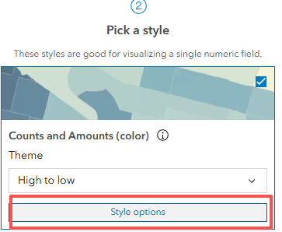
✓ Choose a color ramp you like. If needed, reverse the ramp so higher percentages are darker.
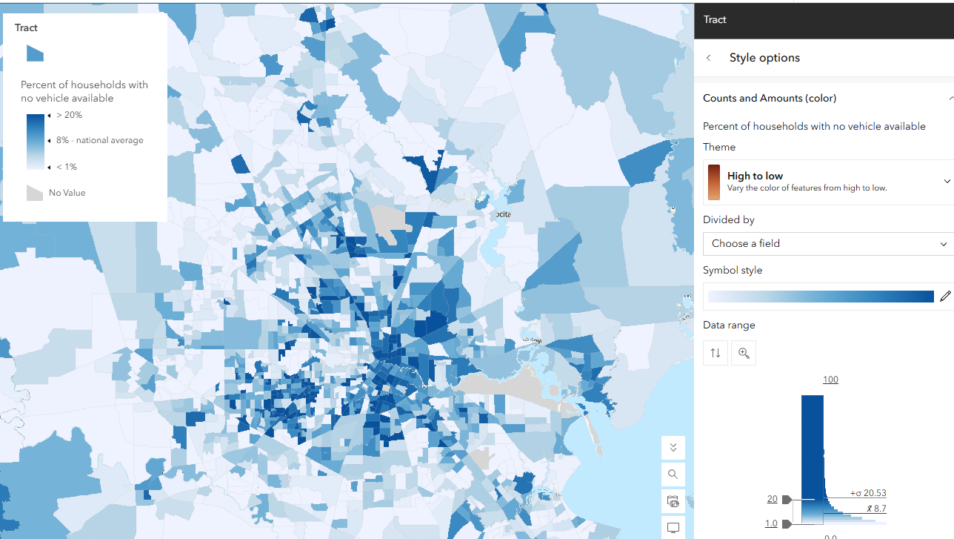

✓ Rename the layer as ‘Percent of Households with No Vehicle Access’
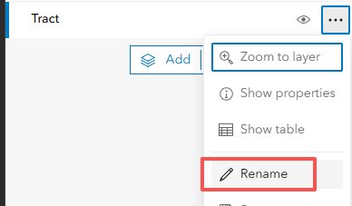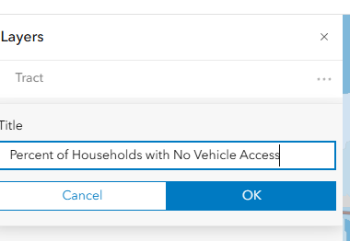

✓ Choose a color ramp you like. If needed, reverse the ramp so higher percentages are darker.

Question 4. What does a dark color census tract represent on your map? (5 Points)
Answer 4:

Step 4. Change the Basemap
A good basemap should provide context without competing with the thematic layer. In this map, labels are important because they help identify neighborhoods and major roads.
✓ Open the Basemap pane from the Contents toolbar.
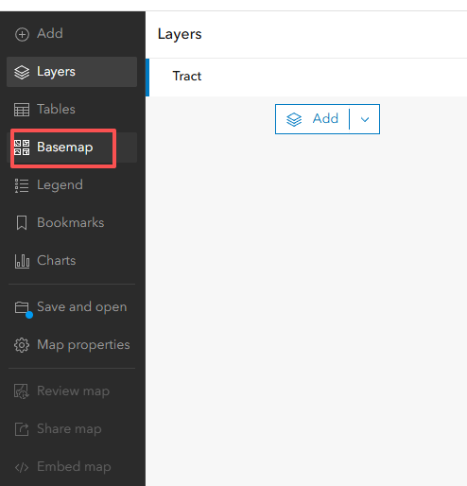
✓ Choose Human Geography Map. If it is not listed in your organization, search Living Atlas for Human Geography Map.
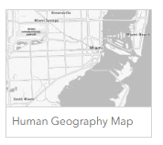
✓ Return to the Layers pane and compare the new basemap with the previous basemap.
Question 5. Why is the Human Geography Map useful for this evacuation-assistance map? (5 Points)
Answer 5:

Step 5. Filter the Map to Harris County
The demographic layer covers a much larger area than Houston. A filter uses attribute-based conditions to limit which features are displayed.
✓ Select the Percent of Households with No Vehicle Access layer.
✓ Open Filter on the Settings toolbar and choose Add new.
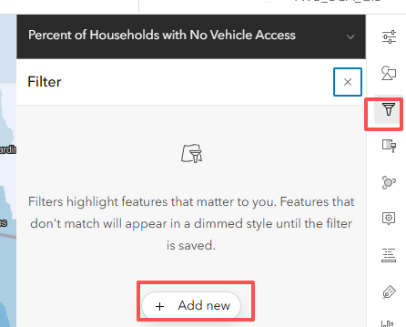
✓ Use County Name as the field.
✓ Keep the operator is and select Harris County as the value.
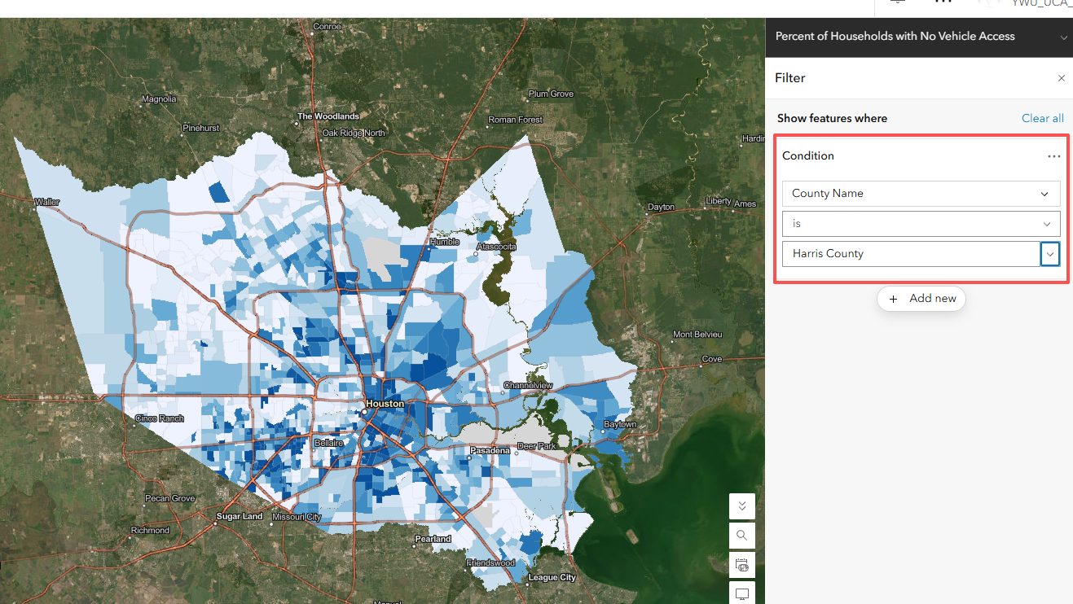
✓ Save the filter. The map should now focus on census tracts within Harris County.
GIS concept: A filter does not change the underlying dataset. It controls which records are displayed based on a logical condition, such as County Name = Harris County.

Question 6. Write the complete filter expression you used to limit the map to Kings County. (5 Points)
Answer 6:

Step 6. Explore the Attribute Table
Every feature layer has an attribute table. Each row represents a geographic feature, while fields (columns) store descriptive information about that feature.
✓ Open the layer options and choose Show table.
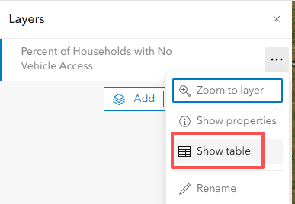
✓ Locate the field Percent of households with no vehicle available.
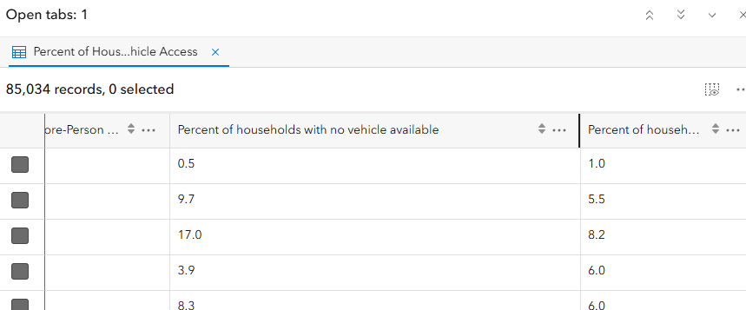
✓ Sort this field in descending order.
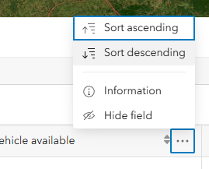
✓ Record the number of census tracts in your current Kings County dataset and identify the highest value.
Question 7. How many census tracts are included in Harris County in the version of the dataset you are using? (5 Points)
Answer 7:
Question 8. What is the highest percentage of households with no vehicle available in your current dataset? (5 Points)
Answer 8:

Step 7. Emphasize Priority Census Tracts
You will now use a feature-specific visual effect to make the highest-priority census tracts stand out while preserving the geographic context of the other tracts.
✓ From the sorted table, identify the 10 census tracts with the highest percentages of households with no vehicle available.
✓ Record the value of the 10th-highest tract. This value will become your threshold.
✓ Close the table and open Effects from the Settings toolbar.
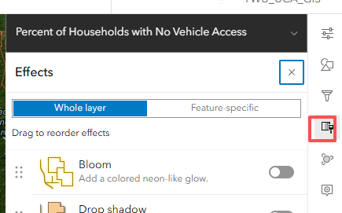
✓ Choose Feature-specific and apply Drop Shadow + Transparency.
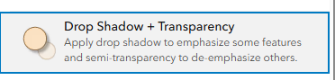
✓ Change the expression so that the highlighted features are those with values at or above the threshold you recorded.
✓ Close the Effects pane and visually inspect the final pattern.
Question 9. What percentage threshold did you use to highlight the top 10 census tracts? Based on the map, describe where these high-priority tracts are concentrated. (10 Points)
Answer 9:

Step 8. Save and Share the Web Map
Saving creates a reusable web map item in ArcGIS Online. Sharing permissions determine who can access that item.
✓ Choose Save and open, followed by Save as.
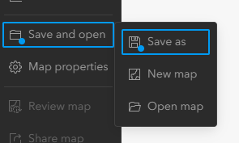
✓ Give the map a clear title, such as Census Tracts in Houston with Low Vehicle Access.
✓ Add appropriate tags such as Hurricanes, Evacuation Assistance, and Houston.
✓ Write a short summary describing the purpose of the map.
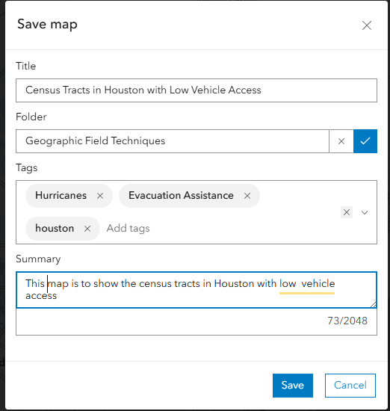
✓ Save the map.
✓ Use Share map > Manage sharing. Change the sharing level to ‘Everyone (Public)’
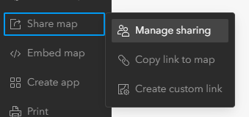
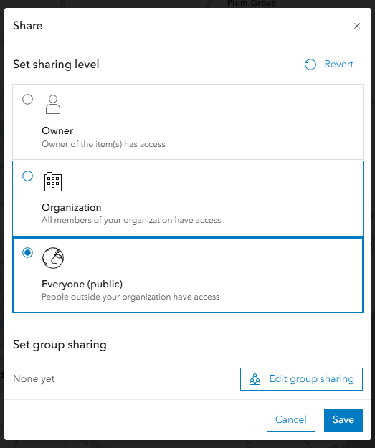
Important: The Esri tutorial demonstrates public sharing, but real GIS projects may contain sensitive data. Always consider privacy, licensing, and organizational policy before sharing a map publicly.

Question 10. Paste the link to your completed web map and briefly explain one real-world decision that an emergency manager could support using this map. (5 Points)
Answer 10:

Step 9. Saving Your Work and Submission
Before leaving ArcGIS Online, confirm that your map has been saved and that you can reopen it from your ArcGIS Online content.
✓ Save the web map and verify that the title, layer styling, Harris County filter, and visual effect are preserved.
✓ Copy the map link for Question 10.
✓ Save your answers in a Word document.
✓ Submit the Word document through the BrightSpace Lab01 link by the due date.
END OF EXERCISE
Homework
Please submit a Word file containing the 10 questions and your corresponding answers through Brightspace. The due date is noon (12:00 p.m.) on Wednesday, Sep 9, 2026.
Source and attribution: This course exercise is adapted and paraphrased from Esri Learn, “Get started with ArcGIS Online,” last tested June 30, 2026. The original tutorial is available under a Creative Commons BY-SA-NC license. Original Esri tutorial

