Exercise 2: Introduction to Survey123
Due date: Midnight (11:59 pm) on Monday, Sep 8, 2025 submitted as Word document to blackboard Lab02 link
This lab counts 6.25 % (50 points out of 800 points) toward your total grade.
In this exercise, you will start working with Survey123, the online GIS source by Environmental Systems Research Institute (ESRI). Survey123 is a simple and intuitive form-centric field data gathering solution that makes creating, sharing, and analyzing surveys possible in three simple steps: ask questions, get answers, and make better decisions. In this exercise, you will learn how to use survey123 to create a campus tree mapping survey that can be used in the Field.
Topics covered in this exercise include:
- How to log into Survey123 with ArcGIS online account
- How to design your questions
- How to publish and share your survey
- How to access your survey in TDC 100
- How to create offline basemap for collecting data offline

Create the Survey

Step 1. Set Up Survey123
- Go to https://survey123.arcgis.com/ and Sign in with your ArcGIS online account details
- Select ‘Organization Link’ and log in with your UCA credential

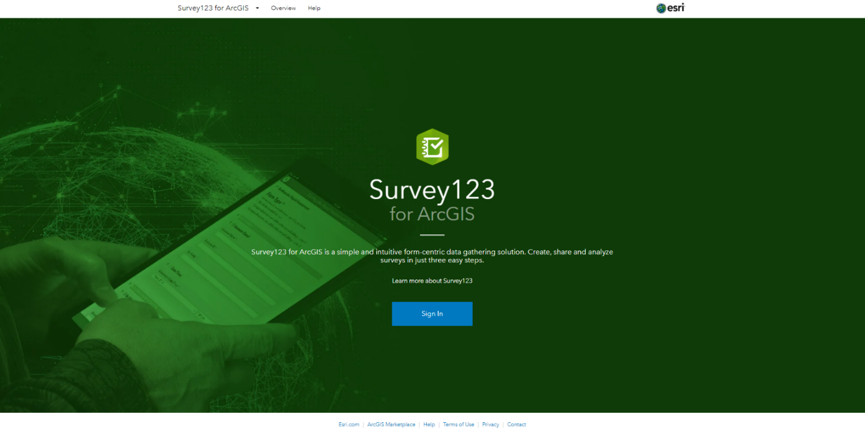
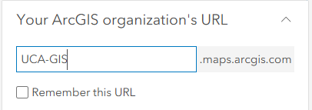
- Click Create a New Survey

- If the box below appears, select Get Started on the Blank survey under Using the web designer

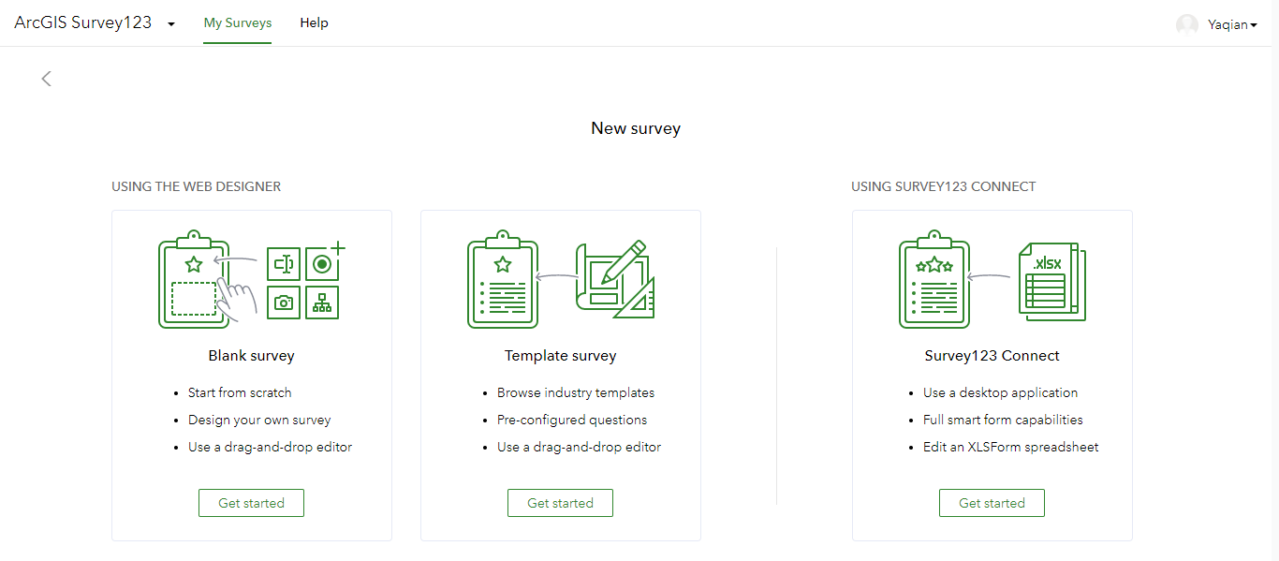
- An empty suvery123 will be shown
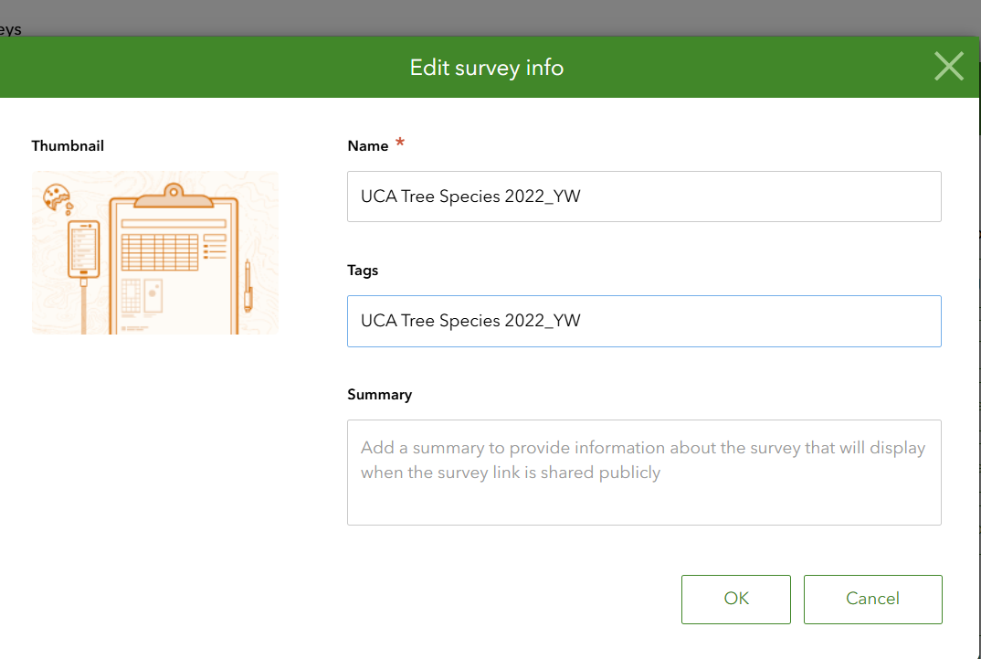
- Click on Untitled survey to type in UCA Tree Species 2025_(your initials). Since this must be a unique name in your organization, you will need to include your initials if others have followed these same steps
- Click on Survey title not set to set the survey header
Text:
UCA Tree Species 2025_(your initials).
- You do not need to change others
- Click Save

After creating an empty Survey123, you will start filling in the questions to get data like the csv file.

Step 2. Design survey questions
Question One:
- Click Dropdown under the Add panel
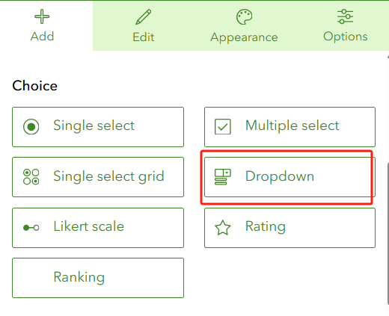
- Drag Question into the first question box
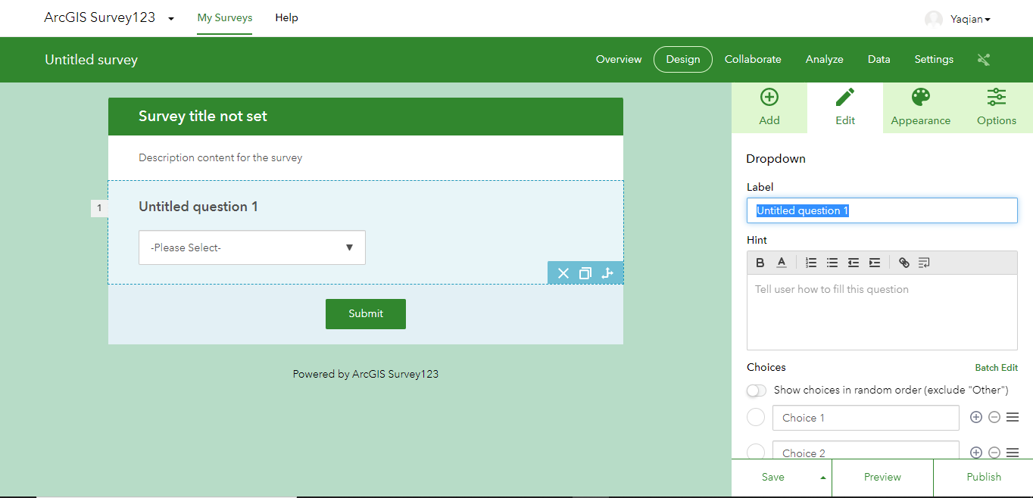
- Fill in the question details
Label:
Deciduous or Evergreen?
Choice:
(you may need to delete one choice by clicking icon):
Evergreen
Deciduous
- You do not need to change others
- Click Save

You first question is designed!
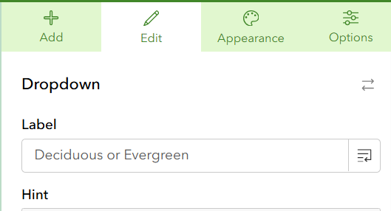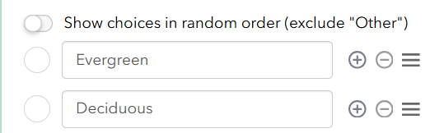
Question Two:
- Click Add panel
- Click Dropdown again
- Fill in question box:
Label
Health Condition
Choice:
Good
Fair
Poor

- You do not need to change others
- Click Save to finish your second question
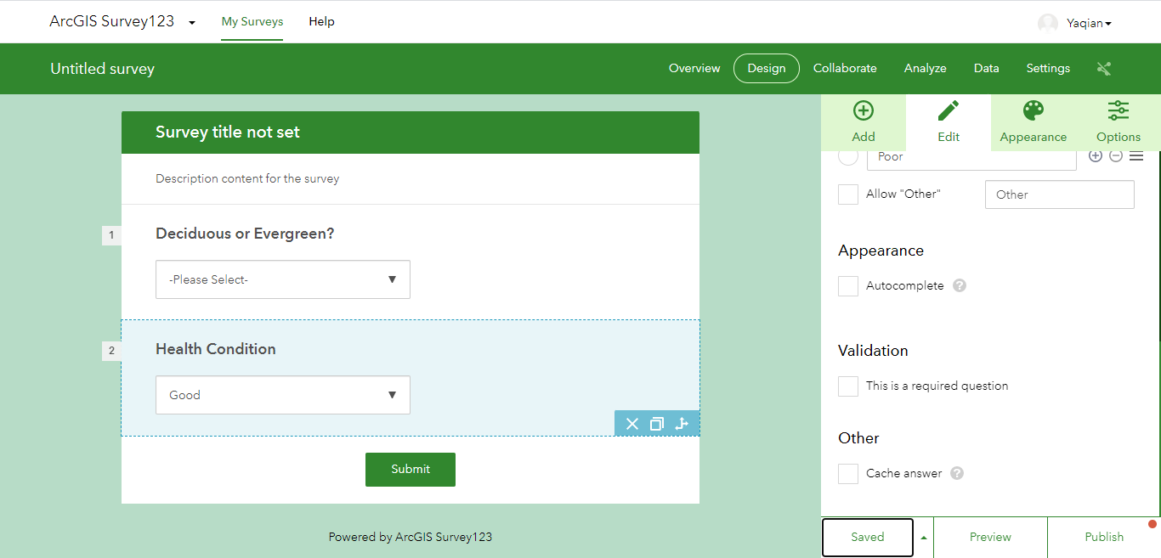
Question Three:
- Click Add again
- Click Number
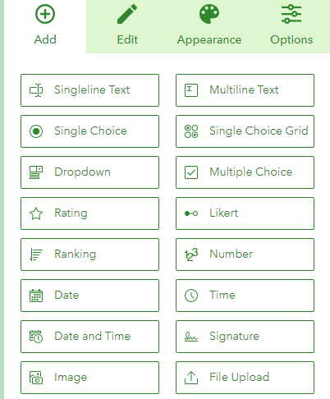
Label:
Tree Height
Hint:
In Meters
- You do not need to change others
- Click Save
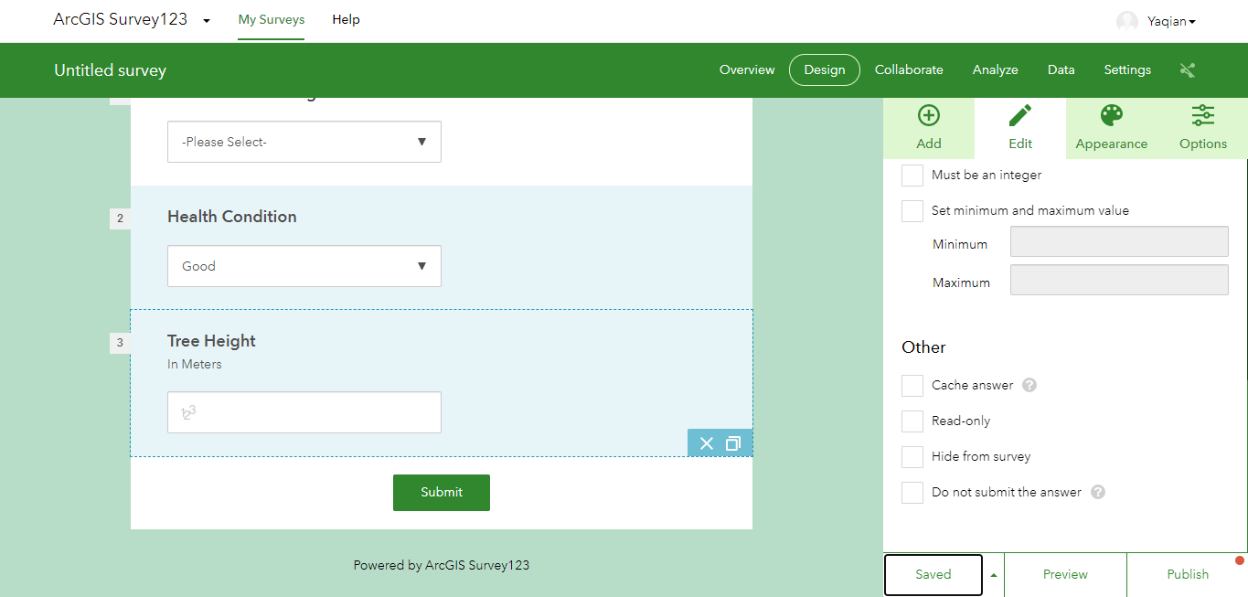
Question Four:
- Click Add again
- Click Number
Label:
Tree Perimeter
Hint:
In Meters
- You do not need to change others
- Click Save
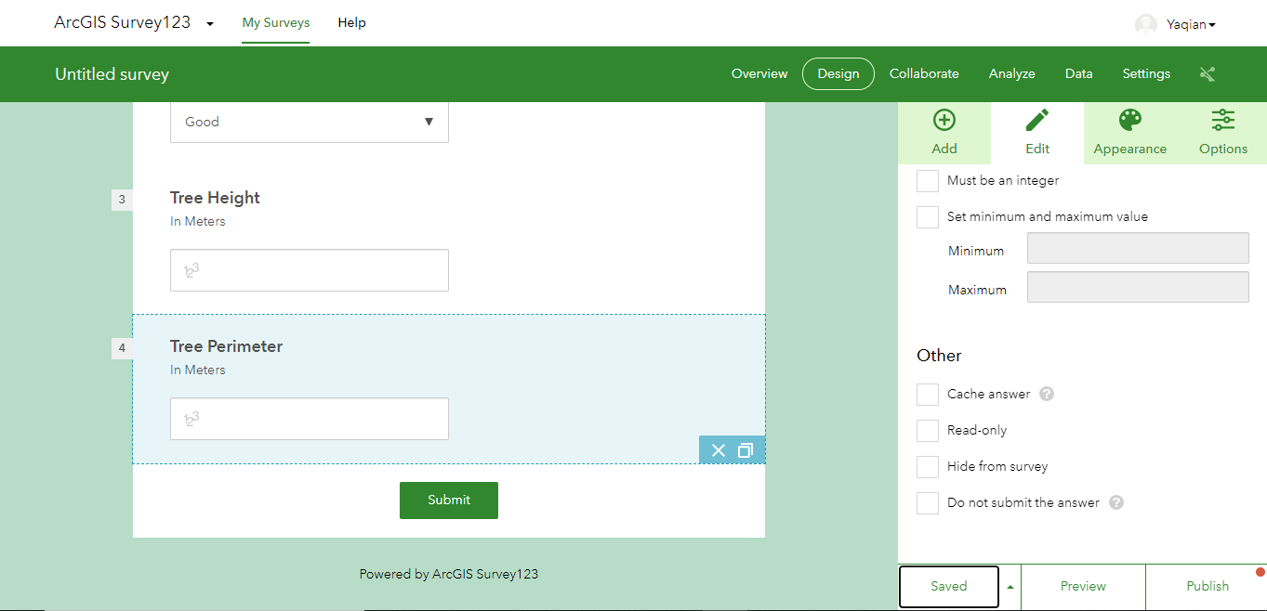
Question Five:
- Click Add again
- Click Number
Label:
Tree Volume
Hint:
In Cubic Meters
- Click on Edit along the Calculation
- In the Edit Calculation window, select Number and insert the following equation
Tree Height*Tree Perimeter* Tree Perimeter /(4*3.14)
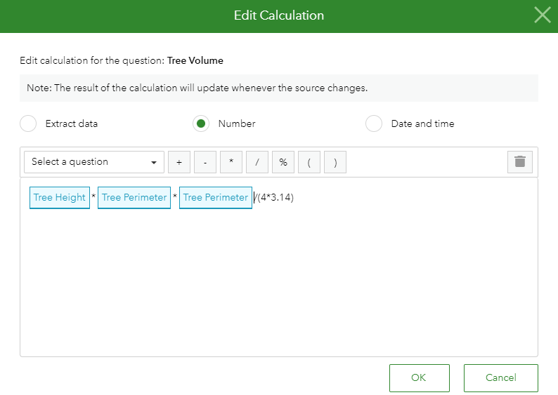
- You do not need to change others
- Click Save
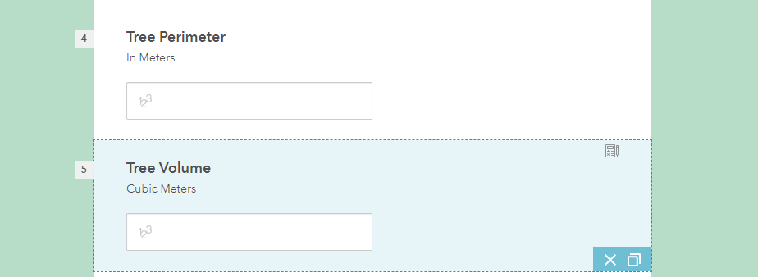
Question Six:
- Click Add again
- Click Dropdown
Label:
Tree Species
Choice:
(you may need to add choices by clicking  icon):
Sugar Pine
Spruce
Purple Ash
Oak
Elm
Crepe myrtle
Red Maple
Magnolia
- Check Allow ‘Other’
- You do not need to change others
- Click Save
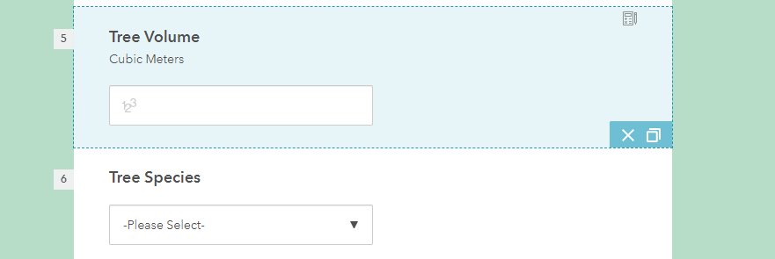
Question Seven:
- Click Add again
- Click Map
Label:
Mark Where you are on Map
Drawing tools
Point
Map and extent
- Click on Expand, select Imagery Hybrid
- Set the default location to Conway, AR
- Tick the box for Use device’s location and ask for location when answering this question
- Tick this is a required question
- You do not need to change others
- Click Save

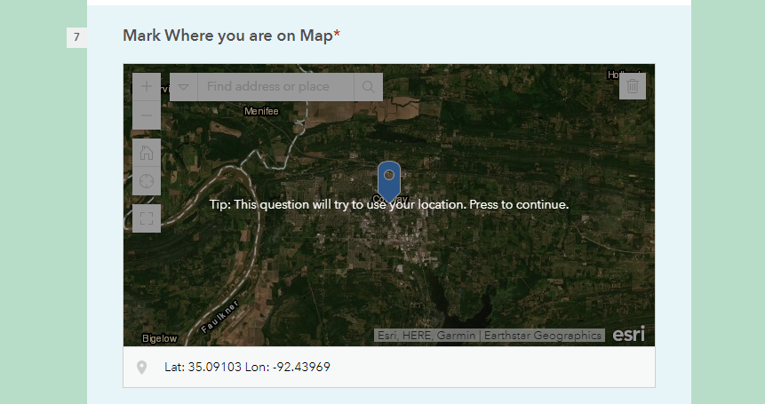
Question Eight:
- Click Add
- Click Image
Label:
Take a Photo of the tree
- Tick this is a required question
- You do not need to change others
- Click Save

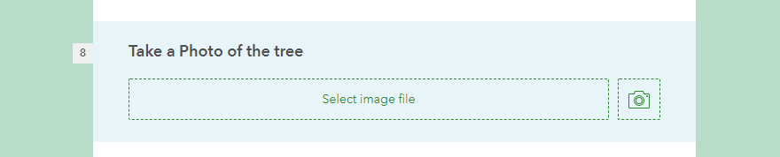
Question Nine:
- Click Add
- Click Date and Time
Label:
Date and Time
- You do not need to change others
- Click Save
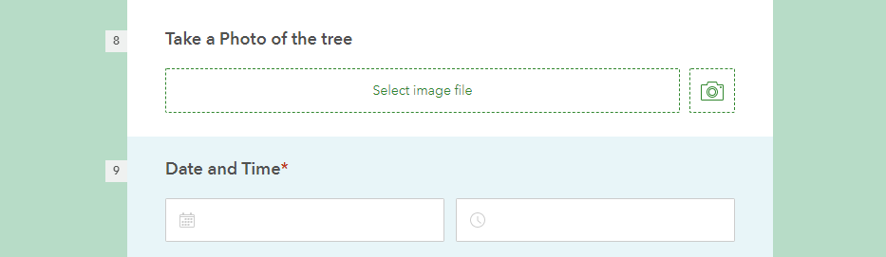
Now you finish all of the questions.

Step 3. Publish your survey123
- Click Preview to check you survey (you may check the dropdown window to see whether the list right or not)
- You can also click on the Phone and Tablet icons to see what it looks like.

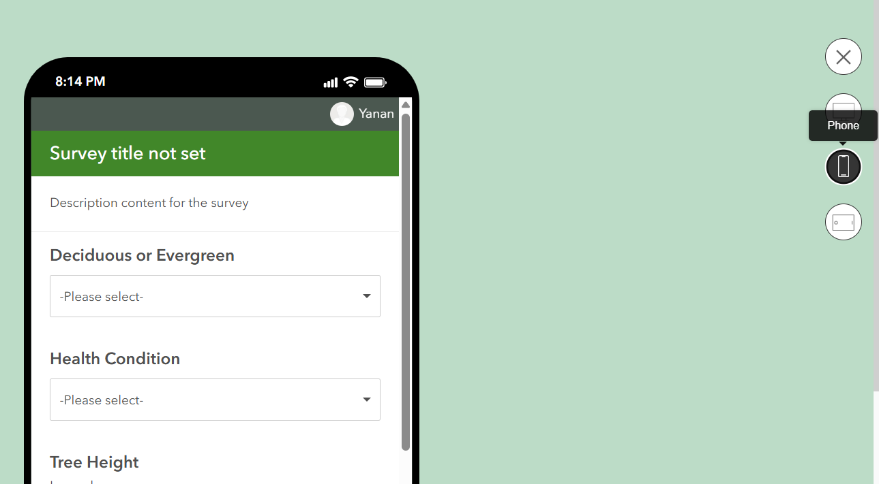
- Click Cross icon to return to design page
- Click Publish followed by OK and Publish. It may need couple minutes
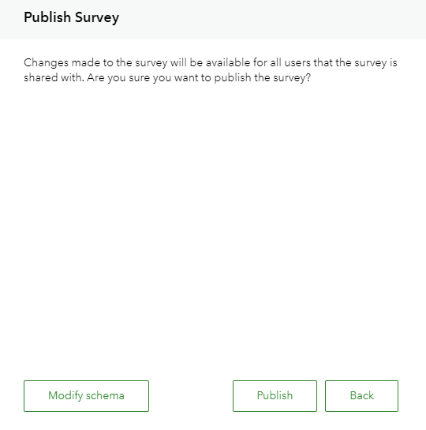
This will publish your survey123 survey online so that you can view the survey on the Survey123 app or in a browser.
This will also add the survey into a folder in your My Content in your ArcGIS Online account
The survey will be there when you login to https://www.arcgis.com/index.html and go to My Content
Note: The survey will have a feature layer and if you click on this, it will ask you if you want to view the survey layer in a map viewer. This is how you see the results points on the map collected from your surveys. We will do this in our following lab exercises.
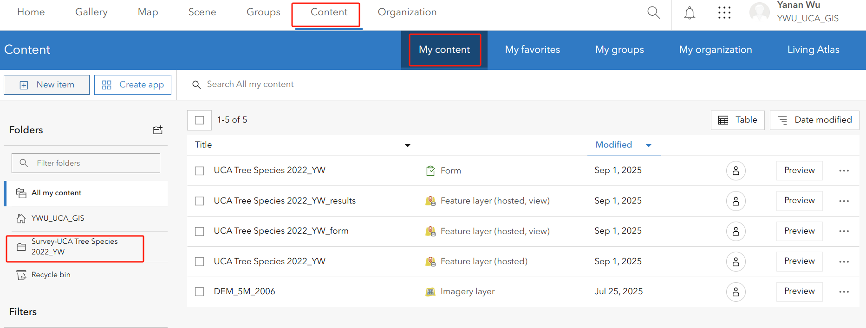

Step 4. Sharing your Survey
- Click Form
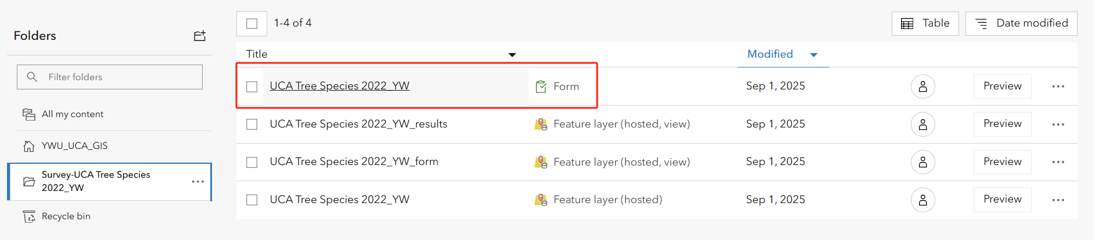
- Manage in Survey124 website
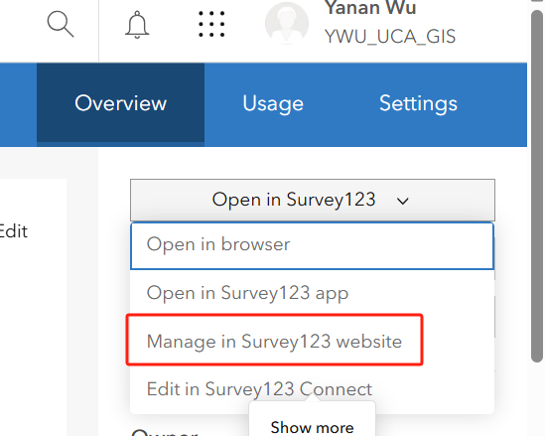
- Click Collaborate

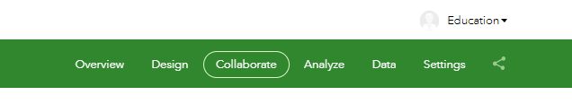
Share this survey
- You will see a link here to your survey
- You can copy this url in link box and paste into your browser to open survey

Who can submit to this survey?
- Tick Everyone

- Tick Save

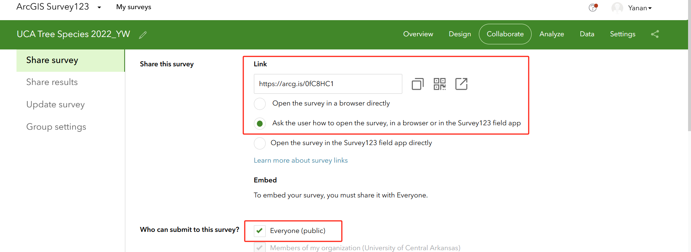

Shar the results
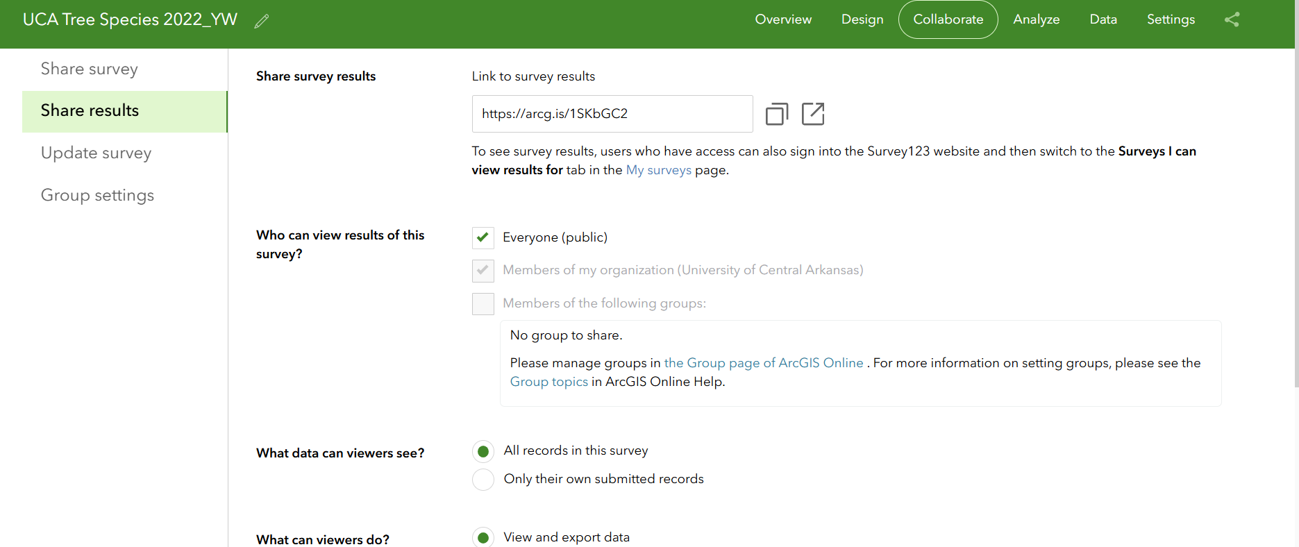
Who can view results of this survey?
- Tick Everyone

What data can viewers see?
- Tick All records in this survey

What can viewers do?
- Tick View and export data
- Tick Save

Note: you can share survey with only your classmates in your school if you have a group set up

Deliverable 1: Please paste the URL of your survey124. Make sure to share everyone, so that I can see it (20 points)

Step 5. Access your Survey in TDC 100
- Sign in with your ArcGIS online account
- Select ‘Your ArcGIS organization’s URL’
- Type ‘UCA-GIS’ to connect to UCA ArcGIS Pro Account
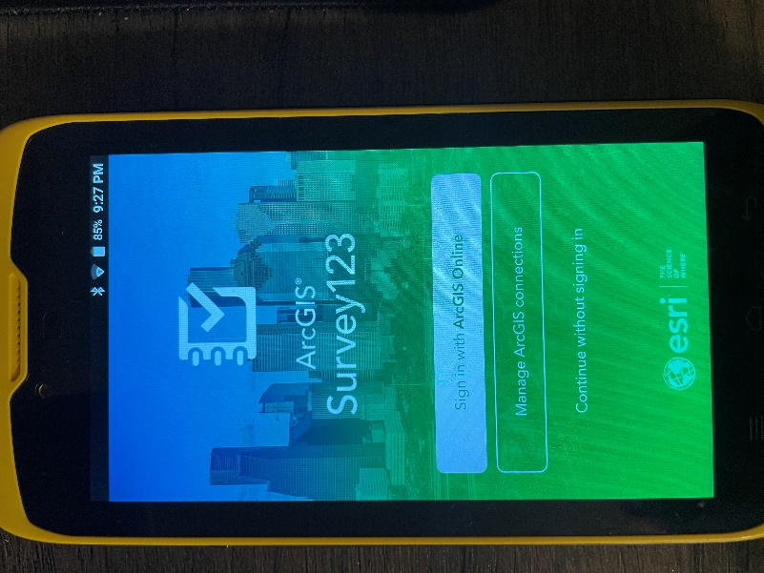
You may notice the survey you just created are not in My Survey123. You will need to download the survey your just created
- Click on your account at top-right corner followed by Download Surveys
- Click on the download icon to download the survey that you just created
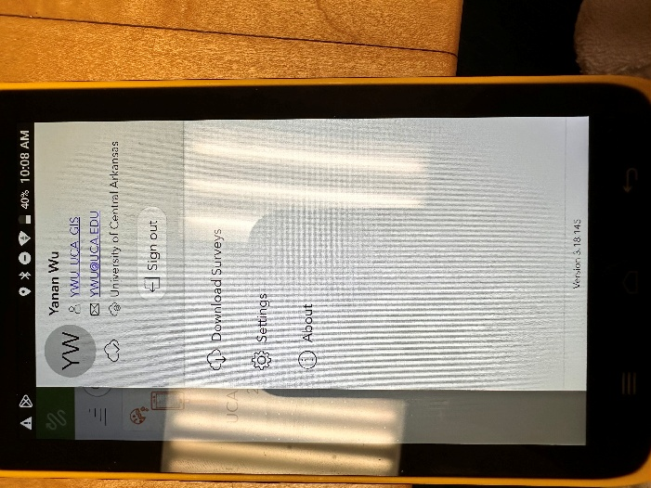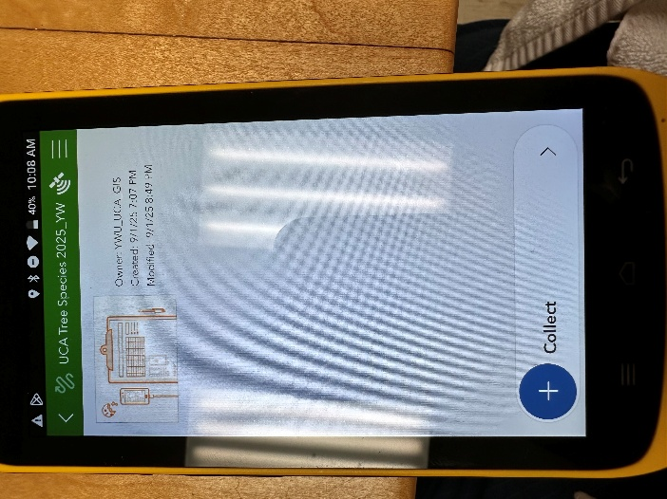
- After downloading, you will find the survey under My Survey123 and you can access to it by clicking on the Survey followed by Collect.

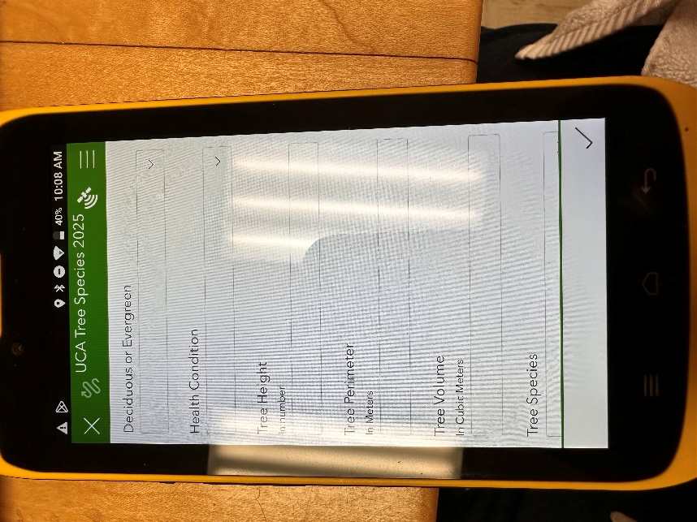

Deliverable 2: Screenshot your survey from your TDC 100 (like the image above) to submit it in a word file to blackboard (10 points)

Deliverable 3: Open your survey in your mobile phone and Screenshot survey from your mobile phone. If you do not have Survey123, you need to download and install first (10 points).

Create an offline map for Survey123
Before going to next step, you may want to check what the map in the survey looks like when you turn off WIFI or Internet Data. This is most the case that you will encounter when you go to the field without internet.
- Scroll down to your survey to find the map. You could see there is a map there
- Turn off the WIFI or Internet Data in the Setting of TDC 100
- Tap on the map again, it shows nothing, although you can still get the lat/lon.
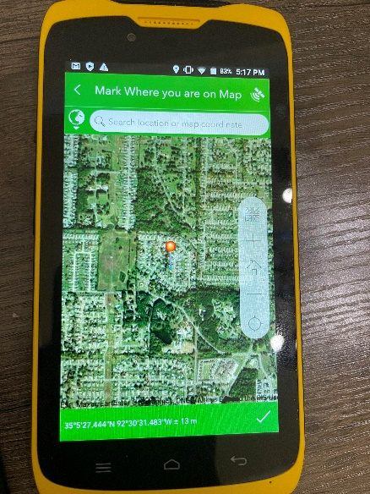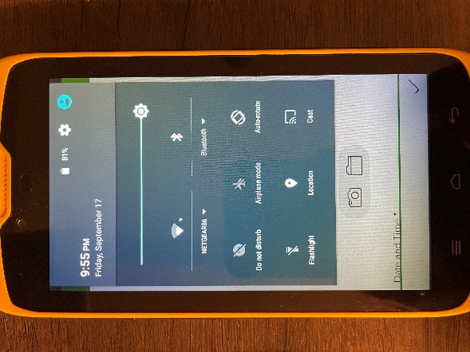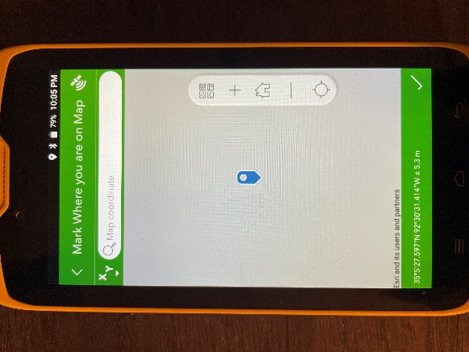

Step 1. Create the offline map areas
- Sign in to the ArcGIS Online website https://arcgis.com/ and click Map. The map will be launched.
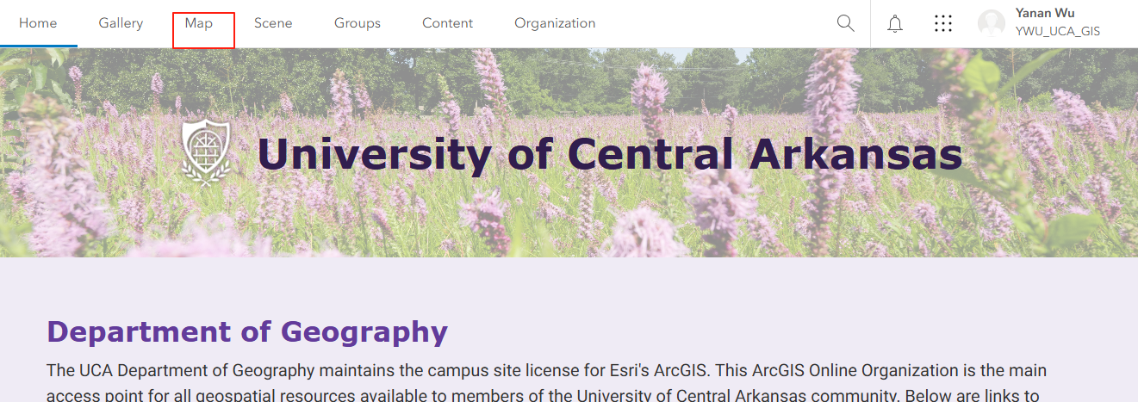
- In the opened map, clicking on More to choose Imagery Hybrid basemap. You can also choose the basemap depending on your need.
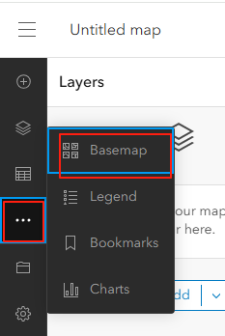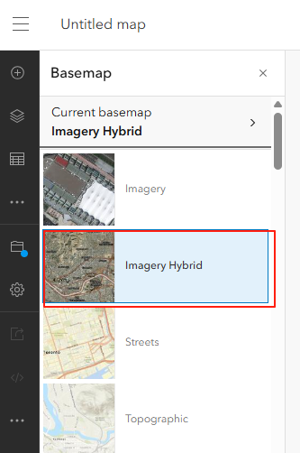

- Click the search icon, in the search bar type University of Central Arkansas to find the place where you will collect the data. Note, you can also zoom in/out to find the place.
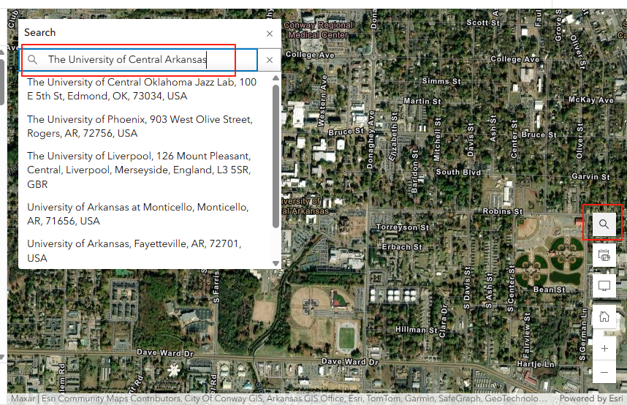
- After you finding the place, you can add the bookmark by clicking on the bookmark icon. Clicking on Add Bookmark and type the name of 2025 UCA Map 2025. You can choose any names that you prefer and also add several bookmarks if you have more than one field sites.
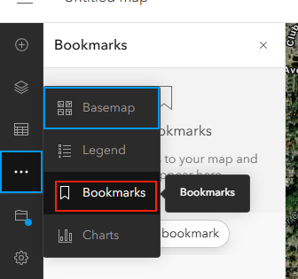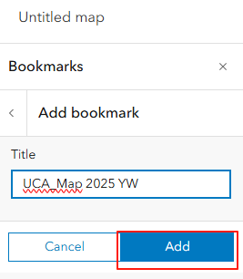
- Save your map by clicking on the Save icon followed by save, giving it a name to remind you that it is for an offline project.
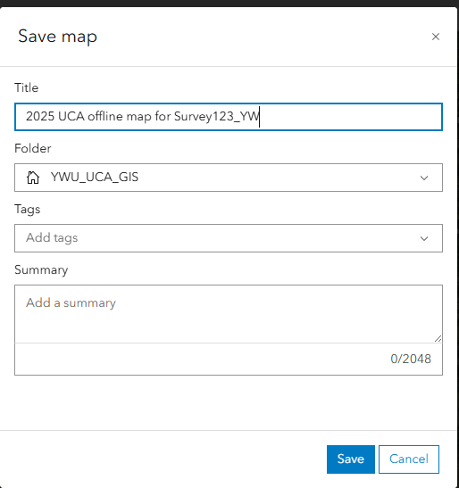
- Title:
2025 UCA offline map for Survey123_(your initial) Since this must be a unique name in your organization, you will need to include your initials if others have followed these same steps
- Tags: offline
- Save in folder: Select the folder you want to save your map
- Click on Save Map

- Click on home icon, go to content. The map you just created is under My content under the folder where you saved your map

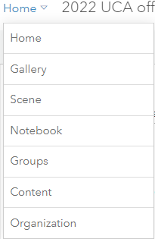

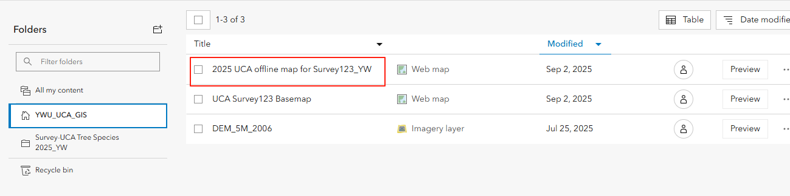
- Click on the expansion icon, click on View items details. The item page should be open.
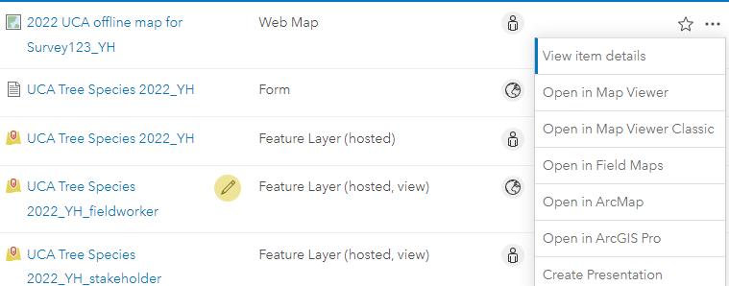
- In the map item page, click the Settings tab and scroll to the Offline settings.
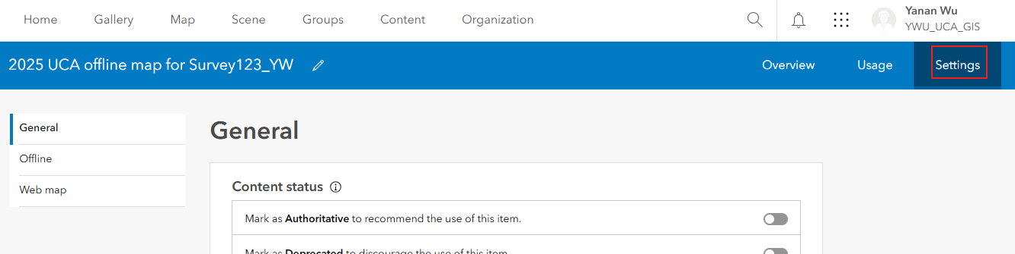

- Click Manage offline Areas.
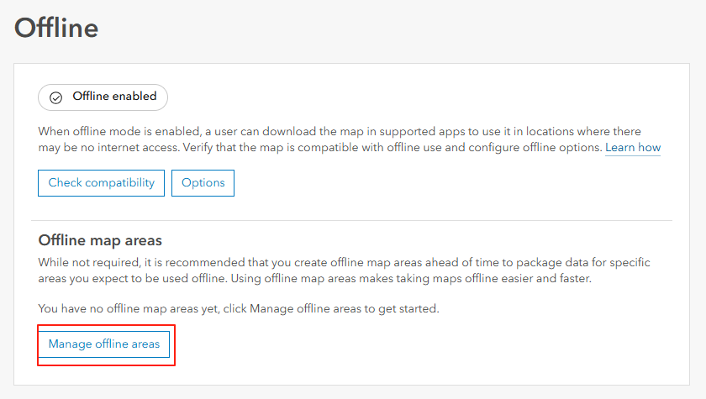
- Go to one of the bookmarks you created by clicking on bookmark icon and select 2025 UCA map for Survey123. Then the map will zoom the place you selected before. Click Create offline area in the pane on the left.

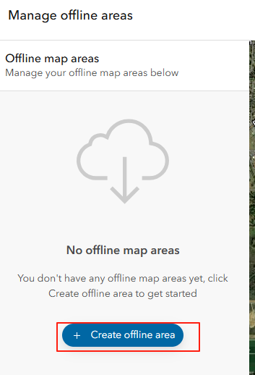
- Click Sketch rectangular map area, and sketch to define the area on the map that you want to take offline. Set the Level of Detail you need while offline. Since this is a basemap, expand Packaging schedule and set it to Never.
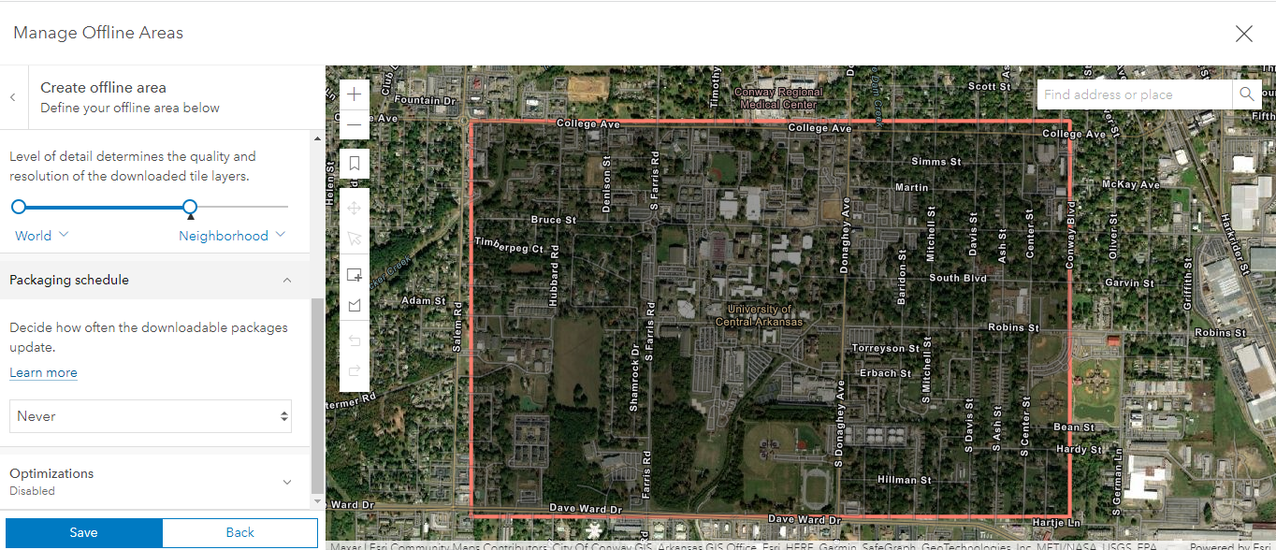
- You do not need to change others
- Click Save.
- Wait for a while. After it finishes packaging, click on the Cross icon to exit the Mange offline Areas page.
- Click on Content
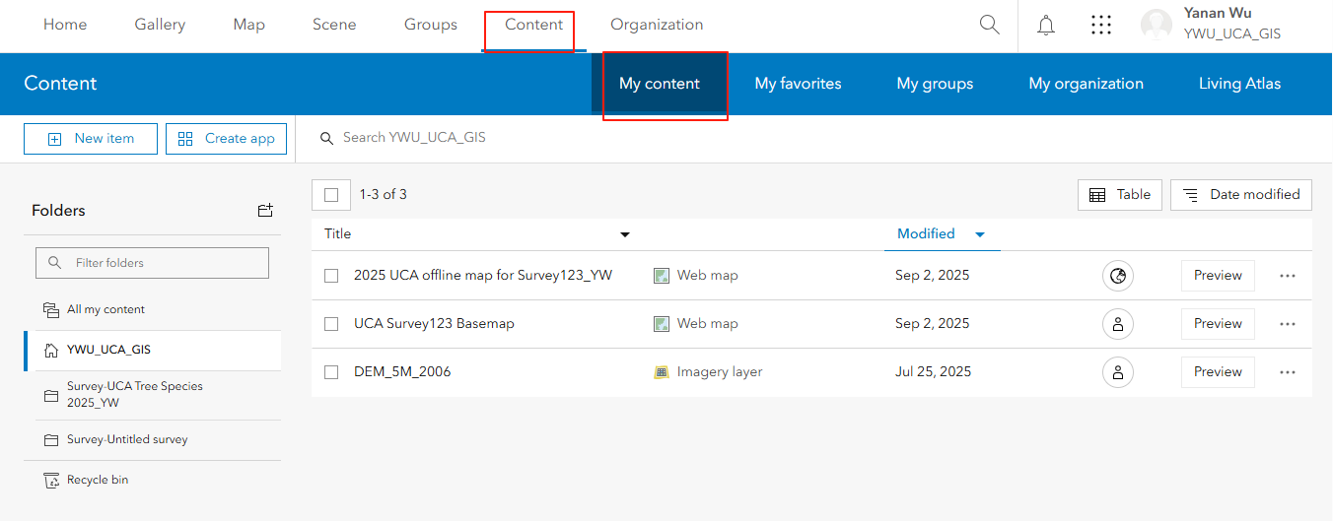
- Select offline map
- In the content page, tick the map that you created and click on Share.
- In the Share window, tick Everyone. Click on Save.
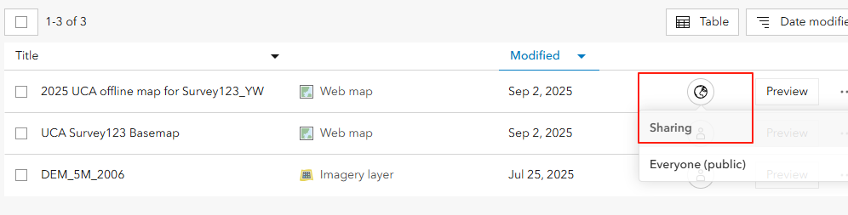
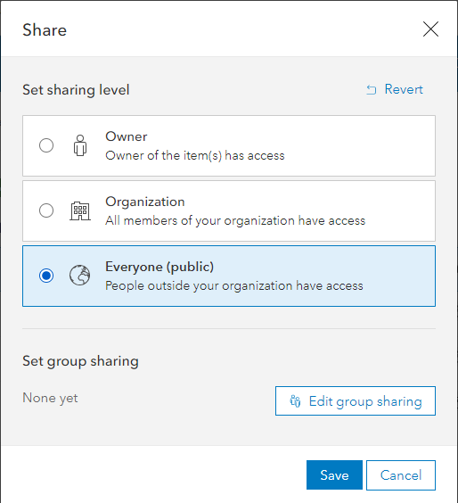

Step 2. Link the survey to the map areas
- Download Survey123 connect (https://www.esri.com/en-us/arcgis/products/arcgis-survey123/resources?rmedium=www_esri_com_EtoF&rsource=/en-us/arcgis/products/survey123/resources) (you will need to scroll down to find the download link). I will choose windows x64 version. You may choose the version that is compatible to your own computer.
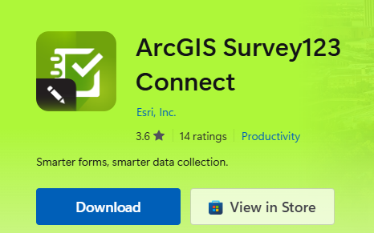
- After you downloading, double-click on the file . It will open the install wizard. For most part you only need to click on Next. when you see the License Agreement, choose I accept the license. You will finally click on Install to install Survey123 Connect.
- After installing, you can find the Survey123 connect in your computer apps under ArcGIS folder.
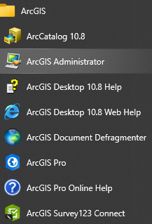
- Click on ArcGIS Survy123 Connect. When you first open, you will need to sign in with your ArcGIS online account. Click on the expansion icon and sign in.
- You will find the Survey you just created is there. Download the survey you are going to link to the map by clicking on the download icon. This gets it onto your computer so you can create the connection between the survey and the map.
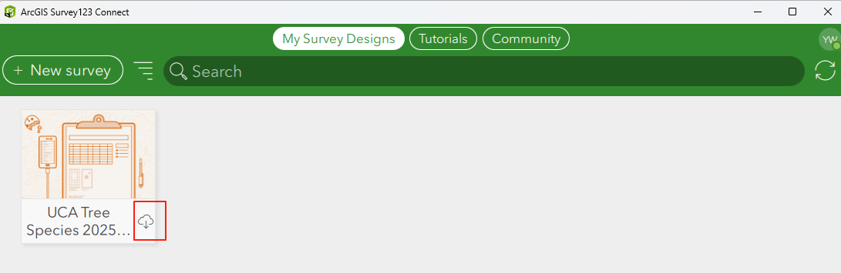
- Click on the survey to open it in Survey123 Connect. Click on Linked Content.
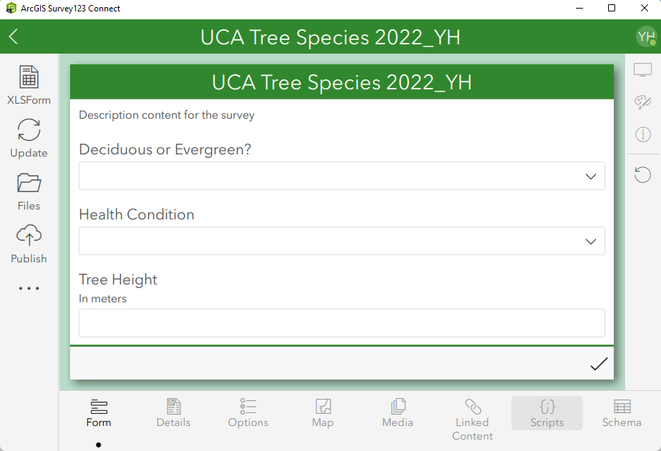
- Click on Link Content again, followed by Online map. Note, your available maps should be different with mine
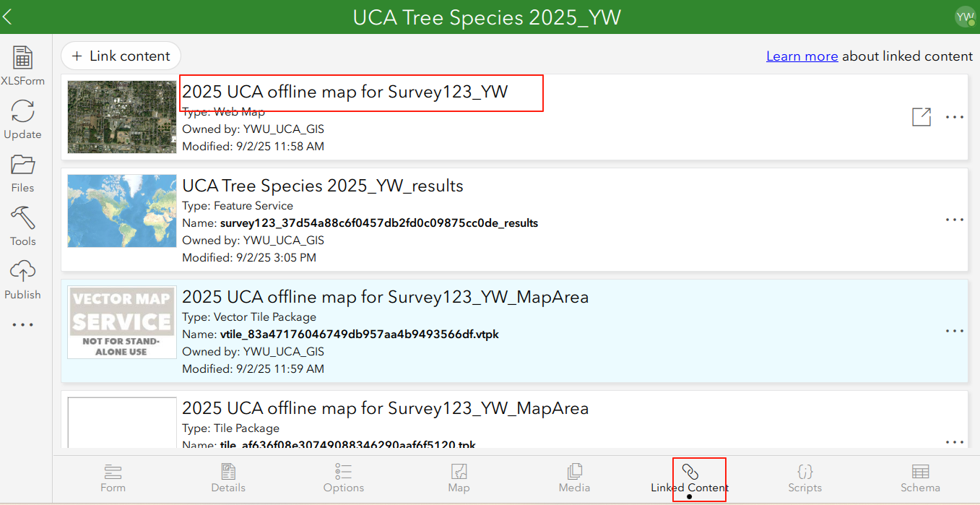
- In the maps window, you will see the map that you just created, e.g., 2025 UCA offline map for survey123_(you initials).

- Highlight it and click on OK. The basemap will connect to your survey.

Step 3. Download the offline area in the TDC 100
- Open you Survey123 on TDC 100.
- Tap the Survey you just created
- Tap the menu in the upper-right corner and tap Offline Maps.
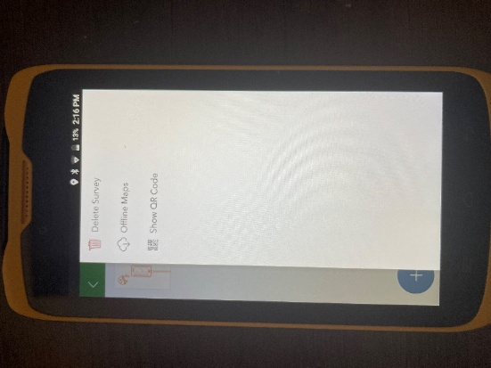
- Download the map area that you just created.

Now you can check the map in the survey again when you turn off WIFI or Internet Data. When you access the map in your survey, you will need to select the basemap you just downloaded by clicking on map icon. After that, you will see the basemap is loaded. Note, if your current location is out of your offline map area, you may see it is still empty. You will need to move your map to the center.
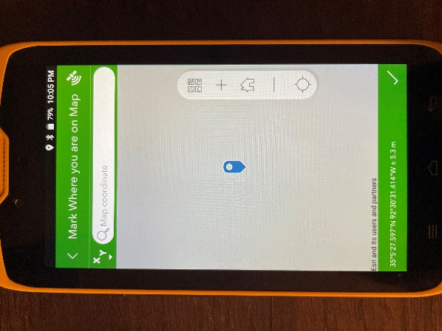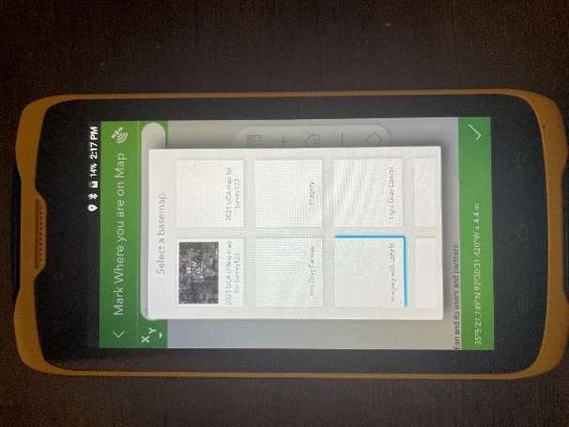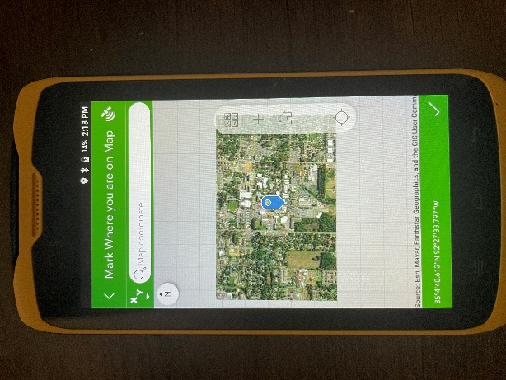

Deliverable 4: Screenshot the map in your survey from your TDC 100 when WIFI and internet data are turned off (like the image above) to submit it in a word file to blackboard (10 points)

Homework
Please submit your deliverable 2,3, and 4. (Deliverable 1 will be published to everyone. Deliverable 2,3, and 4 will be submitted through Blackboard.)

