Exercise 4: Web Experience and HTML
Due date: Midnight (11:59 pm) on Thursday, Sep 25, 2025, submitted as a Word document to Blackboard Lab04 link
This lab counts 6.25 % (50 points out of 800 points) toward your total grade.
Topics covered in this exercise include:
- How to log into Field Map Designer with ArcGIS online account
- How to design your questions
- How to publish and share your survey
- How to access your Field Map

This section will guide you through copying an Experience Builder app. Since the copied experience will be yours, you can explore it in the editing mode to understand how the web experience is configured. For simplicity, the functionality of this experience is kept like that of the dashboard used in section 7.2.
This section provides a predesigned web experience template. You will use this template to create a new app, effectively creating a copy of the web experience.
Section 1: Experience Builder
- In a web browser, go to https://arcg.is/1zm80b to sign in to ArcGIS Online. Alternatively, you can go to ArcGIS Online, sign in, and search for campus reviewer template owner:GTKMobileGIS. You will need to deselect the Only Search in <your ArcGIS Online organization> filter and open the item page of the found template.
  - This is a predesigned Experience Builder app template with a desktop layout designed for reviewing data in the office, typically on a large screen.
- Click Create Web Experience. This creates an app, essentially copying the template app.
- Change the item title to Campus Issue Reviewer_your name.
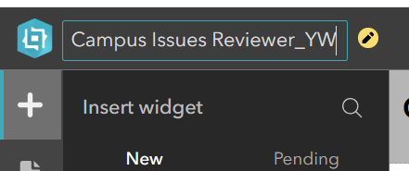
- Next, you will explore the app, on the builder toolbar, click Publish and then click Preview.
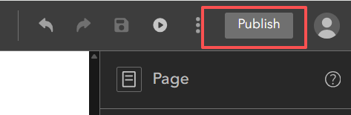
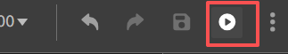
- The web experience opens in a new Browser tab. Next, you will explore its functions.
Note the following widgets:
- Number of Issues, which is a text widget referencing dynamic content from the Issues layer.
- Issues by Type column chart, which is a chart widget.
- Issue Table widget.
- The tabs, which are a Section widget with three views and a Views Navigation widget. The three views are the Info tab, which has the Feature Info widget; the Edit Form tab, which has a Survey123 widget; and the Edit Widget tab, which has the Edit widget of Experience Builder.
- In the header, observe the Status and Issue Type filter.
Making any selections in these two selectors will filter the number, chart, and table widgets mentioned earlier.

Deliverable 1: Provide a screenshot of step 6 to show your selection.
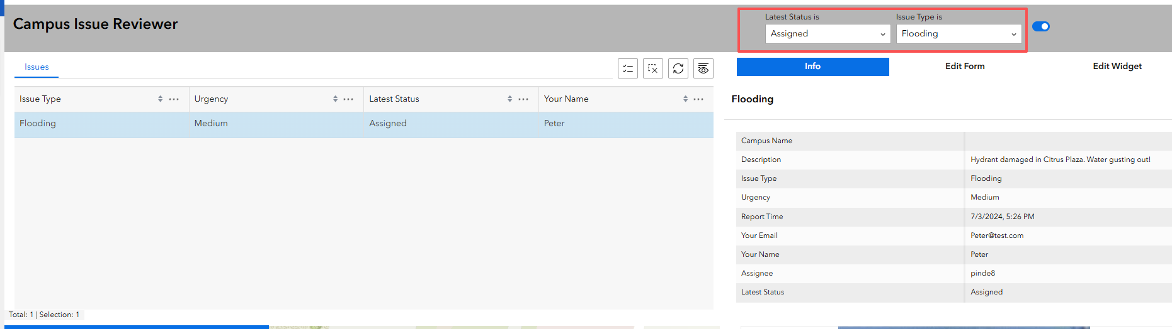
- Click an issue in the Issue table.
The map zooms to the issue location and highlights the issue. The details of the issue display on the Info tab.
Next, you will explore the different ways to edit the data using the Survey123 widget and the Edit widget.
- Randomly select an issue in the left table.
- Click the Edit Form tab.
A Survey123 form displays.
- On the form, complete the required information and click Submit.

Deliverable 2: Provide a screenshot of ‘Your Response was submitted successfully’
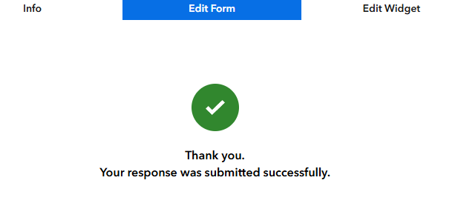
- In the Issue table, click Refresh to update the status of the issue.
- Randomly select one issue from the left table.
- Click the Edit widget.
The Edit widget appears, configured to edit only attributes in this space, although it is capable of editing geometries as well.
- In the Edit widget, update the level of urgency and then click Update.
- In the Issue table, click Refresh.
The Level of Urgency of the issue has been updated.
Next, you will explore how these functions are configured.
- Click the previous Browser tab to return to the configuration mode of the experience.
- On the toolbar on the left, or left sidebar, click the Data button to display the Campus Issue Reviewer map in the app.
The web map has a Source button for you to review the web map’s item page with details if needed.
- On the left sidebar, click the Page button.
This app has only one page. Its outline displays the header and the body, including all the widgets used in the app.
- On the Preview page, hover over the header and click Edit Header.
- Click the Status and Issue Type filter.
Its settings appear on the right side. It is configured to use the Issues layer.
- Click the Issues filter.
- Click SQL Expression Builder and review how the filter is configured on the Status and Issue Type fields.
Because it filters the Issues layer, the filter affects all the widgets using this layer, including the number of issues, the chart, the table, and the map.
- Click Cancel.
- In the Page view, click the Issue table to open the Issue Table settings. Click Action.
Under Message Action, when a record is clicked or selected in the table, the map pans to, zooms to, and flashes the selected record.
Clicking a record in the table selects the record. The selected record is passed to the Feature Info, Survey, and Edit widgets.
Next, you will explore how the Edit Form section is configured.
- In the Page outline, expand Section, expand the Edit Form view, and click the Survey widget.
In the Survey widget settings, the mode is set to Edit an Existing Record. Its source layer is set to the Issues layer, which means that this widget is configured to receive data from the layer when an issue is selected.
- If you made any changes, click Save and Publish. Optionally, share the web experience with everyone or a group.
In this section, you explored the functions of the experience and how the different widgets interact with one another using actions.

Section 2: Explore Map ID
A Map ID serves as a unique identifier for each product developed in Esri application. It ensure your maps are accurately recorded and accessible online. In this section, we will explore two ways to use a Map ID to streamline your work and enhance the power of maps.
- Finding a Map in ArcGIS Online
- You can locate a map by its name in ArcGIS Online.
- Alternatively, you can use the Map ID directly during the search process.
Task: Search for the map in ArcGIS Online using the Map ID below.
Map ID: cee8fdcd0d8f42a3abacdffcdd1ed28f
Deliverable 2: Provide a screenshot showing the ID entered in the search bar and the corresponding map in the search results.
- Embedding a Map with JavaScript
- Maps are a powerful way to share geographic information with users.
- An online map can be shared via a simple URL, or embedded into applications using JavaScript.
- By connecting to a Map ID, JavaScript can display a map in a webpage.
Task: Insert the Map ID above into the file Exercise_4.html to display the map.
- The final output should be a standalone HTML file with your map showing correctly.
Deliverable 2: Submit your HTML file to the lab link. Make sure the file opens properly and the map is displayed..

