Exercise 05 GPS Collection Planning using Navmatrix GPS Mission Planning and Satlook
Due date: Midnight (11:59 pm) on Thursday, Oct 2, 2025, submitted as a Word document to Blackboard Lab05 link
This lab counts 6.25 % (50 points out of 800 points) toward your total grade.
Accurate GPS data collection requires more than just turning on a receiver in the field. Satellite geometry, visibility, and signal strength all directly affect the quality of positional measurements. Careful planning ensures that data are collected when satellite availability and geometry are most favorable, leading to higher accuracy and fewer errors.
In this lab, you will practice GPS mission planning and satellite observation using two tools:
- Navmatrix GPS Mission Planning – a web-based platform that allows you to predict satellite availability, dilution of precision (DOP) values, and satellite visibility for a given location and time. By adjusting planning parameters, you can identify the best time windows for high-quality GPS data collection.
- Satlook – an application on the Trimble TDC 100 receiver that lets you monitor satellites in real time. With Satlook, you can view the sky plot, read raw NMEA output, and evaluate the signal-to-noise ratio (SNR) of satellites during fieldwork.

Part 1
This assignment will require you to use the Navmatrix GPS Mission Planning website: http://gnssmissionplanning.com/.

Click on ‘Begin Planning’, and navigate to the Settings Tab.

You will plan for a GPS collection on 9/25/2025 at the University of Central Arkansas. You will need to fill out the settings form. Please read carefully.
- Search Address: set to ‘University of central Arkansas’, then click on search icon . You will notice, the map will zoom to the UCA. The latitude and longitude information will be automatically filled. Note: If you know the latitude and longitude information, you can fill the latitude and longitude information directly, in that case, you do not need to search Address.
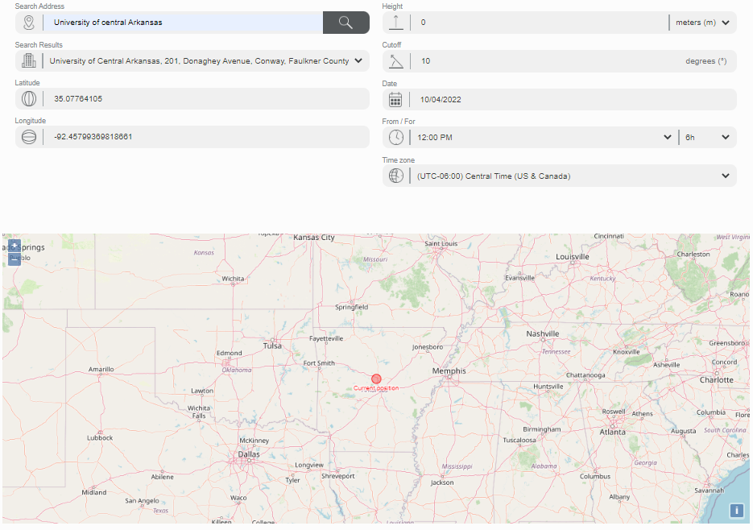
-Height: set to 0 meters
-Cutoff: set to 10 degree.
-Date: set to 9/24/2025
-From/For: 12:00 PM for 6 hours. Note, here assume the data collection time period is from 12: 00 pm to 6: 00 pm.
-Time Zone: Set ‘UTC-6:00 Central Time (US & Canada)’.
After finish setting, click on ‘Apply’. You will see available GNSSs. Note, you may need to wait for couple minutes.
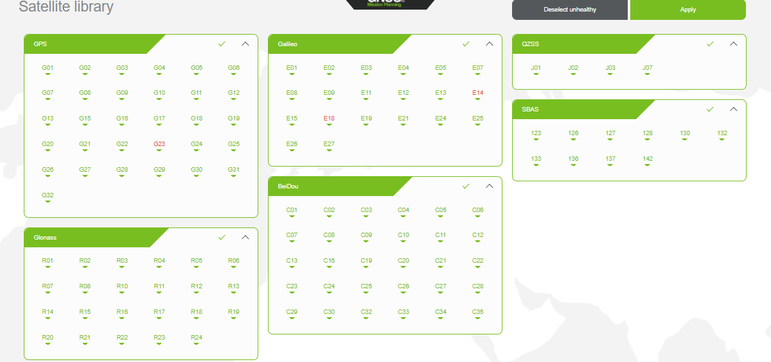
Turn off all of the constellations excepting GPS by clicking on Galileo, QZSS, SBAS, GLONASS, and Beidou.
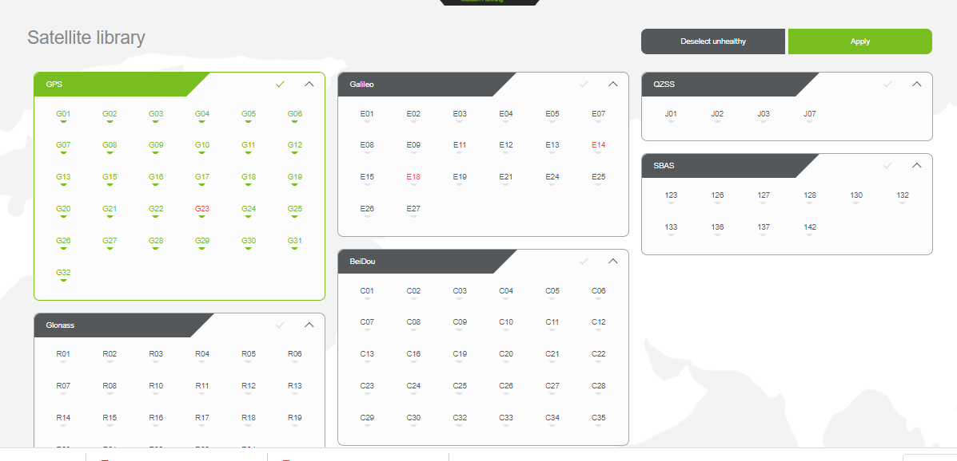
Click on ‘Apply’. It will start to calculate. Note, you may need to wait for couple minutes. When it finished, the ‘Charts’ will be activated. You can navigate to the left panel to read different indexes.
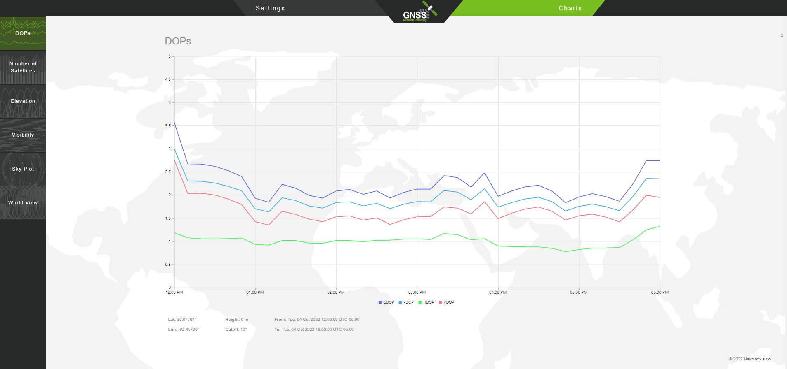
Note, your time may not be shown as 12:00 pm to 6:00 pm as mine. If you select the correct time zone (i.e., UTC-6:00 Central Time (US & Canada)), it should be right.
With the indexes, please answer the following questions (Be careful, do not click on World View at this time, otherwise your results will be lost!).
- During which time period (roughly) is relatively better to collect the data? Why? (Hint, the lower the GDOP/PDOP/HDOP/VDOP, the higher the accuracy) (5 points)
- What is the maximum number of GPS satellites that are predicted to be detected during this time period? (5 Points) (Hint, please refer to ‘Number of Satellites’ panel). Provide a screenshot of ‘Number of Satellites’
- On this time period and at this location, when will satellite G01 be observable? (5 Points) (Hint, please refer to ‘Visibility’ panel). Provide a screenshot of ‘Visibility’

Part 2
Now you will do your own mission planning. You could need to select different time or location as that in Part I.
- Copy the Setting form to your word document. (Note, you can keep height and cutoff as Part I) (5 points)
- Copy the DOPs graph to your document (5 points)
- Copy the number of Satellites to your document (5 points)
- Copy the Visibility to your document (5 points)
- Copy the Sky plot at end time to your document (Hint, you need to scroll the time icon to most right) (5 points)
- When is the best time for you to collect your project data? (5 points)

Part 3
We have learned how to use Satlook to explore satellites in class. Now you will demonstrate how to operate the Satlook app to observe satellite visibility, interpret GNSS signals, and evaluate location accuracy in the field.
Deliverable 1: The sky plot in Satlook shows the spatial locations of satellites and helps you understand how they are distributed around your position. Provide a screenshot of the sky plot and explain which direction has the highest concentration of satellites. (5 points)

Deliverable 2: The NMEA view in Satlook displays GPS information in raw text format. Record the NMEA output and submit it as a .txt file to Blackboard. (No screenshot is required for this deliverable; only the raw .txt file is needed.) (5 points)

Deliverable 3: The SNR display in Satlook shows the signal strength of each satellite. Describe whether the signals were strong or weak at the time of your observation, and provide a screenshot of the SNR display to support your explanation.(10 points)

Homework
Please copy these questions with your answers to a word document and submit it through the Blackboard.

