Exercise 8: Creating ArcGIS Dashboard
Due date: Midnight (11:59 pm) on Thursday, Nov 20, 2025, submitted as a Word document to Blackboard Lab08 link.
This lab counts 6.25% (50 points out of 800 points) toward your total grade.

Data:
For this lab, please continue using the 311_service.zip file that you downloaded from the City of Dallas GIS Portal.

Task 1: Complete Code
Code: Upload zip file include the 311 service data to ArcGIS Online

folder_name = " "
if folder_name not in [f["title"] for f in my_gis.users.me.folders]:
my_gis.content.folders.create(folder_name)

item_properties = {
'title': 'Dallas 311 Service',
'type': 'Shapefile',
'tags': 'Dallas, 311, Service'
}
added_item = my_gis.content.add(item_properties, data = shapefile_path,folder='')

The code above uploads your local ZIP file to your ArcGIS Online account as a Shapefile item.
After running this cell, go to your ArcGIS Online → Content page — you should see a Shapefile item with the title you defined, stored inside the folder you just created.

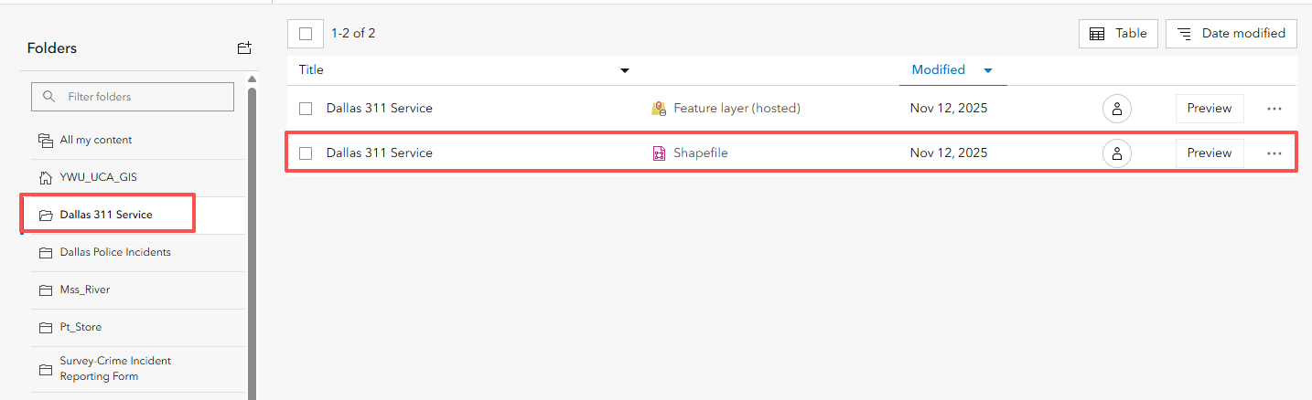

Note on Re-running the Code
If you execute this code multiple times, you may see an error message like:
Item 'dallas_311.zip' already exists. (Error Code: 409).
This message simply means the shapefile has already been uploaded.
To fix it, either:
- Delete the existing item in your ArcGIS Online content before re-uploading, or
- Change the title or file name before uploading again.

Deliverable 1: Upload the ZIP file that includes the 311 service data to ArcGIS Online.
Provide a screenshot of your code and show the Shapefile item in your ArcGIS Online account. (10 points)

Code: Publish the Uploaded Shapefile as a Feature Layer
published item = added_item.publish()

The code above publishes your uploaded shapefile as a Hosted Feature Layer, which allows you to visualize, query, and analyze the data interactively on ArcGIS Online.
After running this code, a new Feature Layer will appear in your Content page.
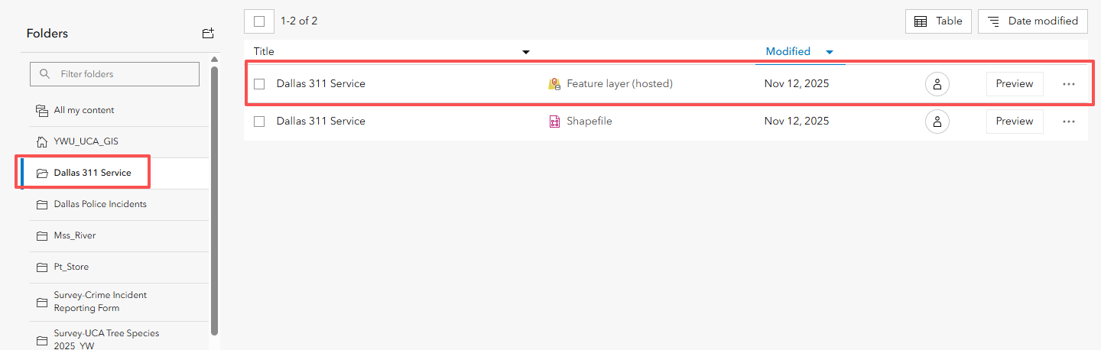

Deliverable 2: Provide a screenshot showing the Feature Layer in your ArcGIS Online account. (10 points)

Task 2: Create a web map
Dashboards only accept Web Maps as input.
To create one, go to your ArcGIS Online Content page — you should now see the Feature Layer you just published. Create a Web Map using this layer.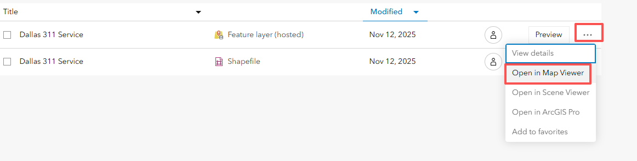
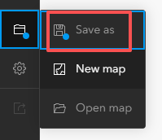
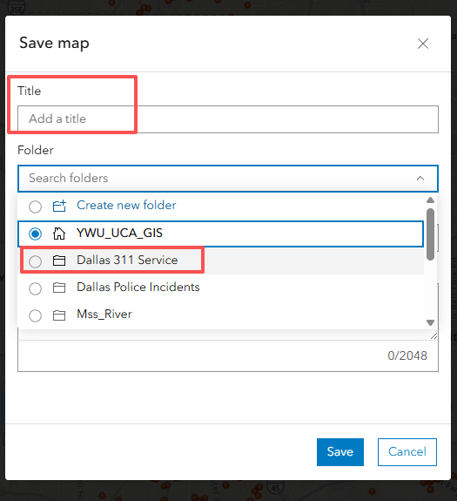

Deliverable 3: Provide a screenshot showing your Web Map in ArcGIS Online. (10 points)

Task 3: Build a Dashboard
- Go to Dashboards → Create Dashboard.
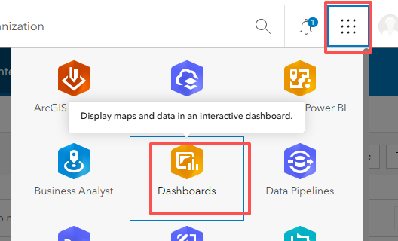
Create dashboards,
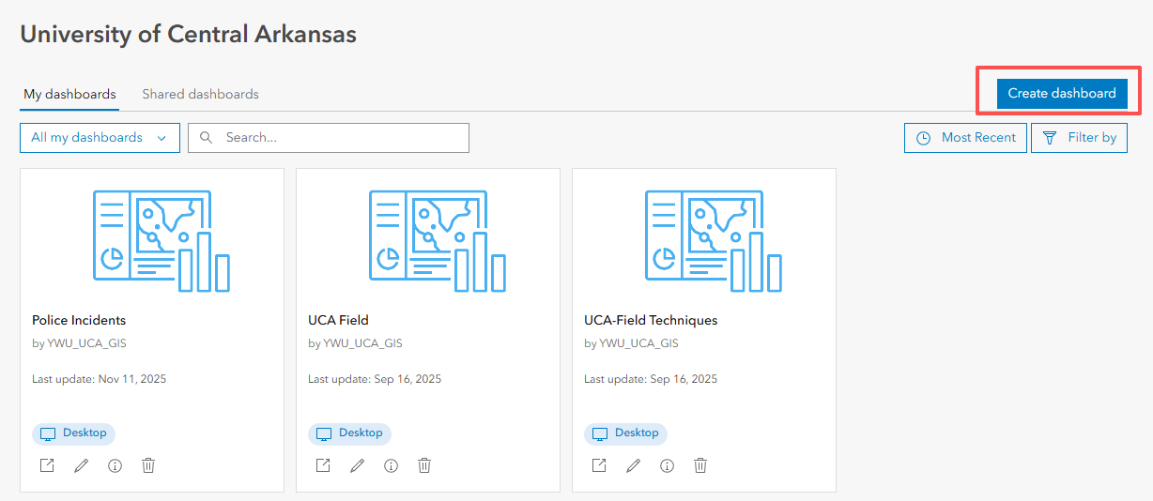
Provide a title for your dashboard. It’s recommended to store it in the same folder as your 311 service shapefile and Feature Layer.
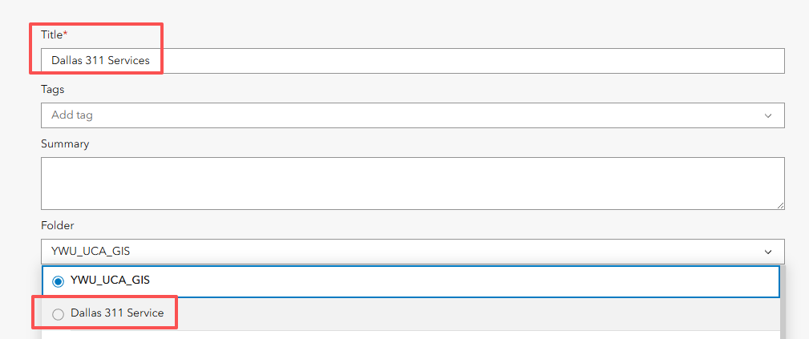
Click the plus (+) button in the central area to add a Web Map.
A pop-up window will appear showing all available Web Maps in your ArcGIS Online account — select the 311 Service Web Map. This step demonstrates why creating a Web Map is necessary: Dashboards only accept Web Maps as map content.
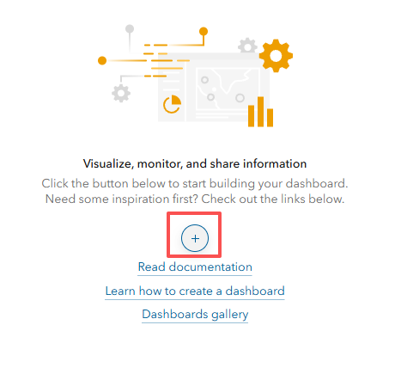
Now in the middle part, is your web map.

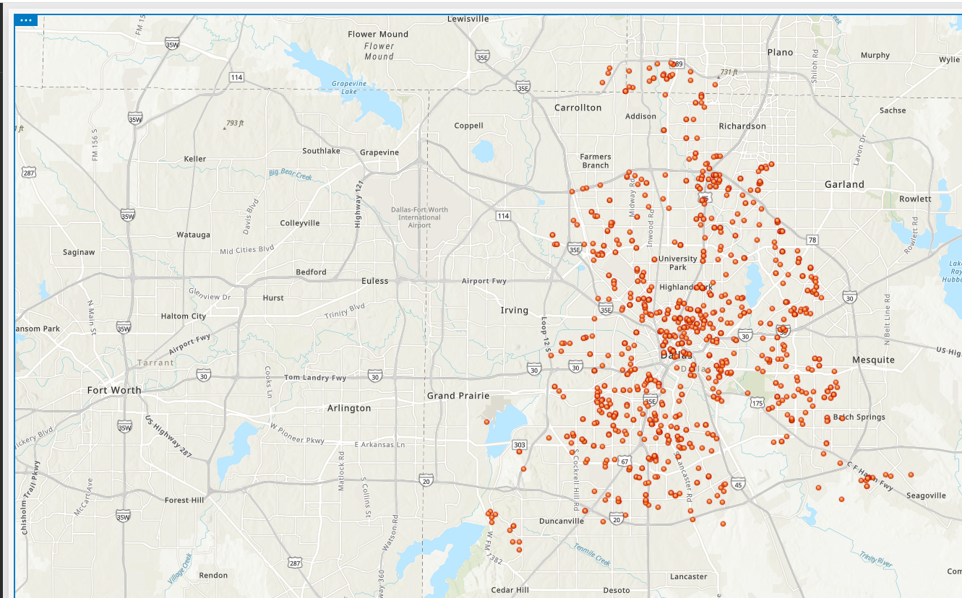
Once your Web Map appears in the center panel:
- Click the blue plus (+) button to add elements to your dashboard.
- Four small plus icons will appear in the corners. To add an element on the left side, click the left plus (+) button.
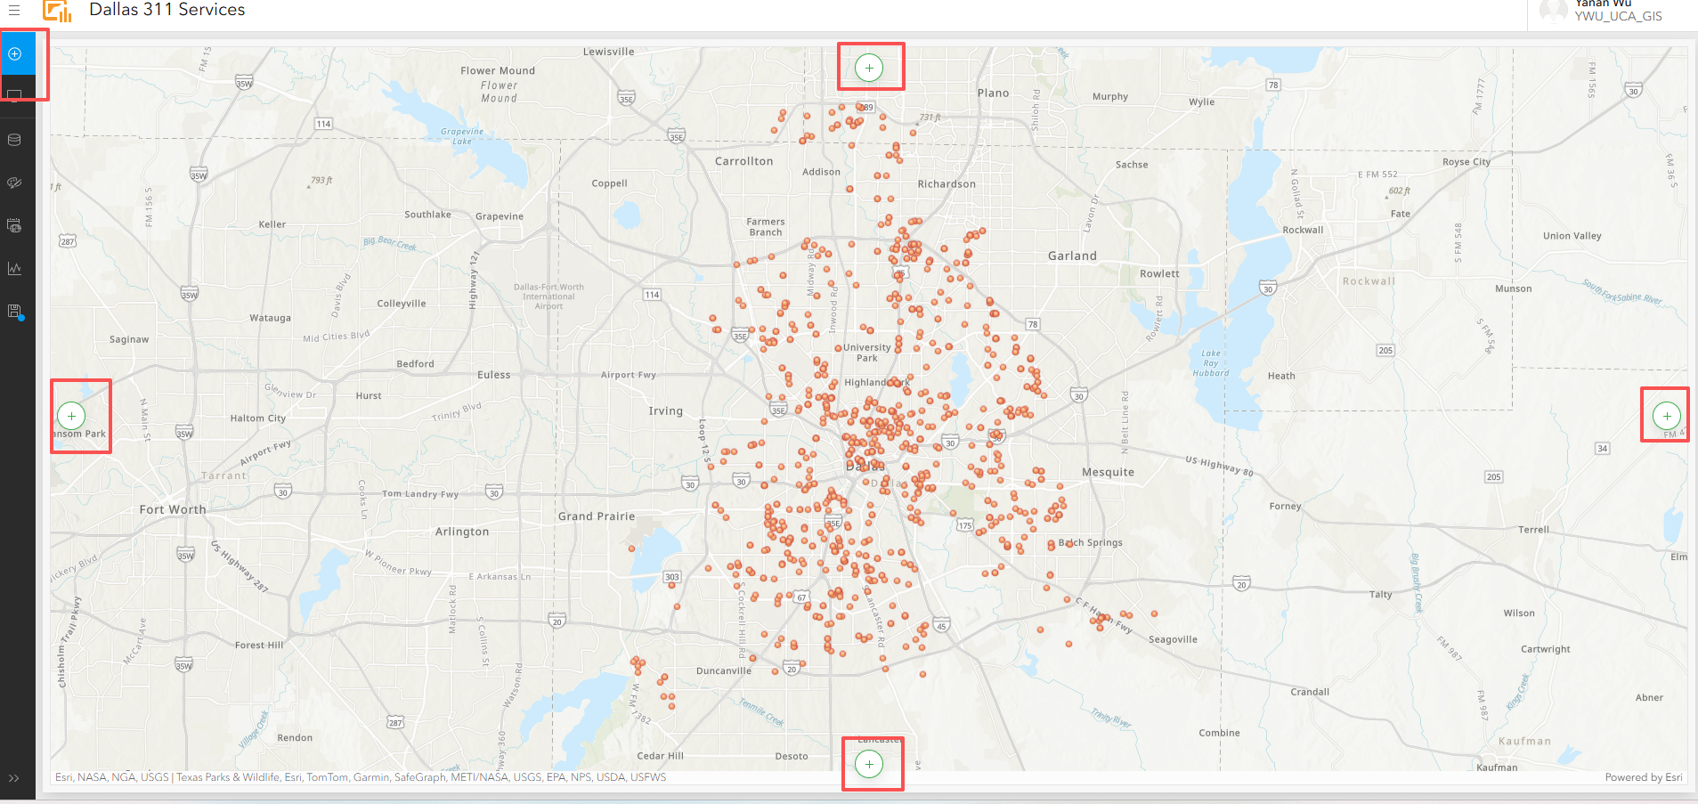

Task 4 : Create a Pie Chart Element:
- Choose the Feature Layer for your element.
- Set the following options:
  - Category field: Type
  - Statistic: Count
  - Field: FID
- A pie chart will appear on the left side, showing the proportion of each 311 service type.
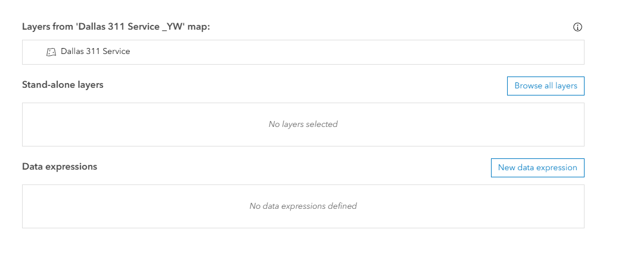
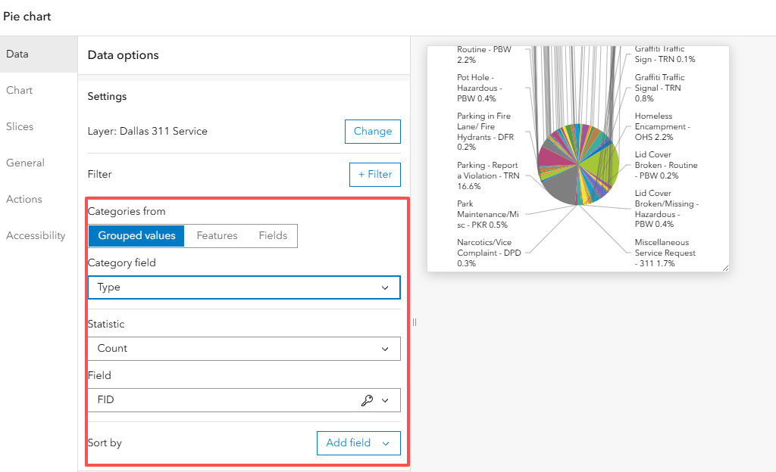

Deliverable 4:
Add one additional element to your dashboard (besides the pie chart).
Provide a screenshot showing at least two elements — the pie chart and one more element you created. (10 points)

