Compass calibration:
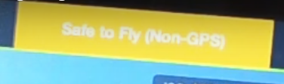
Main menu: - Advance – Sensors – Calibrate IMU

