Exercise 3: ArcGIS Field Map
Due date: Midnight (11:59 pm) on Monday, Sep 8, 2025 submitted as Word document to blackboard Lab02 link
This lab counts 6.25 % (50 points out of 800 points) toward your total grade.
In this tutorial, you will design a Mobile GIS solution to inventory assets in a specified area, such as your campus, community, or a local park. This tutorial will guide you through creating a functional and secure Mobile GIS solution that enhances data integrity and user engagement, ensuring that each layer and form is specifically designed to streamline the data collection process while securing the data against unauthorized modifications.
Topics covered in this exercise include:
- How to log into Survey123 with ArcGIS online account
- How to design your questions
- How to publish and share your survey
- How to access your survey in TDC 100
- How to create offline basemap for collecting data offline

Requirements:
- Data collection capabilities:
  - Ability to collect point, line, and polygon assets.
  - Allow photo attachments for each type of asset.
- Layer configuration:
  - Each layer should have at least a category attribute field with a list of coded values.
  - Each layer must offer more than one feature template.
- Form design:
  - At least one layer’s form must include two or more of the following: combo boxes, radio buttons, switches, or their combinations.
  - The form should be smart, incorporating one conditional visibility, one conditional requirement, and one calculated expression.
- Access and security:
  - Allow mobile workers to access and collect data using your web map and layers in Field Maps.
  - Configure the layers to prevent any mobile worker from modifying data collected by others.
- Data collection:
  - Collect some features using Field Maps mobile app to test your forms and web map.

Step1: Create feature layers and a web map using Field Maps Designer
- Start a web browser, navigate to ArcGIS Online (https://www.arcgis.com, or the URL to your ArcGIS Online organization), and sign in.
- In the upper right of the page, click the app launcher and select Field Maps Designer.
The Maps page displays (Your map displays are different from mine based on the maps that available in your account) all the maps you own or have privileges to edit.
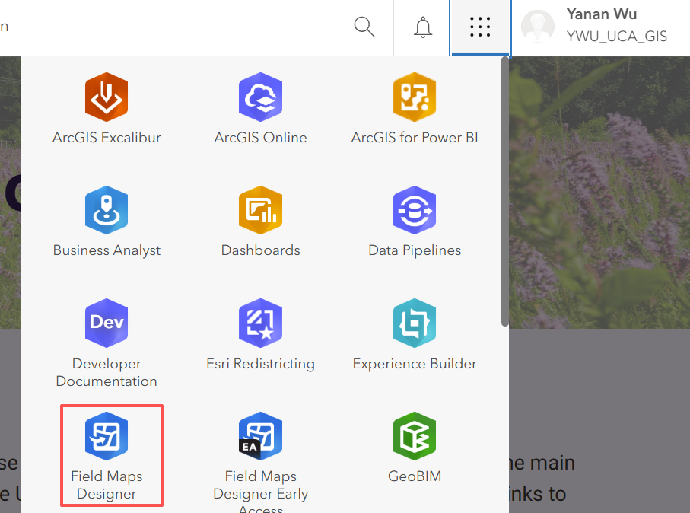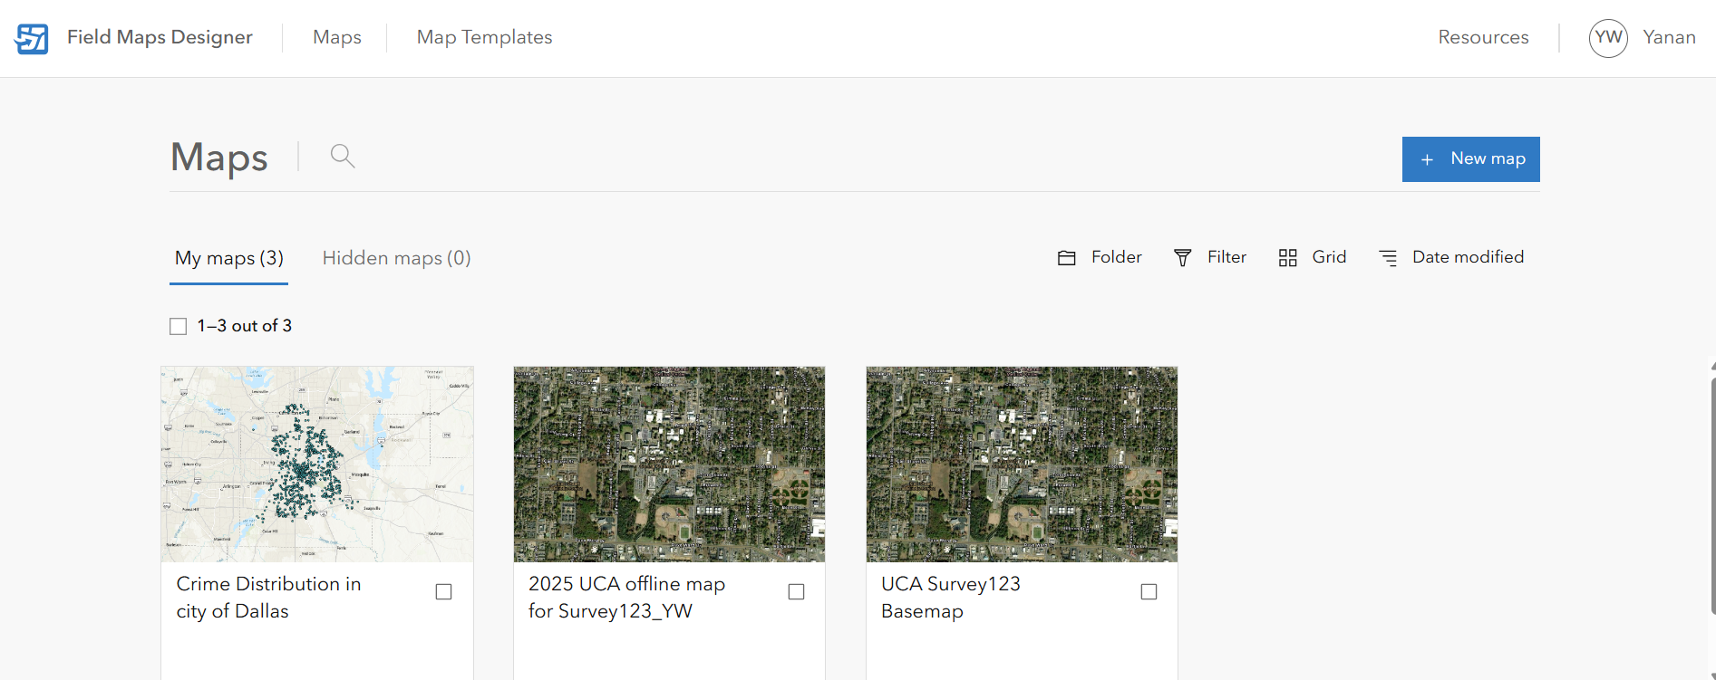
- Click the New Map button. Select start with new layers
- On the Create Layers tab, apply the following settings:
- For Layer name, replace Layer_1 with Point Assets. Keep the Layer type as Point Layer.
- Click the Add button to add another layer.
- For Layer Name, replace Layer_1 with Line Assets. For Layer Type, choose Line Layer.
- Click the Add button to add another layer.
- For Layer name, replace Layer_2 with Polygon Assets. For Layer Type, choose Polygon layer.
- Click Next.
The Layer Settings tab appears. these settings allow you to configure tasks, high-accuracy GPS metadata fields, and z-value and m-value enabled geometries. Tasks are discussed in chapter 6. You don’t need to change these default settings.
Next, you will define the layer’s coordinate system.
- On the Layer Settings tab, apply the following settings:
- Click Advanced settings, expand the Set Coordinate System drop-down list, choose Use a Coordinate System, and click Browse.
- In the Coordinate Systems window, search for Web Mercator.
- In the search result, choose WGS 1984 Web Mercator (auxiliary sphere).
- Click Done.
- Click Next.
The Title and Save tab appears. Here you will set the title of the web map, which is the map name that your mobile workers will see, and the title of the host feature layer, which will include the point, line, and polygon assets sub-layers you defined above.

- On the Title and Save tab, apply the following settings:
- For Map Title, type Asset Inventory.
- For Feature Layer Title, type Assets.
- For Folder, click Create New Folder, type Week 05 Field Map_YourInitial (The feature layer title needs to be unique in your ArcGIS Online organization, so append your initials to make the title unique), and press Enter.
- Click Create Map.
It will take a moment for the map and layers to be created. After they are created, the form builder becomes available. You will build the forms in the next section.
Deliverable 1: Make a screenshot of your initial Field Map. See example below.
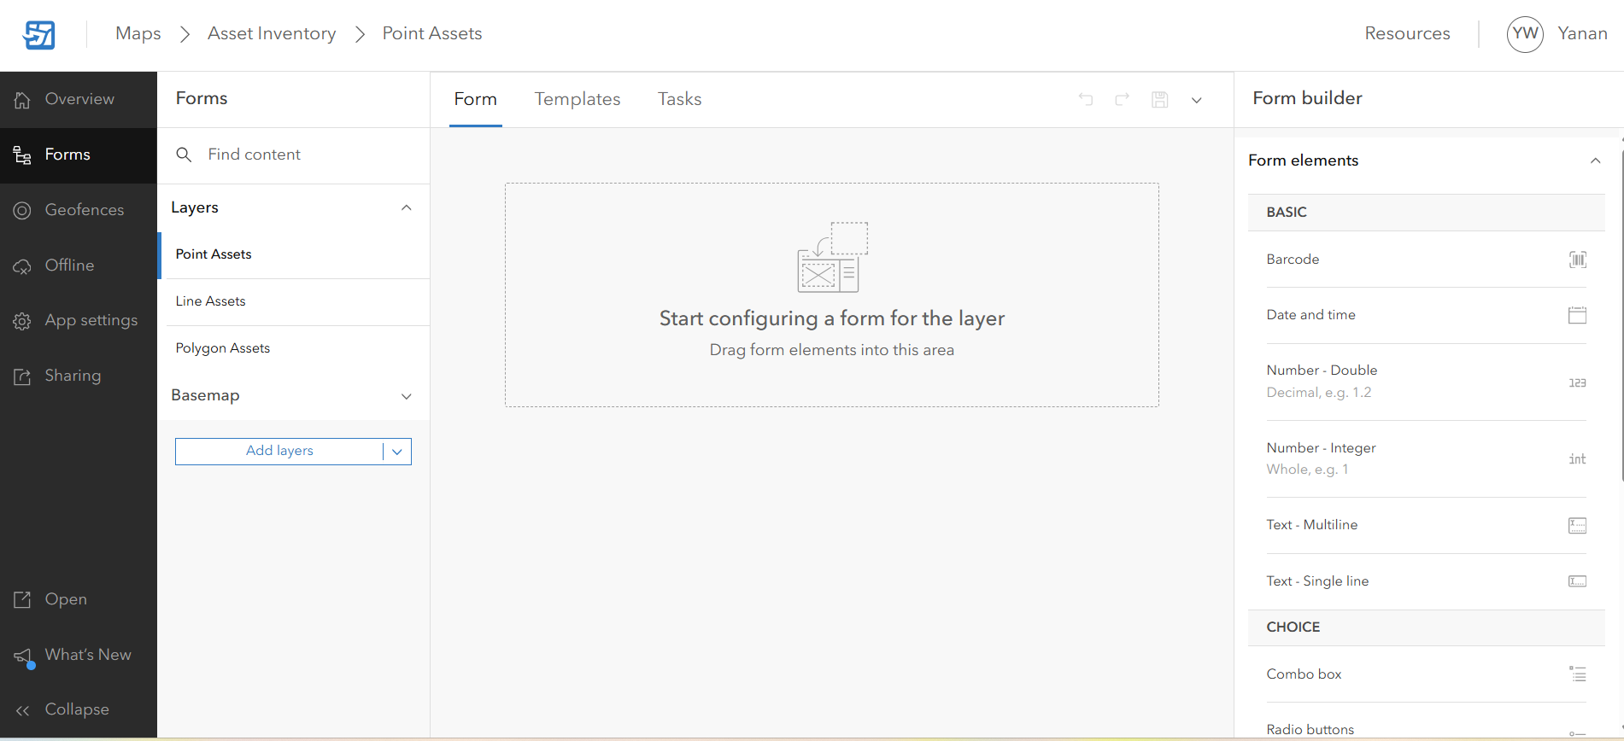

Step 2: Build the forms and design the layer schemas
In this section, you will design a form for each of the layers, and this will create the corresponding attribute fields for the layers.
Note: When editing the map, layers, and form in Field Maps Designer, avoid editing them simultaneously in separate browser tabs. Editing these elements across multiple tabs can result in data loss or data being overwritten.
- In the Forms pane, under Layers, make sure the Point Assets layer is selected.
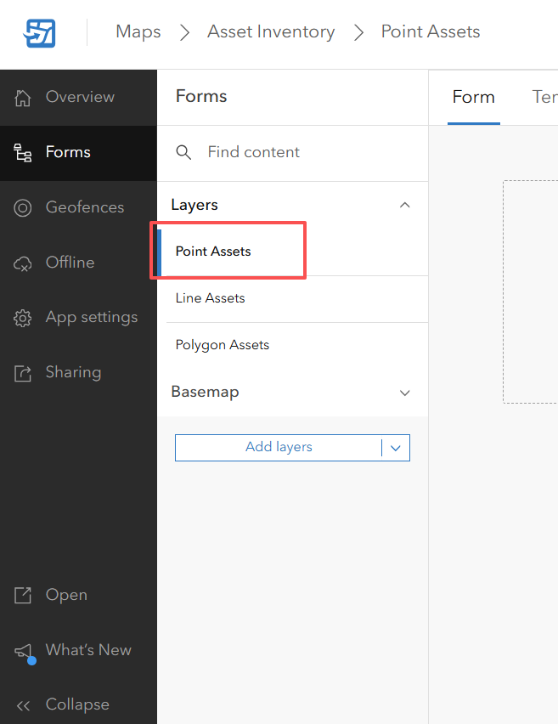
If you have closed the browser, go to ArcGIS Online, sign in, click the app launcher, click Field Maps Designer, and click the map you just created.
The layer has a blank form canvas. You will add the category, condition, need maintenance, notes, city, and inspector name elements to the form and create the fields in the layer.
- In the Form builder pane, drag a Combo Box element to the form.
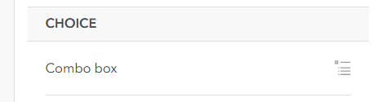
You will be using the download PointAssetCategories.csv file in the next step.
- In the Form builder pane, in the Properties pane, apply the following settings:
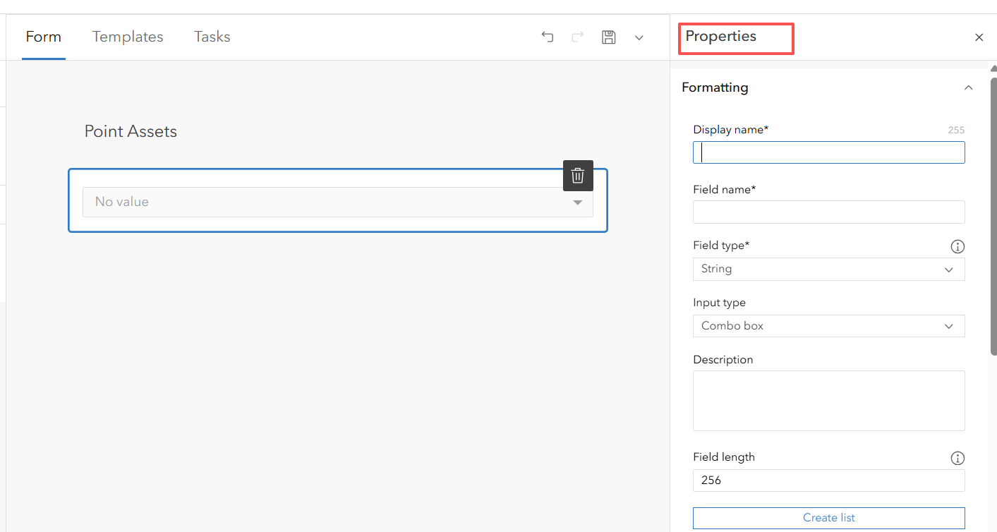
- In the Formatting section, for Display Name, type Category. The Field name will be autofilled as the Display name.
- Click Create List.
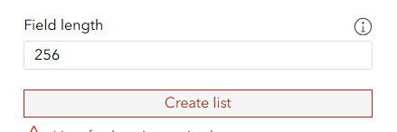
- Click Select from Your Device and browse to and select the PointAssetCategories.csv file you just downloaded.
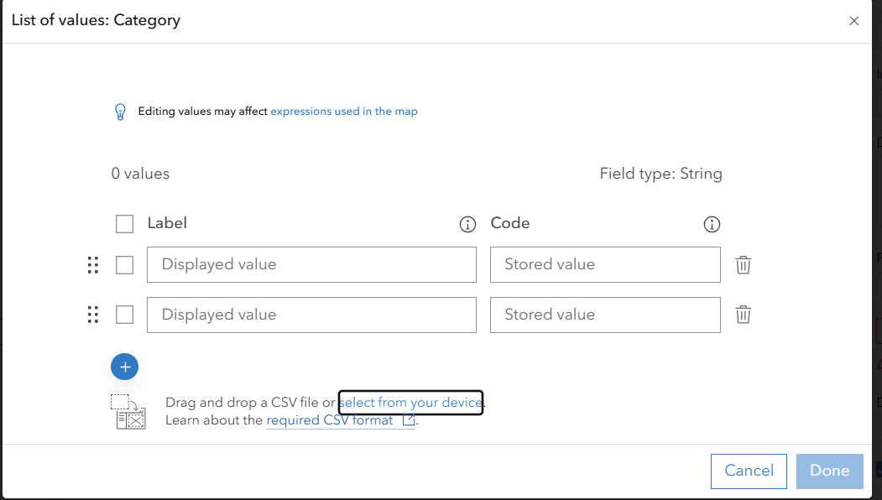
- Review the labels and codes loaded.
- Click Done.
- If prompted with a dialog box asking if you want to continue, click Continue.
- Uncheck the Include “No value” option.
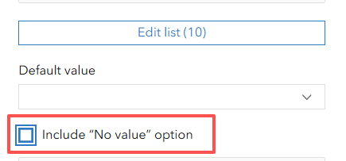
- Under the Logic section, check Required.
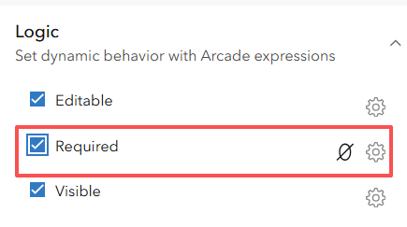
- Close the Properties pane.

- Click the Save to Map button.
In the rest of the section, click Save often to avoid loss of your settings.
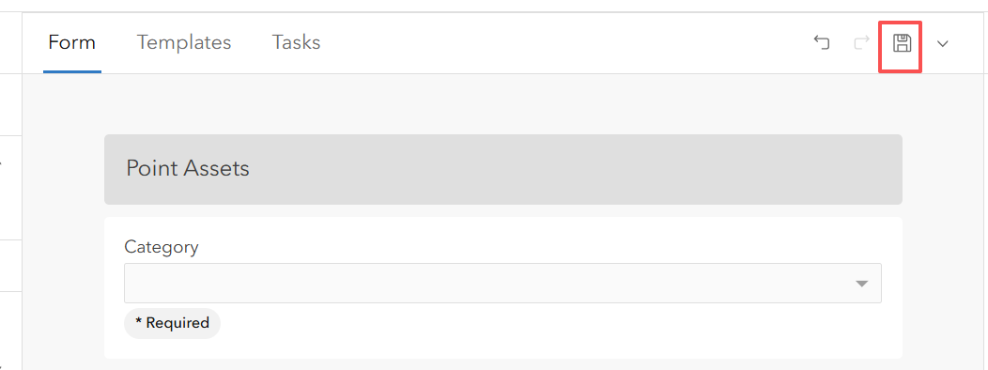
- In the Form builder pane, drag a Radio Buttons element to the form, under the Category element.
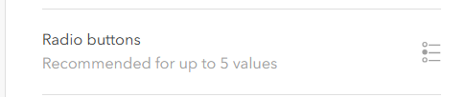
- In the Properties pane, apply the following settings:
- In the Formatting section, for Display Name, type Condition.
- Click Create List.
- Type three labels: Excellent, Fair, and Poor, with each code the same as the label.
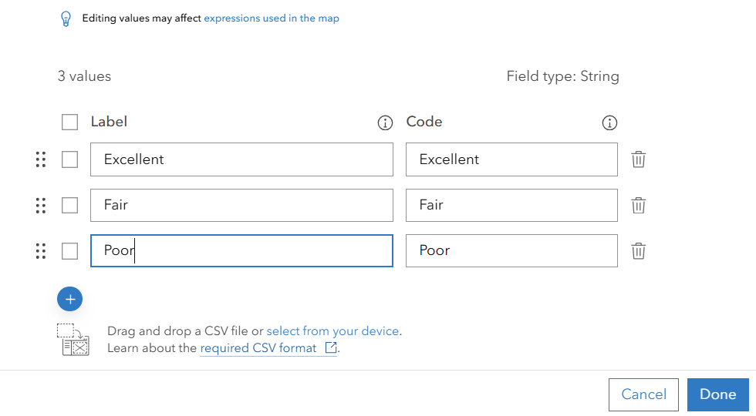
- Click Done and click Continue if prompted.
- Uncheck the Include “No value” option.
- In the Logic section, check Required.
- Close the Properties pane.
Next, you will add the Need Maintenance element.
- In the Form builder pane, drag a Switch element to the form, under the Condition element.
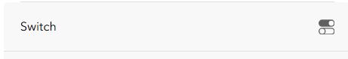
- In the Properties pane, apply the following settings:
- For Display Name, type Need Maintenance.
- Under Switch Values, for Off Value, type No.
- For On Value, type Yes.
- For Default Value, choose No.
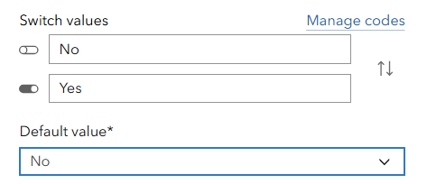
- Close the Properties pane.
Next, you will add a multiline text and two single-line text elements.
- In the Form builder pane, drag a Text – Multiline element to the form, under the Need Maintenance element.
- In the Properties pane, apply the following settings:
- For Display Name, type Notes.
- Close the Properties pane.
- In the Form builder pane, drag a Text – Single Line element to the form, under the Notes element.
- In the Properties pane, apply the following settings:
- For Display Name, type City.
- Close the Properties pane.
- In the Form builder pane, drag a Text – Single Line element to the form, under the City element.
- In the Properties pane, apply the following settings:
- For Display Name, type Inspector.
- Close the Properties pane.
- Click Save to Map.
Next, you will configure the line and polygon assets layers by adding a Category element.
- In the Forms pane, under Layers, click Line Assets.
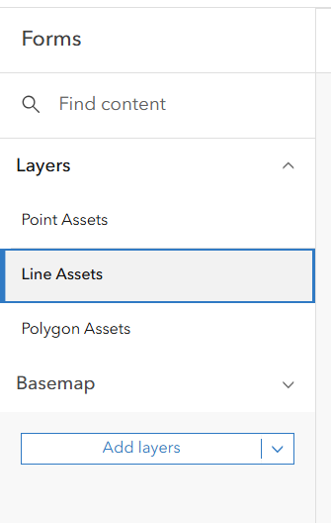
- In the Form builder pane, drag a Combo Box element to the form.

- In the Properties pane, apply the following settings:
- For Display Name, type Category.
- Click Create List.
- Type three labels: Fence, Trail, and Electric Line, with each code the same as the label.
- Click Done and click Continue if prompted.
- Close the Properties pane.
- Click Save to Map.
- In the Forms pane, under Layers, click Polygon Assets.
- Similarly, add a Combo Box element, with Category for Display Name, and Pond, Lawn, Sports Field for Labels and Codes.
- Click Save to Map.
You have built a basic form for each asset layer. Through the process, you have also defined the schemas for the layers. You will review the schemas later in this tutorial.

Step 3: Improve smart forms using Arcade
In this section, you will improve the forms you created in the previous section by adding conditional visibilities, conditional requirements, and calculations.
- Under Layers, click Point Assets.
The form for the Point Assets layer displays. You will configure the Need Maintenance field as visible when the condition is fair or poor, and as required only when the condition is poor.
- Click the Need Maintenance element.
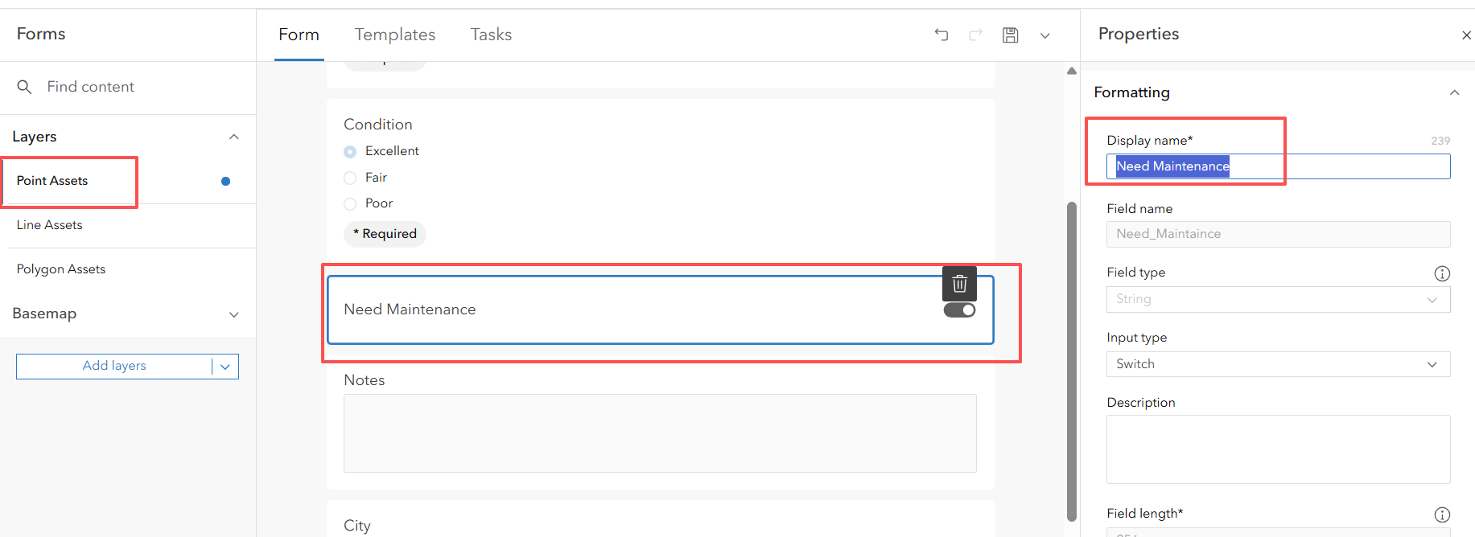
- In the Properties pane, under the Logic section, next to the Required check box, click the Settings button.
- Click New Expression.
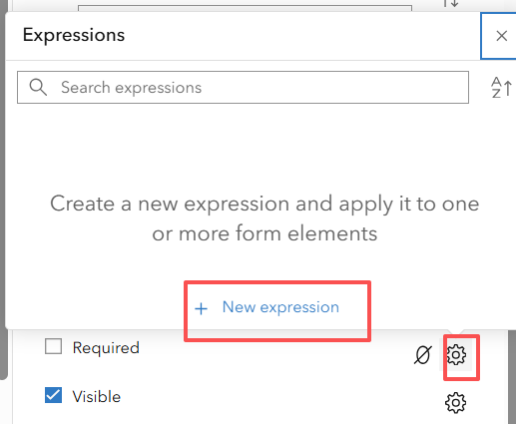
- In the Expression builder window, set the Title as Poor Condition.
- Choose the Condition field, the is operator, and the value Poor.
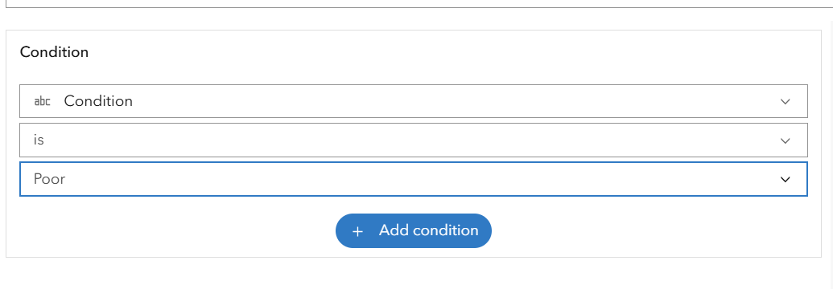
- Observe that the following Arcade syntax is built for you automatically:
DomainName($feature, "Condition") == "Poor"
- Click Done.
The Arcade line of code checks if the Condition attribute value of the current feature being collected is labeled Poor. Because the labels and the codes of the Condition attribute are the same, the code can evaluate the code—in other words, the attribute value—directly, and thus the line of script can also be written as $feature["Condition"] == "Poor", or yet another way as $feature.Condition == "Poor".
- In the Properties pane, under the Logic section, next to the Visible check box, click the Settings button.
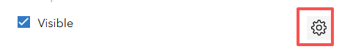
  - Click New Expression.
  - In the Expression builder window, set the Title as Fair or Poor Condition.
  - Choose the Condition field, the is operator, and the value Fair.
  - Click Add Condition.
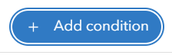
  - Choose the Condition field, the is operator, and the value Poor.
  - Observe the Arcade syntax built looks like the following:
DomainName($feature, "Condition") == "Fair" ||
DomainName($feature, "Condition") == "Poor"
  - Click Done.
Because the labels and the codes of the Condition attribute are the same, the script can also be written as follows:
$feature["Condition"] == "Fair" || $feature["Condition"] == "Poor", or $feature.Condition == "Fair" || $feature.Condition == "Poor".

Next, you will configure the Notes element to be visible only when Need Maintenance is set to Yes.
- Click the Notes element.
- In the Properties pane, next to the Visible check box, click the Settings button.
  - Click New Expression.
  - In the Expression builder window, set the Title as Maintenance Needed.
  - Choose the Need Maintenance field, the is operator, and the value Yes.
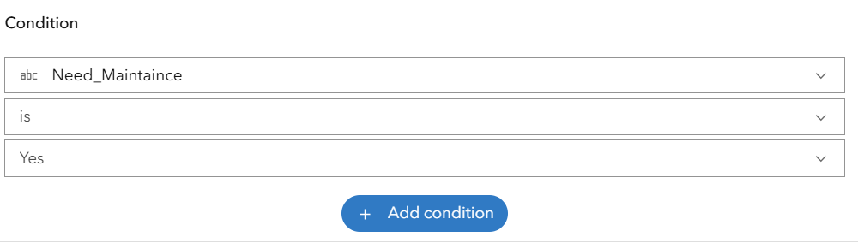
  - Observe the Arcade syntax built looks like the following:
DomainName($feature, "Need_Maintenance") == "Yes".
  - Click Done.
Next, you will calculate the inspector’s full name, so that the mobile workers won’t have to type their names manually.
- Click the Inspector element.
- In the Properties pane, under the Logic section, next to Calculated Expression, click the Settings button.
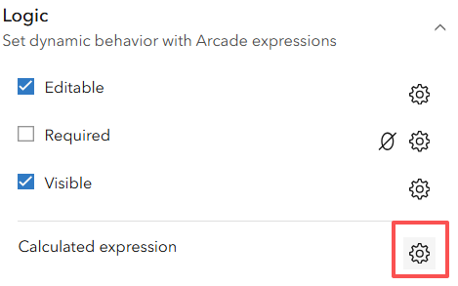
  - Click New Expression.
  - In the Expression builder window, set the Title to Calc Full Name.
  - Click the Functions button (fx) on the right side of the window. Search for GetUser. In the search result, notice the multiple ways to get user info.
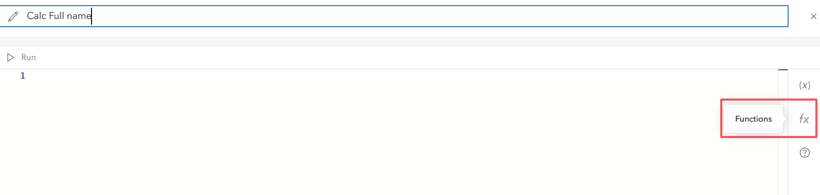
  - Under Portal Functions, notice GetUser(portalObjects?, username?). Click the arrow button on the right to learn more about it.
  - Read the description of the function and understand the parameters and the return value. Scroll down to review the examples.
  - In the script area, type the following：GetUser(Portal(‘https://arcgis.com’)).fullName
  - Click Run and notice your full name displays in the Output area.
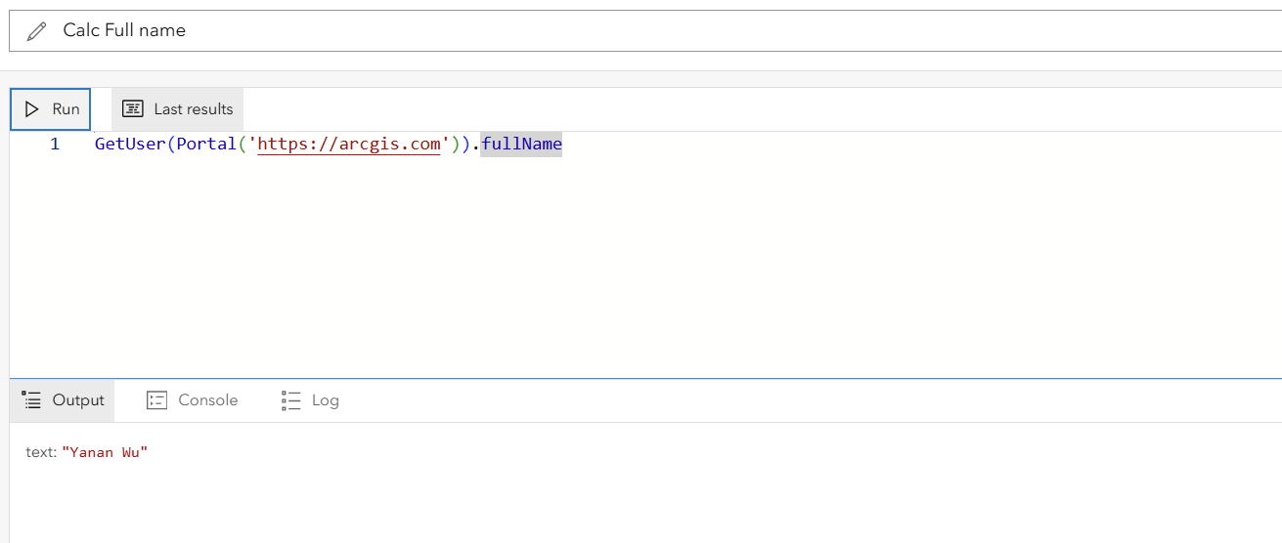
  - Click Done.
Next, you will calculate the city that the asset location is within. You will add the cities layer to the map so that Arcade can access the layer more easily.

- Click Save to Map.
- On the Contents toolbar, click Open and choose Map Viewer.
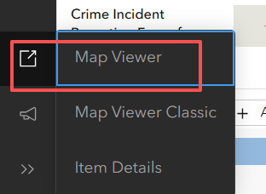
Map Viewer opens with your layer listed. Next, you will add a provided cities layer.
Map Viewer toolbars
Map Viewer has two vertical toolbars on the left and right sides of the view. The dark toolbar on the left is the Contents toolbar. This is used for managing layers and tables. The light toolbar on the right is the Settings toolbar. This is used to access options for configuring and interacting with map layers. there are Expand and Collapse buttons at the bottom of each toolbar to expand or collapse them.
- In Map Viewer, apply the following settings:
- On the Contents toolbar, click the Add button. Select browse layer
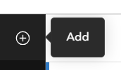
- Above the search bar, click My Content to expand the list. Choose ArcGIS Online.
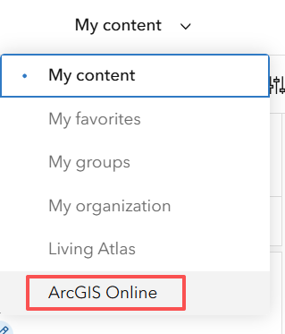
- Search for USA Cities owner:GTKMobileGIS.
- Click Add to add the found layer to the map.
- Click the back arrow to go back to the Layers list.
- Drag the USA Cities layer down to the bottom so that the polygon layer won’t block other layers.
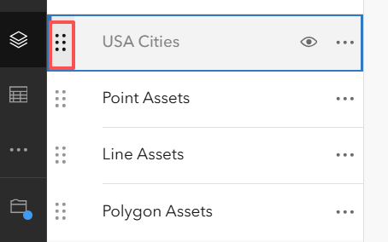
- Zoom in to see the Cities layer display on the map. The Cities layer show data only when you zoom in to specific level.

- Click a city to see the attributes in the pop-up. Notice it has a Name field.

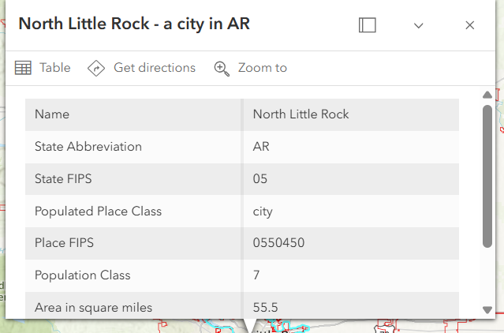
Next, you will change the basemap to Imagery Hybrid, which can serve as a better reference for placing asset locations.
- On the left toolbar, click the Basemap button and select Imagery Hybrid.
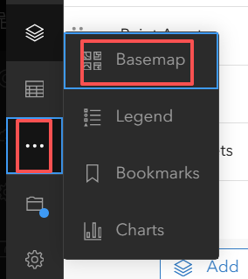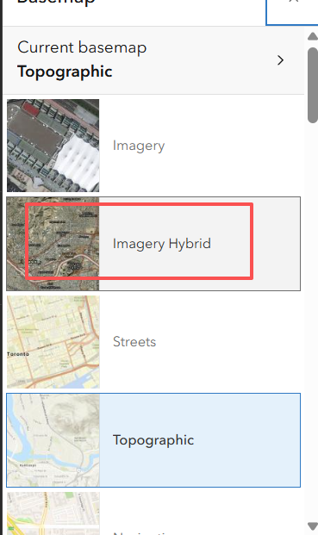
- Click Save and Open. Click Save.
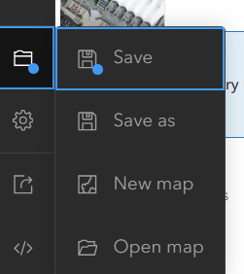
- Close Map Viewer.
You are directed back to Field Maps Designer. Your web map is reloaded automatically to ensure that you work with the latest of your web maps.
- On the form for the Point Assets layer, click the City element.
- In the Properties pane, click the Settings button next to Calculated Expression.
- Click New Expression.
- In the New Arcade Expression window, for Label, type Calc City.
- In the script text area, type the following code:
var cities = FeatureSetByName($map, "USA Cities", ["NAME"]);
var city = First(Intersects($feature, cities));
if (!IsEmpty(city)) {
return city["NAME"];
} else {
return null;
}
- Click Run and notice the output is null.
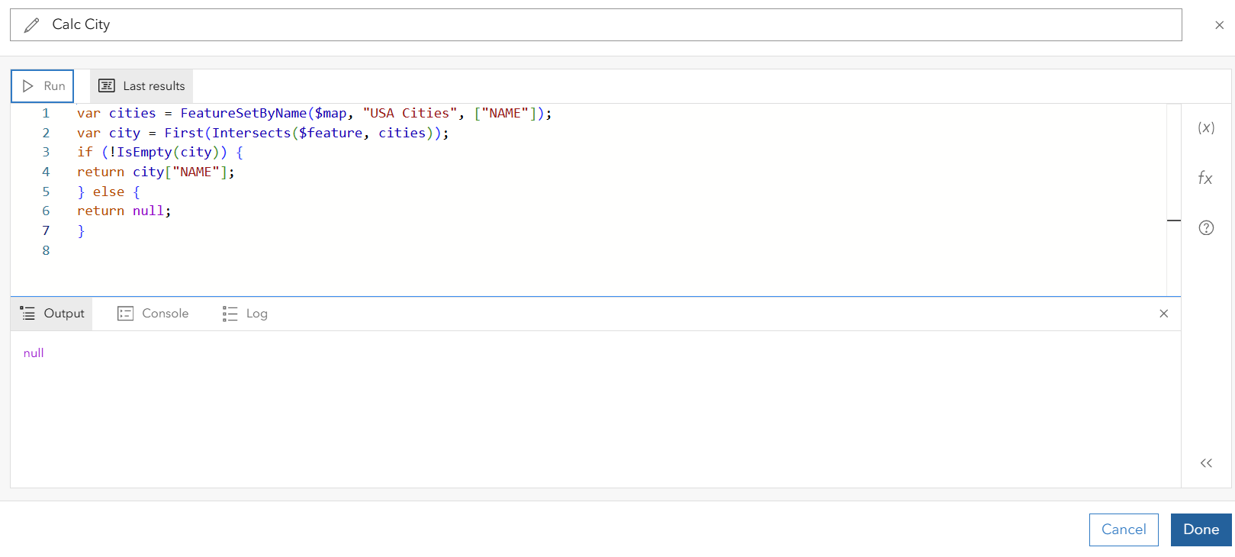
This is because the layer doesn’t yet have features.
- Click Done.
The script first gets the USA Cities layer, along with the geometries and the Name field from your web map, and then uses the current asset point to intersect with the cities polygon layer. If there is an intersecting city, the script returns the city’s Name attribute value; otherwise, it returns null.
- Click Save to Map.
You have authored several of the most used Arcade scripts! these scripts have made your form simpler and more automatic.

Step 4: Style the layers and create feature templates
Note: At the time this book was written, the process for creating feature templates was expected to be streamlined in upcoming ArcGIS Online releases. Check https://arcg.is/1K0f5S0 for updated instructions.
In this section, you will first style the three asset layers in Map Viewer and then create feature templates in Field Map Designer.
- In the lower left of the page, click Open and choose Map Viewer.
Map Viewer opens with your layer listed.
- With the Point Assets layer selected, click the Styles button on the right toolbar.
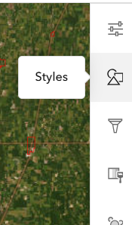
- In the Styles pane, apply the following settings:
- For Choose Attributes, click Field, choose Category, and click Add.
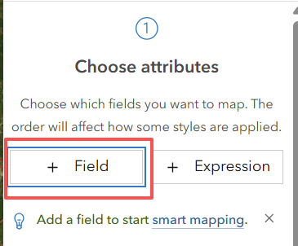
- For Pick a Style, click the Style Options button of Types (unique symbols).
- Each of the categories gets a unique color.
- Click Done and click Done again.
To keep the tutorial flowing smoothly, you can use these simple styles. Feel free to explore the available symbols and enhance the styles—for example, by using icons instead of just colors.
- On the right toolbar, click the Properties button.
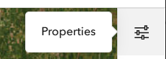
- Click Information to expand it and click Save.
Clicking the Save button here will save the layer’s style to the layer itself, more specifically in the layer definition.
Next, you still style the Line Assets layer similarly.
- In the Layers pane on the left side of the map, click the Line Assets layer.
- On the Settings toolbar, click Styles.
- In the Styles pane, apply the following settings:
- For Choose Attributes, click Field, choose Category, and click Add.
- For Pick a Style, click the Style Options button of Types (unique symbols).
- Click Done and click Done again.
- On the Settings toolbar, click the Properties button.
- Click Information to expand it and click Save.
Next, you still style the Polygon Assets layer similarly but will change the default transparency.
- In the Layers pane on the left side of the map, click the Polygon Assets layer.
- On the Settings toolbar, click Styles.
- In the Styles pane, apply the following settings:
- For Choose Attributes, click Field, choose Category, and click Add.
- For Pick a Style, click the Style Options button of Types (unique symbols).
- For Symbol style, click the Edit button (pencil).
- In the Symbol Style pane, set the Fill transparency to 80%.
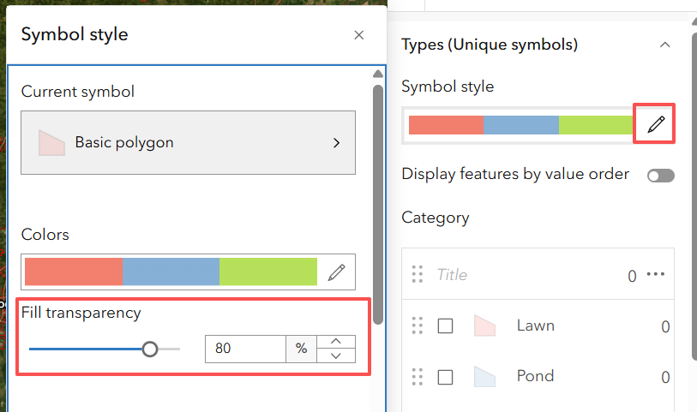
- Click Done and click Done again.
- On the Settings toolbar, click Properties.
- Click Information to expand it and click Save.
- On the Contents toolbar of Map Viewer, click Save and Open and then click Save.
- Close Map Viewer.
You are directed back to the Forms page of Field Maps Designer. Next, you will create the feature templates for each layer.
- In the Forms pane, click the Point Assets layer to select it.
- Click the Templates tab and notice that there is only the New Feature template.
Next, you will create feature templates based on the category field, which contains 10 unique values. Duplicate the current New Feature template nine times for a total of 10 templates.
- Hover over the New Feature template and click the Duplicate button nine times.
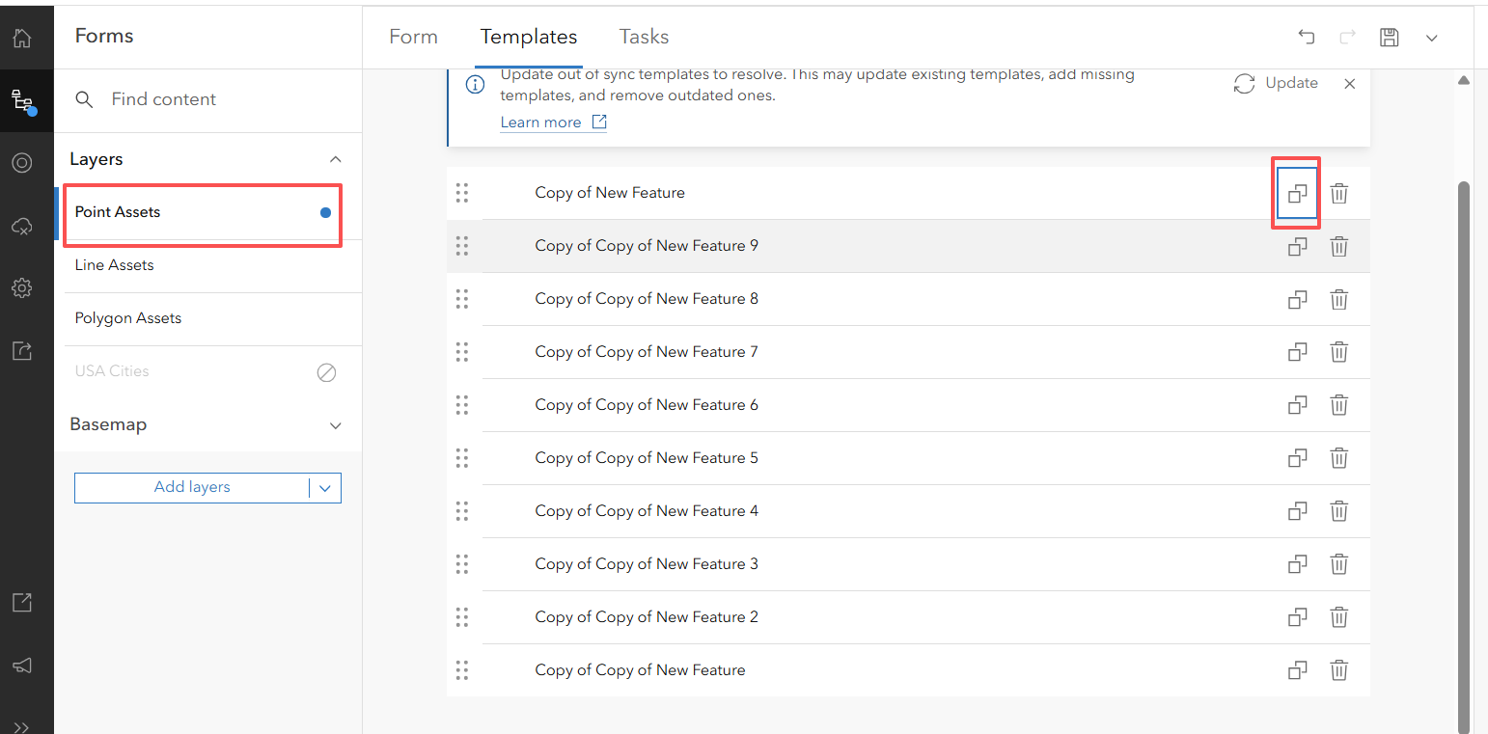
Next, you will click each of the templates to set its category value and display name.
- While the New Feature template is selected, in the Properties pane, under Default Values, click Category and choose Bench. Under formatting, set the Display name to Bench.
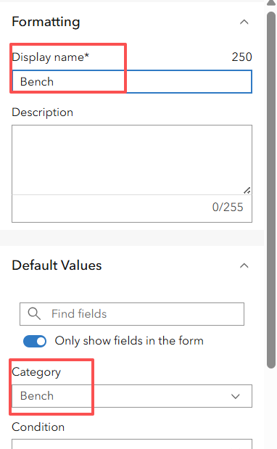
- Repeat the process for the rest of the templates. Set their default Category values and Display names to each of the asset categories. As you do so, notice the symbol of each category display.
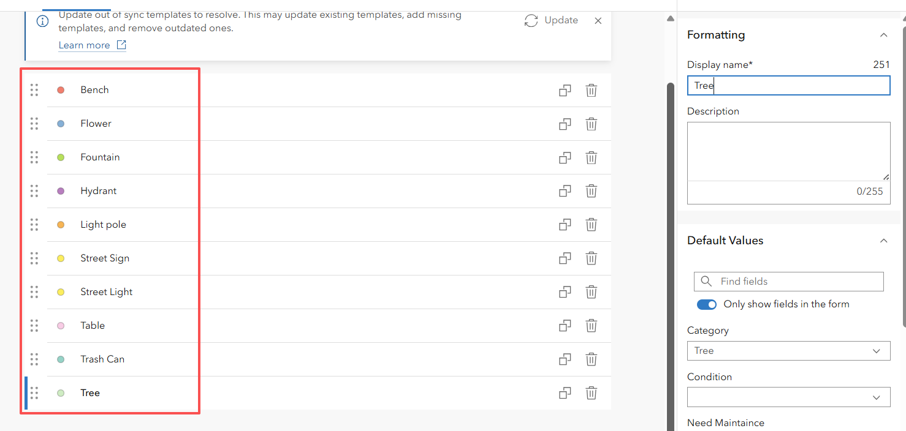
- Click Save.
Similarly, you will create the feature templates for the Line Assets layer. The Category field has three unique values.
- On the Forms pane, click the Line Assets layer to select it.
- Click the Templates tab.
- Hover over the New Feature template and click the Duplicate button twice.
- Click each of the templates and set their default Category values and Display names to each of the asset categories.
- Click Save.
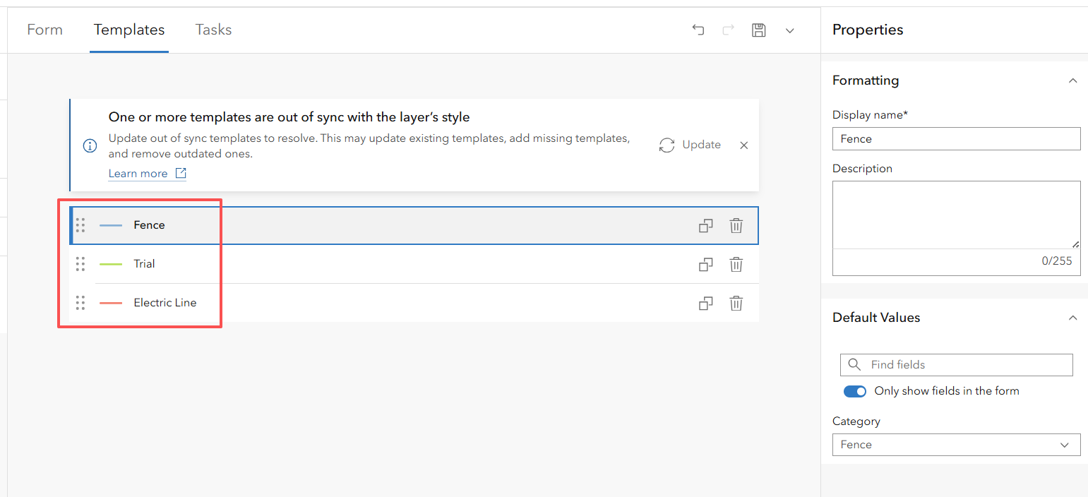
- Repeat the process and create three feature templates for the Polygon Assets layer.
- Click Save.
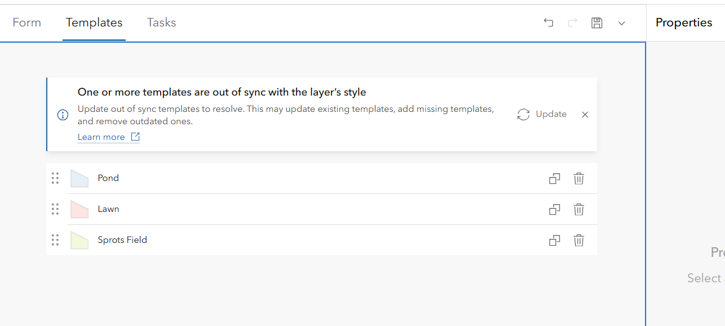

The feature templates configured in this section will make it easier for your mobile workers to select the correct asset category and automatically set the corresponding category value for each one.

Step 5: Refine the layer and app settings
In this section, you will refine the layer settings for better security and the app settings for ease of use.
- Start a web browser, navigate to ArcGIS Online (www.arcgis.com, or the URL to your ArcGIS Online organization), and sign in.
- On the top menu, click Content.
- Under Folders, click All My Content.
Your content items are listed.
- Click the Assets feature layer.
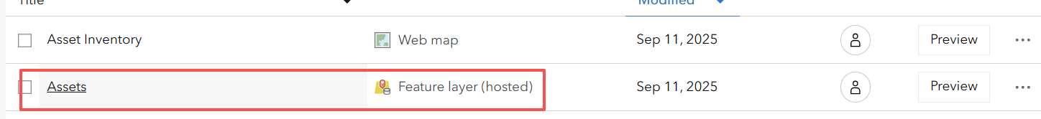
The layer’s item page displays and lists the point, line, and polygon assets sublayers.
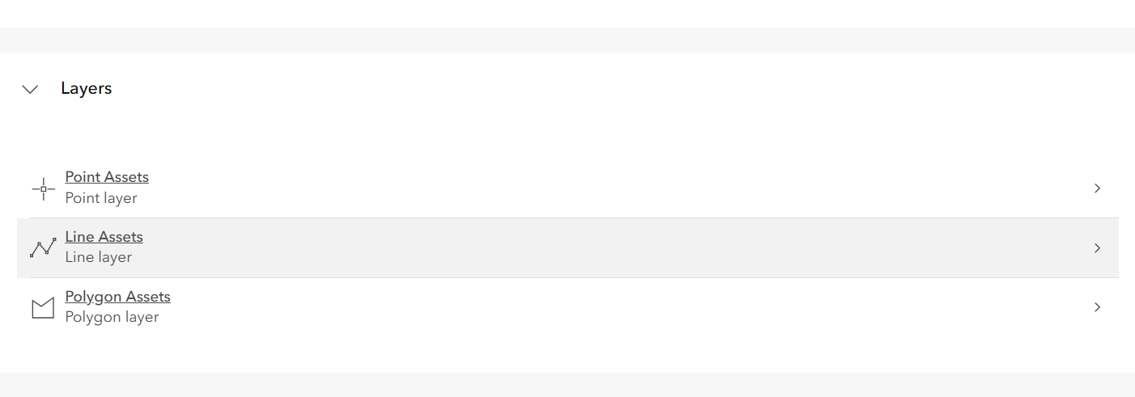
- Under Layers, click the Point Assets layer.
- On the right side of the page, under Attachments, notice that the layer has Enable Attachments selected.
Using this setting, mobile workers can upload photos, videos, PDFs, and other documents when capturing data. The line and polygon assets layers also have attachments enabled.
- In the upper left of the page, click the back arrow to go back to the parent layer.
- Click the Settings tab.
- In the General section, under Public Data Collection, choose Approve This Layer to Be Shared with the Public When Editing Is Enabled.
This setting makes it easier for your instructor or colleagues to access and use your layer. In real projects, you typically wouldn’t make your layer editable by all users.
- In the Feature Layer (Hosted) section, under Editing, review the following settings:
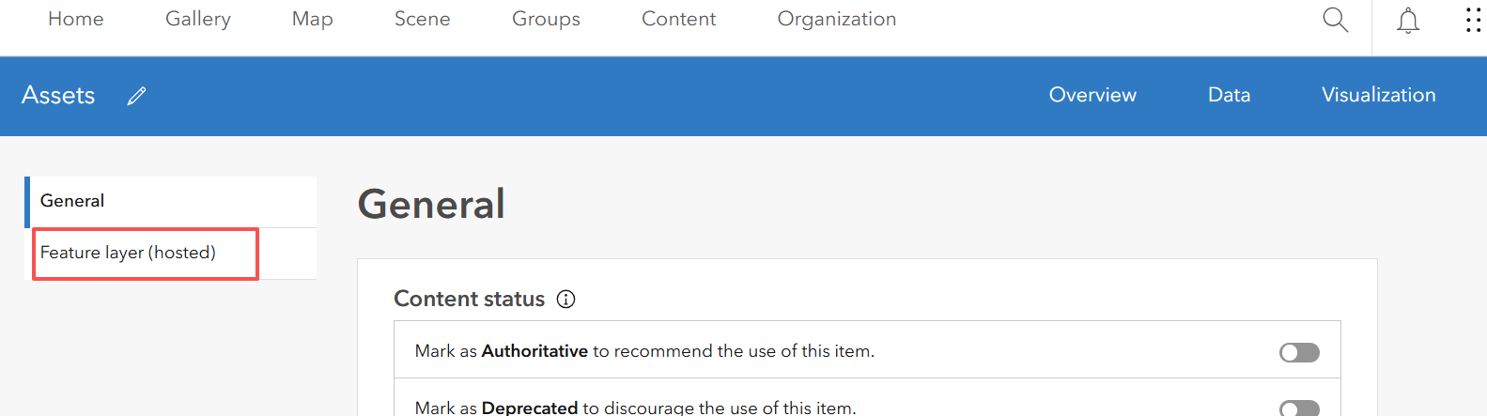
- Notice that this layer is editing enabled, which is why your mobile workers can use this layer to capture data.
- Notice the option Keep Track of Changes. Leave as is.
When enabled, this setting records changes to the feature layer in a system change log. By default, changes are retained for 180 days, allowing you to restore data during this period, such as identifying and reinstating deleted records.
- Notice the option Keep Track of Who Edited the Data is selected. This adds four editor tracking fields to your layer: CreationDate, Creator, EditDate, and Editor. The field names may vary.
- Notice the Enable Sync option. This option is needed for offline support, and it adds the GlobalID field to your layer.
- For the question What Features Can Editors See, choose Editors Can Only See their Own Features.
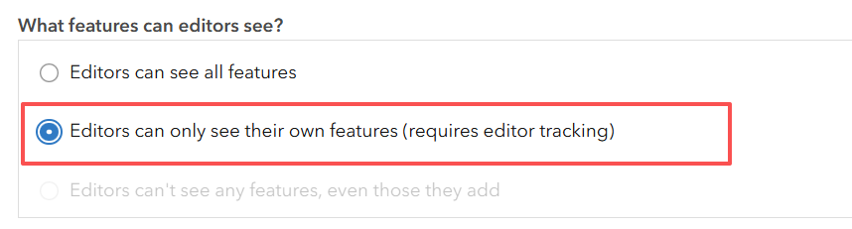
This setting enhances the security of your layer by preventing mobile workers from deleting or editing other workers’ data. In subsequent chapters, you will use view layers to further enhance the security of your data.
- Click Save.
- Click the Data tab on the top and review the table view of your data.
The Point Assets layer’s attribute table displays. You layer is empty for now.
- Click the Fields tab and review the following fields of the Point Assets layer:
- CreationDate, Creator, EditDate, and Editor are editor tracking fields.
- GlobalID field.
- The fields that were created by Field Maps Designer.
- Click the Category field and review the List of Values (Domain).
As you were designing the form for the layer, the elements were saved as fields in the attribute table.
- In the upper left, note the layer drop-down list. Click the list to select the Line Assets or the Polygon Assets layer to review their schemas.
This book will use metric measurements throughout, so it is recommended that you change your measurement settings.
- In the upper right, click your profile picture and click My Profile. On the left, click View My Settings. Scroll down to the Units section and choose Metric.
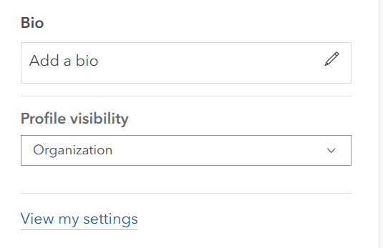
Next, you will review the app settings of the map in Field Maps Designer.
Content – My content – Week 05 Field Map – Asset Inventory
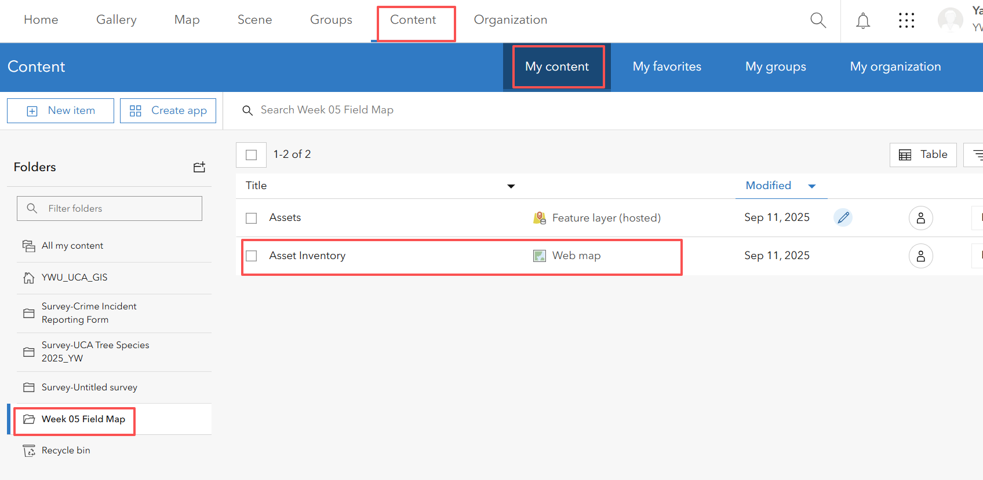
- Click the Asset Inventory map and Open in Field Map Designer
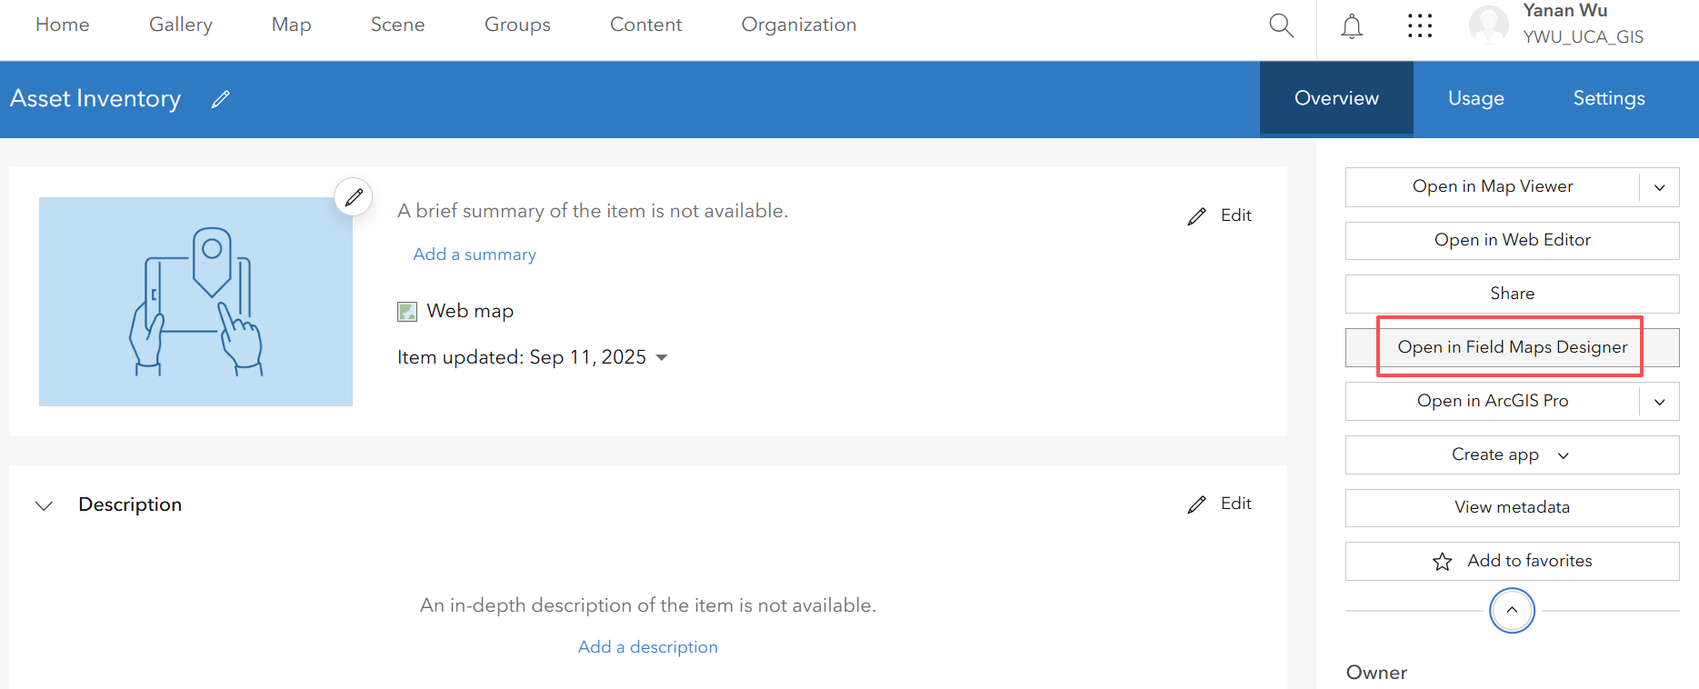
- On the Contents toolbar, click App Settings.
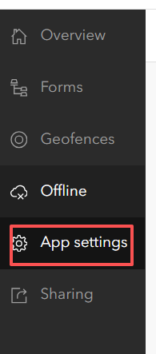
- Click Collection to expand it.
- Increase the default location accuracy requirement from 10 meters to 30 meters.
- In the upper-right corner of the page, click Save Changes.
For indoor environments such as classrooms or offices without an indoor positioning system, the location accuracy of your phone or tablet may be low. Setting the accuracy threshold to 30 meters or more will allow you to experiment with data capture indoors in the next section.

For real-world projects, you may require higher location accuracy by reducing the threshold to a smaller value to ensure the quality of your data.
- On the Contents toolbar, click the Sharing button.
- Click Set Sharing Level, choose Everyone, and click Save.
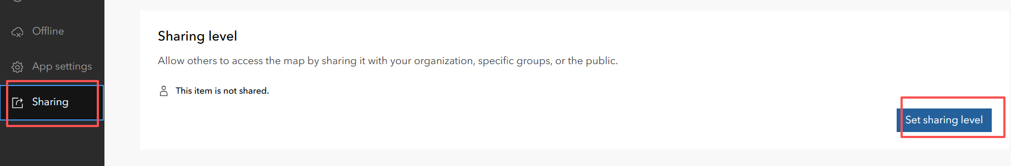
- Under Sharing Options, notice the URL and QR code options.
In the next section, you will use one of the two options to open the map on your mobile device.
Step 6: Use the Field Maps mobile app to collect data
In this section, you will use Field Maps on your mobile device to collect data. The tutorial is based on the iPhone edition of Field Maps, but other editions will be similar. If possible, consider taking a walk around your campus, community, or a local park to capture some assets.
- Install ArcGIS Field Maps on your mobile device if you haven’t done so.
Field Maps is available from Google Play for Android devices and the App Store for Apple devices.
- Tap the Field Maps app to open it. Sign in with your ArcGIS Online account.
Find and open the Asset Inventory web map you created in the previous section. Optionally, you can use a similar web map with improved layer styles by scanning the QR code below on your mobile device.
Now please use the Field Map that you created to collect the data!

