Exercise 5 Generate a Standardized Map
In this exercise, you will start working with ArcGIS Pro to make maps. You have learned attribute table, standardization, and classification in the class. In this exercise, you will learn how to make a standardized map for population density.
Topics covered in this exercise include:
- How to join spatial and non-spatial data
- How to export vector data
- How to generate a standardized map
- How to use different classification methods
- How to create a layout
- How to share the map

Data
This project contains one vector polygon layer: County, representing county boundary of Arkansas and one excel sheet: Population, representing population in each county in Arkansas in 2020. The county boundary data is from Arkansas GIS office and the population data is from US census. Download Exercise_5.zip. Save it into the location you are choosing and unzip it by right-clicking on Exercise_5.zip. In the drop-down window, choose by “Extract All”.

Step 1. Create a project in ArcGIS Pro

- In the search bar at the left corner, type “ArcGIS Pro”. You will see the software “ArcGIS Pro”. Click on it, the ArcGIS Pro will be loaded.
Note, this can also be done by navigating to All Apps followed by the ArcGIS Folder. Within the ArcGIS Folder, select ArcGIS Pro.
- Create a project to host your maps by clicking on Map icon.
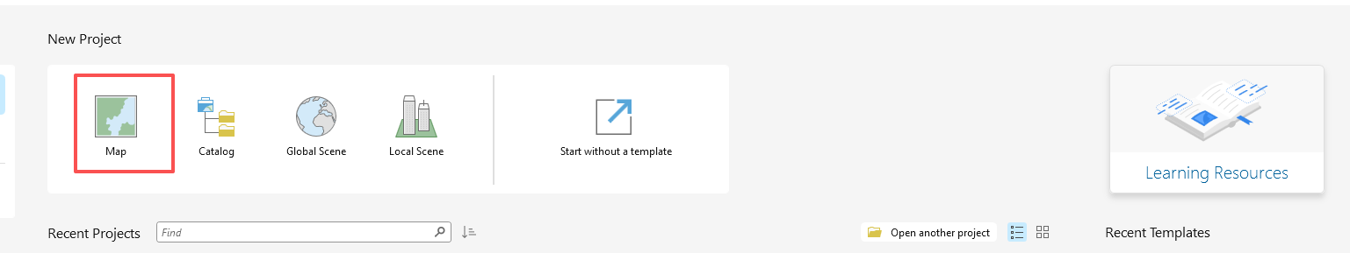
- The Create a New Project window should be shown. Define the name for your project. You can give any name that you prefer. Then click on Folder icon, find the location that you want to save your project.
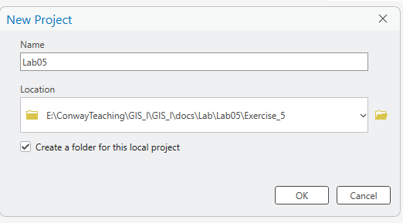
- You do not need to change others.
- Click on OK.
An empty map with default background world maps should be shown. You will need to add data into the ArcGIS Pro.

Step 2. Join spatial and non-spatial data

We have a spatial data of Arkansas boundary and a non-spatial data of Arkansas population. We will need to join the two datasets to explore the population distribution in Arkansas.
- Click on Add Data button under Map tab.
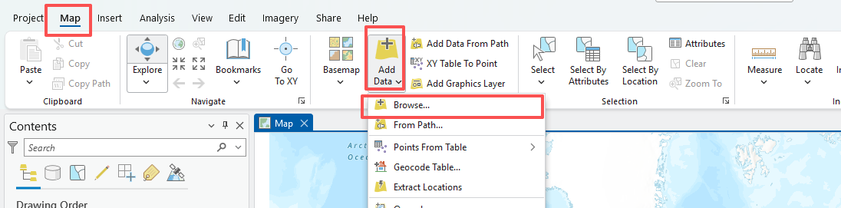
- Navigate to the location where you stored your data. Highlight both data layers, click on OK.
Wait for a while, the data layers will be loaded into ArcGIS Pro. You can find them in the Contents panel.
- Open the attribute table of County layer by right-clicking on it. In the drop-down menu, select Attribute Table.
- Open the population table by right-clicking on it. In the drop-down menu, select Open.
Explore the tables, answer the following question.

Question 1. Which field in County’s attribute table and population table, respectively, can be used to join the spatial and non-spatial data? (Hint, fields to be used to join spatial and non-spatial data need to have the exactly same values) (5 points)

Name field in Conunty, County field in population
- Right-click on County layer. In the drop-down menu, select Joins and Relates, followed by Add Join.
- In the Add Join window, set “County” for Input Table, “Name” for Input Field, “Population.csv” for Join Table, and “County” for Join Field.
- You do not need to change others.
- Click on OK to execute the Join.
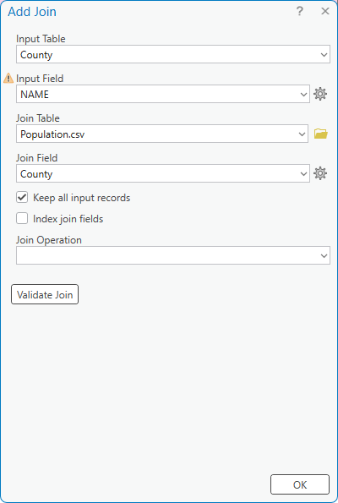
Open the attribute table for County layer again. You should find that the population in 2020 for each county in Arkansas was attached to the County table.
As the join is temporary, if you want to use the data for future application, you will need to export the data and save it as a new vector data file.
- Right-click on County. In the dropdown menu, select Data, followed by Export Features.
- In the Export Features menu, set “County” to Input Features. It should be the default setting.
- Set “County_POP” to Output Feature Class. Note: the data file is stored in the Exercise_5.gdb in default. You can change the location to store the output by clicking on the Folder icon. In this exercise, you will save the data in the Exercise_5.gdb.
- Click on OK.
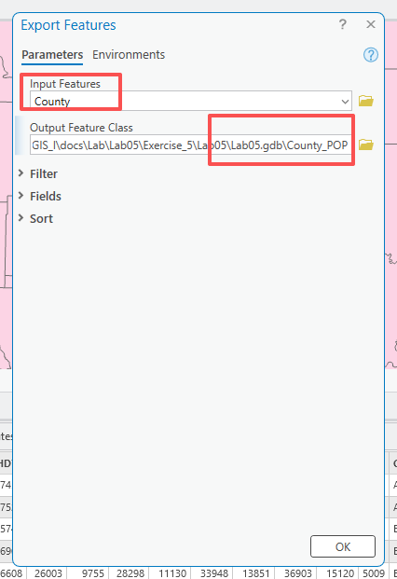
The County_POP should be automatically loaded into the ArcGIS Pro. You should be able to find it in the Contents panel.
- Remove County layer and Population.csv by right-clicking on each of them, in the drop-down menu, select Remove.

Step 3. Generate a standardized map

As you will standardize the population in this exercise, you will need to calculate the areas for each county.
- Right-click on County_POP layer. In the drop-down menu, select Attribute Table.
In the attribute table, you may notice that there are two new fields, named “Shape_Length” and “Shape_Area”. They represent the perimeter and areas of each county in Arkansas, respectively. They are automatically generated, as the data file is stored to the geodatabase. If the data file is not stored in the geodatabase, it will not be generated, and you will need to use the method you learned in Exercise 1 to calculate the area. In this exercise, you will use the “Shape_Area” to standardize the population. Note: the unit of the area will be the square of the linear unit of the layer. The linear unit can be found in the Properties of the layer, which you’ve learned in Exercise 1.
Recap
- Right-click on County_POP layer. In the drop-down menu, select Properties.
- In the Layer Properties: County_POP window, click on Source, followed by Spatial Reference

Question 2. What is the unit for the values in “Shape_Area”? (5 points)

Answer: meter
Now, you will standardize the population and generate a population density map.
- Right-click on the County_POP layer, in the drop-down menu, click on “Symbology”.
- In the Symbology-County_POP window, set “Graduated Colors” for “Primary symbology”. Select “POP20” for “Field” and “Shape_Area” for “Normalization”. Select your favorite color for “Color Scheme”. Select “Natural Breaks (Jenks)” for “Method” and “6” for “Classes”. Note: you will learn color section in the following lectures. Here is a demonstration of how to select colors.
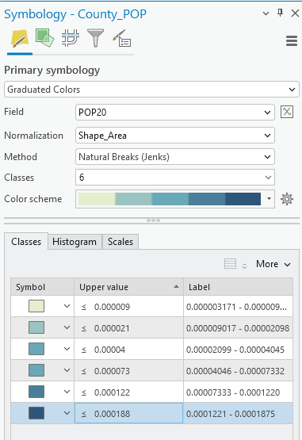

Question 3: Based on the population density map, which regions are crowded? Are they in your expectation and why? (5 points)
Little rock.
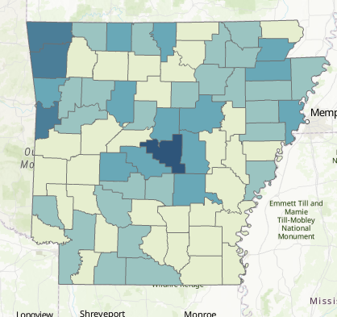

Step 4. Create a layout and share your map
You’ve learned how to create a layout in Exercise 1.
Recap:
- Navigate to the Insert Tab and Select New Layout.
- From the list, select ANSI Portrait Letter 8.5” x 11” (this should be the first option). A new blank layout should be added.
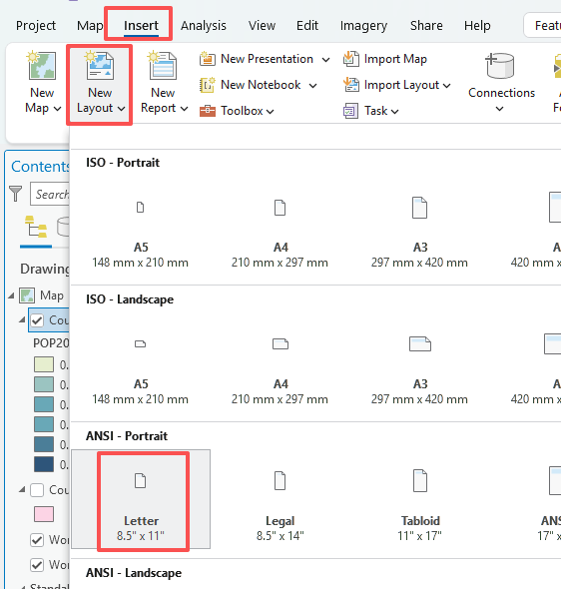
- To add the map to the layout, click on Map Frame under the Insert Tab.
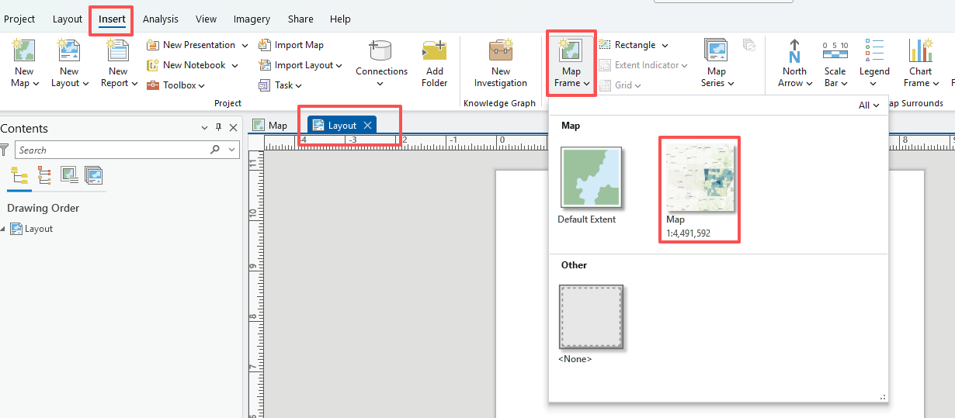
- In the layout, draw a rectangle in any empty space, the map you just worked should be added.
Note: you will learn how to make a better map in the following exercises.
You’ve learned how to share your layout in previous exercise, you will learn more. In this exercise, you will share your map in PNG format.
- Navigate to the Share Tab and select Export Layout.
- In the Layout window, select “PNG” for the File Type. Save the file to the location you are choosing and set the name as “Population density map in 2020_ Natural Breaks.png”. Check the box of “Clip to graphics extent” and “Transparent background” (Transparent background can be selected after you change color depth to ’32-bit Alpha’, see instructions after). Set “300 dpi” for “Resolution” and “32-bit with Alpha” for “Color depth”.
- Click on Export.
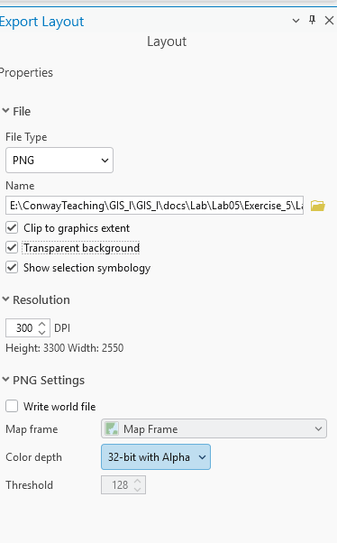

Deliverable 1: paste the ‘Population density map in 2020_ Natural Breaks.png’ file below (5 points).
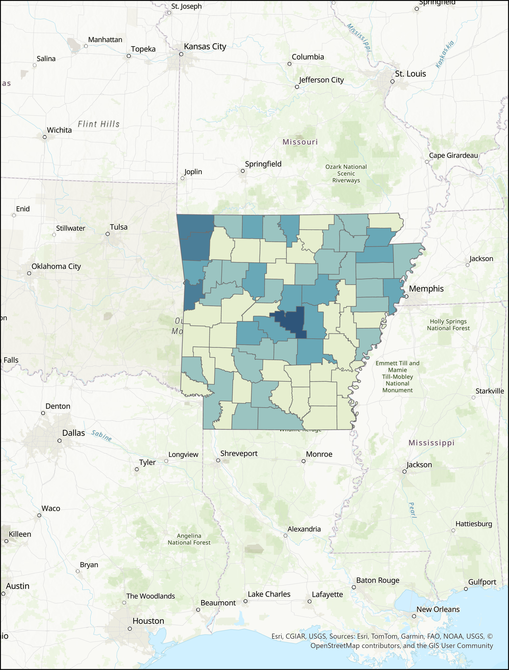

Deliverable 2: Repeat Steps 3-4 to generate a PNG file with ‘Method’ to ‘Equal Interval’ and ‘6’ for ‘Classes’ and paste the map below (6 points). (Hint, the Layout will be changed automatically along with the map)
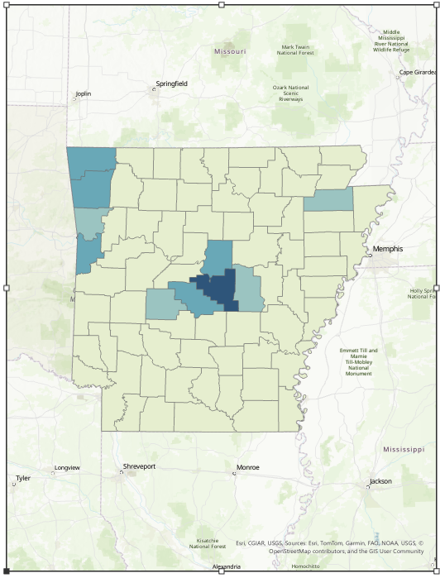

Deliverable 3: Repeat Steps 3-4 again to generate a PNG file with ‘Method’ to ‘Quantile’ and keep ‘6’ for ‘Classes’ and paste the map below (6 points). (Hint, the Layout will be changed automatically along with the map)
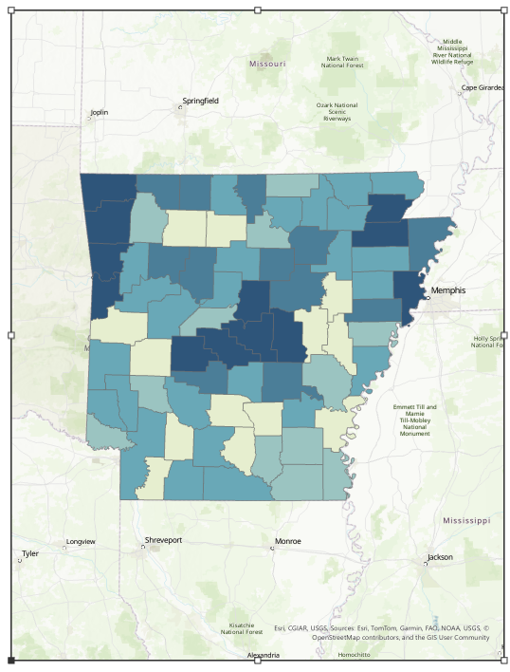

Questions 4: Comparing deliverables 1 to 3, which classification method is good for population density in Arkansas and why? (6 points)

3 is good.

Deliverable 4: Repeat Steps 3-4 again to generate a PNG file with ‘Method’ to ‘Quantile’ and ‘10’ for ‘Classes’ and paste the map below (6 points). (Hint, the Layout will be changed automatically along with the map)
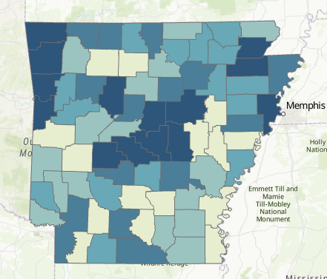

Questions 5: Comparing deliverables 3 to 4, do you think increasing the number of classes improve the visualization of population density in Arkansas and why? (6 points)

4 is better,

END OF EXERCISE

Homework
Please submit a word file with five questions and four deliverables through Blackboard.

