Exercise 8: Digitizing New Data
In this exercise, you will learn the process of creating and editing spatial datasets using on-screen, or heads up, digitizing. This is one of the many methods of data creation used in GIS. This exercise will also introduce you to techniques for searching for background images in Google Eearth Pro.
Topics covered in this exercise include:
- Create a new shapefile
- Add fields to a new shapefile
- Edit spatial data using the editing function in ArcGIS Pro
- Digitize within Google Earth Pro
- Open KML data to in ArcGIS Pro

Data
This project contains one raster data layer: nat_mall.img, representing buildings near the National Mall in Washington, DC. The data is a satellite image and from the National Agriculture Imagery Program (NAIP). Download Exercise_8.zip. Save it into the location you are choosing and unzip it by right-clicking on Exercise_8.zip. In the drop-down window, choose by “Extract All”.

Step 1. Create a project and load data into ArcGIS Pro

- In the search bar at the left corner, type “ArcGIS Pro”. You will see the software “ArcGIS Pro”. Click on it, the ArcGIS Pro will be loaded.
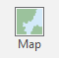
Note, this can also be done by navigating to All Apps followed by the ArcGIS Folder. Within the ArcGIS Folder, select ArcGIS Pro.
- Create a project to host your maps by clicking on Map icon.
- The Create a New Project window should be shown. Define the name for your project. You can give any name that you prefer. Then click on Folder icon, find the location that you want to save your project.
- You do not need to change others.
- Click on OK.
An empty map with default background world maps should be shown.
- Rename the map. Double-click on Map in the Contents Pane. This will open the Map Properties Window. In this window, change the name under the General Tab to National Mall.
- Click OK to accept the change.

You will need to add data into the ArcGIS Pro.
- Click on Add Data button under Map tab.
- Navigate to the location where you stored your data. Highlight nat_mall.img layer, click on OK.
Wait for a while, the data layers will be loaded into ArcGIS Pro. You can find them in the Contents panel.
- You can turn off the Topographic base map if you’d like.
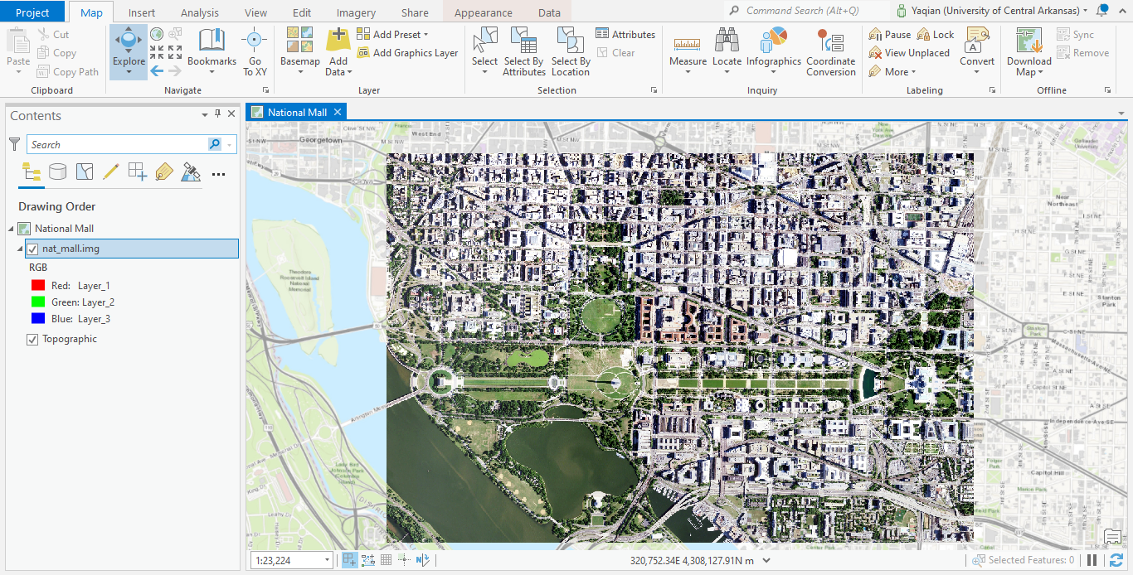
This exercise will have you create a new shapefile and digitize new features into the file. Note, that you could also use a feature class within a geodatabase as you learned in Exercise 4. Here, this exercise will have you work with a shapefile, which is a standalone file used to store vector data outside of a geodatabase. There are different ways to create a new shapefile. Here, you will use the Create Feature Class tool, which can be used to make shapefiles and feature classes.
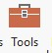
- In the Analysis Tab select the Tools icon. This will launch the Geoprocessing Pane.
- Search for the Create Feature Class tool.
- In the window of Create Feature Class, click on the Folder icon to save it to a folder of your choosing, name the new layer nat_mall_draw.shp, define the Geometry Type as “Polygon” and set the Coordinate System to “Current Map”.
- Leave others as default
- Run the tool to create the new file. The new file should add to the list of layers in the Content Pane.
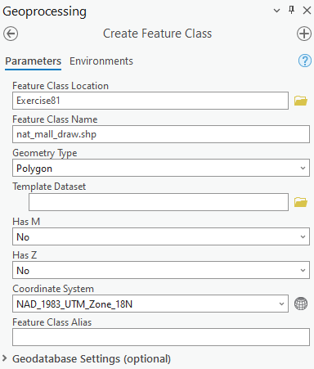
This exercise will have you digitize the extent of buildings near the National Mall in Washington, DC. However, there are still a few more steps before you can begin. First, you would need to store the name of the building in the attribute table. So, you need to add a field.
- Right-click on the nat_mall_draw layer in the Contents Pane then select Attribute Table. The attribute table should load.

Question 1. What are fields already included in the table? (6 points)
- You would like to add a new field called “name.” Click on Add icon at the top of the table.

- A new table should load called Fields: nat_mall_draw. At the bottom of the list of fields, you can add new fields. In the Field Name column type “name” (without the quotes) and set the Data Type to Text (this is because you will type a text string in this field). You do not need to specify an Alias. Click Save at the top of the screen to create the field.
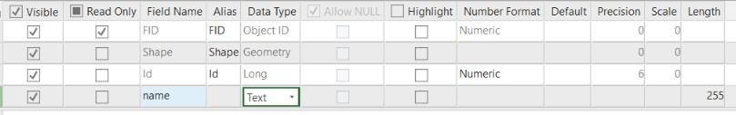
- Return to the nat_mall_draw attribute table. You should now see the new “name” column.
Deliverable 1. Screenshot the attribute table showing the name field. (5 Points)

- To free up space, exit out of the tables.

Here, you will draw polygon features. I have generally found that these are easier to draw if they are symbolized using no fill and only an outline. So, this exercise will have you change the symbology of the layer.
- Right-click on the nat_mall_draw layer and select Symbology.
- Click on the symbol in the Symbology Pane.
- Switch to Properties as opposed to Gallery.
- Change the Color to No Color.
- Change the Outline Color to something easy to see. You may also want to increase the Outline width. I chose to use 1 pt.
- Click Apply to accept the changes.

- You may want to exit out of the Symbology Pane to save space.

Step 2. Drawing
You are now ready to start drawing and editing the attribute table.
- Navigate to the Edit Tab.
- Select Map Topology, which forces features to be in 2D surface.
- Turn on the Attribute Pane by clicking on Attributes icon
You will begin by drawing in the Capital Building.
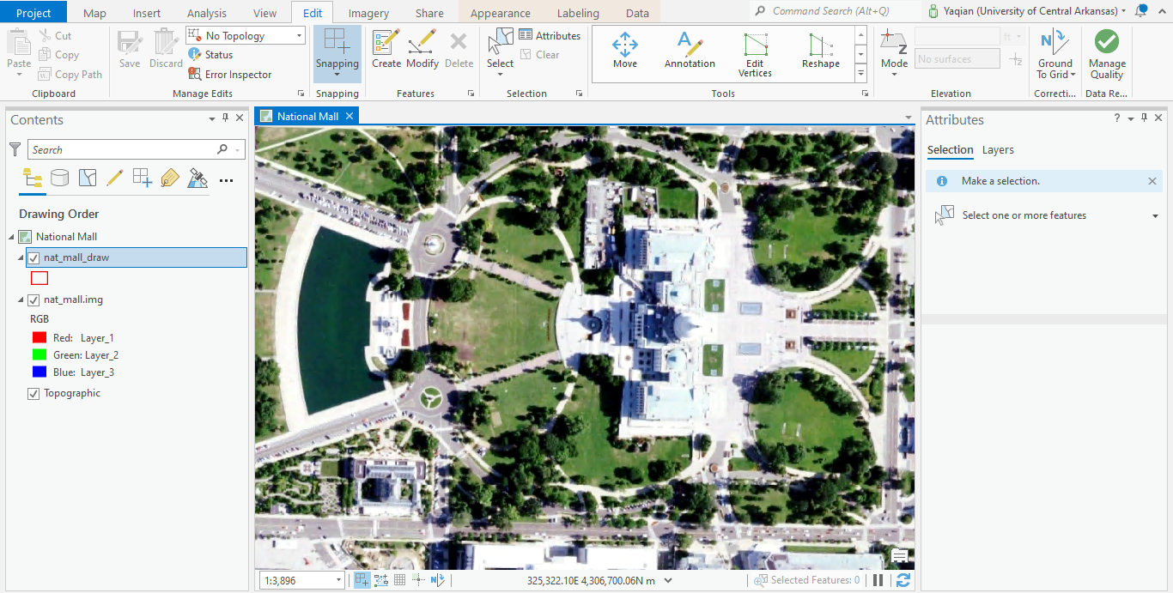
- Zoom in so that the Capital Buildings fill a large portion of the map space. The larger the object of interest is on the screen, the easier it will be to trace it.

- Click on the Create button 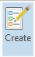. This will load the Create Features Pane. You are now ready to start drawing. Click on the layer in the Create Features Pane in which you want to draw a new feature. In this case, you only have one layer available, nat_mall_draw; however, if more vector layers were included in the layout then you would need to choose which to draw into. Click on nat_mall_draw to draw into it. You are now ready to draw.
- Since this is a building, and we would expect to have right angles on each corner, I would suggest using the right-angle drawing tool. Feel free to experiment with the different drawing tools.
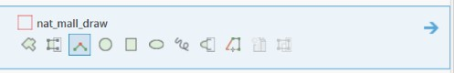
- If you hover over the different drawing tools, a brief explanation will be provided. I chose to use the third option, so that right angles are enforced.
- Once you’ve selected a drawing tool, move to the map space and click once at the location on the map where you want to add a vertex. Continue clicking to add additional vertices. Work your way around the object, just like you were walking the perimeter. When you get to the last vertex, double-click. This will close the feature and create a new polygon object. Note that your drawing doesn’t have to be perfect.
Note: If you would like to erase your last vertex, use CTRL+Z. Once you’ve completed an object and it is still selected, you can remove or delete the object by using CTRL+Z.
Here is an example of my result.
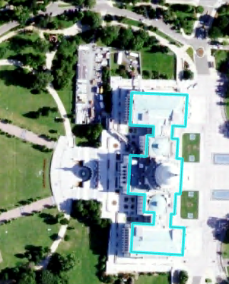

There are many tools available to clean up or improve your drawing. I would encourage you to experiment with the tools available in the tools list. Hovering over a tool will provide a brief explanation. You can also expand it through clicking on expansion icon.
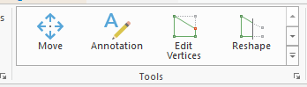
If you are not happy with the quality of your drawing, you can always delete it and try again. Note, that there are tools available to move the whole feature, add vertices, remove vertices, edit vertices, reshape features, split single features into multiple features, merge multiple features into a single feature, modify features, and delete features.
The Snapping options 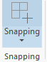allow you to enforce snapping. For example, if you were drawing line features and you wanted them to connect, such as rivers or roads, you could use snapping to enforce this. In default, snapping is selected.
When you are drawing, it is also important that you save often so as not to lose your work. Let’s save your work.
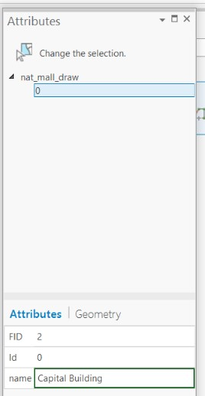
- Click the Save button under the Manage Edits group in the Edit Tab.
- Again, save often so as not to lose any work.
Now, we would like you to name the building in the attribute table.
- Navigate to the Attributes Tab. Since you were just using the Create Features Pane, the Attribute Pane is now probably behind it, but there should be a tab at the bottom of the screen. If you can’t find it, click on the Attributes button again in the Selection area of the Edit Tab.
- Make sure that the capital building polygon is selected.
- In the Attributes Tab, type in “Capital Building” (without the quotes) in the “name” field.
- Click on Apply
- Save your work again.
You have now successfully created a new polygon and edited the associated attributes.

Draw polygons for the following buildings:
Capital Building, National Gallery of Art East, National Gallery of Art West, American Indian Museum, Air and Space Museum, Hirshhorn Museum, Natural History Museum, and American History Museum

You can use the image below to locate these buildings.
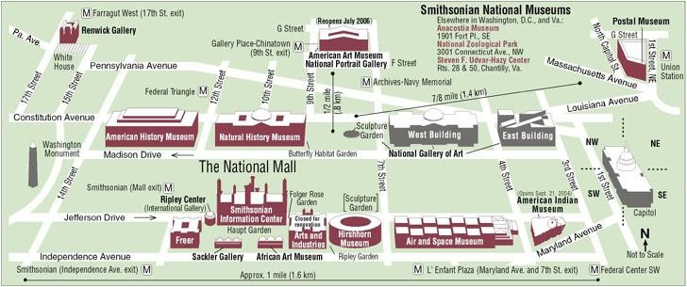
Image from Smithsonian Associates: https://smithsonianassociates.org/ticketing/
Provide the name of each building in the attribute column “name” field. Again, remember to save your edits and project often. These are two separate processes.
Note: Throughout this process, you will need to switch between drawing and navigating the map space. The navigation tools are available under the Map Tab while the drawing tools are available under the Edit Tab. You will need to switch back and forth. If you need to select a feature, the Selection Tool is available both in the Map Tab and in the Editing Tab. Remember that the attributes displayed in the Attribute Pane are for the selected feature. If you want to view the layer attribute table at any time, you can do so by opening the attribute table. This is a good way to check your edits.
Drawing in ArcGIS Pro, especially for a beginner, can be frustrating. Take your time and don’t hesitate to ask if you have any questions.
- After finishing drawing, right-click on the nat_mall_draw layer and select Symbology.
- Set “Unique Values” for Primary symbology, set “name” for Field 1. Select your favorite color scheme.
- The digitized polygons should be shown in different colors.
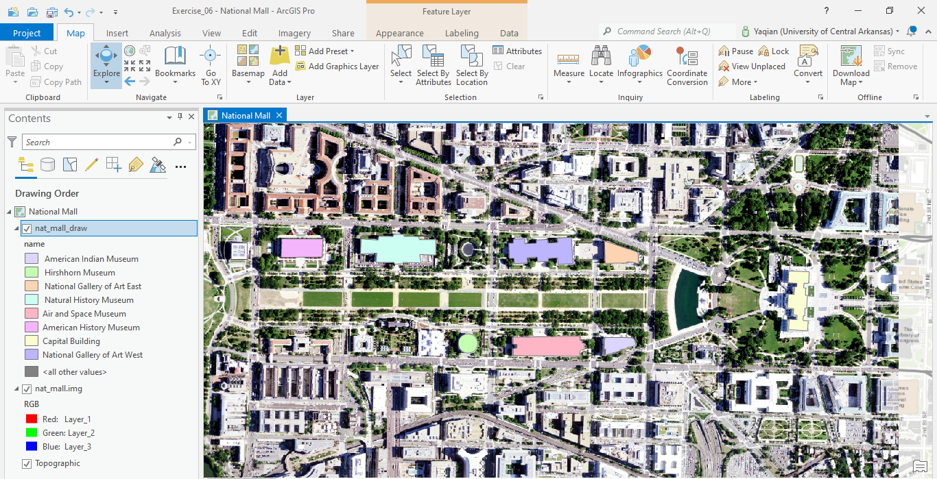
Deliverable 2. Screenshot the map and the attribute table showing the digitized buildings and their corresponding names. (24 Points)

Step 3. Drawing in Google Earth
Drawing new features can be accomplished with different software tools. For example, Google Earth (https://earth.google.com/web/) is an open-source tool to create new data. Here, we will experiment with drawing in Google Earth. We will then import the Google Earth data to a layer for use in ArcGIS Pro. You will specifically work with Google Earth Pro, which is currently free and can be obtained here: https://www.google.com/earth/desktop/. Note, in the Lab computer, Google Earth has already been installed.
In this second exercise, you will draw three of the finger lakes of New York.
- Open Google Earth Pro. This can be done by navigating to All Apps followed by Google Earth Pro. Note that you can also use a Task Bar or Desktop shortcut if they are available on your machine.
- Once the program launches, navigate to the Finger Lakes Region of New York. If you’re not sure where this region is, you can search for it using the search bar.
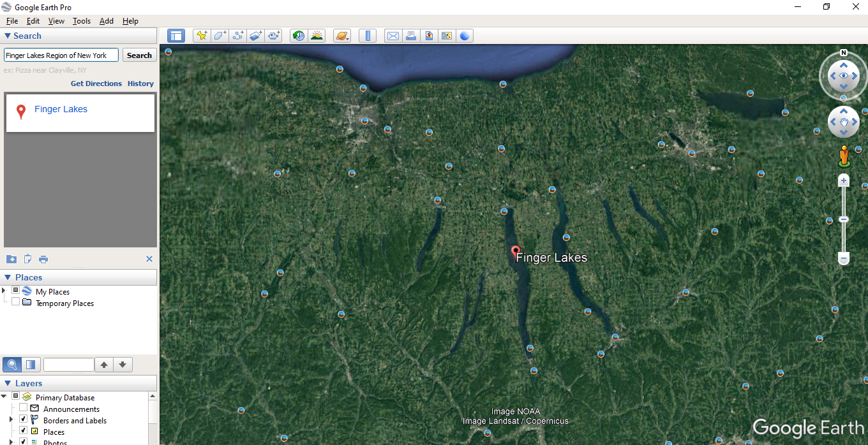
You will digitize three of the Finger Lakes: Seneca, Cayuga, and Owasco.
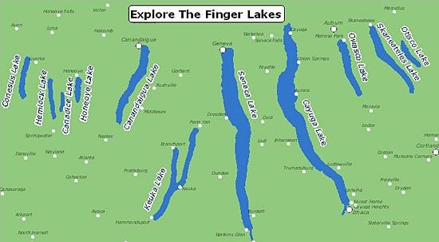
Here are the required steps to digitize in Google Earth Pro.
- First, you will want to create a new folder under My Places. Right-click on My Places then select Add followed by Folder. Name the folder Lakes. Click on OK.
- Click on the Lakes folder under Places. Select Add then Polygon. Name the polygon as “Seneca”.
- It might be easier to digitize if you make the feature hollow. Do this by selecting Style, Color. Change the Area to Outlined as opposed to Filled+Outlined. You can also change the color to your preferred one. Note, do not close the window.
- Find Seneca Lake.
- Move your mouse to the map, you could notice the cursor is changed. Digitize the boundary of the lake using the cursor.
- Click on OK, if you finished.
Note: You do not need to spend a lot of time digitizing these features. A rough polygon is fine.
- Repeat this process to digitize Cayuga and Owasco lakes. Make sure to save the features in the same folder but as separate polygons.
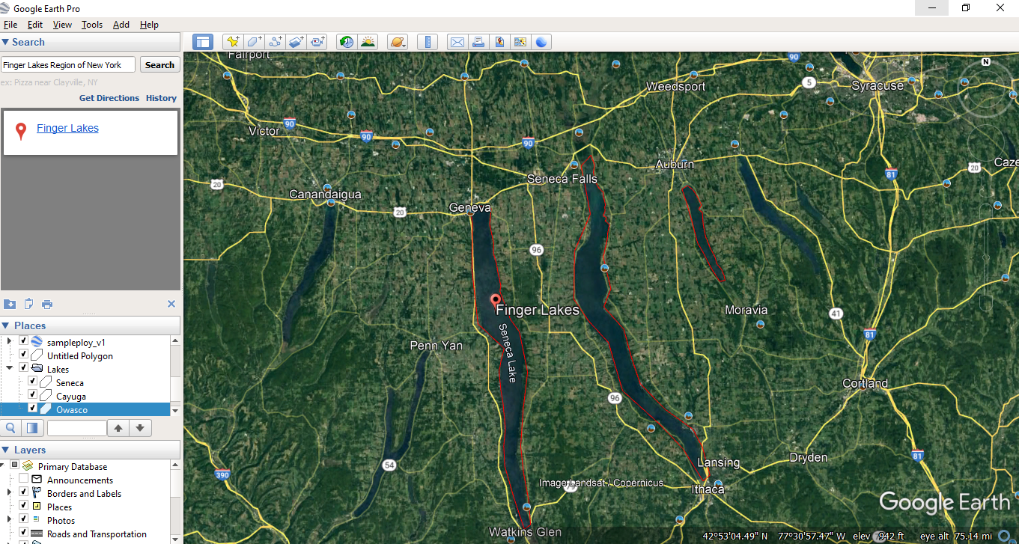
Deliverable 3. Screenshot the map showing the digitized rivers. (9 Points)
Now that you have features, you will save them to KML/KMZ format. KML stands for Keyhole Markup Language, and a KMZ file is a compressed version of a KML file.
- Right-click on the Lakes folder under Places. Select Save Places As. Set the type to KML and save the file to your preferred folder.
You are now done working in Google Earth Pro. You will now return to ArcGIS Pro to complete this portion of the lab.

Back in ArcGIS Pro, you will need to create a new map. Since this is a different geographic area, we do not want to use the National Mall map.
- Insert a new map and name it Finger Lakes by clicking on New Map under Insert Tab

ArcGIS Pro 2.8 and thereafter can read KML file directly. If you use an early version, you want to update your ArcGIS Pro.
- Click on Add Data under Map Tab.
- Find the KML file you just created. Click on OK. You should see the Lakes layer is added.

Now, we will show you how to change the base map. By default, the Topographic base map is used. Here, this exercise will have you change the base map to an image base map.
- Navigate to the Map Tab. Click on the dropdown arrow on the Basemap icon. This will load a list of available base maps.
- Change the base map to the Imagery Hybrid base map.
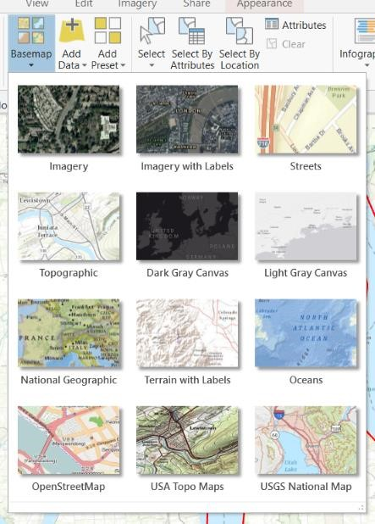
Note: Base maps can be slow to load, depending on your computer and internet connection. So, it is important to remember to save your work often if you are using base maps.

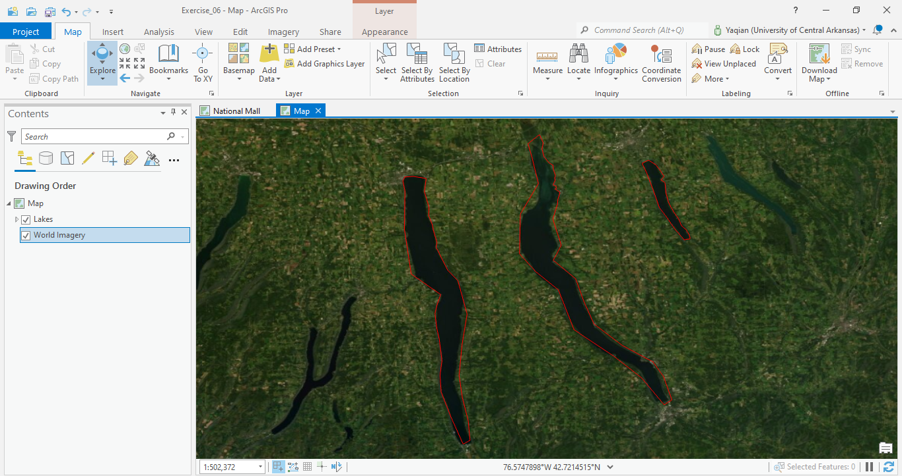
Deliverable 4. Screenshot the map showing the digitized rivers in ArcGIS Pro. (6 Points)

END OF EXERCISE

Homework
Submit a word file with one question and four deliverables through Blackboard.

