Question 1. How many counties have population greater than 14000 in 2010 and covid-19 cases greater than 50 on May 1st? (5 points)
Answer 1: 14
Deliverable 1. Screenshot the map showing the 51 selected counties. (5 points) (Please turn off other layers to see the results clearly)
Question 2. Is the number of selected counties same as the previous one in Question 1? (5 points)
Question 3. How many counties experienced increasing population between 1970 and 2010? (5 points)
Answer: 51
Question 4. How many hospitals are within 5 miles of a railroad? (5 points)
Answer: 101
Question 5. How many town halls in Faulkner county? (5 points)
Answer: 2
Question 6. How many town halls that are in Faulkner County and within 2 miles of a railroad? (5 points)
Answer: 1
Question 7. How many streams intersect a railroad? (5 Points)
Answer: 19
Deliverable 2. Please also provide a screenshot of your resulted map (5 Points).
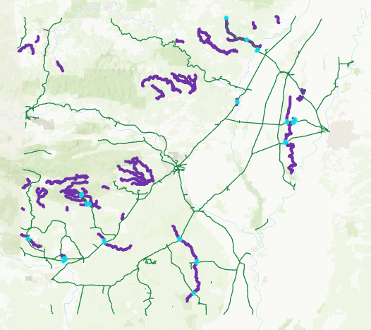
Question 8. How many hydrographic landmarks are within 10 miles of a stream? (5 Points).
Answer: 15
Deliverable 3. Please also provide a screenshot of your resulted map (5 Points).
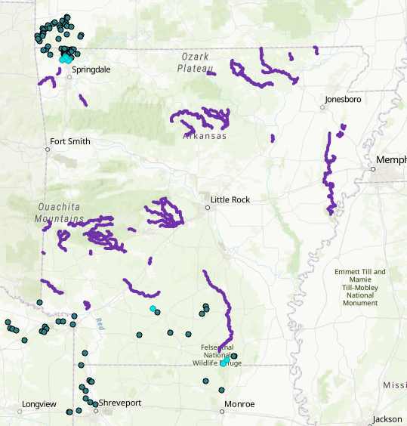
Deliverable 3. Please provide a screenshot of your created database including two feature classes (10 Points).

