Lab 1.1: Introduction to ArcGIS Pro
Due date: Thursday, Feb 27, 2025 submitted as Word document to Canvas Lab03 link
This lab counts 9 % toward your total grade.
Objectives: In this lab, you will start working with ArcGIS Pro, the desktop GIS software by Environmental Systems Research Institute (ESRI). This desktop software is fully integrated with other ESRI products, such as ArcGIS Online, and offers a 64-bit, tab-based interface. It is a very powerful tool for viewing spatial data, querying spatial data, making maps, conducting spatial analysis, and working with remotely sensed imagery. However, before you can make full use of this software, you have to know the basics. This is the intention of this exercise.
Topics covered in this exercise include:
- How to open a map project file
- How to add layers to a map
- How to repair broken data sources
- How to change the symbology and drawing order of data layers
- How to explore layer properties
- How to zoom and pan around a map
- How to view attribute tables and query attribute information

Step 1. Open a Map Project
Map project files (.aprx files) allow you to work with your spatial data. Within a project file, you can store multiple maps, scenes, and map layouts. You can also reference a variety of spatial data layers. Note that project files do not house the raw data layers. So, if you share this file with a colleague or friend, he or she will be able to open it, but the data layers may not draw correctly or at all. You would need to provide the raw data also. In this course, you should never deliver a project file, as we will not be able to grade this.
We need to download and open the Exercise_1.aprx file.
- Download the Exercise_1.zip file
You will need to extract the compressed files by right-clicking on Exercise_1.zip. In the drop-down window, choose ‘7-zip’ followed by ‘Extract Here’ or choose ‘Extract all’ and save it to the location of your choosing.
- Open ArcGIS Pro.
This can be done by navigating to All Apps followed by the ArcGIS Folder. Within the ArcGIS Folder, select ArcGIS Pro. Note that you can also use a Task Bar or Desktop shortcut if they are available on your machine.
- After ArcGIS Pro launches, select “Open another project.”
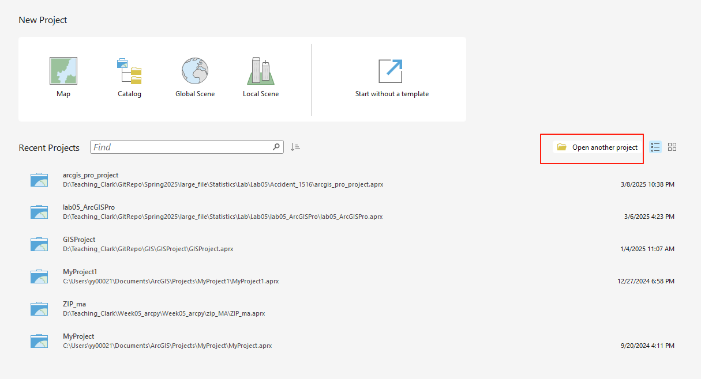
- Navigate to the directory that houses the material for this course. The project files are in the Exercise_1 folder where it was saved on your local machine.
- Select Exercise_1.aprx. Click OK to open the project.
- If necessary, navigate to the Arkansas map.
Note: If you’d prefer, you can also just double-click on the Exercise_1.aprx file within the uncompressed folder directly to launch ArcGIS Pro.
This project contains one map. This map is for Arkansas and contains a variety of data layers. One vector point layers have been provided: Airports. One vector line layer has been provided: Railroad. Two vector polygon layers have been provided: County and Soil_AR. Finally, three raster grids have been provided: LULC_FALL_CAST2006, DSM_2006_AR2, and HILLSHADE_AR2. The concepts for vector and raster data will be introduced in the following classes.
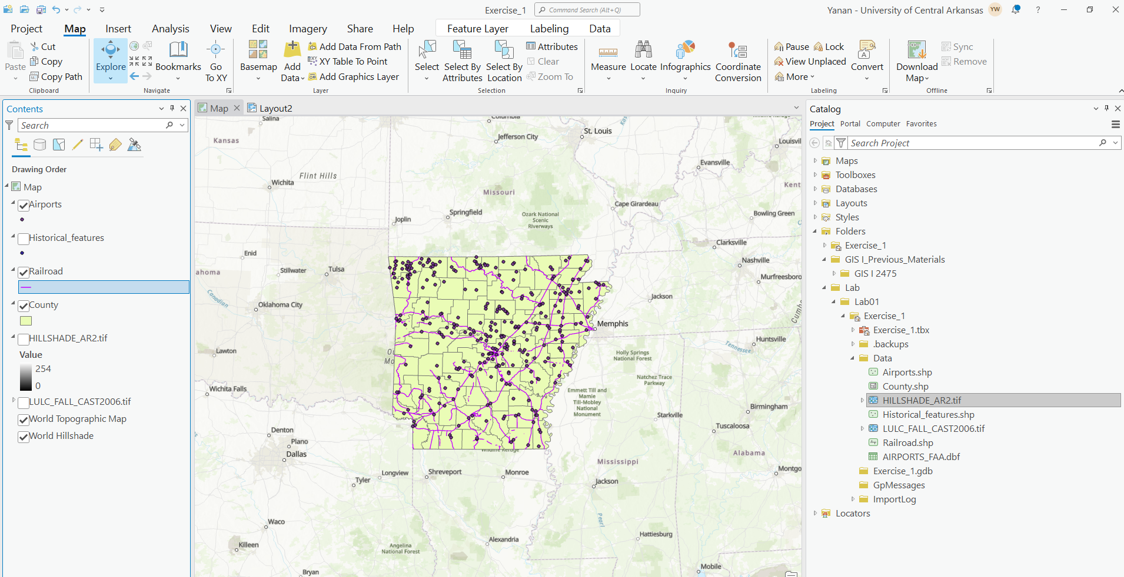
We will now further investigate ArcGIS Pro and these data layers.

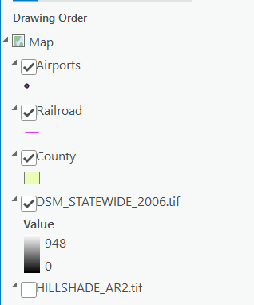
Step 2. Working With the Contents Pane
The layers displayed on the map are listed in the Contents Pane on the left side of the display. Note that the map layers are organized by drawing order. Layers further up the list display above layers further down in the list. Generally, point features draw above line features which draw above polygon features. Raster layers are generally at the bottom of the list. Features that are turned on will have a check mark in the box next to the layer name.

Question 1. How many layers are included on this map excepting the background layers of World Topographic Map and World Hillshade? (5 Points)
Answer 1:
You can turn off layers by clicking in the box to remove the check mark.
- Check off the County layer.
As you can see, when the layer is turned off, you can see layers below it. Layers higher up in the list of layers draw above layers that are beneath them in the Contents Pane. You can change the drawing order by moving the layers around in the Contents Pane.
- Turn the County layer back on.
- Click on the LULC_FALL_CAST2006 layer and drag it above the County layer.
As you can see, the LULC_FALL_CAST2006 layer is now being displayed above the county boundaries. So, if you need to change the drawing order of your layers, you can use this method.

Step 3. Add a New Layer to the Map
You will now add a new layer to the map within your project. Specifically, you will add a vector point layer of historical feature locations in Arkansas.
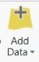
- Click the Add Data button. This button is available under the Map Tab within the Layer Section.
- Navigate to your directory that stores the lab material. Specifically, navigate to the Exercise_1 folder. Within this folder, there should be a folder called Data. Open this folder.
- Within the folder, select the Historical_features data. Click OK to add it to the map.
As you can see, the locations for historical features are now displayed in the map.

Step 4. Repair data source
When you open a map, the data referenced by each of the layer is accessed. When the data sources has been moved, renamed, deleted, or is otherwise inaccessible, that layer doesn’t draw, and its broken status is indicated in the Content pane with a red exclamation point !. To repair a broken data source, we only need to relink the lay in the Content pane to the data source. To practice this process, save your project by clicking on the Save button at the top-left corner, followed by clicking on the Cross icon at the top-right corner to close ArcGIS Pro.
- Navigate to the Exercise_1 folder. Rename Data to DataBackup.
- Double-click on the Exercise_1.aprx file within the Exercise_1 folder to launch ArcGIS Pro.
- You can see a ! before Historical_features layer, and there are no historical features showing in the map. This indicates the data source for the layer is broken. Click on the exclamation !, navigate to the Exercise_1 folder, open DataBackup folder, select the Historical_features data again, followed by OK. Now the broken data source is fixed, and the map displays the historical features.

Step 5. Change the Symbology of a Point Layer
Once the point layers have been added to your map, you may want to change the symbology. Note that ArcGIS Pro generally will assign a symbology randomly, so it may not be optimal to show the features of interest.
- Double-click on the point symbology for the Historical_features in the Contents Pane (the point feature used to show the Historical_features locations). The Symbology Window should load.

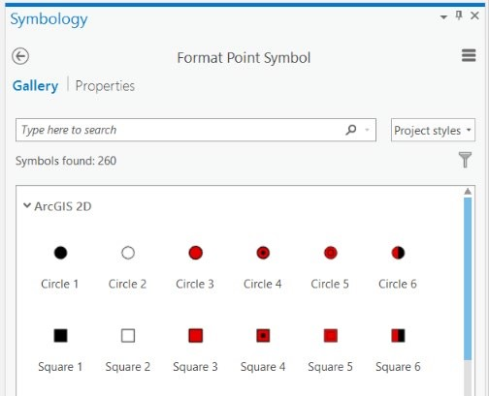

This Symbology Window allows you to change the symbology. The Gallery allows you to select from and search for available symbols. The Properties allow you to manually change the fill and outline color. A search of the available symbols in the Gallery didn’t yield an appropriate symbol. So, we will change the properties manually.
- Click on Properties in the Symbology Window.

- Click on the Layers Options (looks like a grid stack).
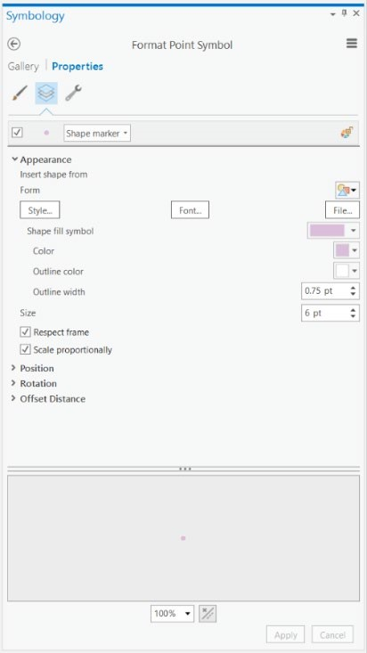
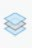
- Change the Color, Outline Color, and Size to settings you feel are appropriate.
- Click Apply to accept the changes.

Step 6. Change the Symbology of a Line Layer
You will now change the symbology of the line layer that represents railroad. This time, we will use the Gallery.
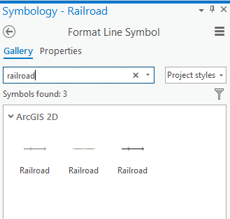
- Double-click on the line symbology for Railroad in the Contents Pane (the line feature used to show the railroad locations). The Symbology Window should now show the symbology for this feature as opposed to the historical feature.
- Navigate back to the Gallery options.
- Search for “railroad.”
- Select a symbology that seems appropriate.

Step 7. Change the Symbology of a Polygon Layer
You will now change the symbology of the Soil_AR layer. This layer shows the extent of soil types in the Arkansas state.
- Double-click on the polygon symbology for Soil_AR in the Contents Pane (the polygon feature used to show the soil types). The Symbology Window should now show the symbology for this feature as opposed to the previously selected layers.

- Click on Properties in the Symbology Window.
- Click on the Symbol Options (looks like a brush).
- Change the Color, Outline Color, and Outline Width to settings you feel are appropriate.
- Click Apply to accept the changes.
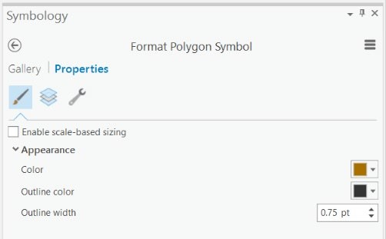
Note: You may have to turn off some layers to see the soil layer.

Step 8. Change the Symbology of a Raster Layer
All of the above examples demonstrated how to change the symbology of vector layers: points, lines, and polygons. Now, you will investigate changing the symbology of a raster layer. Specifically, you will change the colors used to symbolize the elevation data.

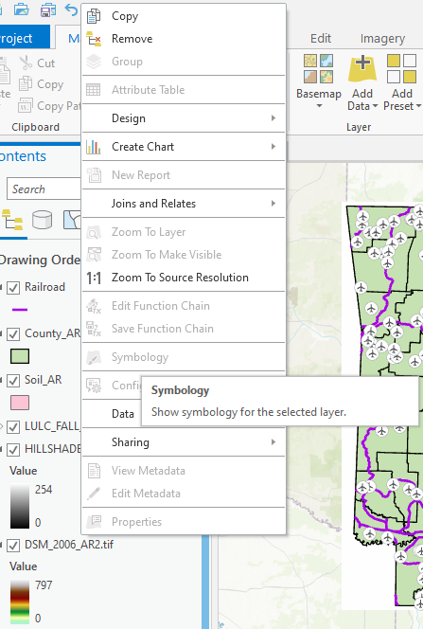
- Right-click on the DSM_2006_AR2 layer then select Symbology.
- In the Symbology Window, leave the Symbology as Stretch.
- Under Color Ramp, change the Color Scheme to a color scheme of your choosing.

Note: You may have to turn off some layers to see the elevation surface.
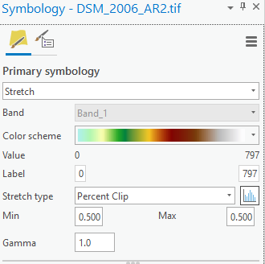

Step 9. Change a Layer Name in the Contents Pane
Other than changing the symbology of a layer, you can also change the name of the layer in the Contents Pane. Note that this does not change the name of the file. It is only changing how the name is displayed in the Contents Pane.
- Right-click on the DSM_2006_AR2 layer then select Properties.
- Under General options, change the Name to “DSM_2006_AR.”
- Click OK to accept the change.
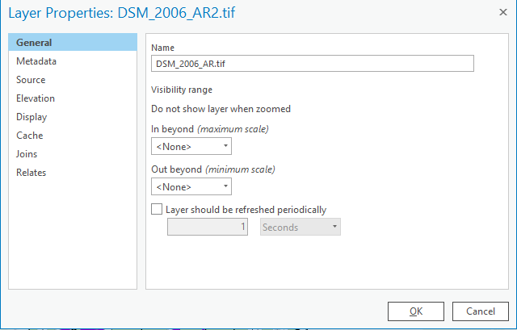

Step 10. Viewing Feature Attributes
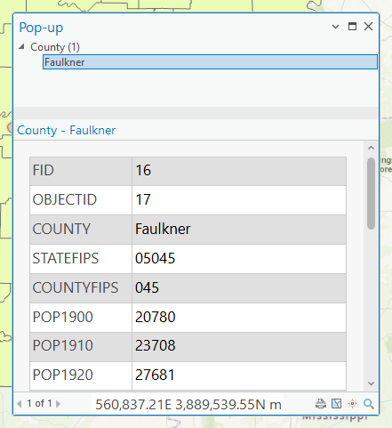
When you click in the map space and over a map feature, a dialog box appears that provides attribute information. This allows for an interactive means to explore attribute information.
- Make sure the County layer is turned on.
- Click on Faulkner County. A dialog box should open that provides information about this county.

Note: If you’re not sure which county is Faulkner County, please see the map below.
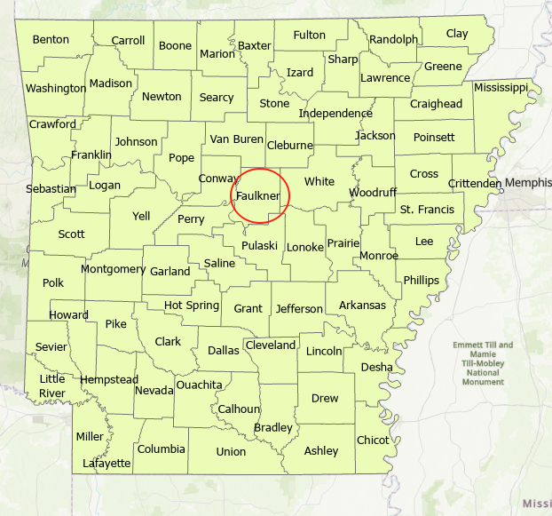
Use the information provided to answer the following questions.
Question 2. What was the population of Faulkner County in 1970? (Hint: POP1970 represents population in 1970) (5 Points)
Answer 2: 31572
Question 3. How did the population of Faulkner County change during last four decades? (Hint: POP1980, POP1990, P0P2000, andPOP2010 represent population in 1980, 1990, 2000, and 2010) (5 Points)
Answer 3: increase
- Keep your Airports layer on.
Use the layer to answer the following questions.
Question 4. How many landing strips in Faulkner County? (Hint: count the number of airport symbols within the Faulkner County) (5 Points)
Answer 4: ten

Step 11. Moving Around the Map
Under the Map Tab and in the Navigation Section, a variety of tools are available for navigating around the map.
The Explore Tool allow you to navigate around the map space. Here are some pointers.
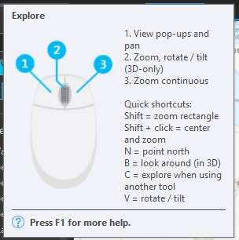
- Hovering over the Explore Tool brings up a dialog box that provides navigation information (shown here to the right).
- Clicking and holding allows you to pan around the map space.
- You can also pan by using the keyboard arrow keys.
- Using the mouse roller allow you to zoom in and out.
- Clicking then selecting shift allows you to draw a box to zoom in.
- Holding down the right mouse button and moving the mouse allows for continuous zooming.
- Holding down V while moving the mouse allow you to rotate the map. The map is north oriented by default.
The Bookmark Tool allows you to bookmark a map position so that you can return to it later.
Generally in ArcGIS Pro, if you hover over a tool, a helpful dialog box will load.
Hover over the tools referenced below to answer the questions posed.
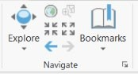

Question 5

Question 5. What is the purpose of the tool labelled above? (5 Points)
Answer 5: zoom to the full extent
Another zoom/panning option is to zoom to the extent of a certain layer.
- Right-click on the Soil_AR layer in the Contents Pane.
- Select Zoom to Layer.

Question 6. What did happen to the map? (5 Points)
Answer 6: the map zoom to the layer
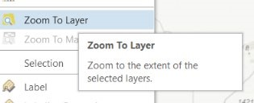

Step 12. Working with Attribute Tables
One of the benefits of a GIS is the ability to link spatial and aspatial or tabulated data. For example, the County layer available in this project does not just provide the county boundaries; it also provides tabulated or aspatial data about the counties. You can view this information using the attribute table.
- Right-click on the County layer and select Attribute Table.
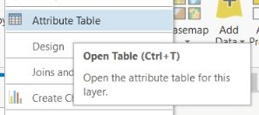

The attribute table should open.
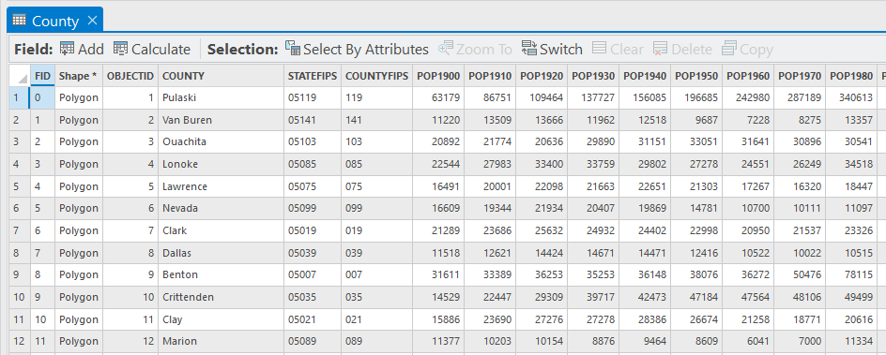
- Locate the “POP2000” field in the table. POP2000 represents the total population in year 2000.
- Right-click on the field name and select Sort Descending. This will reorder the counties in descending order based on population in 2000.
Question 7. What is the county with largest population in in Arkansas in 2000? (The county name is in the ‘NAME’ field) (5 Points)
Answer Q7: Pulaski
The county with smallest cases should appear at the bottom of the list. Alternatively, you can resort the data using Sort Ascending.
Question 8. What county had the smallest population in 1990?
(Hint: use the “POP1990” field)? (5 Points)
Answer Q8: Calhoun
It is also possible to create a new field in an attribute table. You will now create a new field in which to calculate population change.

- In the County attribute table, click the Add button.
- Name the new field “change” (without the quotes) under Field Name column.
- Define the field as Long.
- In the Fields Tab at the top of the screen, select Save.
Back in the attribute table, if you navigate to the end of the attribute table, you will see that a new field has been added. The field is called “change”. In this field, you will now calculate the population change between 1970 and 2010.
- Right-click on the “change” field and select Calculate Field. A Calculate Field window should open.
- Provide the expression to calculate change. Here, we will subtract the 1970 population (POP1970) from the 2010 population (POP2010). Instead of typing the syntax, select (double click) the POP1970 and POP2010 fields from the list of available fields.
- Once you have generated the syntax, click Apply to execute the calculation.

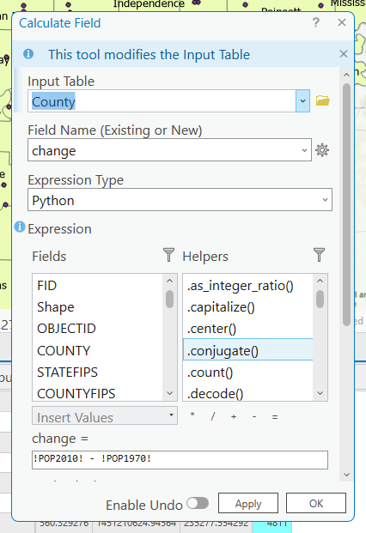
Back in the attribute table, you should now have numbers in the new “change” field. Negative values would indicate decrease in population whereas positive value would indicate increase in population. Use this new field to answer the following questions.
Question 9. Which county experienced the greatest population increase between these years? (Hint, you can sort the field by right-clicking on the field name (i.e., change) and select Sort Descending or Ascending) (5 Points)
Answer 09: Benton
You can also calculate geometric measures into an attribute column. This can be done using the Calculate Geometry Attributes Tool. You will work with a variety of tools in this course, so this will serve as an introduction to setting up and running a tool.

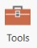
- Before using Calculate Geometry Attributes Tool, you need to create a new field to store the geometric measures. This can be done by clicking the Add button in in the County attribute table. Name the new field “Area” (without the quotes) under Field Name column.
- Define the field as Double.
- In the Fields Tab at the top of the screen, select Save.
Back in the attribute table, if you navigate to the end of the attribute table, you will see that a new field named ‘Area’ has been added.

- Navigate to the Analysis Tab then select Tools. This will open the Geoprocessing Window.
- Search for Calculate Geometry Attributes.
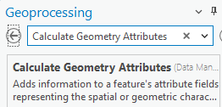

- Click on the Tool to open it.
- Set the Input Feature to County.
- Set the Field as Area
- Select Area for Property
- Set the Area Unit to Square kilometers.
- Set the Coordinate System to Current Map [Map].
- Click Run to execute the tool.
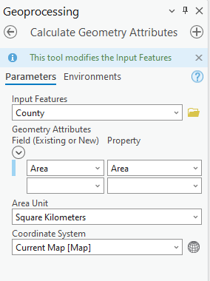
Back in the counties layer attribute table, you should see that new numbers are added to the ‘Area’ field. This field now contains the area of the county in square kilometers. Use this field to answer the following question.
Question 10. What is the area of Faulkner County in square kilometers? (5 Points)
Answer 10: 1718

Step 13. Saving the Project
You can save your work by navigating to the Project Tab then selecting Save. If you want to save a new copy you can use Save As. Remember to save often as you work through the lab exercises.

Step 14. Creating a New Layout
To finish this exercise, you will add a new Map Layout to your project. Map projects can house multiple 2D and 3D maps along with multiple map layouts.
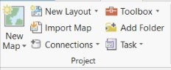
- Navigate to the Insert Tab and Select New Layout.
- From the list, select ANSI Portrait Letter 8.5” x 11” (this should be the first option). A new blank layout should be added.
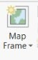
- To add the map to the layout, click on Map Frame under the Insert Tab.
- In the layout, draw a rectangle in any empty space, the map you just worked should be added.
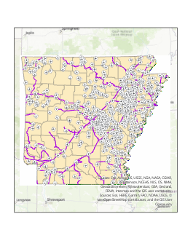
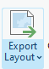
In later exercises, you will learn how to create effective map layouts. Here, we simply want to show you how to save the map as a graphic file.
- Navigate to the Share Tab and select Export Layout.

This will allow you to save a map layout as a graphic file, such as PDF or JPEG. If we ask you to turn in a map layout in this class, you will need to export it to a graphic file using this method as opposed to providing the project file.
Lab 1.2: Introduction to ArcGIS Online

END OF EXERCISE

Homework
Please submit a word file with 10 questions and corresponding answers. Please submit through Blackboard.

