Exercise 24: Raster Analysis using ModelBuilder
This exercise will describe how to create a model using ArcGIS ModelBuilder.
Specifically, you will create a model using raster analysis techniques and
input raster data. The goal will be to produce a model that predicts the
habitat of the Yellowed-Bellied Salamander (Imado thisupocus). Within the
study area extent, this salamander can be found in deciduous forested
landscapes above 800 meters. It only occupies core forested areas (core
areas >250 acres), and on the following landforms: steep slopes, slope
crests, upper slopes, flat summits, sideslopes, and coves.
Topics covered in this exercise include:
1. Create a ModelBuilder tool using raster analysis tools and techniques
2. Use reclassify and raster calculator operations
3. Change environment settings
4. Summarize raster model output within polygon features
5. Perform table joins
Step 1. Open a Map Project
First, we need to download and open the Exercise_24.aprx file.
Download the Exercise_24 data from https://www.wvview.org/. All
lab materials are available on the course webpage and linked to the
exercise. You will need to extract the compressed files and save it to
the location of your choosing.
Open ArcGIS Pro. This can be done by navigating to All Apps followed
by the ArcGIS Folder. Within the ArcGIS Folder, select ArcGIS Pro.
Note that you can also use a Task Bar or Desktop shortcut if they are
available on your machine.
After ArcGIS Pro launches, select “Open another project.”
Navigate to the directory that houses the material for this course. The
project files are in the Exercise_24 folder where it was saved on your
local machine.
Select Exercise_24.aprx. Click OK to open the project.
If necessary, navigate to the WV map.
1
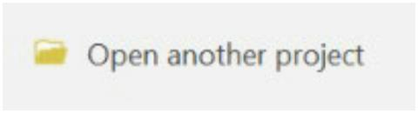

Note: If you’d prefer, you can also just click on the Exercise_24.aprx file
within the uncompressed folder directly to launch ArcGIS Pro.
This project contains a single map that contains six data layers.
Study_Boundary_Dissolved: polygon extent of study area boundary
defined relative to watershed extents
watersheds: polygon watershed extents that are within the study area
nlcd_2011: categorical raster grid of land cover from the 2011 National
Land Cover Database (NLCD)
fragment: categorical raster grid of forest fragmentation estimates (This
grid was created using the Landscape Fragmentation Tool made available by
the University of Connecticut:
http://clear.uconn.edu/tools/lft/lft2/index.htm)
elu: categorical raster grid of ecological land units (ELUs)
elevation: digital elevation model (DEM) raster grid in meters
Note: All of the raster grids are 30 by 30 meter resolution.
2
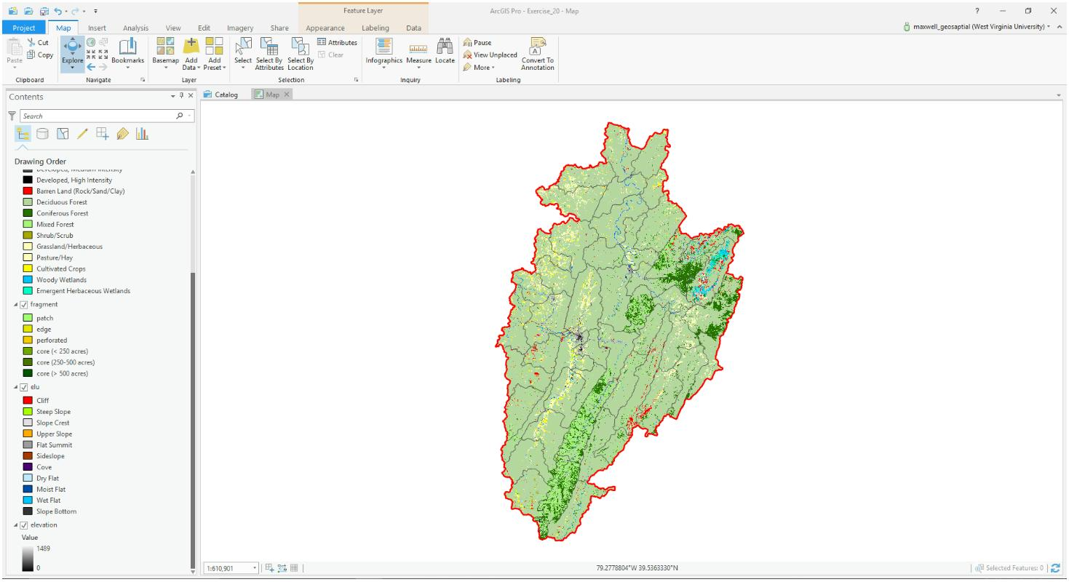

Note: The symbology for these raster
grids were applied using a layer file.
Here is a brief explanation of how layer
files can be created and used. Once the
layer has been symbolized, this
symbology can be saved as a layer
file. A layer file is not a copy of the
spatial data; instead, it simply
saves the symbology settings. To
save a layer file, right-click on a
layer in the Contents Pane then
select Save as Layer File. Note that
older layer files can generally be used in newer versions of the software.
However, newer layer files cannot be used in older versions of the software.
Once a layer file has been saved, it can be used to symbolize a new layer. In
the Symbology Pane, layer files can be imported. So, layer files can be used
to save and apply symbology.
Step 2. Create a New Toolbox
Before you begin the analysis, you will need to create a new toolbox in which
to save your model. You will do so using ArcCatalog.
In ArcGIS Pro, navigate to the View Tab then select Catalog View. This
will open the Catalog View if it is not already open.
In the Catalog View, double-click on Toolboxes. This will open a list of
available toolboxes.
Right-click in the toolbox space within the Catalog View then select
New Toolbox. Provide a name to save the new toolbox.
Note: Each project has a default toolbox associated with it. You can use this
toolbox. Here, we are having you create a new toolbox so that you know
how to do so. Tools, such as models, must be saved inside of toolboxes.
Step 3. Creating the Model
Return to ArcGIS Pro. You will not need to use ArcCatalog again in this
lab, so you can close it if you’d like.
3
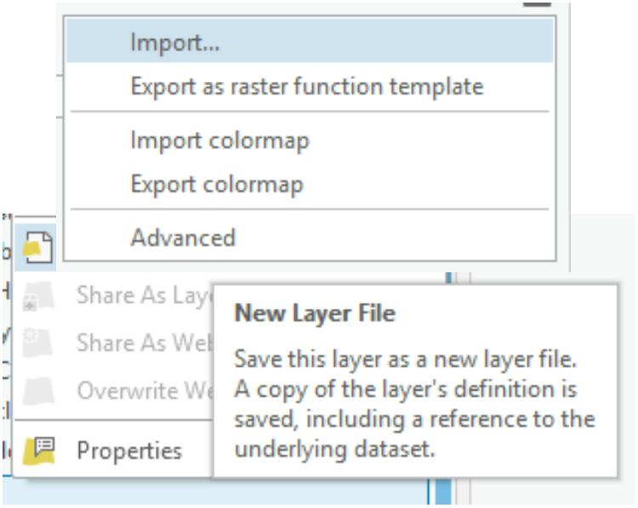

Navigate to the Analysis Tab then select ModelBuilder
under the Geoprocessing area. This will open the
ModelBuilder window.
In the ModelBuilder Tab, click on the Save As button.
Navigate to the toolbox you just created and save the
model in the toolbox as species_model.
In this lab we will define the required habitat as deciduous forest land cover
at elevations above 800 meters in core forested areas (core areas >250
acres) and on the following landforms: steep slopes, slope crests, upper
slopes, flat summits, sideslopes, and coves. To create this model you will
need to complete the following analysis tasks:
1.
Use the Raster Calculator Tool to create a binary land cover
classification in which deciduous forests are recoded as 1 and all
other classes are coded as 0.
2.
Use Raster Calculator Tool to create a binary elevation
classification in which all elevations above 800 meters are coded as
1 and all elevation less than 800 meters are coded as 0.
Use the Reclassify Tool to recode all core forests (core areas
>250 acres) as 1 and all other forests as 0.
Use the Reclassify Tool to code steep slopes, slope crests, upper
slopes, flat summits, sideslopes, and coves as 1 and all other
landforms at 0.
3.
4.
5.
Multiply all the resulting binary grids to find all grid cells in the
study area that meet all the criteria.
This section of the exercise will guide you in creating the model. Once your
model is complete, it should look like the model presented below.
4
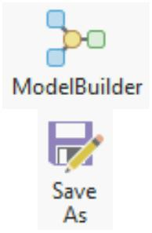

First, change the environment settings for the model.
In the ModelBuilder Tab and in the Model area, select
the Environments button.
Set the Current Workspace and the Scratch Workspace
to the Exercise_24.gdb geodatabase that is in the
Exercise_24 folder.
Set the Output Coordinate System to be the same as Current Map
[Map] (should be NAD 1983 UTM Zone 17 North).
Set the Processing Extent to be the same as the
Study_Area_Dissolved layer.
Set the Snap Raster to the elevation layer.
Set the Cell Size to be the same as the elevation layer (should be
30).
Set the mask to the Study_Area_Dissolved layer.
Click OK to save these environment settings.
Note: Environment settings changed within ModelBuilder are only honored
by operations performed within the model, not by all operations performed
within the project.
5
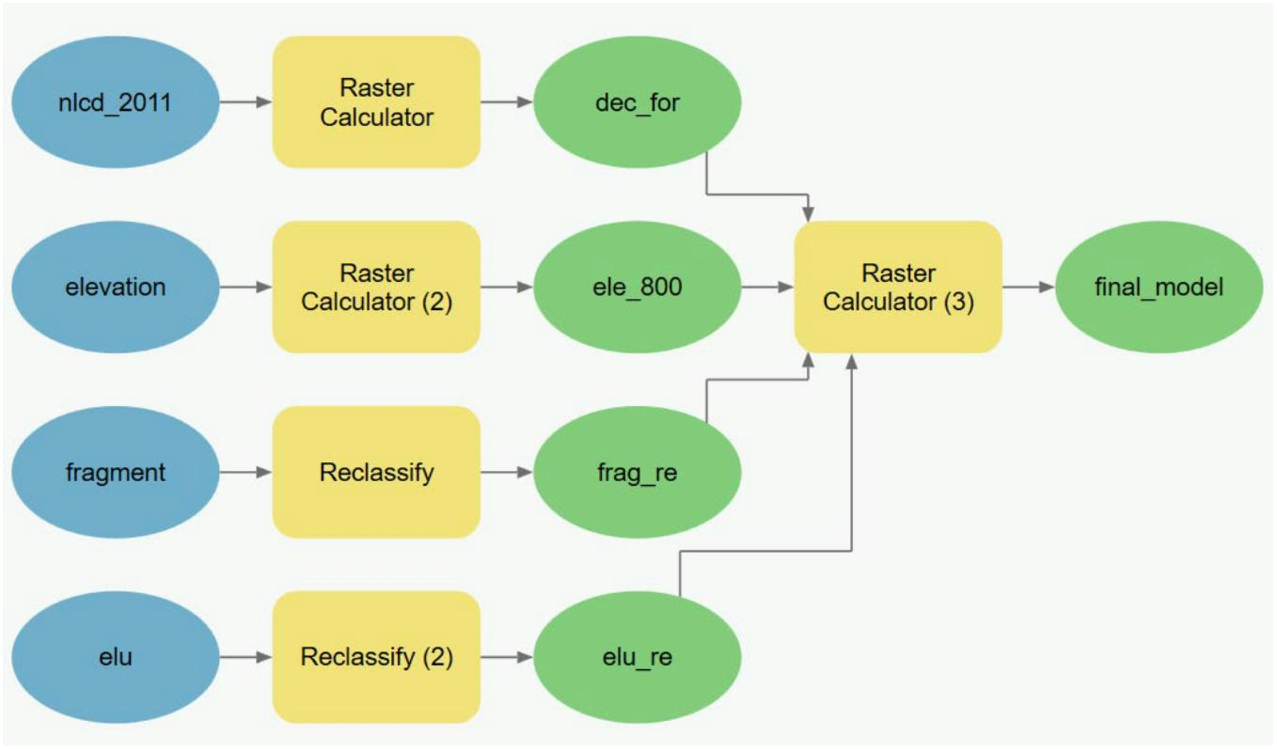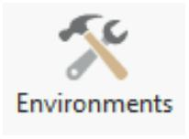

Add the two input layers to the model by dragging them from the
Contents Pane to the model area.
There are many options for adding tools to the model. Here, you will use
ArcToolbox.
Right-click on the Tools button under ModelBuilder. This will open the
Geoprocessing Pane. In the Geoprocessing Pane, click on Toolboxes to
view ArcToolbox. Tools can be added by dragging them from
ArcToolbox to the model area.
Add the following tools to the model.
1. Raster Calculator Tool (You will need 3) (This can be found in the
Map Algebra subtoolbox of the Spatial Analyst Toolbox.)
2. Reclassify Tool (You will need 2) (This can be found in the Extract
subtoolbox of the Spatial Analyst Toolbox.)
6
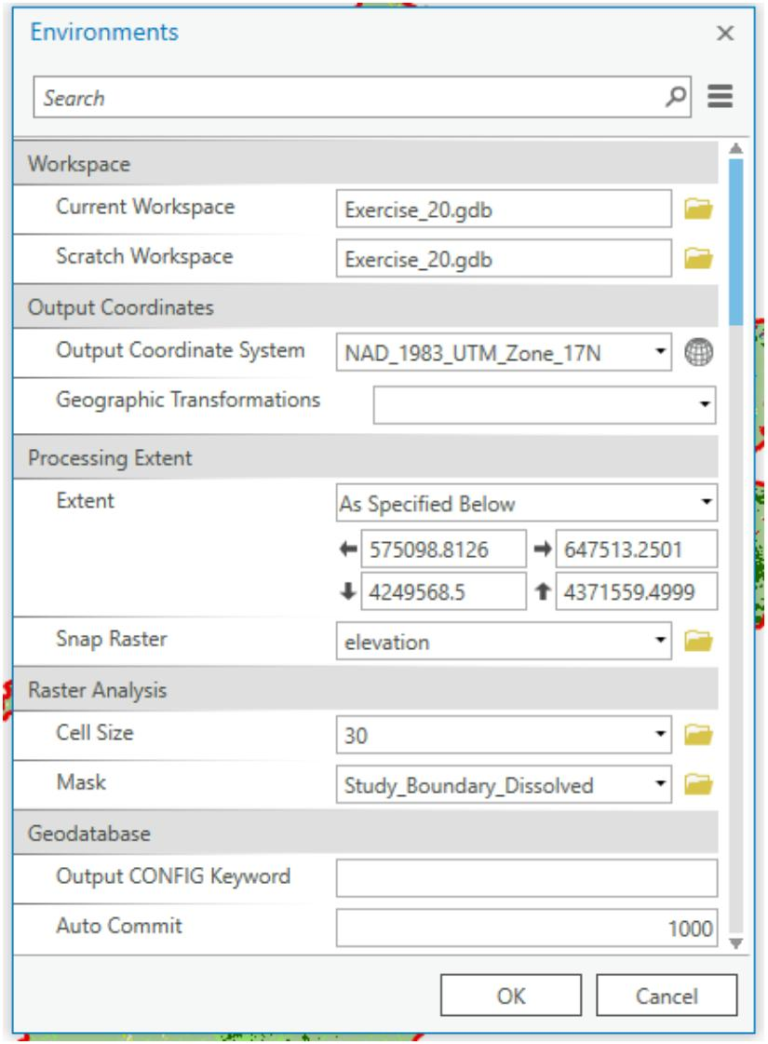

You will now need to specify the settings for each tool. The outputs will
automatically save to the Exercise_24.gdb geodatabase, as this was
defined as the working directory. To edit the settings for each tool, click on
each tool to open up the wizard. Once you have specified the desired
settings, click OK to accept the changes. Note that links between inputs and
tools and tools and outputs will be created as you change the settings.
Extract deciduous forest from nlcd_2011 using Raster Calculator
Tool
a. Use the following raster calculator expression: "%nlcd_2011%"
==41
b. Output Raster = dec_for
Extract elevations above 800 meters from elevation using Raster
Calculator Tool
a. Use the following raster calculator expression: "%elevation%"
>800
b. Output Raster = ele_800
Extract core forested areas (core areas >250 acres) from fragment
using Reclassify Tool
a. Input Raster = fragment
b. Reclass Field = “VALUE”
c. Use the table below to reclassify the raster.
d. Output Raster = frag_re
Old Values
New Values
1
2
3
4
5
6
0
0
0
0
1
1
NODATA
NODATA
Extract landforms from elu using Reclassify Tool
a. Input Raster = elu
b. Reclass Field = “VALUE”
c. Use the table below to reclassify the raster.
7
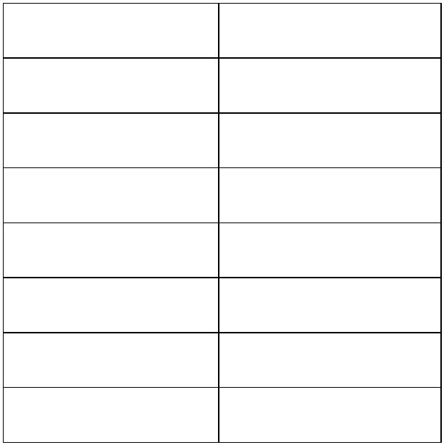

d. Output Raster = elue_re
Old
New
Values
Values
10
11
12
13
14
20
21
30
31
32
33
0
1
1
1
1
1
1
0
0
0
0
NODATA NODATA
Multiply results to obtain the final model using Raster Calculator
Tool
a. Use the following raster calculator expression: "%dec_for%" *
"%ele_800%" * "%frag_re%" * "%elu_re%"
b. Output Raster = final_model
You should now have a completed model that looks like the one shown
above.
Save your model by clicking on the Save button in the
Model area of the ModelBuilder Tab.
Note: You can make your model graphic a little neater by using
the Auto Layout Button. This can be used to make the graphic
more orderly. Blue indicates inputs, yellow indicates tools or
processes, and green indicates outputs.
8
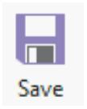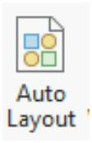

Step 4. Execute the Model
Now that you have a complete model, it can be executed. Before you
execute the model, it is generally a good idea to validate the model.
Click on the Validate Tool in the Run area of the
ModelBuilder Tab to validate the model. If no issues are
flagged, no issues were detected.
You can now run your model. Do this by clicking the Run
Button in the Run area of the ModelBuilder Tab.
Once the model executes, no layers will be added to your
map. You will need to add the final_model output to the
map to answer the questions below. To do this, right-click on the
output model graphic then select Add to Display. Feel free to add all of
the other intermediate outputs.
Use the results to answer the following questions. Note that cells coded as 1
met all of your criteria whereas cells coded as 0 did not meet all of your
criteria.
Question 1. How many pixels were found
to be suitable habitat? (2 Points)
Question 2. What is the cell size of the
model? (2 Points)
Question 3. What is the area of suitable
habitat in square meters? (2 Points)
Question 4. What is the area of suitable
habitat in hectares? (2 Points)
Question 5. What is the area of suitable
habitat in acres? (2 Points)
9
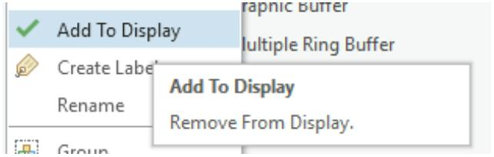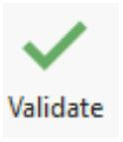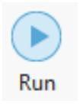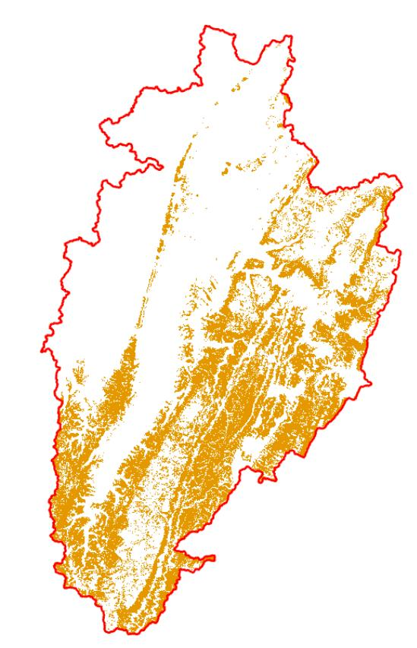

Step 5. Summarize Results by Watershed
You will now explore your results relative to watershed boundaries. First,
you will use the Tabulate Area Tool to obtain the area of suitable habitat
by watershed. You will then join this result to the watersheds layer. Lastly,
you will perform some attribute table calculations to obtain the percentage
of suitable habitat.
Navigate to Spatial Analyst Tools followed by the Zonal subtoolbox.
Open the Tabulate Area Tool.
Set the Input Raster or Feature Zone Data to the watersheds layer.
Set the Zone Field to the “HU_12_NAME” field.
Set the Input Raster or Feature Class Data to the final_model layer.
Make sure the Class Field is set to “VALUE.”
Name the Output Table model_table.
Make sure the Processing Cell Size is set to 30 (this should happen by
default).
Click Run to execute the tool. The output should automatically be
added to your map.
Open the resulting table to answer the following questions.
Question 6. Which watershed has the largest area designated as habitat?
(2 Points)
10
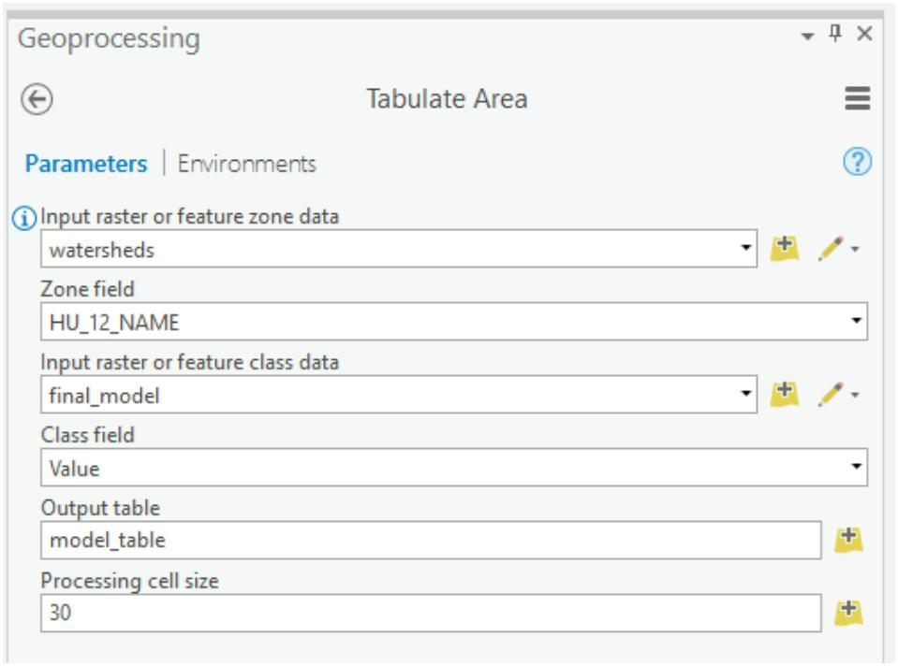

Question 7. Do any watersheds have no predicted habitat for this
organism? (2 Points)
Now, you will join the result to the watershed layer using a Table Join.
Right-click on the wetlands layer in the Contents Pane. Select Joins
and Relates followed by Add Join. This will open the Add Join Tool.
Make sure the Layer Name or Table View is set to watersheds.
Set the Input Join Field to the “HU_12_NAME” field.
Make sure the Join Table is set to model_table.
Make sure the Output Join Field is set to “HU_12_NAME.”
Click Run to execute the join.
The join has now been performed. If you open the attribute table for the
watersheds layer, it will now contain the columns from model_table;
however, these are just temporary. To save them to the layer, you will need
to make a copy.
Right-click on the watersheds layer in the Contents Pane. Select Data
followed by Export Features. This will open the Copy Features Tool.
Make sure the Input Feature is set to watersheds.
Name the Output Feature Class results_by_watersheds.
Click Run to execute the tool.
11
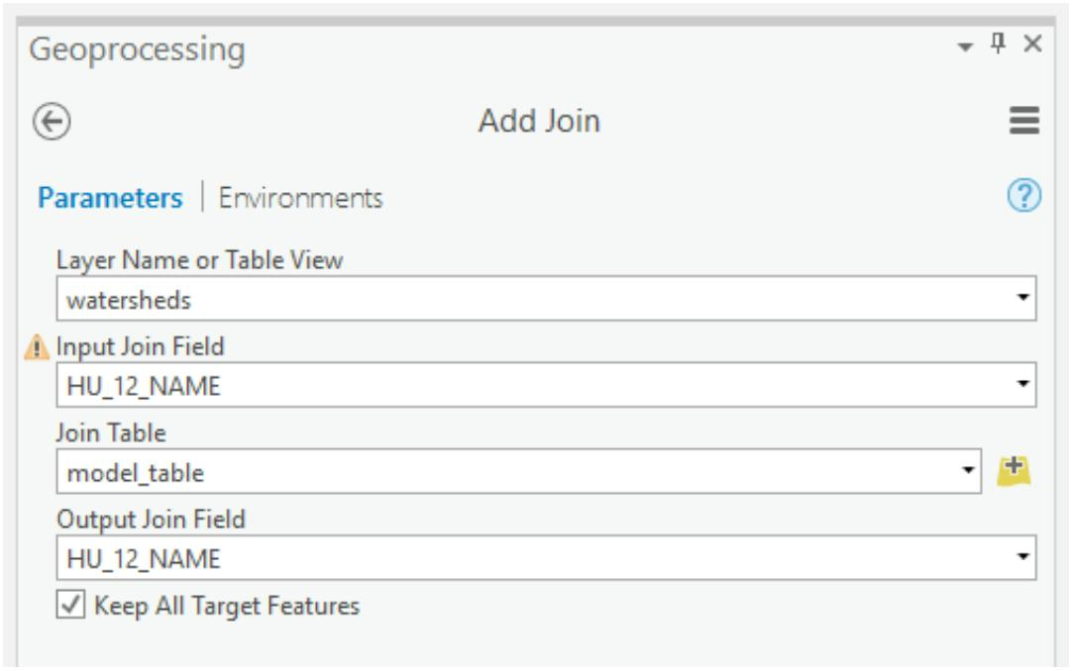

The result should automatically add to your Contents pane. You will now
calculate the percentage of suitable habitat by watershed.
Open the attribute table for the results_by_watersheds layer.
Click the Add Field Button in the attribute table.
Name the field “per_hab” (without the quotes) and define
it as Double.
Click Save in the Fields Tab to add the new field.
Navigate back to the attribute table for the results_by_watershed
layer. The “per_hab” field should be at the end of the table.
Right-click on the name of the “per_hab” field the select Calculate
Field. This will open the Calculate Field Tool.
Make sure the Input Table is set to results_by_watershed.
Make sure the Field Name is set to “per_hab.”
Use the following syntax to calculate the field:
(!model_table_VALUE_1! / !Shape_Area!) * 100
Click Run to perform the calculation.
Use the results of the calculation in the “per_hab” field to answer the
following questions.
Question 8. Which watershed had the largest percentage of predicted land
area as habitat? (2 Points)
Question 9. What percentage of the Gandy Creek Watershed was predicted
as suitable habitat? (2 Points)
Question 10. What percentage of the Sugar Creek Watershed was predicted
as suitable habitat? (2 Points)
12
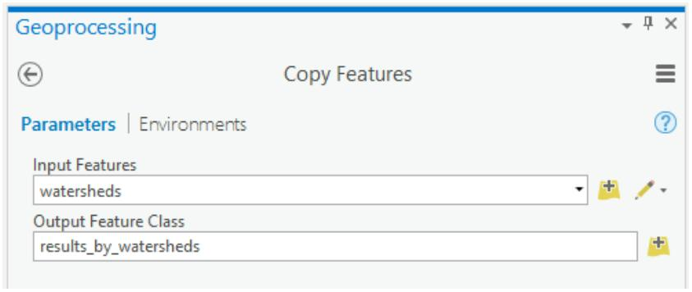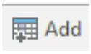

Step 6. Make a Map of Your Model
Deliverable 1 (10 Points)
Create a map of your model result (10 Points). Make sure it is in PDF format
and include the following:
1.
2.
Your name (1 point)
The model output. Zero values should not be shown (made hollow).
Only the 1 or true values should be shown (3 Points)
The watershed boundaries displayed with only borders and no fill (2
Points)
An appropriate legend displaying the watershed boundaries and the
predicted habitat. The zero values should not be in your legend. No
file names should appear in the legend (2 Points)
An appropriate north arrow, title, and scale bar (2 point)
3.
4.
5.
Extra: Step 7. Create Tool from a Python Script
The previous lab showed you how to create a tool from a model created
using ModelBuilder. Tools can also be created from python scripts. This part
of the lab is optional and provides a quick demonstration of how to create a
new tool from a Python script.
Topics covered in this exercise included:
1. Create a new tool from a Python script
A Python script has been provided in the Exercise_24_Extra folder within
the Exercise_24 folder called roughness.py. This script calculated
topographic roughness, which you calculated in a previous lab. It was
originally developed by Dr. Jeff Evans and implemented in the ArcGIS
Geomorphometry & Gradient Metrics Toolbox:
http://evansmurphy.wixsite.com/evansspatial/arcgis-gradient-metrics-
toolbox. Here, you will turn this script into a tool.
Navigate to the Catalog Tab then right-click in the Toolboxes area.
Click Add Toolbox.
Navigate to the Exercise_24 folder and select the toolbox created
earlier.
Double-click in the Toolbox area to see the available toolboxes. Your
toolbox should have been added.
13


Right-click on your toolbox then select New followed by Script.
In the window, click on the folder button associated with Script File
and navigate to the Exercise_24_Extra folder to select the
roughness.py script.
Change the label to “Topographic Roughness” (without the quotes).
Navigate to the Parameters section. You will now need to set up the
user-defined parameters that are already specified in the script. This
will allow users to implement the script like a tool as opposed to
interacting with the Python code directly. You will need to specify four
user-defined parameters:
a. Parameter 1
i. Label = Input DEM
ii. Name = demRaster
iii. Data Type = Raster Dataset
iv. Type = Required
v. Direction = Input
b. Parameter 2
i. Label = Analysis Window
14
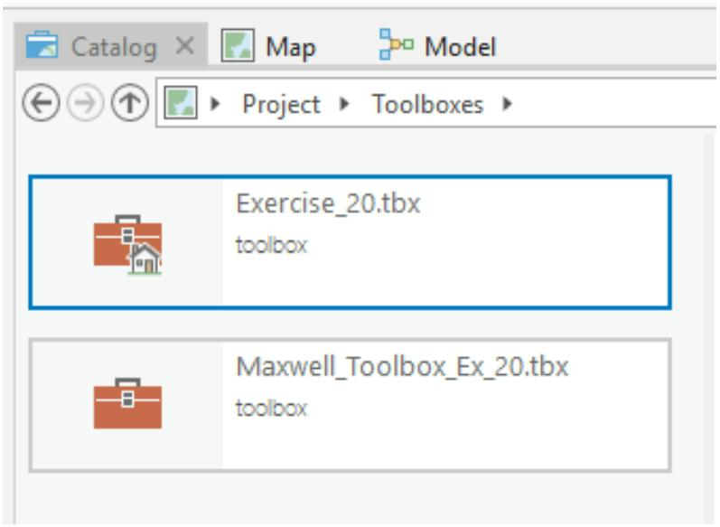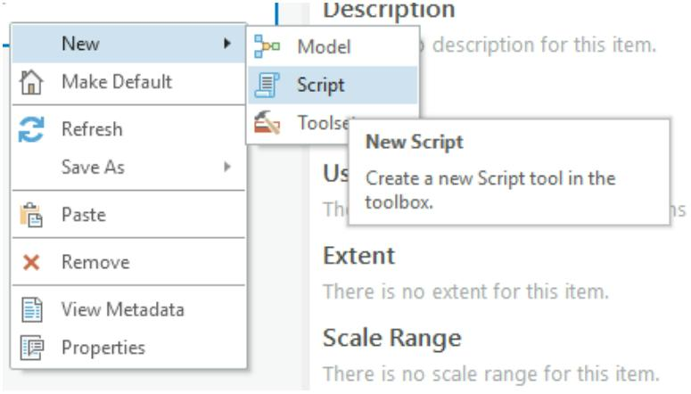

ii. Name = analysisWindow
iii. Data Type = Neighborhood
iv. Type = Required
v. Direction = Input
c. Parameter 3
i. Label = Extent
ii. Name = ext
iii. Data Type = Extent
iv. Type = Required
v. Direction = Input
d. Parameter 4
i. Label = Output Roughness Surface
ii. Name = outRasterName
iii. Data Type = Raster Dataset
iv. Type = Required
v. Direction = Output
Click OK to accept these parameters.
If you would like to view the script you can navigate to it in the file
directory, selecting Open With, then choosing Notepad. This will open the
script in a Notepad document. In this script roughness has been defined as
the square root of the standard deviation of elevation values within a defined
window. In the script, the function arcpy.GetParatmerAsText calls for user-
defined parameters.
The required user-defined parameters are:
1.
2.
The input DEM (demRaster = arcpy.GetParameterAsText(0))
The analysis window (analysisWindow =
arcpy.GetParameterAsText(1))
15
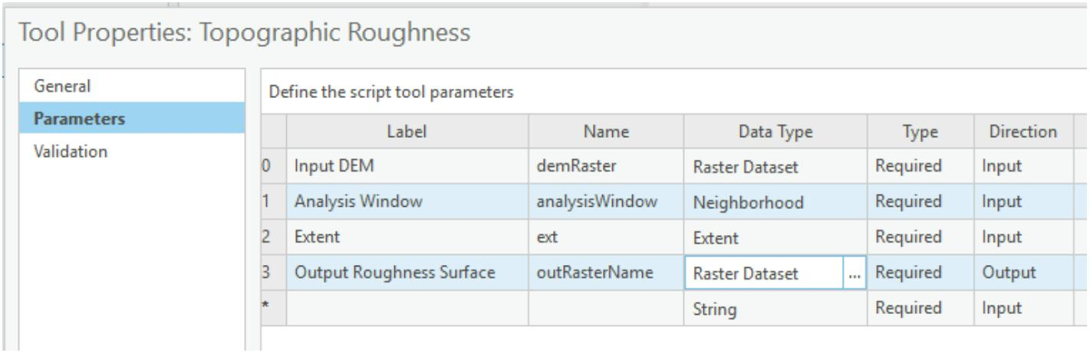

3.
4.
The extent of the analysis (ext = arcpy.GetParameterAsText(2))
The output roughness surface (outRasterName =
arcpy.GetParameterAsText(3))
The parameters you set above allows the user to input the four required user
defined parameters using the tool as opposed to interacting with the code
directly. The end user is able to provide an input raster grid as a digital
elevation model, define the window shape and size used to specify the
neighborhood, provide an analysis extent, and name and save the output
raster surface. Note that the parameters must occur in the correct order
(e.g. Input Raster, Analysis Window, Extent of Analysis, Output Roughness
Surface). Also, you must specify the correct variable name, as defined in the
script.
You are now ready to execute the tool to see if it works.
Double-click on the script to open the Geoprocessing Pane. The tool
should have the name provided by changing the label (“Topographic
Roughness”). All four parameters should be available for the user to
specify.
A DEM called test_dem has been provided in the Exercise_24_Extra
folder. Set this as the Input DEM.
For the Analysis Window, use a circular window with a radius of 9 cells.
Make sure the extent is the same as the test_dem layer. To do this,
you will need to browse for the layer.
Name the Output Roughness Surface rgh_test and save it to the
Exericse_20.gdb geodatabase.
Once the tool executes, the resulting roughness surface should be added to
your map.
The ability to build tools from ModelBuilder models and from Python scripts
greatly expands the analytical capabilities of ArcGIS Pro. If you build your
own stools using ModelBuilder or scripts, you can easily share them with
others by sharing your toolbox.
END OF EXERCISE
16

