Exercise 09: Raster Analysis
Due date: Midnight (11:59 pm) on Monday, November 17, 2025 submitted as Word document to blackboard Lab09 link
This lab counts 6.67 % (60 points out of 900 points) toward your total grade

Since raster data have a fundamentally different data structure compared to vector data, different tools and techniques are used to work with, process, and analyze these data. In this exercise, you will undertake a variety of raster analysis techniques. The exercise will use raster analysis techniques to determine suitable locations to potentially build a new protestant church.

Topics covered in this exercise include:
- Create a variety of raster analysis outputs including: Euclidean distance grids, topographic slope grids, topographic aspect grids, binary grids, and kernel density grids
- Convert vector data to raster data
- Use a variety of raster analysis tools and techniques including: Euclidean distance, raster calculator, reclassify, kernel density, slope, and aspect
- Answer spatial analysis questions by combining raster analysis tools

Step 1. Open a Map Project
First, we need to download and open the Exercise_09.aprx file.
- Download the Exercise_09.zip file. You will need to extract the compressed files and save it to the location of your choosing.
- Open ArcGIS Pro. This can be done by navigating to All Apps followed by the ArcGIS Folder. Within the ArcGIS Folder, select ArcGIS Pro. Note that you can also use a Task Bar or Desktop shortcut if they are available on your machine.
- After ArcGIS Pro launches, select “Open another project.”
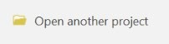
- Navigate to the directory that houses the material for this course. The project files are in the Exercise_09 folder where it was saved on your local machine.
- Select Exercise_09.aprx. Click OK to open the project.
Note: If you’d prefer, you can also just click on the Exercise_09.aprx file within the uncompressed folder directly to launch ArcGIS Pro.
This project should contain one map that houses the data needed for the lab: Suitability. The data have already been symbolized. However, feel free to change the symbology. Throughout the lab, you may want to turn layers on and off so that it is easier to visualize the results of your analysis.
The Suitability map houses the data required for the lab. It includes the following layers:
Churches: point locations of existing protestant churches
towns: point location of towns
interstates: line features representing interstates highway
public_land: polygon features of public lands
Counties1: polygon county boundaries representing the extent of your study area in central Arkansas
dem2006_ctl: digital elevation model (DEM) of the region in meters
Your goal will be to create a binary (0/1 or FALSE/TRUE) surface in which cells coded as 1 would be adequate to locate new church. Here are the criteria:
- Within 5 miles of interstate highways
- On slopes of less than 15 degrees
- With a low population density of existing churches nearby
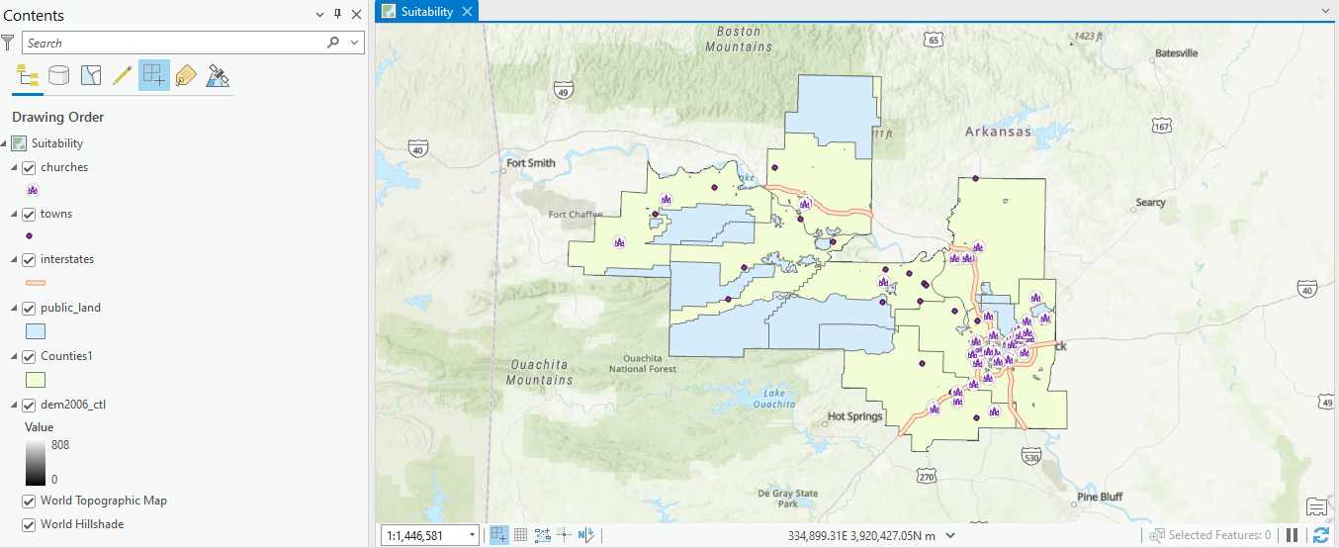

Step 2. Defining Environment Settings
Since you will perform many spatial analysis operations in this lab, you will start by setting the environment settings. It is generally a good idea to set environment settings any time you will perform spatial analysis operations in a project. Also, this can speed up you processing, as you will not need to set environments for each tool individually. In short, we highly recommend this.
- Make sure the Suitability map is active.
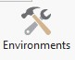
- Navigate to the Analysis Tab then select Environments in the Geopocessing Area.
- Change the Current Workspace and the Scratch Workspace to the Exercise_09.gdb geodatabase in the Exercise_09 folder. This will cause all of the outputs to automatically be saved to this location.
- Set the Output Coordinate System to Current Map [Suitability] (should be NAD 1983 UTM Zone 15 North) under Output Coordinates.
- Set the processing extent to be the same as the Counties1 layer under Processing Extent.
- Set the cells size to be the same as the dem2006_ctl layer (should be 28.5, meaning 28.5 by 28.5 meters) under Raster Analysis.
- Also under Raster Analysis, set the Mask to the Counties1 layer and Snap Raster to the dem2006_ctl layer.
- You do not need to change any of the other settings.
- Click Okay to accept these settings.
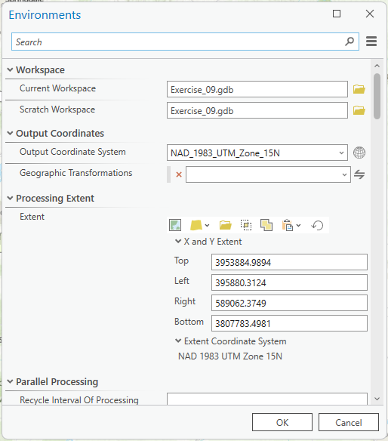
Note: Setting the snap raster to the dem2006_ctl layer means that all the raster grids you create will align perfectly with the dem2006_ctl layer. We recommend setting a snap raster, especially if you plan to perform any raster overlay, as you will do here, since this results in a cleaner overlay, as the cells align perfectly.

Step 3. Create Euclidean Distance Grids
Two of the criteria in this simple model is distance from interstate highway and distance from towns. So, you will need to create Euclidean distance grids relative to these variables. Euclidean distance calculates the straight line (Euclidean) distance from a source to the created cell. This is accomplished using the Euclidean Distance Tool.
Note: In this lab, we will access tools from ArcToolbox. However, there are many ways to access tools in ArcGIS Pro. For example, some of the more common tools are provided in the Tools list in the Analysis Tab.
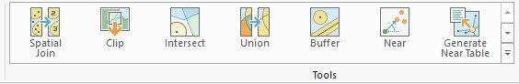
Once you open the Geoprocessing Pane, you can access favorite tools or search for Tools.
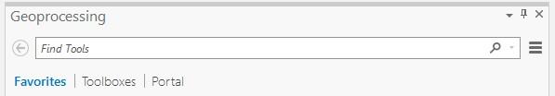
We have decided to demonstrate ArcToolbox here so that you get a sense of where the tools are located in the Toolbox directory. You can also create your own tools and toolboxes, which will be investigated in later labs.
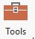

- In the Analysis Tab, select Tools from the Geoprocessing Area. This should open the Geoprocessing Pane.
- In the Geoprocessing Pane, navigate to the Toolboxes.
Note: We will not provide these directions for accessing other tools. We will just tell you where to find them within ArcToolbox.
We will start by calculating distance from towns.
- Navigate to Spatial Analyst Tools followed by the Distance subtoolbox and Legacy subtoolbox.
- Click on the Euclidean Distance Tool.
- Set the Input Raster or Feature Source Layer to the towns layer.
- Name the Output Distance Raster town_dist (this will save to the Exercise_009.gdb geodatabase, as defined in the environment settings).
- You do not need to change any of the other settings.
- Click Run to execute the tool. The output should automatically be added to your map.
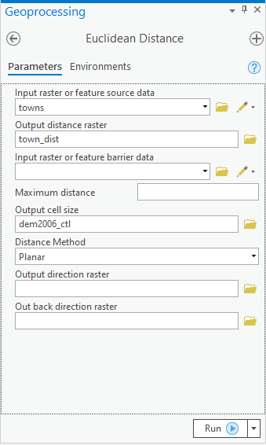
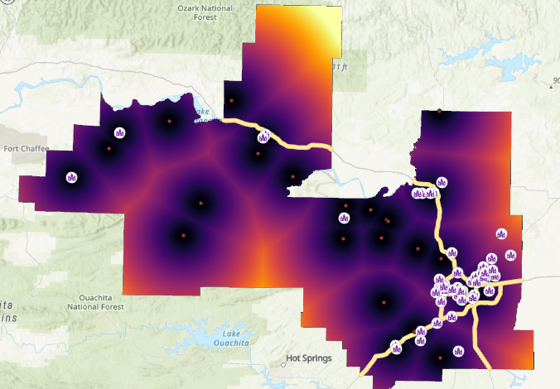
- Note, your resulted color for town_dist may be different as mine, as ArcPro will randomly pick up a color for it. You can change the color scheme by right-clicking on the layer followed by Symbology.
- Complete a similar process to obtain the distance from interstate highways. Name the output highway_dist.

Deliverable 1. Provide a screen capture of your result that shows highway_dist. (12 Points)
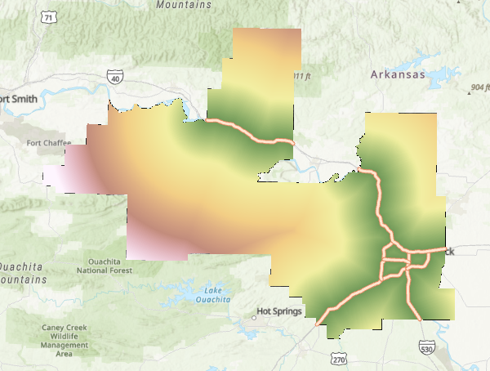

Step 4. Calculate Topographic Slope from a DEM
You have been provided with a DEM, which represents elevation measurements. However, in this model, you need topographic slope, not elevation. Luckily, you can easily derive topographic slope from raster-based elevation data using the Slope Tool.
- Navigate to Spatial Analyst Tools followed by the Surface subtoolbox.
- Click on the Slope Tool.
- Set the Input Raster to the dem2006_ctl layer.
- Name the Output Raster slp_d.
- Make sure the Output Measurement is set to “Degrees.”
- You do not need to change any of the other settings.
- Click Run to execute the tool. The output should automatically be added to your map.
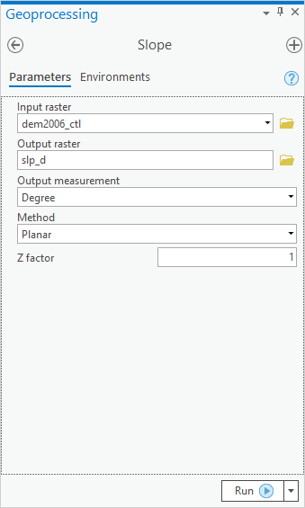
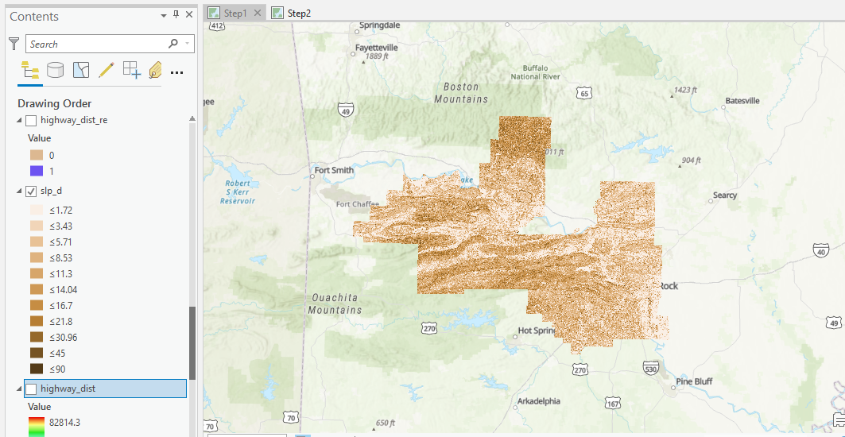

Deliverable 2. Provide a screen capture of your result that shows slp_d. (12 Points)
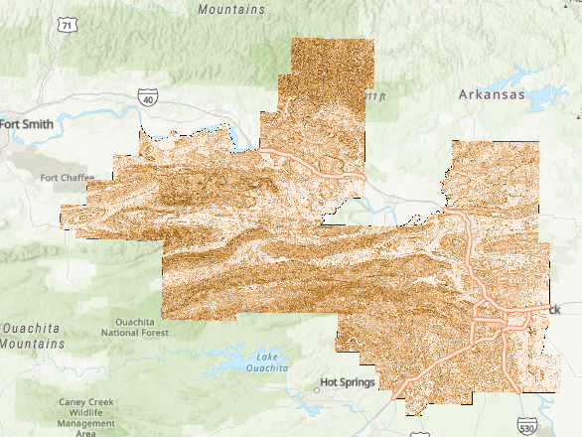

Step 5. Using Raster Calculator to Produce Binary Grids
You have now created surfaces that represent the distance from towns, distance from interstate highways, and topographic slope. However, you have not found cells that meet the model criteria. To obtain this, you will use the Raster Calculator Tool. This tool allows you to perform mathematical and logical operations on cells and write the result to a new raster grid. Here we will make use of the logical operators to find cells that meet a certain criteria. Cells that meet the criteria will be coded as 1, or TRUE, whereas cells that do not meet the criteria will be coded as 0, or FALSE. These 1/0 or TRUE/FALSE grids are known as binary raster grids. Let’s start by finding all the cells that are within 5 miles of a highway.
- Navigate to Spatial Analyst Tools followed by the Map Algebra subtoolbox.
- Click on the Raster Calculator Tool.
- Provide the following syntax: "highway_dist" <= 8046.75 (This number is roughly equivalent to 5 miles. You have to specify the distance in meters because the horizontal units of this map are in meters, and that is how the distance units in the Euclidean distance grid are defined).
- Name the Output Raster highway_dist_re.
- Click Run to execute the tool. The output should automatically be added to your map.
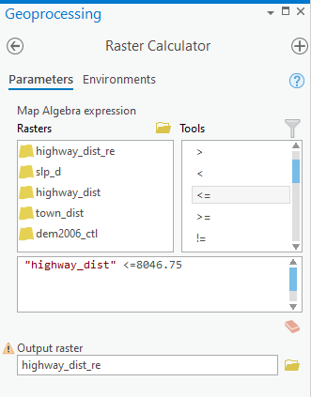
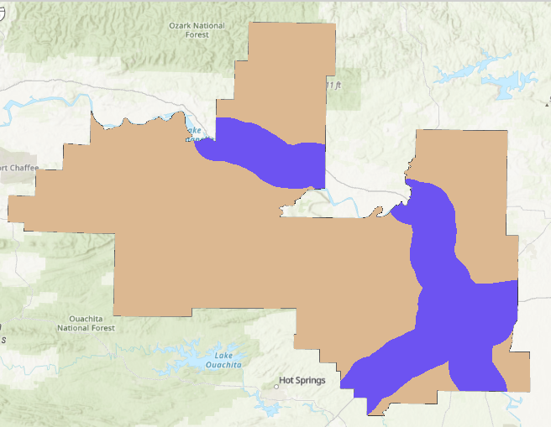
- Complete a similar analysis to find all of the cells the meet the topographic slope criteria (The slope must be less than 15 degrees). Name the output slp_d_re. (Hint, the syntax should be "slp_d"<=15)

Deliverable 3. Provide a screen capture of your result that shows slp_d_re. (12 Points)
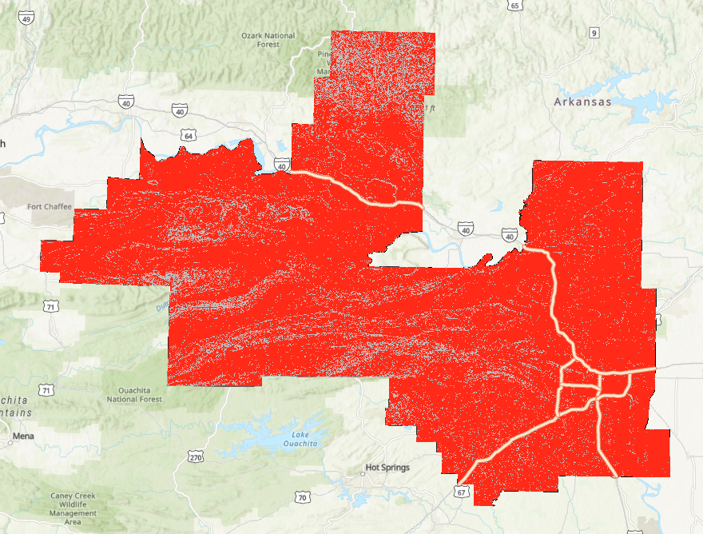

Step 8. Create Point Density Grid
You only have one more criteria to model. Here we will find all cells with an estimate less than 200 persons per square kilometer. You will do this using the Point Density Tool. This tool calculated the density of features or a phenomena.
Navigate to Spatial Analyst Tools followed by the Density subtoolbox.
- Click on the Point Density Tool.
- Set the Input Point Features to the churches layer.
- Set the Population Field to “MEMBERS2.” (This is the number of members for each Church)
- Name the Output Raster point_den.
- Make sure the Output Cell Size is set to same as dem2006_ctl.
- Set the search radius to 2000 (this is equivalent to 2,000 meters or 2 kilometers).
- Set the Area Units to “Square Kilometers.” So, the density estimate will be person per square kilometers.
- You do not need to change others.
- Click Run to execute the tool. The output should automatically be added to your map.
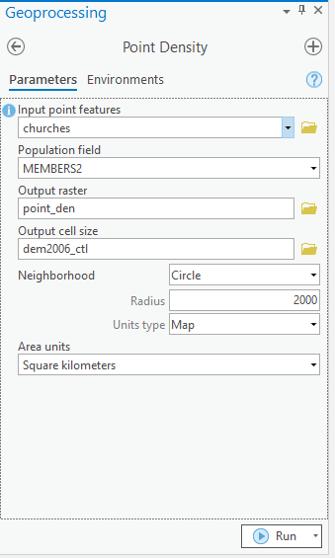
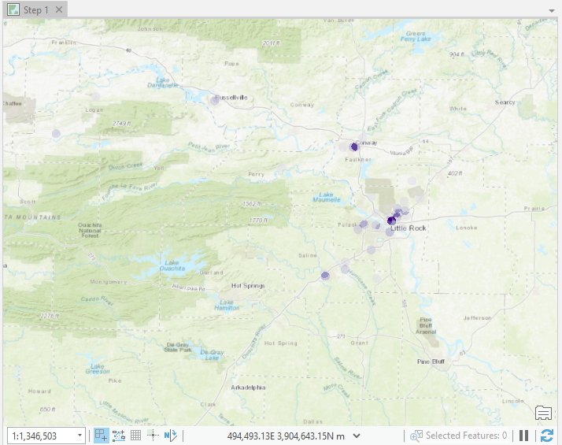
You have now produced a point density surface. However, you still need to produce the binary surface. For this model, let’s find all cells with an estimate less than 200 persons per square kilometer.
- Navigate to Spatial Analyst Tools followed by the Map Algebra subtoolbox.
- Click on the Raster Calculator Tool.
- Use the Raster Calculator Tool to produce this surface. Save your output as pd_re.
- Provide the following syntax: "point_den" <=200
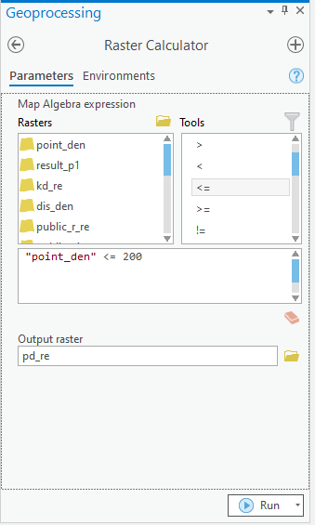
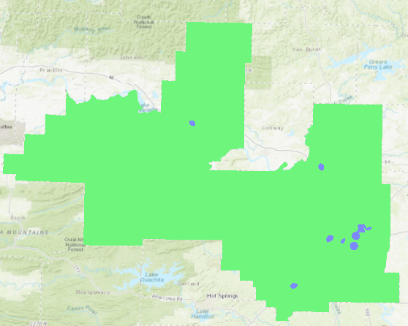
Use the attribute table of the result to answer the following question.

Question 3. How many cells met this criteria? (12 Points) (Hint: In the attribute table of pd_re, the Count corresponding to Value of 1 is the right one)
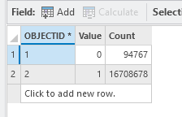

Step 9. Create Final Suitability Model
You have now produced all of the required binary grids. Now, you are ready to produce the final model. This can be accomplished by simply multiplying all of the binary grids together using the Raster Calculator Tool. Any cell in the final grid that is coded as 1 has met all of the criteria and is thus suitable to build a church.
- Use the Raster Calculator Tool to multiply the five binary raster grids together and obtain the final model. Name the output result_p1.
"pd_re" * "slp_d_re" * "highway_dist_re"
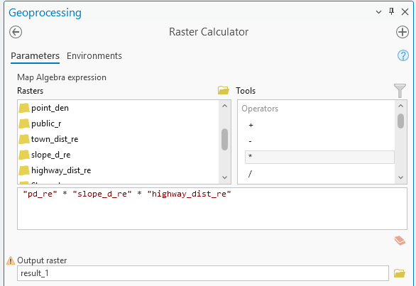
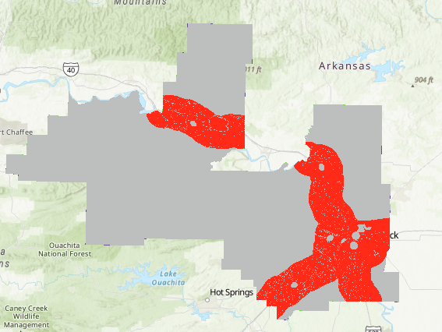

Deliverable 4. Provide a screen capture of your result that shows result_p1. (12 Points)

Homework
Please submit a word file with answers for all questions, together with the 4 deliverables.

END OF EXERCISE

