Exercise 3: Exploring Spatial Data
Due date: Midnight (11:59 pm) on Monday, Sep 15, 2025 submitted as Word document to blackboard Lab03 link
This lab counts 6.67 % (60 points out of 900 points) toward your total grade.

In this exercise, you will explore the characteristic of a variety of spatial data types within ArcGIS Pro. One of the goals of this lab is to foster a deeper understanding of the data we work with within a GIS.

Topics covered in this exercise include:
- Using raster and vector data
- Exploring vector and raster data
- Exploring data characteristics
- Converting between data types

Step 1. Open a Map Project

First, we need to download and open the Exercise_3.aprx file.
- Download the Exercise_3.zip file. Save it to the location of your choosing. You will need to extract the compressed files by right-clicking on Exercise_3.zip. In the drop-down window, choose “Extract All”.
- Within the uncompressed folder ‘Exercise_3’, directly click on the Exercise_3.aprx (If your computer does not automatically add the .aprx extension, please open the file listed as ‘ArcGIS Project File) to open this project file.
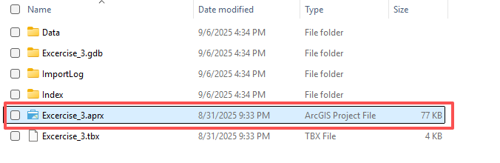
This project should contain one map that houses the data needed for the lab. The data have already been symbolized. However, feel free to change the symbology. You can turn layers on and off as needed and pan and zoom as needed.
Here is a brief description of the included data layers.
Airport: point features representing the locations of features related to Airport in Arkansas
Historical_features: point features representing historical features in Arkansas
Railroad: line features representing railroad in Arkansas
County: county boundaries for Arkansas as polygons
DSM_2006_AR2: digital surface model (DSM) for the entire state with elevation reported in meters
HILLSHADE_AR2: shaded relief surface derived from a digital elevation model (DEM)
NLCD2011_LC_Arkansas: land cover dataset for the entire state from the 2011 National Land Cover Database (NLCD)
Faulkner2: aerial orthophotograph of Faulkner county
provided by the Arkansas GIS office.
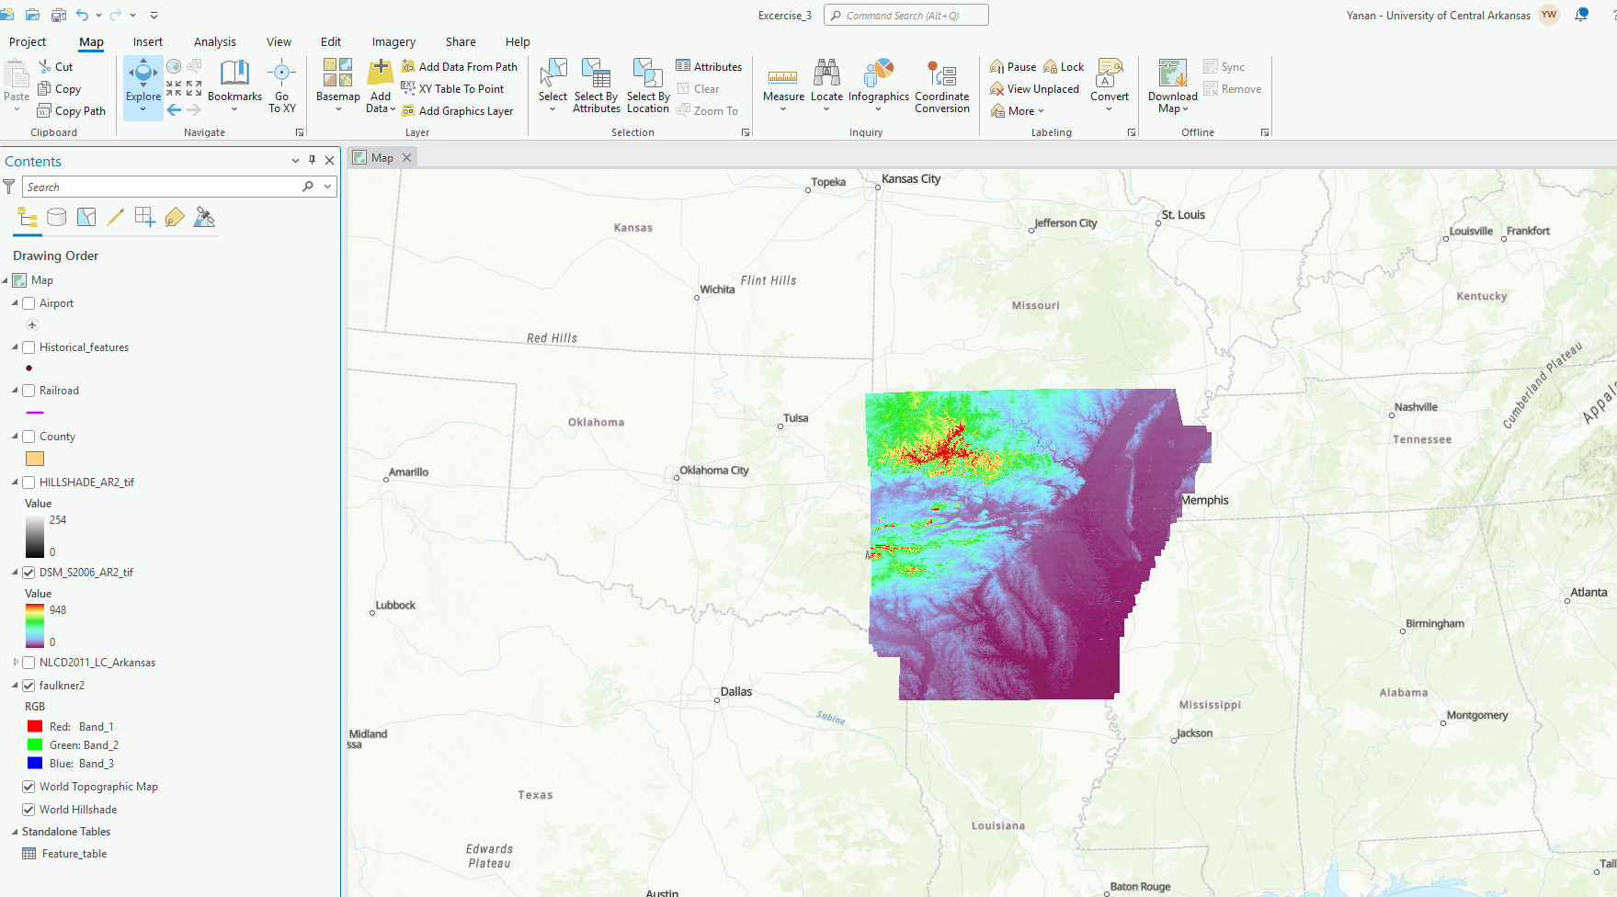

Step 2. Exploring Datums and Projections
We have learned datum and projection in exercise 2. In this lab, we will learn more about it. Data layers commonly have datums assigned. This is the reference system to which the map coordinates are defined. A datum is an ellipsoid model of the earth that was produced using an associated ground reference measurements. When you specify you position as latitude and longitude, this is done relative to a datum. Note that the same locations will commonly have different coordinates in different datums, as they are different models of the earth. Data layers can also be projected to a flat surface, as opposed to the spherical surface of the earth. In that case, the data layer will also have a defined projection. Not all data layers are projected, or have an associated projected coordinate system. However, most layers do have a datum, or geographic coordinate system defined since the coordinates must be reference relative to a model of the earth. This information is provided in the layer properties, which we will now explore.
Recap:
- Right-click on the Airport layer in the Contents Pane then select Properties. This will open the Layer Properties menu.
- In the Layer Properties window, navigate to Source and the Spatial Reference area. Check the spatial reference of Airports layer.
- Right-click on the DSM_2006_AR2 layer in the Contents Pane then select Properties. This will open the Layer Properties menu.
- In the Layer Properties window, navigate to Source and the Spatial Reference area. This provides the spatial reference information for the layer. Check the spatial reference of DSM_2006_AR2 layer.

Question 1. Does the railroad vector layer have the same spatial reference (projected coordinate system or geographic coordinate system) as the airports vector and DSM raster layers? (3 Points)

Answer: Yes
Maps also have spatial reference information. Unless the coordinate system is manually changed, the map will be assigned the same coordinate system as the layer that is first added to the map.
- Right-click on Map in the Contents Pane then select Properties. This will open the Map Properties menu.
- In the Map Properties window, navigate to Coordinate System. This provides the spatial reference information for the map.

Question 2. Is this map currently being displayed in a geographic or projected coordinate system? (3 Points)

Answer: Projected coordinate system

Step 3. Attribute Tables
We have learned attribute tables in exercise 1. In this exercise, we will learn more about it. Let’s explore the attribute table for the Historical features layer.
- Right-click on the Historical_features layer in the Contents Pane and select Attribute Table. This will open the attribute table associated with this layer.
In an attribute table, each row, or record, is associated with one map feature. In this case, the attributes stored in each row are associated with one historical feature. The columns, or attributes, in the attribute table represent the aspatial or tabulated data associated with each map feature.
The number of features, in this case, historical feature, is provided at the bottom of the table as X of Y selected (e.g., 0 of 3,384 selected). The first number is the number of selected features, and the second number is the total number of features.

Question 3. How many historical features are included in this layer? (3 Points)

Answer: 3384 features in total
Each column in the table has an associated field type that impacts what can be stored. The available field types are shown in the table below. Note that short and long integers cannot hold decimal values. Long integer fields can hold larger numbers than short integer fields. Both float and double fields can store decimal values. Text fields hold strings, or non-numeric data. If numbers are added to a text field, they will be treated like text or strings as opposed to numbers. Date fields hold dates.
Field Type | Description
Short Integer | Integer values between -32,768 and 32,767
Long Integer | Integer values between -2,147,483,648 and 2,147,483,647
Float | Decimal values with 1-6 decimal places
Double | Decimal values with more the 6 decimal places
Text | Text strings
Date | Data info (mm/dd/yyyy)

If you hover over the attribute column name, information will be provided about the attribute. Use this method to answer the following questions.

Question 4. What field type is the “FEATURE_ID” field? (3 Points)

Answer: long type
It is also possible to summarize the field information. Let’s summarize the “FEATURE_CL” field to find the number of historical feature in each places.
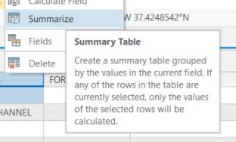
- Right-click on the “FEATURE_CL” field in the attribute table and select Summarize. This will launch the Summary Statistics Tool.
- Name the Output Table (Add .dbf as file extension to set up table type) and save it to a folder of your choosing (it is important, otherwise you may be not able to find your result. So please save your output!).
- Set the statistics field to “OBJECTID” and the Statistic Type to “Sum.”
- Make sure the case field is set to “FEATURE_CL” (this should already be selected).
- Click Run to execute the tool.

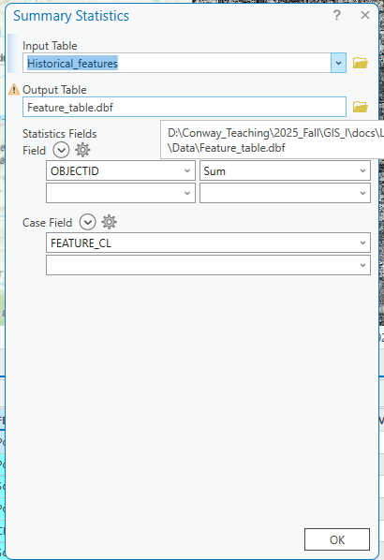

A new table should be generated and added to your Contents Pane. Scroll down to the most bottom and open the table to answer the following questions.
There are two columns in the table: FREQUENCY (frequency of each FEATURE_CL) and SUM_OBJECT (sum of the object ID)
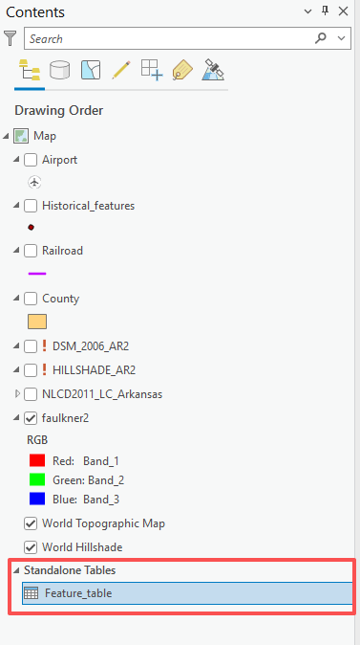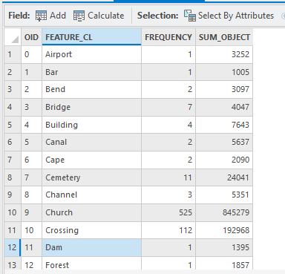

Question 5. How many historical features occurred on Bridge (hint: use the “FREQUENCY” field)? (3 Points)

Answer: 7
Now, use similar techniques to those described above to answer questions relating to the County layer.
Question 6. What field type is the “Jun22” field? (3 Points)
Answer: DOUBLE

Step 4. Raster Data Characteristics
Raster data are composed of grid cells and are commonly used to model data in which there is a value everywhere, such as elevation, depth to bedrock, depth to water table, topographic slope, mean annual precipitation, mean annual temperature, and humidity. We can generally group raster data into three types. Continuous raster grids are those that model or map a numeric or continuous variable, such as interval and ratio data. In contrast, categorical raster grids model categorical or nominal data. Lastly, images are a special type of raster data in which cells or pixels hold brightness values associated with different ranges of the electromagnetic spectrum which together produce a picture.
Information about the raster grid can be found in the Layer Properties window.
- Right-click on the DSM_2006_AR2 layer in the Contents Pane then select Properties.
- In the Layer Properties window, navigate to Source and the Raster Information area. Use the provided information to answer the following questions.
Question 7. What is the cell size of this raster (note that the units are meters)? (3 Points) (Hint, refer to cell size X/ cell size Y)
Answer: 5
Use similar methods to answer the following questions about the HILLSHADE_AR2 layer.
Question 8. What is the pixel depth? (3 Points)
Answer: 8 bit
Not all raster grids have attribute tables. However, it is common for categorical raster grids to have one. Here, we will explore the attribute table for the NLCD2011_LC_Arkansas layer, which is a categorical raster of land cover. These data are a portion of the 2011 National Land Cover Database (NLCD).
- Right-click on the NLCD2011_LC_Arkansas layer in the Contents Pane and click on Attribute Table.
This attribute table has a total of 8 columns or attributes and 15 records or features. Note that each record is associated with a certain pixel value. There is not a new row for each pixel (if there were, that would be a very large table). The value stored in the “Value” field is the value stored in each pixel. This value is a placeholder or a stand-in for a category, in this case a land cover category. The land cover category associated with each value is provided in the “NLCD_2011” field.

Question 9. What land cover category is associated with a value of 81? (3 Points)

Answer: Hay/Pasture
The “Count” field provides the number of pixels in each category. Note that this is not an area in area units, such as square kilometers, square miles, square feet, square meters, or hectares. It is simply a count of pixels. To convert this count to a land area, you will need to multiply the count by the area of each pixel and use conversion factors to change the units if necessary.
Use the attribute table and your answers from above to answer the following questions.

Question 10. What is the area for cultivated crop? (3 Points) (Hint, area= number of pixels x size of a pixel)

Answer: 30675057 *30 *30 =

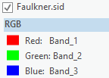
Image data are raster data. However, they are unique in that they are commonly made up of a stack of multiple raster grids. For example, the Faulkner2 image is a true color image that is composed of three raster grids or image bands. In this image specifically, three raster grids have been provided that record brightness for the red, green, and blue channels. In the Contents Panel, you can see that Band 1 is being displayed using the red channel, Band 2 is being displayed using the green channel, and Band 3 is being displayed using the blue channel. Since these grids or bands represent red, green, and blue, respectively, this image simulates human vision. Uncheck all of other layers to see the Faulkner2 layer.
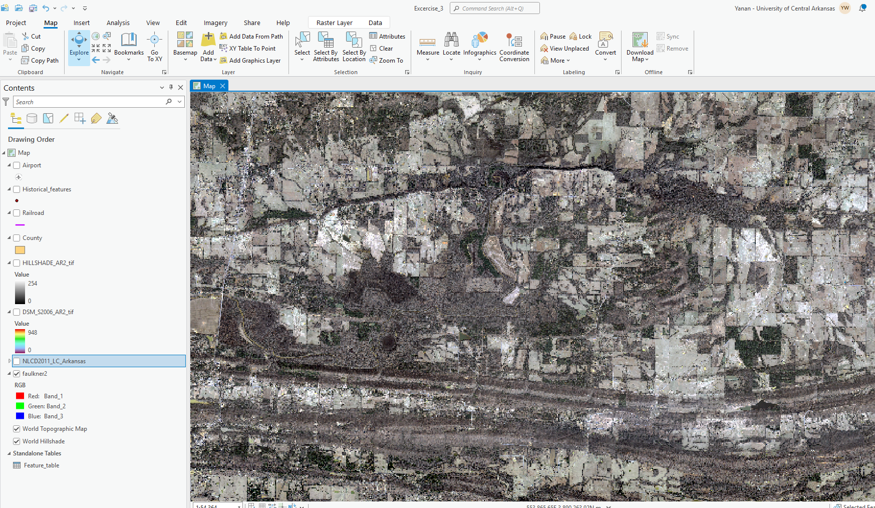

Step 5. Data Conversion
It is possible to convert your data to different formats. For example, raster data can be converted to vector data and vector data can be converted to raster data. This may be necessary to fulfill the needs of an analysis or for map production.
Here, we will convert the county polygon boundaries to a raster layer.
- Navigate back to the original map that contains the Arkansas data.
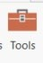
- Navigate to the Analysis Tab. Select Tools in the Geoprocessing area. This will open the Geoprocessing Pane.
- Click on Toolboxes.

- Navigate to Conversion Tools followed by To Raster.
- Click on the Polygon to Raster tool.
- Set the Input Features to County.
- Set the Value Field to “POP00” (This is the population in the year 2000 as reported by the US Census).
- Name the Output Raster Dataset county_pop and save it to the Exercise_3 folder.
- Set the Cell size to 500 (meaning 500 meters).
- Do not change any of the other settings.
- Click Run to execute the tool.

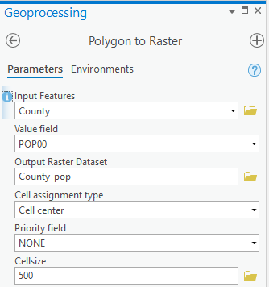

This tool should generate a raster surface of 500 by 500 meter grid cells. A county_pop layer should be added to the Contents. Each grid cell will hold a population measurement in 2000. Notice that all grid cells within each county have the same value.

Deliverable 1. Provide a screenshot of county_pop layer showing population in 2000. (10 points)(You may want to turn off other layers)

Let’s now convert the raster grid back to a polygon.

- Navigate to the Analysis Tab. Select Tools in the Geoprocessing Area. This will open the Geoprocessing Pane.
- Click on Toolboxes.

- Navigate to Conversion Tools followed by From Raster.
- Click on the Raster to Polygon tool.
- Set the Input Raster to county_pop.
- Set the Field to “VALUE.”
- Name the Output Polygon Features county_from_raster and save it to the Exercise_3 folder.
- Uncheck Simplify Polygons.
- Click Run to execute the tool.
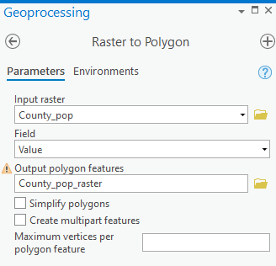
This will produce a new polygon vector layer of county boundaries. A county_from_raster layer should be added to the Contents. If you zoom in, you will notice that the boundaries are now very blocky, reflecting the coarseness of the raster grid from which they were derived.
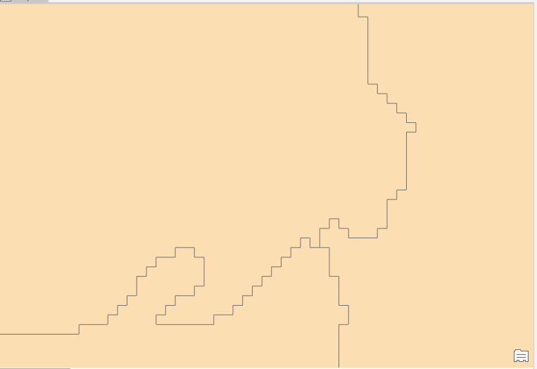

Deliverable 2. Provide a screenshot of the blocky boundaries of Faulkner county in the county_from_raster layer. (10 points) (Hint, you need to zoom in to Faulkner county)

The purpose of this exercise was to show you how to investigate the characteristics of vector and raster data in ArcGIS Pro. If you are uncertain as to the characteristics of your data, a good place to start investigating is the Layer Properties Window for the layer of interest. Here, you can find information about the datum, projection, and characteristics of the data. As you work with geospatial, it is important to think about how the structure of the data can impact your data visualization and analysis. A good geospatial professional should strive to understand the data he or she is working with.

END OF EXERCISE

