Question 1. What is the projected coordinate system for this layer? (4 Points)
Answer: NAD 1983 UTM Zone 15N

Question 2. What is the datum for this layer? (4 Points)
Answer: NAD 1983

Question 3. In what linear unit are the measurements specified? (4 Points)
Answer: Meters

Question 4. In what UTM zone is Arkansas located? (4 Points)
Answer: 15

Question 5. How does the zone number change as you move east across the United States? (4 Points)
Answer: Increase

Question 6. How many state plane systems does Arkansas have? (4 Points)
Answer: 2

Question 7. What property (distance, local angels, area, shape) are conformal projections designed to maintain? (4 Points)
Answer: local angels, and shape

Question 8. Does the Mercator projection distort size? (3 Points

Answer: Yes
Question 9. What was the reported distance in kilometers between New York and London (they are red points on the map)? (3 Points) (Hint, be careful when measure the distance. If you got two segments, which means you click twice by wrong. You also need to double-click to finish.)
Answer: 8379.92

Question 10. Does the Mollweide projection distort shape? (4 Points)
Answer: Yes

Question 11. Again, measure the planer distance between New York and London. Does the distance change compare the one in Question 9? (4 Points)
Answer: Yes
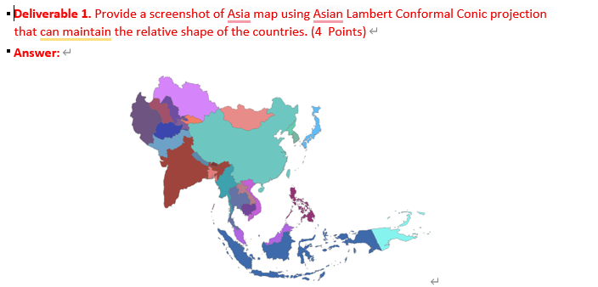
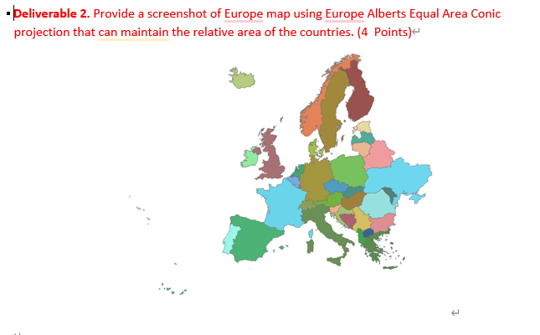

Question 12. Comparing the Arkansas map before and after reprojection, tell the difference (4 Points)

Answer: The angle change
