Exercise 8: Vector Analysis
Due date: Midnight (11:59 pm) on Monday, November 10, 2025 submitted as Word document to blackboard Lab08 link
This lab counts 6.67 % (60 points out of 900 points) toward your total grade.

In this exercise, you will learn to use a variety of vector analysis and geoprocessing methods. You will then use these methods to answer some questions. Individually, these tools can be used to answer simple questions. However, they can be combined to answer more complex questions in a multi-part analysis. GIS professionals commonly use these methods on a daily basis, so they are important to add to your list of skills.

Topics covered in this exercise include:
- Execute a variety of vector analysis techniques including: dissolve, clip, buffer, intersect, union, and summarization.
- Use vector analysis tools provided in ArcGIS Pro.
- Answer spatial analysis questions by combining vector analysis tools.

Step 1. Open a Map Project
First, we need to download and open the Exercise_10.aprx file.
- Download the Exercise_8.zip file. Save it to the location of your choosing. You will need to extract the compressed files by right-clicking on Exercise_8.zip. In the drop-down window, choose “Extract All”.
- Click on the Exercise_10.aprx file within the uncompressed folder directly to launch ArcGIS Pro.
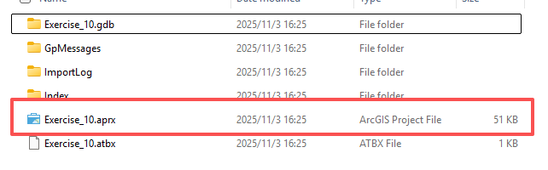
This project should contain one map that houses the data needed for the lab. The data have already been symbolized. However, feel free to change the symbology. Throughout the lab, you may want to turn layers on and off so that it is easier to visualize the results of your analysis.
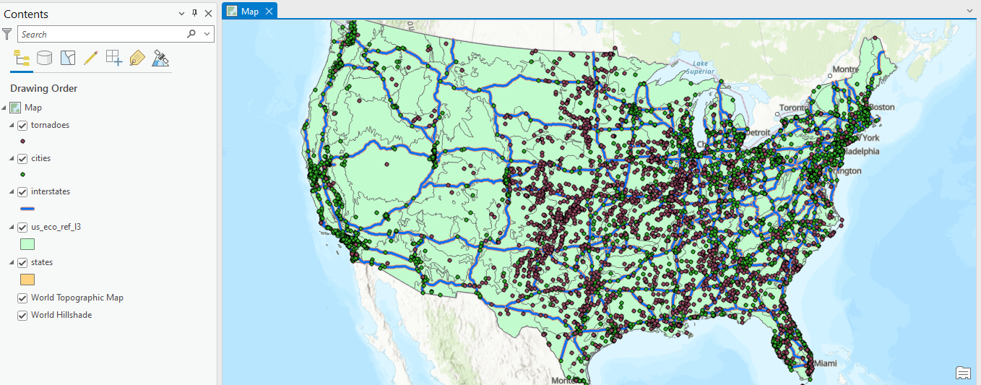
Here is a brief description of the data layers you will use in this exercise.
tornadoes: point features representing the locations of tornadoes
cities: point feature representing the locations of major cities in the United States
interstates: line features representing major interstates in the United States
us_eco_ref_l3: polygons representing Level III ecoregions in the United States (data provided by the US Environmental Protection Agency)
states: polygon features representing states

Step 2. Defining Environment Settings
Since you will perform many spatial analysis operations in this lab, you will start by setting the environment settings. It is generally a good idea to set environment settings any time you will perform spatial analysis operations in a project. Also, this can speed up your processing, as you will not need to set environments for each tool individually. In short, I highly recommend this setting.
- Navigate to the Analysis Tab then select Environments in the Geopocessing Area.
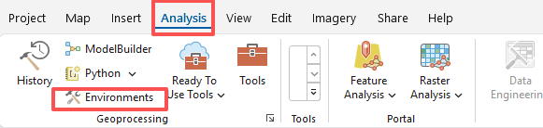
- Change the Current Workspace and the Scratch Workspace to the Exercise_10.gdb geodatabase in the Execise_10 folder in your downloaded copy of the data. This will cause all of the outputs to automatically be saved to this location (Note, my screenshot may be different from yours).
- Set the Processing Extent to be the same as the states layer by clicking on the states layer in the dropdown window.
- Click Ok to accept these settings.

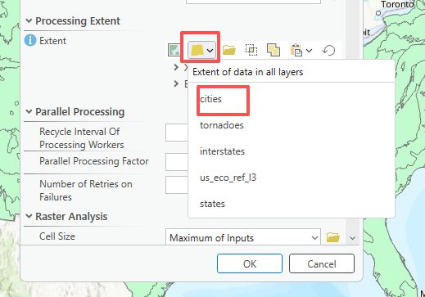

Step 3.1 Performing a Dissolve
First, we will perform a dissolve on the states layer. Dissolve is a generalization operation used to generalize boundaries. For example, this tool can be used to dissolve state boundaries to the boundary for the entire country, census block boundaries to census block group boundaries, and small watershed boundaries to large watershed boundaries.
In this exercise, we will dissolve the state boundaries to regional boundaries using an attribute field.
Note: In this lab, we will access tools from ArcToolbox. However, there are many ways to access tools in ArcGIS Pro. For example, some of the more common tools are provided in the Tools list in the Analysis Tab.
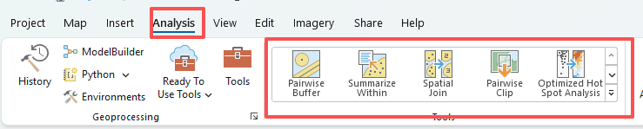

Once you open the Geoprocessing Pane, you can access your favorite tools or search for Tools.
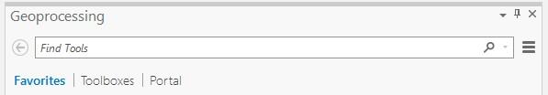
We have decided to demonstrate ArcToolbox here so that you get a sense of where the tools are located in the Toolbox directory. You can also create your own tools and toolboxes, which will be investigated in later labs.
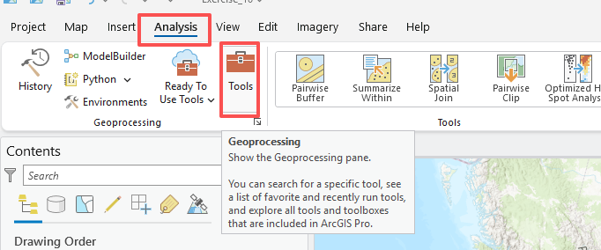

Step 3.2 Performing a Dissolve
- In the Geoprocessing Pane, Search ‘Dissolve’
- Click on the Dissolve Tool.
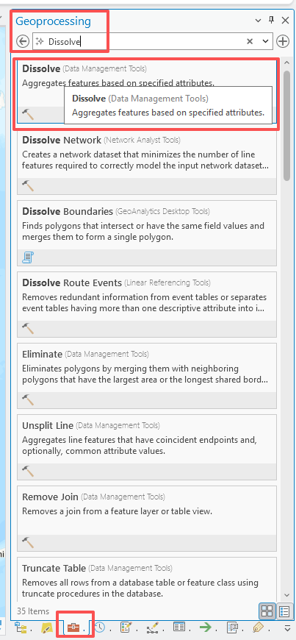
- Set the Input Features to the states layer.
- Name the Output Feature Class regions (this will save to the Exercise_10.gdb geodatabase, as defined in the environment settings).
- Set the Dissolve_Fields(s) to “SUB_REGION.” You do not need to change any other settings.
- Click Run to execute the tool.
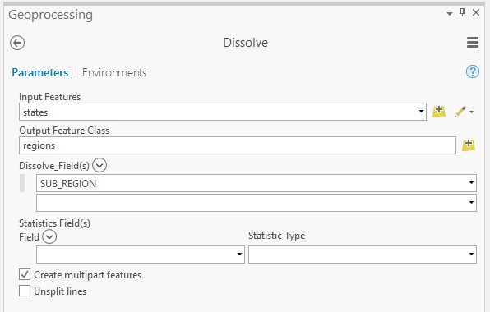

Question 1. How many different subregions were differentiated? (8 Points) (Hint: open the attribute table of the regions layer to find the total number of subregions.)
Answer: 9

Question 2. In what subregion is Arkansas located? (7 Points) (Hint: Left-click on the subregion where Arkansas is located, and it will show a pop-up. The SUB_REGION field is for the name of the subregion.)
Answer: W S Cen

Step 4. Buffer and Clip
You will now make use of the buffer and clip operations to answer a question. Specifically, we would like to find the number of tornadoes that were within 100 miles of the city of Indianapolis, Indiana. Buffer is a form of proximity analysis: it is used to find features or areas that are within a distance of other features. Clip is used to extract features or portions of features that fall within another feature. These are some of the most commonly used vector analysis operations. They have many uses.
First, you will need to extract Indianapolis from the cities layer. You can do so by querying the attribute table.
Use a table query to extract the point feature representing Indianapolis. Use the “AREANAME” field.

- Navigate to Map Tab, and click on Selected by Attributes icon in Selection Area, this will open Select Layer By Attribute window
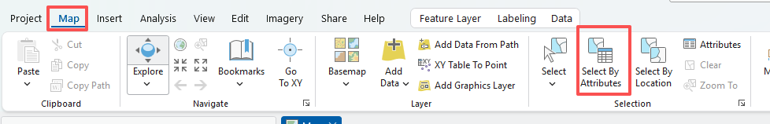
- Make sure Input Rows is cities layer.
- Set the Selection type to “New selection”.
- Click on New expression, set AREANAME for WHERE, change the operator to “is equal to”, and define the value as Indianapolis
- Click on Apply to execute the query.
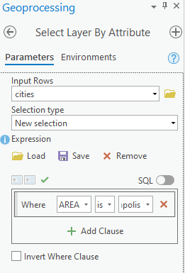
- Once you have selected this city, right-clicking on the cities layer in the Contents Pane then selecting Data followed by Export Features. By default, only selected features will be exported. Set the name of Output Feature Class as Indianapolis. Click OK export it

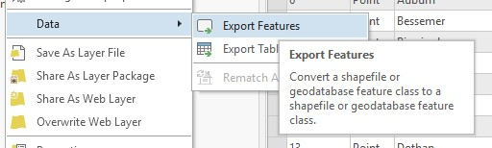
- The exported feature Indianapolis layer should automatically be added to your map as a new layer.
Note: It is not really necessary to export the feature once it has been selected, as the geoprocessing tools generally will only be conducted for selected features. However, we are demonstrating this step here to show how to export features from a dataset.
Now, you will create a buffer around the city of Indianapolis with a radius of 100 miles. You will do this using the Buffer Tool.
- Within Geoprocessing Panel, Search ‘Buffer’ Tool.
- Set the Input Features to the Indianapolis layer.
- Name the Output Feature Class Indianapolis_Buffer.
- Specify the Distance as Linear Units, 100, and US Survey Miles.
- You do not need to change any of the other settings.
- Click Run to execute the tool.

This will generate a circle with a radius of 100 miles that has the point representing Indianapolis at its center.
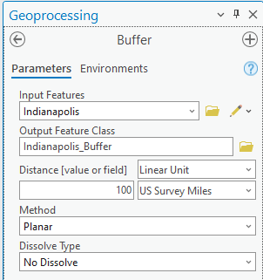
You now have defined the area that is within 100 miles of Indianapolis. You will now extract all of the tornadoes that fall within this area. You will do this using the Clip Tool.
- Within Geoprocessing Panel, Search ‘Clip’ Tool.
- Set the Input Features to the tornadoes layer.
- Set the Clip Features to the Indianapolis_Buffer layer.
- Name the Output Feature Class tor_near_Indianapolis.
- You do not need to change any of the other settings.
- Click Run to execute the tool. The result will add to your map automatically.
Note: For the Clip Tool, the Input Features are what you are wanting to extract while the Clip Features are what you are wanting to extract them relative to. Think of the Input Features as the dough and the Clip Features as the cookie cutter.
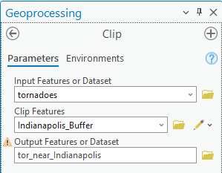
Use your result to answer the following questions.

Question 3. How many tornados recorded in this file occurred within 100 miles of Indianapolis? (7 Points) (Hint: open the attribute table of tor_near_Indianapolis layer to find the total number of tornados.)
Answer: 28

Question 4. How many of these features in tor_near Indianapolis were a 2 on the F-scale? (7 Points) (Hint: Right-click on “F_SCALE” field in the attribute table and select Sort Descending or Ascending)
Answer: 2

Deliverable 1. Provide a screenshot capture of your result that shows the tornados within a buffer of 100 miles from Indianapolis (7 Points) (Note, you want to turn off other layers to clearly see your outputs)
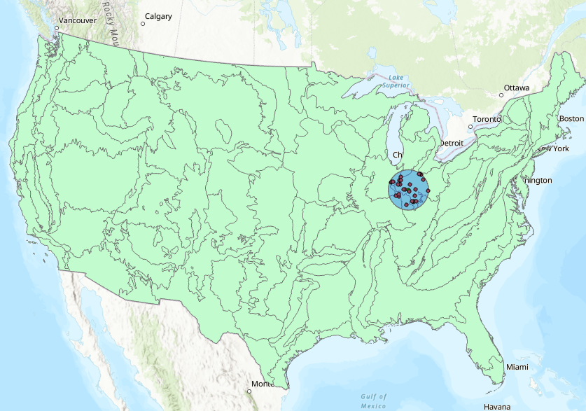

Step 5. Intersection and Union
Two polygon layers have been provided in this lab: states, representing states in the contiguous United States, and us_eco_reg_l3, representing Level III ecoregions in the United States.
You will use these layers to explore the Intersect Tool. Specifically, you will use this tool to create a new layer that divides the United States into both states and ecoregions. Or, the layer will contain both sets of boundaries. The Intersect Tool is used to intersect boundaries, but only in overlapping areas.
- In Geoprocessing Panel, search ‘Intersect’ Tool.
- Add the states and us_eco_ref_l3 layers to the list as Input Features.
- Name the Output Feature Class eco_state_isect.
- Leave the ‘Attributes To Join’ option to “All attributes.” This means that all attribute fields from both layers will be included in the output attribute table.
- You do not need to change any of the other settings.
- Click Run to execute the tool. The result will add to your map automatically.
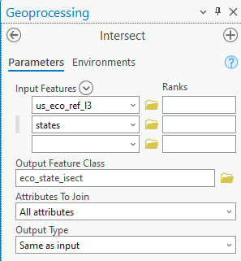
Note: When geoprocessing operations are performed that change the geometry of the resulting features, geometric fields in the attribute table are not automatically updated. For example, in this analysis there is a field in the states layer called “AREA” that give the area for each state. This area will not be updated to show the correct area of the resulting features once the states have been split along the ecoregion boundaries. So, be cautious when using geometric fields, as they can be incorrect as a result of the geoprocessing operations performed. You can always calculate new geometric fields.
Use the results of this analysis to address the following questions.

Question 5. How many features were created as a result of the intersection? (7 Points) (Hint: open the attribute table of eco_state_isect layer to find the total number of features)
Answer: 809
Now, you will find the state that has the most unique Level III ecoregions within it. Before you undertake this analysis, make sure to clear your selections. First, you will use the Dissolve Tool to combine all features that are in the same state and are the same Level III ecoregion.
- In the Geoprocessing Panel, Search Dissolve Tool.
- Set the Input Features to the eco_state_isect layer.
- Name the Output Feature Class eco_state_dissolve.
- Set the Dissolve_Fields(s) to “STATE_NAME” and “US_L3NAME.”
- You do not need to change any other settings.
- Click Run to execute the tool.
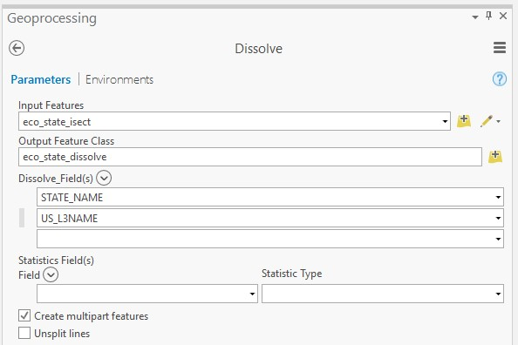
Next, you will perform a summarization using the attribute table.
- Open the attribute table for the eco_state_dissolve layer.
- Right-click on the “STATE_NAME” field and selection Summarize to open the Summary Tool.
- Make sure the Input Table is set to eco_state_dissolve.
- Name the output table eco_cnt_by_state.
- Set the Statistic Field(s) to “US_L3NAME” and the Statistic Type to “COUNT.”
- Make sure the Case Field is set to “STATE_NAME.”
As this is currently set up, the number of different ecoregions will be counted for each state.
- Click OK to execute the tool.
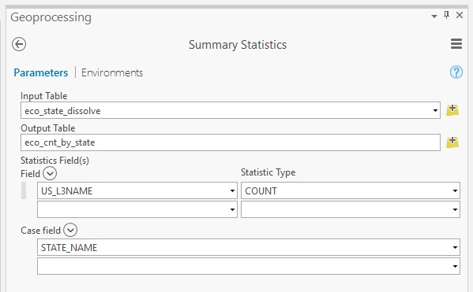
Right-click on eco_cnt_by_state table in the Contents and select Open. Use the resulting table to answer the following question.
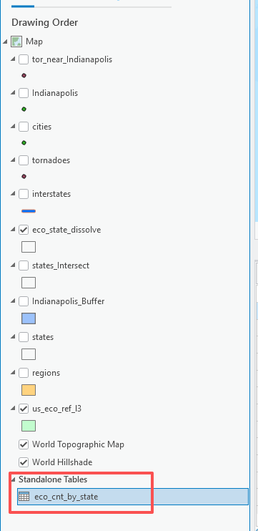

Question 6. Which state in the contiguous United States has the largest number of unique Level III ecoregions? (7 Points) (Hint: right-click on the COUNT_US_L3NAME field, and select Sort Descending. The first state has the highest number of unique Level III ecoregions. You can find the state name in STATE_NAME field.)
Answer: California
The intersect operation can be used to intersect a variety of features including points and polygons, lines and polygons (try interstates data), and polygons and polygons. However, only overlapping, or intersecting area, is maintained. The union operation is only used on polygon features. In contrast to intersect, all areas are maintained, not just overlapping areas. Let’s run a quick experiment with the Union Tool.
- In Geoprocessing Panel, search ‘Union’ Tool.
- Add the states and us_eco_ref_l3 layers to the list it Input Features.
- Name the Output Feature Class eco_state_union.
- Leave the ‘Attributes To Join’ option to “All attributes.” This means that all attribute fields from both layers will be included in the output attribute table.
- You do not need to change any of the other settings.
- Click Run to execute the tool. The result will add to your map automatically.
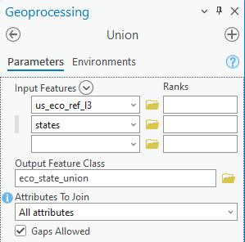

Use the result to answer the following questions.

Question 7. Which produced more features, intersect or union? And why? (10 Points)
Answer: Union, because Union main all features.

END OF EXERCISE

Homework

Submit a word file with 7 questions and corresponding answers together with one deliverable. Please submit it through Blackboard.

