Question 1. Which field in County’s attribute table and population table, respectively, can be used to join the spatial and non-spatial data? (Hint, fields to be used to join spatial and non-spatial data need to have the exactly same values) (5 points)

Name field in Conunty, County field in population

Question 2. What is the unit for the values in “Shape_Area”? (5 points)

Answer: meter

Question 3: Based on the population density map, which regions are crowded? Are they in your expectation and why? (5 points)
Little rock.
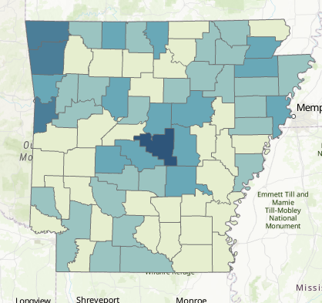

Deliverable 1: paste the ‘Population density map in 2020_ Natural Breaks.png’ file below (5 points).
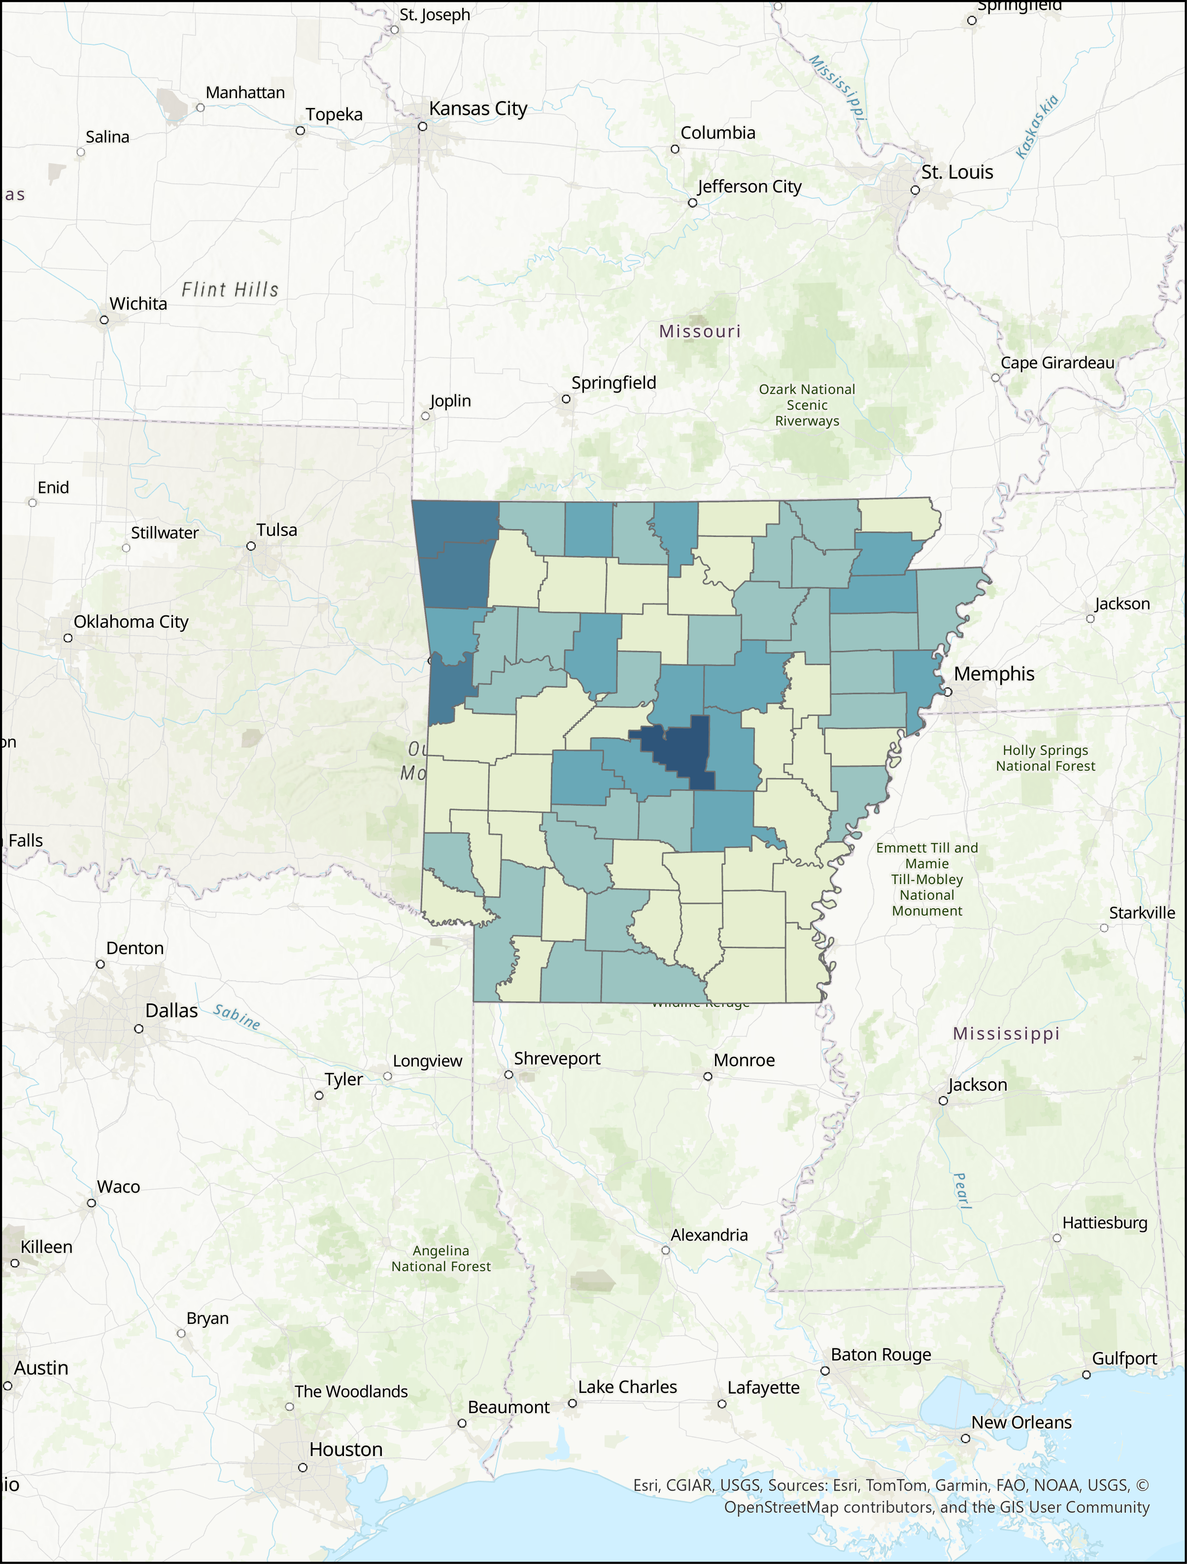

Deliverable 2: Repeat Steps 3-4 to generate a PNG file with ‘Method’ to ‘Equal Interval’ and ‘6’ for ‘Classes’ and paste the map below (6 points). (Hint, the Layout will be changed automatically along with the map)
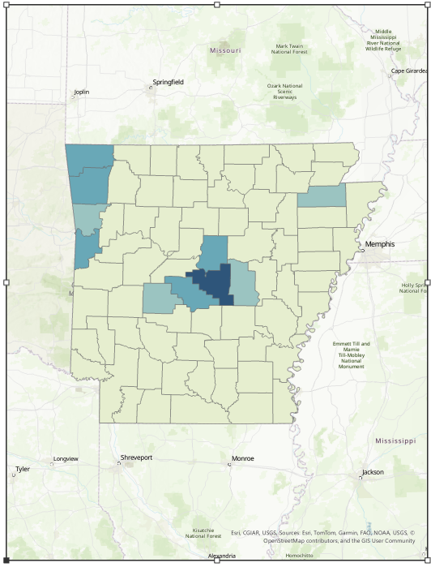

Deliverable 3: Repeat Steps 3-4 again to generate a PNG file with ‘Method’ to ‘Quantile’ and keep ‘6’ for ‘Classes’ and paste the map below (6 points). (Hint, the Layout will be changed automatically along with the map)
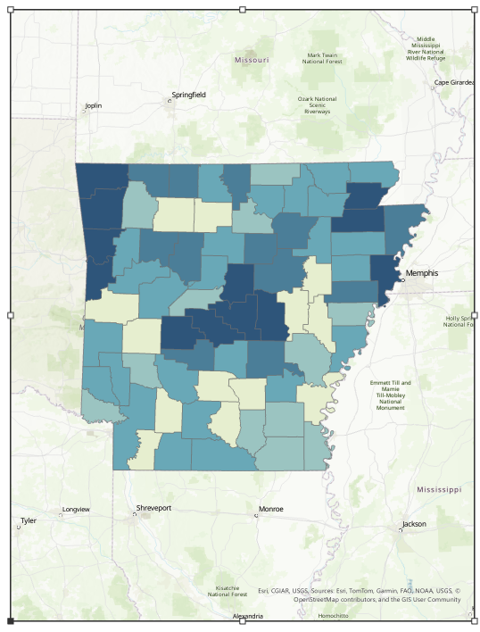

Questions 4: Comparing deliverables 1 to 3, which classification method is good for population density in Arkansas and why? (6 points)

3 is good.

Deliverable 4: Repeat Steps 3-4 again to generate a PNG file with ‘Method’ to ‘Quantile’ and ‘10’ for ‘Classes’ and paste the map below (6 points). (Hint, the Layout will be changed automatically along with the map)
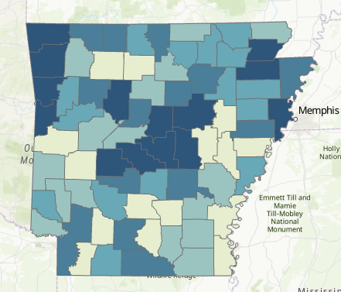

Questions 5: Comparing deliverables 3 to 4, do you think increasing the number of classes improve the visualization of population density in Arkansas and why? (6 points)

4 is better,

