Exercise 7 Georeferencing Resampling
Due date: Midnight (11:59 pm) on Monday, October 20, 2025 submitted as Word document to blackboard Lab06 link
This lab counts 6.67 % (60 points out of 900 points) toward your total grade.

Occasionally you will need to use a scanned paper map as a background for digitizing or other work. First, you will need to scan your map into a suitable image file format, such as TIFF, JPEG, or IMG. Once the map exits as a digital file, you can load it into ArcGIS Pro as a raster layer. However, this map or image will not draw in the correct location relative to the map datum and/or projection because it does not have spatial reference information. In order to get the image to draw at the correct location, you will need to georeference it relative to reference data. This exercise shows you how to undertake this process. It will guide you through referencing a map of a historical map of Venice, Italy. You will validate your results using the root mean square error measure (RMSE).
Another common pre-processing task is changing the cell or pixel size of a raster grid, including aerial and satellite images. The exercise will also show you how to perform resampling in ArcGIS Pro using a variety of methods.

Topics covered in this exercise include:
- Georeference an image using control points and reference data
- Assess the quality of a georeferenced result using RMSE
- Perform raster resampling

Step 1. Download data
First, you need to download and open the Exercise_7.aprx file.

Download the Exercise_7.zip file. You will need to extract the compressed files and save it to the location of your choosing.

Step 2. Copy Data
The image you will georeference is a historic map of Venice, Italy (venice2.jpg). So that the original files are not altered, you will georeferenced copies of the files as opposed to the originals. I highly recommend georeferencing from a copy.

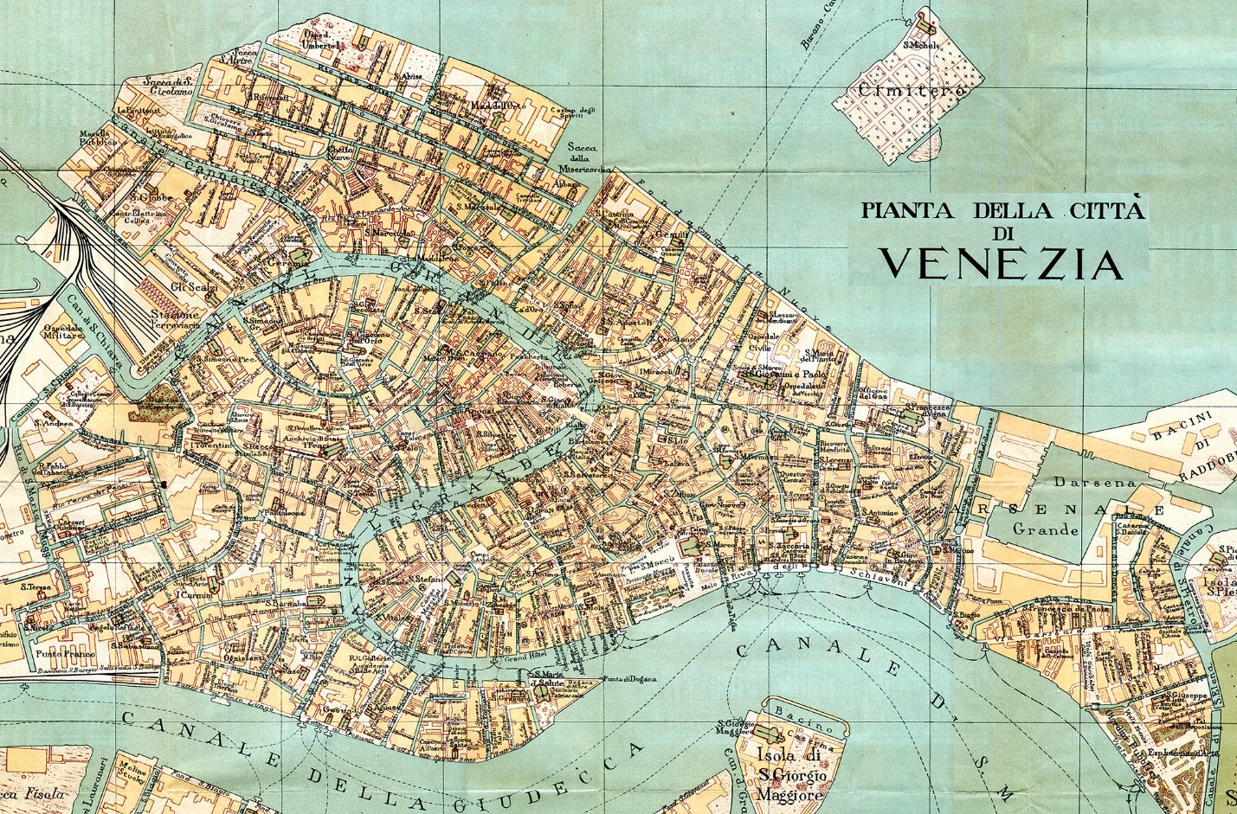
- Create a new folder within the Exercise_7folder and call it Working.
- Copy the image (venice2.jpg) in the Exercise_7 - Data folder to the newly created Working folder. Use this copy of the images in this exercise, not the original one. If something goes wrong you still have the originals.

Step 3. Open a Map Project
- Open ArcGIS Pro. This can be done by navigating to All Apps followed by the ArcGIS Folder. Within the ArcGIS Folder, select ArcGIS Pro. Note that you can also use a Task Bar or Desktop shortcut if they are available on your machine.
- After ArcGIS Pro launches, select “Open another project.”
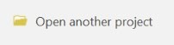
- Navigate to the directory that houses the material for this course. The project files are in the Exercise_7 folder where it was saved on your local machine.
- Select Exercise_7.aprx. Click OK to open the project.
Note: If you’d prefer, you can also just double click on the Exercise_7.aprx file within the uncompressed folder directly to launch ArcGIS Pro.
This project should contains two maps: Venice and Resample. The Venice map contains one layer, Venice_Bound, which is a vector bounding box around the island. You will use the ESRI Basemap to reference this image. Second, the Resample map contains two layers: point and Faulkner. You will use these data to investigate raster resampling.
- Navigate to the Venice map.

Step 4. Georeference the Venice Map
When performing a georeference, the goal is to use reference or source data and control points to reference an image relative to a datum and/or projection. Here, you will use the ESRI World_Imagery basemap to reference the map. The first step is to add the unreferenced data.

- Use the Add Data button to add the venice2.jpg layer to the map (or right click the venice2.jpg data in Catalog and select ‘Add to current map’). Make sure to use your copy of the data that is in the Working folder you created under the Exercise_7 folder. The ArcPro may need couple of minutes to load the data.
You will notice that the map does not draw at the correct location. This is because it has not been georeferenced yet.
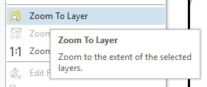
- Right-click on the venice2.jpg layer in the Contents Pane then select Zoom to Layer. This will zoom the map to the extent of the unreferenced image. Your goal is to change the reference, so the map draws at the correct location.
Here are some tips for georeferencing.
- The reference data should be of high quality. High spatial resolution images are preferred so that details can be distinguished. Positional errors in the reference image will impact the quality of the georeference. So, you should use reference data that has been referenced well.
- You will need multiple control points. The number of control points needed depends on the algorithm being used. Here, you will need to produce at least four control points.
- You must be able to find and identify the control points in both the reference data and the data being georeferenced. For example, you could use a road crossing or sidewalk intersection identifiable in both images.
- Avoid using ground features as control points, such as building corners. This is because buildings often lean in orthophotography due to vertical relief displacement. So, the true position is distorted.
- The control points should be spread across the unreferenced image as opposed to clustered. This is so that the algorithm can do a decent job georeferencing the whole image.
Please keep these tips in mind as you select control points.
You will now prepare to collect control points.
- Make sure the venice2.jpg image is highlighted in the Contents Pane. This is so that the software will know that this is the image to be georeferenced.
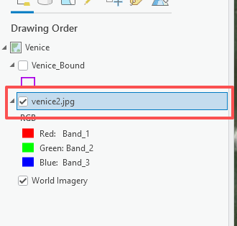
- Under the Imagery Tab, select Georeference. This will activate the Georeferencing Tab.
- Click on the Control Point Table button to open the table. It will be empty because you haven’t added control points yet.
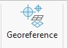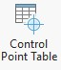

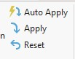
Note: If the Auto Apply option is selected, the image will be updated as you add control points. We would suggest not using this option. So, make sure that it is deselected. If you want to update the image as you add control points you can use the Apply button. If you want to remove all of the control points, you can use the Reset option.
Note, in ArcGIS Pro, you must select the location in the unreferenced image first, then select the same location in the reference data. The location in the unreferenced data is called the From Point and the associated point in the reference data is the To Point. Together, they create a control point.
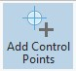
Control points are added using the Add Control Points button.
Below is an example of a From Point and To Point.
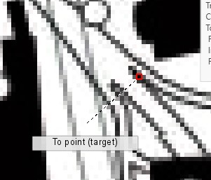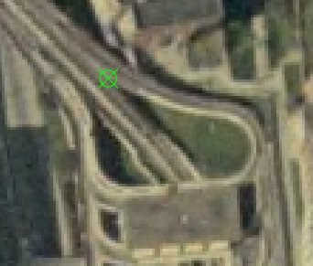
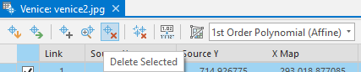
When georeferencing in ArcGIS Pro, you will need to navigate between the unreferenced data and the reference data. This can be accomplished by right-clicking on the venice2.jpg or Vince_Bound layer in the Contents Pane and then selecting Zoom to Layer. You can then navigate the map space using the mouse or the Explore tools under the Map Tab. Once you’ve established a control point, it will be added to the Control Point Table. If you would like to delete a control point, you can select it and then use the Delete Selected button in the table.
- Create at least four control points scattered around the map. If you would like to wait until you have created all the control points for the image to be updated, make sure the Auto Apply option is not selected. If you select Apply, you can update the image. If you would like to not use one of your control points you can delete it from the table. As you create your control points, make sure that you use the tips provided above. Also, make sure that they can be located in both images.
- You want your control points in your reference image and unreferenced image as closely as possible, as it could influence your final accuracy
Below is an example of six control points displayed over the reference data and the associated table.
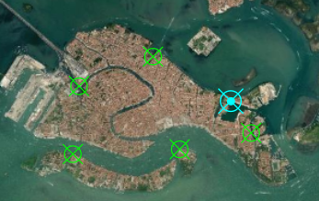
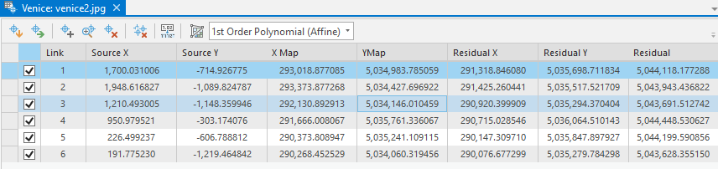

Deliverable 1. Provide a screenshot of your map that shows control points displayed over the reference data, such as the above one. (5 Points)

Once you have established control points, you are ready to perform the georeferening. In this exercise, you will use the 1st Order Polynomial (Affline) method, which requires at least three control points.
- In the Georeferencing Tab and in the Adjust panel, select the Transform Button then select 1st Order Polynomial (Affline) from the list.
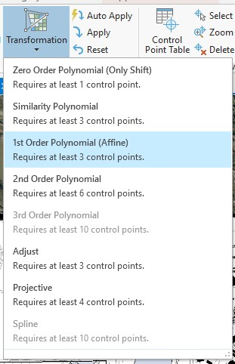
- In the Control Point Table, make sure all of the control points are checked. Select Apply in the Adjust panel of the Georeferening Tab.
- The Georeferencing pop-up window provides an estimate of the RMSE using the control points as the forward RMSE.
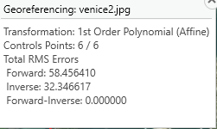

Question 1. What forward RMSE did you obtain for your georeferencing operation? (5 Points) (Note, this value is different for different control points. If your forward RMSE is larger than 100, you want to re-selected your control points)
Let’s save your georeferecning results using Save as New. 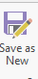
- Click the Save as New button in the Save panel of the Georeferencing Tab. This will open the Save As Tool.
- Set the Output Location to the Working folder under the Exercise_7 folder.
- Name the output venice_referenced.tif.
- Make sure the Format is set to TIF. You may need to scroll down.
- You do not need to change any of the other settings.
- Click Export to run this process.
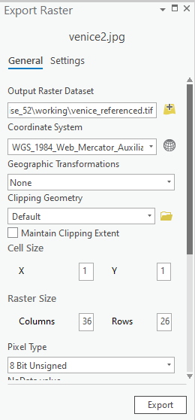
- Once the tool executes, the output will be added to the map automatically. If not, you will need to add the output to your map. Under the Map Tab, select Add Data. Navigate to the Working folder under the Exercise_7 folder.
- Note, if you don’t see the file, you may need to refresh the folder with the refresh button in the corner of the window.
Right-click on the venice_referenced.tif layer and select Zoom to Layer. The result is shown below.
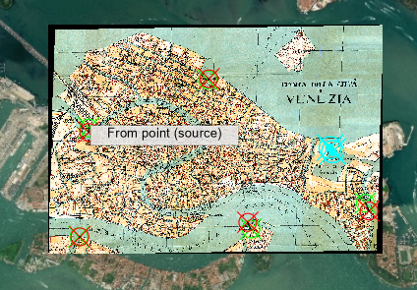
You are now done georeferencing this image.

Deliverable 2. Provide a screenshot of your result that shows how the historic map has been referenced to the base imagery, such as the above screenshot. (10 Points)
- In the Georeferening Tab, click Save in the Save panel followed by Close Georeferencing in the Close area. 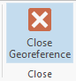
Note: Clicking Save will apply the georeference to the
venice2.jpg image that is stored in the Working folder under the Exercise_7 folder. You can save your georeferenced this way as opposed to using Save as New as we did above. However, this will alter the original file. That is why it is best to work with a copy of the data.

Step 5. Resampling Methods
Another common raster pre-processing task is resampling or changing the cell size. Generally, grids are coarsened as opposed to resampling to a smaller cell size. If you resample to a smaller cell size, you aren’t generally gaining information but duplicating values. There are many reasons why you might resample a raster grid, such as to meet the needs of a mapping project, to align and have the same cell size as other raster grids in an analysis or model, to reduce processing time, and/or to decrease file size.
There are many methods available to resample a raster grid. Please answer some general questions about the resampling methods here.

Question 2. In cubic convolution, how many original cell values are used to determine the new cell value? (10 Points) (Hint, cubic convolution will use 16 neighboring cell values)

Question 3. In bilinear interpolation, how many original cell values are used to determine the new cell value? (10 Points) (Hint, bilinear interpolation will use 4 neighboring cell values)
Let’s explore different resampling methods in ArcGIS Pro.
- Navigate to the Resample Map.
In this portion of the exercise, you will resample this aerial photograph using different resampling methods. This is an orthophotograph image for a portion of Faulkner County, Arkansas provided by the Arkansas GIS office. It is a true color image with red, green, and blue bands and with a 1-meter spatial resolution.
Resampling in ArcGIS Pro can be performed using the Resample Tool.
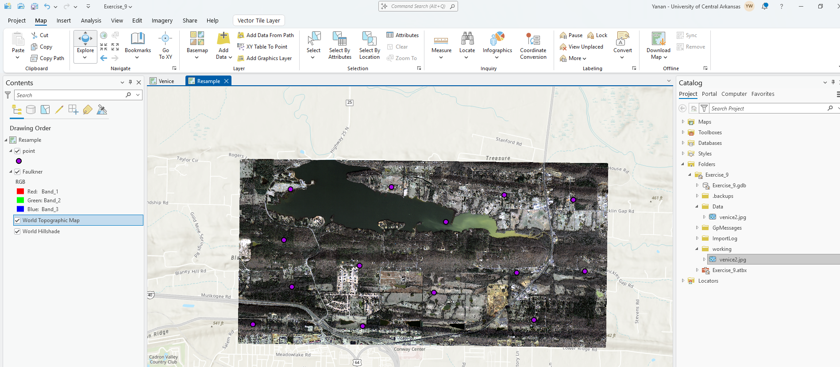
Note: In this lab, we will access tools from ArcToolbox. However, there are many ways to access tools in ArcGIS Pro. For example, some of the more common tools are provided in the Tools list in the Analysis Tab.

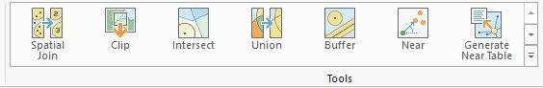
Once you open the Geoprocessing Pane, you can access your favorite tools or search for Tools.
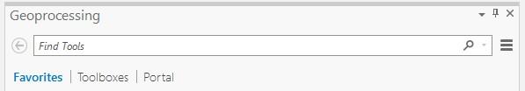
We have decided to demonstrate ArcToolbox here so that you get a sense of where the tools are located in the Toolbox directory.
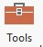
- In the Analysis Tab, select Tools from the Geoprocessing Area. This should open the Geoprocessing Pane.
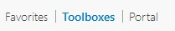
- In the Geoprocessing Pane, navigate to the Toolboxes.
Note: We will not provide these directions for accessing other tools. We will just tell you where to find them within ArcToolbox.
- Navigate to Data Management Tools followed by the Raster subtoolbox. The Resample Tool can be found under Raster Processing.
- Click on the Resample.
- Set the Input Raster to the Faulkner layer.
- Name the Output Raster Dataset faulkner_nn.tif and save it in the Working folder.
- Set the Output Cell Size to 10 by 10 meters. The X value should be set to 10 and the Y value should be set to 10.
- Set the Resampling Technique to Nearest (this should be the default). Click Run to execute the tool.
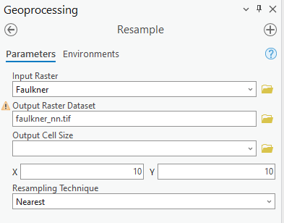
The result should automatically be added to the map. Note that this is a coarser representation of the data, as the data were resampled from a 1 m cell size to a 10-meter cell size.
- Repeat this process using a 10-meter cell size and the bilinear interpolation method followed by the cubic convolution method. Name the bilinear interpolation output Faulkner_bl.tif and the cubic convolution result Faulkner_cc.tif.

Deliverable 3. Provide three screenshots of faulkner_nn.tif, faulkner _bl.tif, and faulkner _cc.tif (10 Points) (Note, when you submit please provide the corresponding name to your screenshots)
You now have four versions of the image: the original image with a 1 m cell size and the three resampled images with a 10-meter cell size. Another method for resampling an image is pixel aggregation. This method calculates a statistic from the pixels or cells that fall within the new pixel or cell, such as the mean, sum, median, maximum, or minimum. You will now resample the image using this method as made available with the Aggregate Tool.
- Navigate to Spatial Analyst Tools followed by the Generalization subtoolbox.
- Click on the Aggregate.
- Set the Input Raster to the Faulkner layer.
- Name the Output Raster Dataset faulkner_agg.tif and save it in the Working folder.
- Set the Cell Factor to 10. This means that the cell size will increase by a factor of 10. So, the output will have a 10-meter cell size as opposed to a 1-meter cell size.
- Set the Aggregating Technique to Mean. This means that the average pixel value from the 1-meter pixels that fall in the 10-meter pixel will be returned.
- You do not need to change any other settings.
- Click Run to execute the tool.
Note: This tool only works for a single band. So, only the first band in the stack is aggregated, in this case, the red band. If you wanted to perform this operation for all of the bands, the tool would have to be executed separately for each band. You could then create a raster stack from them. This can be accomplished using the Composite Bands Tool. We will not ask you to do so here.
To compare the data, you will extract the pixel values from each grid at the point locations provided in the point layer. You will do this using the Extract Multi Values to Points Tool.
Navigate to Spatial Analyst Tools followed by the Extraction subtoolbox.
- Click on the Extract Multi Values to Points.
- Set the Input Point Features to the point layer.
- Add all of the images to the Input Rasters list and define the Output Field Names as specified below:
- faulkner2.tif = orig
- faulkner_nn.tif = nn
- faulkner _bl.tif = bl
- faulkner_cc.tif = cc
- faulkner_agg.tif = agg
- Make sure “Bilinear interpolation of values at point locations” is not selected.
- Click Run to execute the tool.
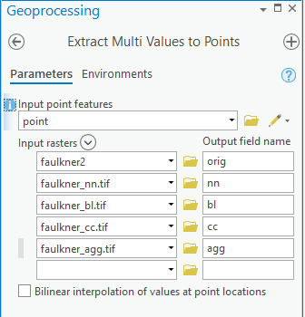
- Open the attribute table for the point layer. The new fields should have been added. The records correspond to the pixel values at that pixel or cell location.
Use the cell attribute table to answer the following question.

Question 4. Do the points have the same values for each band for different resampling methods? Why? (10 Points)
Note: In the attribute table “b1” corresponds to the red band, “b2” corresponds to the green band, and “b3” corresponds to the blue band. The “agg” result is for the red band only.

END OF EXERCISE

Homework
Submit a word file with 4 questions and corresponding answers together with 3 deliverables. Please submit it through Blackboard.

