Exercise 4: Table, Spatial Queries, and Database
In this exercise, you will explore table, spatial queries, and database in ArcGIS Pro. First, you will be introduced to a variety of querying techniques using a variety of vector datasets for Arkansas. Then you will learn how to produce a database in ArcGIS Pro. During the processes, you will use these new skills to answer a variety of questions using varying techniques and combinations of techniques.

Topics covered in this exercise include:
- Perform table queries in ArcGIS Pro
- Perform spatial queries in ArcGIS Pro
- Combine query techniques to address spatial problems
- Build database in ArcGIS Pro

Step 1. Open a Map Project

First, we need to download and open the Exercise_4.aprx file.
- Download the Exercise_4.zip file. Save it to the location of your choosing. You will need to extract the compressed files by right-clicking on Exercise_4.zip. In the drop-down window, choose “Extract All”.
- Within the uncompressed folder ‘Exercise_4’, directly click on the Exercise_4.aprx (If your computer does not automatically add the .aprx extension, please open the file listed as ‘ArcGIS Project File) to open this project file.

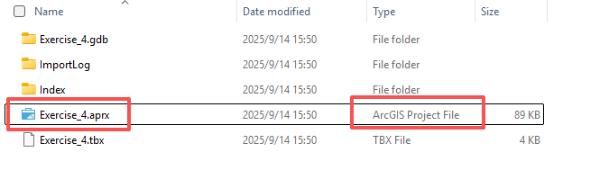
- This project should contain one map that houses the data needed for the lab. The data have already been symbolized. However, feel free to change the symbology. Throughout the lab, you may want to turn layers on and off so that it is easier to visualize the results of your query.

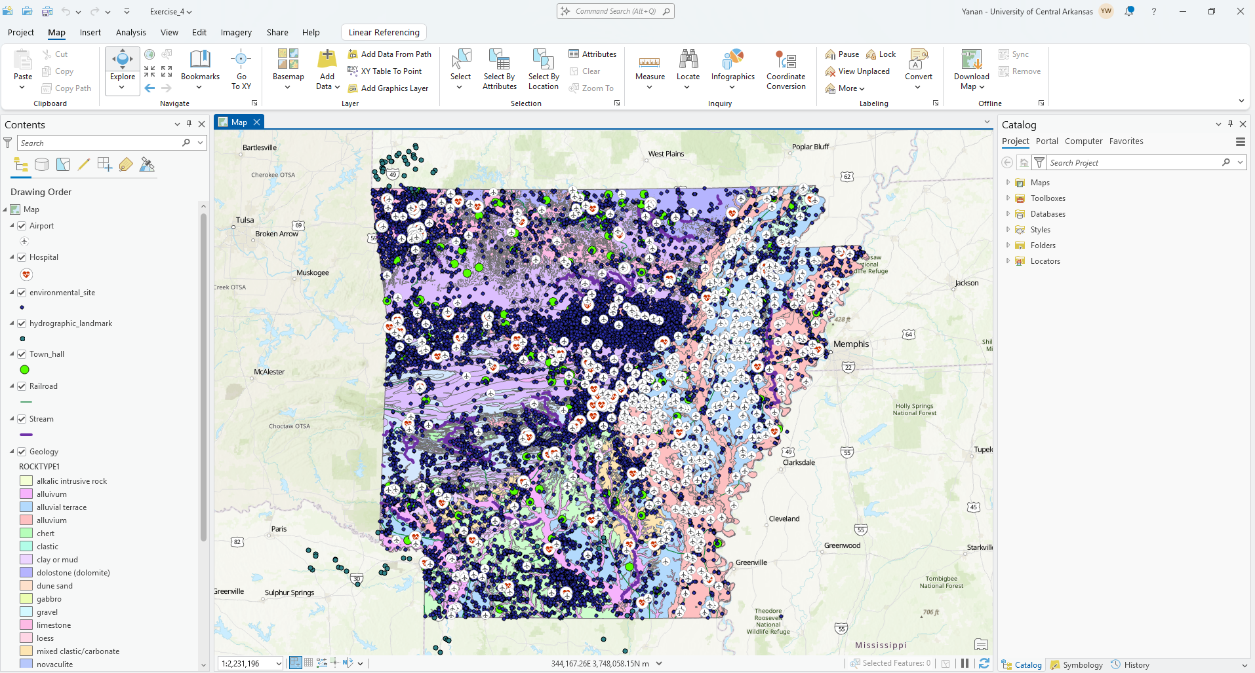
Here is a brief description of the data layers you will use in this exercise.
Airport: point features representing the locations of feature airports in Arkansas
Hospital: point features representing the locations of hospitals in Arkansas
environmental_site: point features representing location data for facilities, incident sites, and monitoring points at the permit level
hydrographic_landmark: point feature representing hydrographic landmark features
Town_hall: points representing towns hall or courthouse in Arkansas
Railroad: line features representing railroad
Stream: line features representing ecological sensitive waterbodies in the state
County: county boundaries for Arkansas as polygons
geology: polygons representing geologic layers in the state

Before we proceed to nonspatial/ spatial queries, here are some explanations of the available operators.
Is Equal to (=): must be exactly equal to the value or text specified
Does Not Equal (<>): must not equal the value or text specified (opposite of equals)
Is Greater Than/Is Greater Than or Equal To (> or >=): Must be
greater than or greater than or equal to the value specified
Is Less Than/Is Less Than or Equal To (< or >=): Must be less than or less than or equal to the value specified
Includes The Value(s): specify a list of values to search for to select features/if value is found feature will be selected
Does not Include The Value(s): specify a list of values to search for/if value is found feature will not be selected (opposite of Includes The
Value(s))
Is Null: find all features with Null in specified field
Is Not Null: final all features without null is specified field (opposite of Is Null)
Is Above Average: select all features that have an above average value in that field
Is Below Average: select all features that have a below average value in that field (opposite of Is Above Average).
AND: used when you want to produce a SQL statement in which multiple criteria must be met
OR: used when you want to produce a SQL statement in which at least one of two criteria must be met
NOT: used when you want to produce a SQL statement in which one criterion must be met but not another criterion.
XOR: used when you want to produce a SQL statement in which one of two criteria must be met, but not both

Here are brief explanations of the selection types.

New selection: create a new selection that will not be impacted by prior selections.
Add to the current selection: add features that meet a new query to the list of currently selected features
Remove from the current selection: remove features that meet a new query from the list of currently selected features.
Select subset from the current selection: select features that meet a new query from the list of features that have already been selected
Switch the current selection: invert the selection or unselect features that are selected and select those that are not
Clear the current selection: clear the current selection so that no features are selected

Step 2. Description of Table Queries
We will begin by experimenting with table queries. Here, we will make use of the Select By Attributes Tool. This tool can be found under the Map Tab and in the Selection Area.

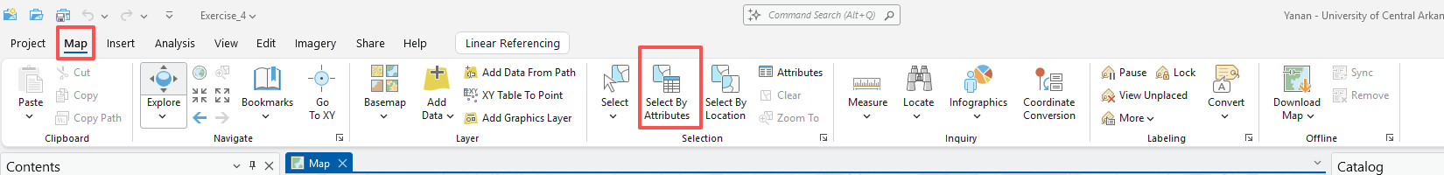

Let’s experiment with this tool using a few examples.
You can perform table queries, queries that only use attribute information and are not dependent on geometry or location, by using Structured Query Language (SQL) to query the attribute table. Here, you will perform a query to find all of the counties with greater than 50 confirmed Covid-19 cases on May 1st 2020.
- Click on the Select By Attributes Tool in the Selection area of the Map Tab to open the Select Layer By Attribute Pane.
- Set the Input Rows to County.
- Set the Selection type to “New selection.”
- Click the “Add Clause” to create a new clause.

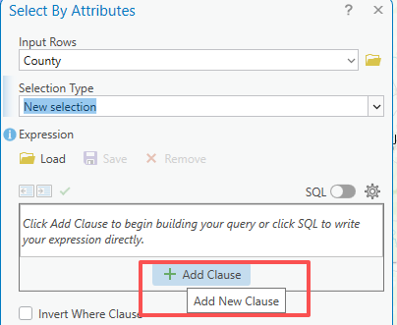

- In the new clause, set the field to “May1” (this field provides the confirmed Covid-19 cases on May 1st), change the operator to is Greater Than, and define the value as 50.
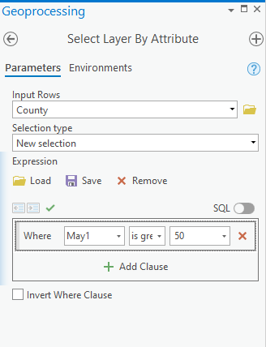
- Click Apply (or Run) to execute the query.
A total of 14 counties should be selected. There are many ways to see the number of selected features. Here are the methods that we would suggest.
- Use the List by Selection view in the Contents Pane. This will tell you how many features are selected in each layer.
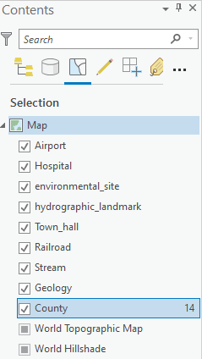
- Open the attribute table for the layer of interest (i.e., County) to view the number of selected features. The number of selected features will be provided at the bottom of the attribute table.
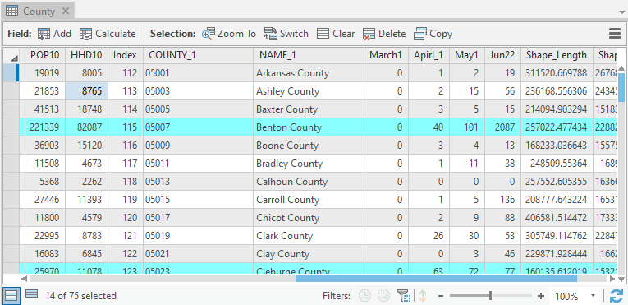
- The bottom of the map area will provide the number of selected features. However, this is for all of the layers. So, this may not provide the correct answer for you if you have features selected in multiple layers but are only interested in the number of selected features in a certain layer. So, use this with caution.
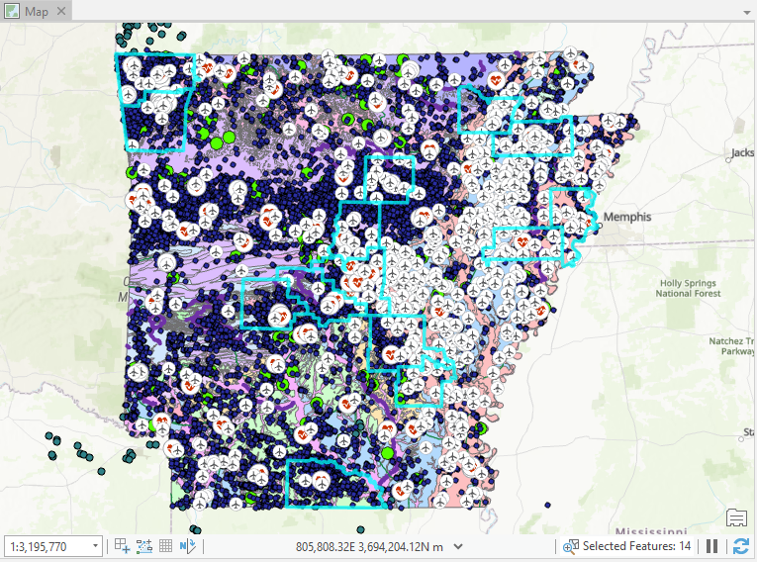

Once you have performed a query, it is important to remember to clear the selection so that it does not impact later queries. Note that this isn’t always necessary, but we will have you do so here for good practice.
- Click on Clear in the Selection area of the Map Tab to clear your selection.
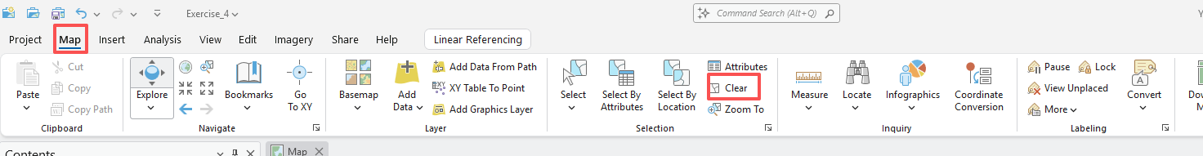
You will now perform a query that involves multiple clauses. Specifically, you will find all counties that had a population greater than 14,000 in 2010 and with the confirmed Covid-19 cases on May 1st as greater than 50.
- Click on the Select By Attributes Tool in the Selection area of the Map Tab to open the Select Layer By Attribute Pane.
- Set the Input Rows to County.
- Set the Selection type to “New selection.”
- Click the “Add Clause” to create a new clause.
- In the new clause, set the field to “POP10” (this is the population of the county reported in the 2010 US Census), change the operator to is Greater Than, and define the value as 14000.
- Click Add Clause again to add the next clause.
- Leave the first argument as And.
- In the clause, set the field to “May1”, change the operator to is Greater Than, and define the value as 50.
- Click Apply (or Run) to execute the query.

Question 1. How many counties have population greater than 14000 in 2010 and covid-19 cases greater than 50 on May 1st? (5 points)

Answer 1: 14

It is also possible to perform queries in sequence as opposed to using multiple clauses. Let’s now perform a query to find all counties that have a population greater than 14,000 excluding Craighead County in 2010.
- Click on Clear in the Selection section of the Map Tab to clear your selection.
- Click on the Select By Attributes Tool in the Selection area of the Map Tab to open the Select Layer By Attribute Pane.
- Set the Input Rows to County.
- Click the “Add Clause” to create a new clause.
- In the new clause, set the field to “POP10” (this is the population of the county reported in the 2010 US Census), change the operator to is Greater Than, and define the value as 14000.
- Click Apply (or Run) to execute the query.
This should select 52 counties. Now, you will perform a second query to remove Craighead County.
- Do not clear the selection this time.
- Click on the Select By Attributes Tool in the Selection area of the Map Tab to open the Select Layer By Attribute Pane.
- Set the Input Rows to county.
- Set the Selection type to “Remove from the current selection.” (You are doing this because you want to remove Craighead County from the previous selection).
- Click the “Add Clause” to create a new clause.
- In the new clause, set the field to “NAME” (this field holds the name of the county), change the operator to “is Equal to”, and define the value as Craighead (You can get the county name from the available drop down list. This is the preferred methods since the query is case sensitive. You have to specify the value or string exactly as it is represented in the attribute table.)
- Click Apply (or Run) to execute the query.
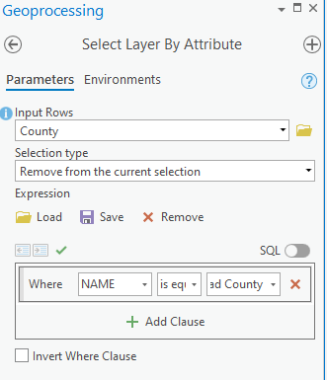
This should decrease the number of selected features to 51 counties.

Deliverable 1. Screenshot the map showing the 51 selected counties. (5 points) (Please turn off other layers to see the results clearly)

Instead of using the clause mode to build your queries in the Select By Attributes Tool, it is also possible to build SQL statements directly. This offers a more powerful means to undertake queries. We will now experiment with this method.
First, we will reproduce the second query to find all counties that had a population greater than 14,000 in 2010 and with the Covid-19 cases on May 1st as greater than 50.
- Click on Clear in the Selection section of the Map Tab to clear your selection.
- Click on the Select By Attributes Tool in the Selection area of the Map Tab to open the Select Layer By Attribute Pane.
- Set the Input Rows to County.
- Set the Selection type to “New selection.”
- Click ‘SQL’ to turn on the SQL option
- Provide the following syntax: POP10 > 14000 AND May1 > 50 (Note that suggestions of field names and operators will be made as you type).
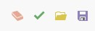
- If you would like to validate the statement before running the query, you can use the validate option. After your validation, a pop-up message should appear stating ‘The SQL expression is valid’.
- Click Apply (or Run) to execute the query.
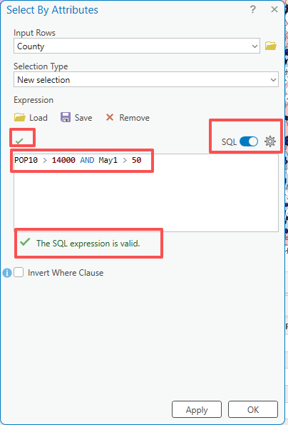

Question 2. Is the number of selected counties same as the previous one in Question 1? (5 points)

You will now execute an additional query using SQL mode to find counties in which the population increase between 1970 and 2010.
- Click on Clear in the Selection section of the Map Tab to clear your selection.
- Click on the Select By Attributes Tool in the Selection area of the Map Tab to open the Select Layer By Attribute Pane.
- Set the Input Rows to County.
- Set the Selection type to “New selection.”
- Click ‘SQL’ to turn on the SQL option.
- Provide the following syntax: POP10 > POP70 (this is the population of the county reported in the 1970 and 2010 US Census).
- If you would like to validate the statement before running the query, you can use the validate option.
- Click Apply (or Run) to execute the query.

Question 3. How many counties experienced increasing population between 1970 and 2010? (5 points)
Answer: 51

Step 3. Description of Spatial Queries
Spatial queries are those that rely on the spatial information to perform the selection. They cannot be completed using only the attribute information. For example, finding all hospital that are within a defined distance of railroad would be an example of a spatial query as it relies on the spatial relationship between the hospital and railroad. In ArcGIS Pro, spatial queries are performed using the Select by Location Tool.
Let’s perform a spatial query to find all hospitals that are within 5 miles of a railroad.
- Click on Clear in the Selection section of the Map Tab to clear your selection.
- Click on the Select By Location Tool in the Selection area of the Map Tab to open the Select Layer By Attribute Pane.
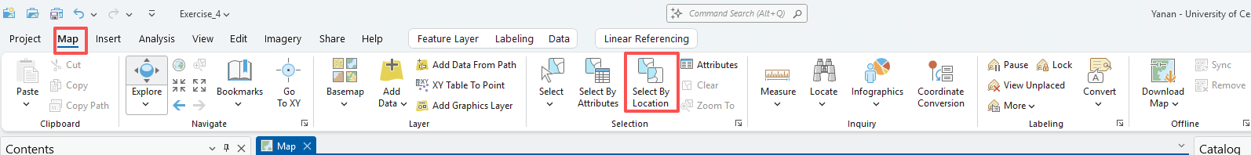
- Set the Input Features to Hospital.
- Set the Relationship to “Within a distance.”
- Set the Selecting Features to Railroad.
- Set the search distance to 5 and the units to US Survey miles.
- Leave the selection type as “New selection.”
- Click Apply (or Run) to execute the query.
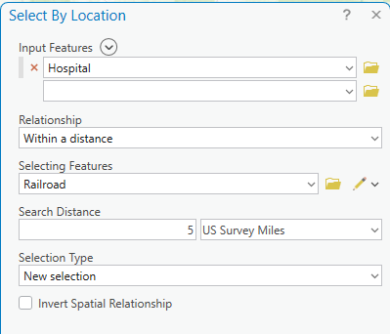

Question 4. How many hospitals are within 5 miles of a railroad? (5 points)

Answer: 101

Here are some explanations for the available relationships. We’ve also learned in the class. You may want to refer to the slides.
Intersect: select input features that intersect the selecting features. This is the default.
Within a distance: select input features that are within the specified Euclidean distance of the selecting features.
Contains: Select any input feature that contains, even partially, a selecting feature.
Completely contains: select any input feature that completely contains a selecting feature.
Within: select any input feature that is within, even partially, a selecting feature.
Completely within: select any input feature that is completely within a selecting feature.
Are identical to: select any input feature that has identical geometry to a selecting feature.
Boundary touch: select any input feature that has a boundary that touches a selecting feature.
Share a line segment with: select any input feature that shares a line segment with a selecting feature.
Crossed by outline of: select any input feature that is crossed by the outline of a selecting feature.
Have their center in: select any input feature that has its center in the selecting features. The center for lines is defined as the midpoint and the center for polygons is defined as the centroid.

A full list of relationships with descriptions can be found here:
https://pro.arcgis.com/en/pro-app/tool-reference/data-management/select-layer-by-location.htm.

Step 4. Combining Table and Spatial Queries
Some queries will require you to combine table and spatial queries. We will demonstrate a few examples here.
Let’s find all of the town hall that occur within Faulkner County. You will begin by using a table query to select Faulkner County.
- Click on Clear in the Selection section of the Map Tab to clear your selection.
- Click on the Select By Attributes Tool in the Selection area of the Map Tab to open the Select Layer By Attribute Pane.
- Set the Input Rows to County.
- Set the Selection type to “New selection.”
- Click the Add New Expression button.
- In the new clause, set the field to “NAME”, make sure the operator is set to is Equal to, and define the value as Faulkner.
- Click Apply (or Run) to execute the query.
- Now, Faulkner County should be selected.

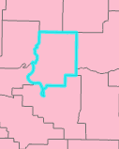

Next, you will perform the spatial portion of the query. Note that only the selected features will be used.
- Do not clear the selection before beginning.
- Click on the Select By Location Tool in the Selection area of the Map Tab to open the Select Layer By Attribute Pane.
- Set the Input Features to Town_hall.
- Set the Relationship to “Intersect.” Alternatively, you can use “Within.” They will yield the same result.
- Set the Selecting Features to County. Turn on ‘Use the selected records:1’.
- Do not define a Search Distance.
- Leave the selection type as “New selection.”
- Click Apply (or Run) to execute the query.
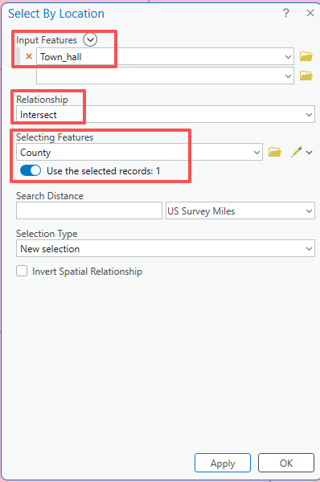

Question 5. How many town halls in Faulkner county? (5 points)

Answer: 2

Lastly, let’s further expand upon this selection by finding all of the town halls that are in Faulkner County and within 2 miles of a railroad.
- Do not clear the selection before beginning.
- Click on the Select By Location Tool in the Selection area of the Map Tab to open the Select Layer By Attribute Pane.
- Set the Input Features to Town_hall.
- Set the Relationship to “Within a distance.”
- Set the Selecting Features to Railroad.
- Set the Search Distance to 2 and the units to Miles.
- Change the selection type to “Select subset from the current selection.”
- Click Apply (or Run) to execute the query.
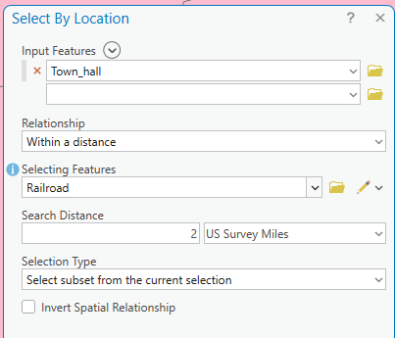

Question 6. How many town halls that are in Faulkner County and within 2 miles of a railroad? (5 points)

Answer: 1

Note: If you select the “Invert spatial relationship option,” this will cause features that do not meet the criteria to be selected. For a table query, the “Invert Where Clause” option will also cause features that do not meet the criteria to be selected.

Step 5. Perform Your Own Queries
Using the techniques described above, answer the following questions using table, spatial, or a combination of table and spatial queries. Be careful to clear your selections as needed. If you need any help, don’t hesitate to ask. Note that there may be multiple methods to answer these questions. However, you can answer all the questions using only queries. There is no need to use other spatial analysis methods.

Question 7. How many streams intersect a railroad? (5 Points)

Answer: 19

Deliverable 2. Please also provide a screenshot of your resulted map (5 Points).
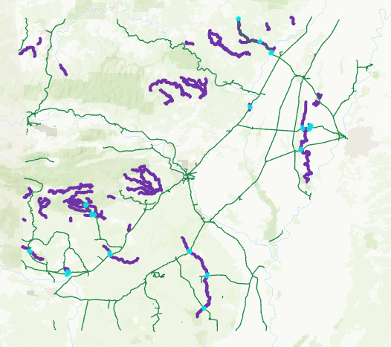

Question 8. How many hydrographic landmarks are within 10 miles of a stream? (5 Points).

Answer: 15

Deliverable 3. Please also provide a screenshot of your resulted map (5 Points).
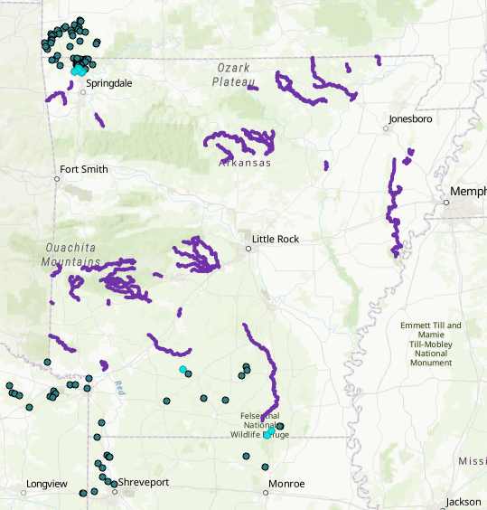

Play with Query to explore environment sites with Faulkner county and rock type in Faulkner county.

Step 6. Build a file database
A database can be used to organize data in an effective way, especially when your project data are large. In this step you will learn how to use ArcGIS Pro to create a file database.

- To begin, create an empty map by clicking on New Map under the Insert Tab.
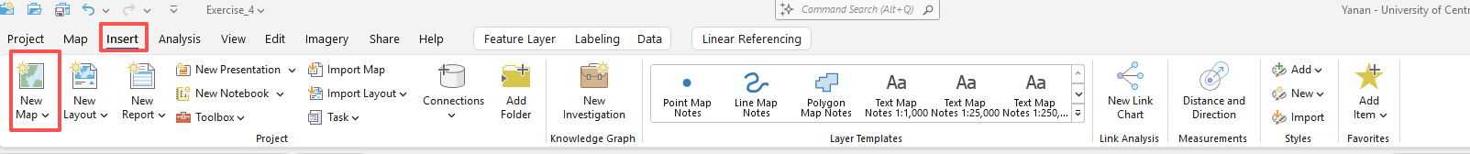
- Click on Catalog Pane under the View Tab.
- In the Catalog window, if you expand Databases, you can find the database that is associated with Exercise_4, named “Exercise_4.gdb”. This database is automatically created. However, the data are needed to be imported into the database manually. Expand Exercise_4.gdb, you will find the data that you used before in this exercise.
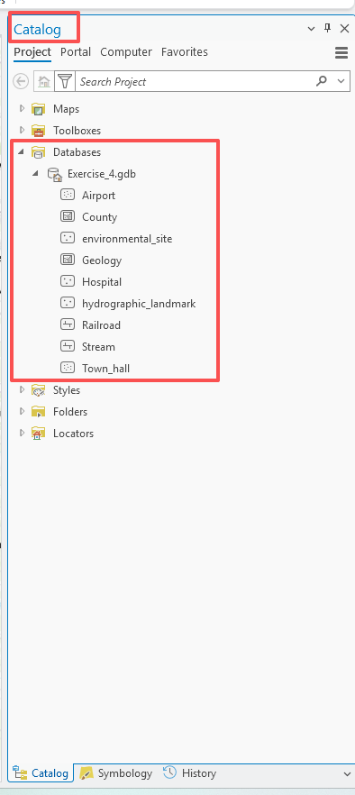
- For practice, we will create a new database. Expand Folders, you will find the folder for Exercise_4. Right-click on Exercise_4, followed by New and File Database. A database named “New File Geodatabase.gdb” will be created under the Exercise_4 folder. Rename the database by right-clicking on it, followed by Rename. Assign the new name as “MyDatabase.gdb”.
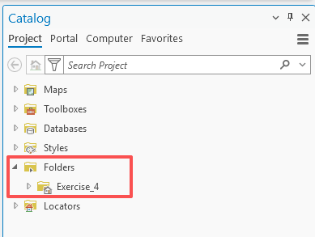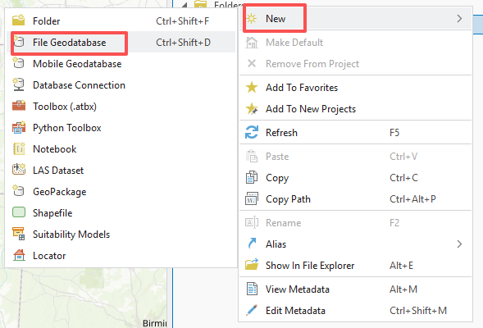
- If you expand “MyDatabase’, you will find there is nothing there. That is because we did not add any feature classes there.
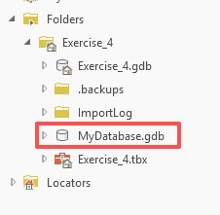
We can either import an existing vector, raster, or table into database or we can create a new feature class. We will practice both.

- Right-click on “MyDatabase.gdb”, followed by Import and Feature Class.
- In the Feature Class to Feature Class window, click on folder icon . In the Input Features window, double-click on Exercise_4.gdb. Highlight on Town_hall feature class, followed by OK. Set Output Location as “MyDatabase.gdb” (it should be in default).You do not need to change others. Click on Run to execute the function.
- You will find the TownHall is added into “MyDatabase.gdb”.
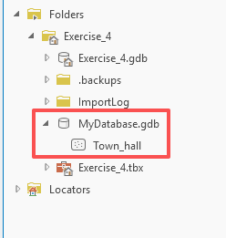
Now, we will create a new feature class. In the process, we will practice how to create domain and subtypes.
- Right-click on “MyDatabase.gdb”, followed by Domains.
- In the Domains:MyDatabse window, add new domaon through ‘Click here to add a new domain’. set “BuildingName” for Domain Name, “Text” for Field Type, “Coded Value Domain” for “Domain Type”, “Default” for both Split Policy and Merge Policy. Use the left table to set for Code and Description.
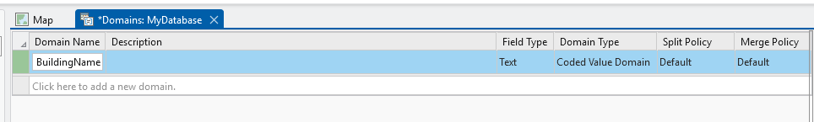

- Click on Save under Domains Tab.
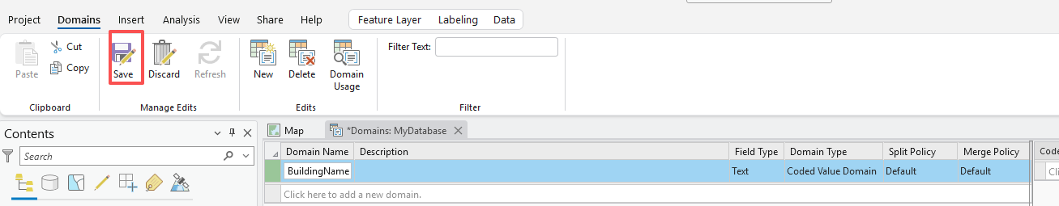
- Right-click on “MyDatabase.gdb”, followed by New and Feature Class.
- In the Create Feature Class window, set “Building” as Name and “Polygon” for Feature Class Type. Clear the check marker before Z values. Click on Next. Add two new fields named “Name” and “Color”, and the “Text” and “Short Integer” for Data Type, respectively. You do not need to change others. Click Next until the last page. Click on Finish.
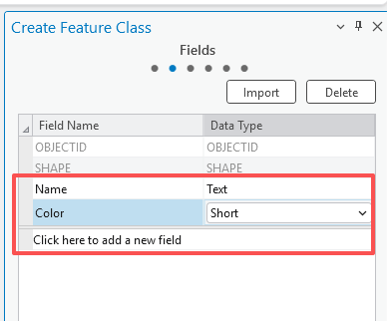
- You will find a new feature class, named Building is added to the database. Note, the Building feature will not be automatically added to the Mapped Area. If you want to add it to the Mapped Area, you need to right-click on it, followed by ‘Add to Current Map’. Also, the Building feature is an empty feature, which can be used in digitalization. You will learn it in later class.
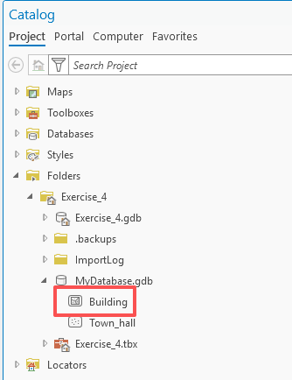
- Right-click on Building, followed by Data Design and Domains, you will find the domains are the same as the ones you just created. This is because domains are created at database level.

Deliverable 3. Please provide a screenshot of your created database including two feature classes (10 Points).

END OF EXERCISE

Homework
Submit a word file with eight questions and corresponding answers together with three deliverables. Please submit it through Blackboard.

