Exercise 2: Terrain and Hydrological Analysis
This exercise describes how to produce a variety of terrain derivatives from digital elevation models (DEMs). The processes outlined here make use of a variety of raster analysis tools and techniques. In addition, you will learn how to use hydrology tools available in the Spatial Analyst Toolbox to derive a variety of hydrologic surfaces and eventually derive watershed boundaries.

Topics covered in this exercise include:
- Create slope, aspect, and hillshade raster grids from a DEM
- Create and interpret surface curvature grids
- Use neighborhood analysis and raster math to produce more complex terrain outputs
- Fill a DEM for hydrologic modeling
- Create a flow direction grid and flow accumulation grid
- Produce a synthetic stream network
- Create watershed boundaries
- Calculate stream order

Data
This project contains one raster layer: USGS_1_n35w094_utm.tif, representing the DEM in Quachita region, Arkansas, US. Download Exercise_2.zip. Save it in the location you are choosing and unzip it by right-clicking on Exercise_2.zip. In the drop-down window, choose “Extract All”.

Step 1. Add Data to Map in ArcGIS Pro

Before adding the data, you will need to create a project in ArcGIS Pro.
- In the search bar at the left corner, type “ArcGIS Pro”. You will see the software “ArcGIS Pro”. Click on it, the ArcGIS Pro will be loaded.
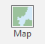
Note, this can also be done by navigating to All Apps followed by the ArcGIS Folder. Within the ArcGIS Folder, select ArcGIS Pro.
- Create a project to host your maps by clicking on the Map icon.
- The Create a New Project window should be shown. Define the name (Exercise_2) for your project. Then click on Folder icon, find the location where you want to save your project.
- You do not need to change others.
- Click on OK.
Now, you will add the data to the map.
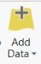
- Click the Add Data button. This button is available under the Map Tab within the Layer Section.
- Navigate to your directory that stores the data. Specifically, navigate to the Exercise_2 folder.
- Within the folder, select the USGS_1_n35w094_utm.tif. Click OK to add it to the map.

Step 2. Defining Environment Settings
Since you will perform many spatial analysis operations in this lab, you will start by setting the environment settings. It is generally a good idea to set environment settings any time you will perform spatial analysis operations in a project. Also, this can speed up your processing, as you will not need to set environments for each tool individually.
- Navigate to the Analysis Tab then select Environments in the Geoprocessing Area.
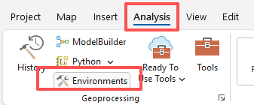
- Check and change (if needed) the Current
Workspace and the Scratch Workspace to the Exercise_2.gdb geodatabase in the Exercise_3 folder. This will cause all of the outputs to automatically be saved to this location.
- Set the Output Coordinate System to Current Map [Part I] (should be NAD 1983 UTM Zone 15 North) under Output Coordinate Systems.
- Set the processing extent to be the same as the USGS_1_n35w094_utm layer under Processing Extent.
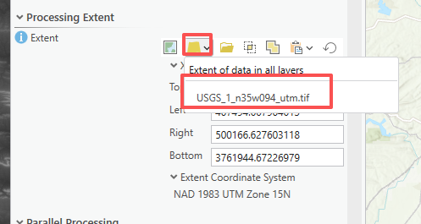
- Set the Cell Size to be the same as the USGS_1_n35w094_utm layer (should be ~28.2, meaning 28.2 by 28.2 meters) under Raster Analysis.
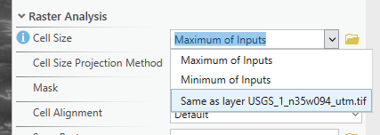
- Also under Raster Analysis, set the Mask to the USGS_1_n35w094_utm layer and Snap Raster to the USGS_1_n35w094_utm layer.
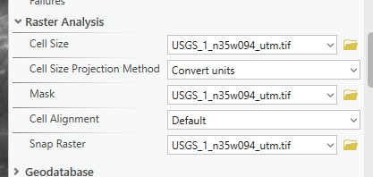
- Click Okay to accept these settings.

Note: Setting the snap raster to the USGS_1_n35w094_utm layer means that all the raster grids you create will align perfectly with the original. We recommend setting a snap raster, especially if you plan to perform any raster overlay, as you will do here, since this results in a cleaner overlay, as the cells align perfectly.

Step 3. Create Topographic Slope, Topographic Aspect, and Hillshade Grids
First, you will create topographic slope, aspect, and hillshade grids from the DEM data. You will begin with slope.
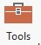
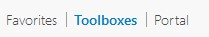
- In the Analysis Tab, select Tools from the Geoprocessing Area. This should open the Geoprocessing Pane.
- In the Geoprocessing Pane, navigate to Toolboxes.
- Navigate to Spatial Analyst Tools followed by the Surface subtoolbox.
- Click on the Slope Tool(Spatial Analysis Tools). Set the Input Raster to the USGS_1_n35w094_utm layer.
- Name the Output Raster slope (this will save to the Exercise_3.gdb geodatabase, as defined in the environment settings).
- Make sure the Output Measurement is set to “Degree”.
- Make sure the Method is set to “Planar.” Make sure the Z Factor is set to 1.
- Click Run to execute the tool. The output should automatically be added to your map.

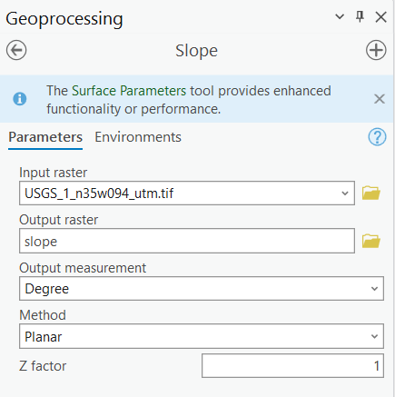

Deliverable 1. Screenshot the map showing the slope of the study region. (3 points)
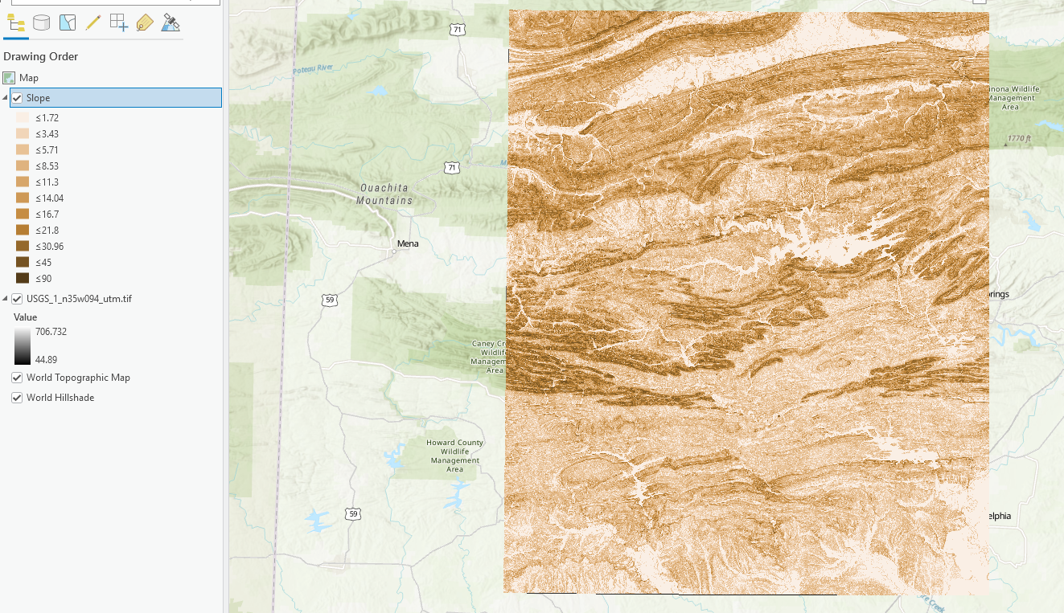
Now, you will create a topographic aspect grid.
- Navigate to Spatial Analyst Tools followed by the Surface subtoolbox.
- Click on the Aspect Tool(Spatial Analyst Tools).
- Set the Input Raster to the USGS_1_n35w094_utm layer.
- Name the Output Raster aspect.
- Make sure the Method is set to “Planar.”
- Click Run to execute the tool. The output should automatically be added to your map.
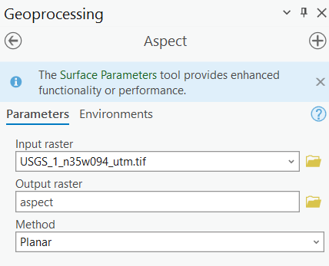

Question 1. In the default legend generated for the aspect grid, what azimuth range is defined as southeast? (3 Points) (Hint, refer to the legend of Aspect)
112.5 – 157.5

Now, you will create a hillshade.
- Navigate to Spatial Analyst Tools followed by the Surface subtoolbox.
- Click on the Hillshade Tool(Spatial Analyst Tools).
- Set the Input Raster to the USGS_1_n35w094_utm layer.
- Name the Output Raster hillshade.
- Leave the Azimuth set to 315 and the Altitude set to 45.
- You do not need to change any additional settings.
- Click Run to execute the tool. The output should automatically be added to your map.
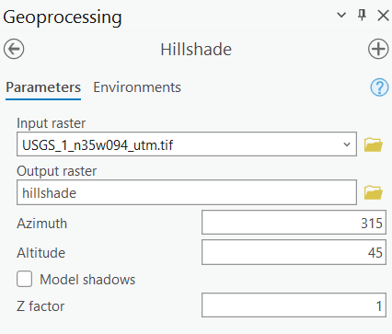
Note: Hillshade images are useful for displaying elevation data. They are much more visually appealing than a DEM.

Question 2. Explain what the altitude option defines (Hint: refer to the exclamation mark beside Altitude in the Hillshade window). (3 Points)
Altitude angle is the light source above the horizon. 90 degree is overhead.

Feel free to experiment with the azimuth and altitude options to determine how they impact the resulting hillshade surface.

Step 4. Create Curvature Grids
You will now create curvature grids for curvature, profile curvature, and plan curvature.
- Navigate to Spatial Analyst Tools followed by the Surface subtoolbox.
- Click on the Curvature Tool(Spatial Analyst Tools).
- Set the Input Raster to the USGS_1_n35w094_utm layer.
- Name the Output Curvature Raster curv.
- Name the Output Profile Curvature Raster pro_curve.
- Name the Output Plan Curvature Raster plan_curve.
- You do not need to change any additional settings.
- Click Run to execute the tool. The output should automatically be added to your map.
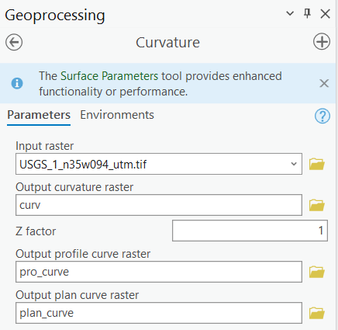
Note: If you do not define an output for the profile and plan curvature, only the curvature raster will be generated.

Deliverable 2. Screenshot the map showing profile curvature of the study area. (3 Points)
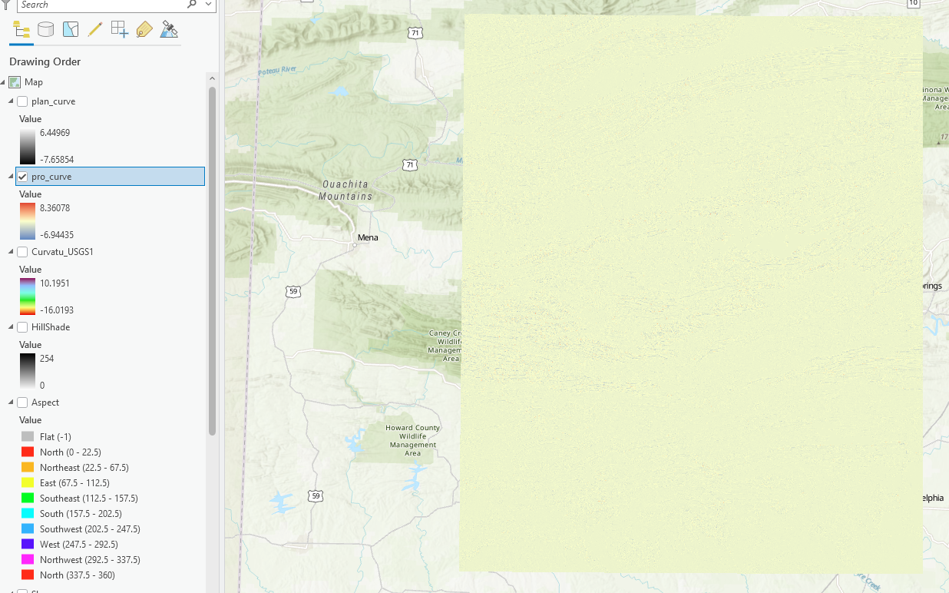

Step 5. Create a Slope Position Raster Grid
You will now learn to create more complex terrain derivatives using the Raster Calculator Tool and neighborhood analysis. We will begin with slope position, which provides a measure of slope position from the valley bottom to the ridge. Note that this measure is dependent on the window size specified.
You will start by finding the mean elevation value within a circular radius of 9 cells around each cell.
- Navigate to Spatial Analyst Tools followed by the Neighborhood subtoolbox.
- Click on the Focal Statistics Tool.
- Set the Input Raster to the USGS_1_n35w094_utm layer.
- Name the Output Raster mean.
- Define the Neighborhood using a “Circle” with a radius of 9 cells.
- Make sure the Statistic Type is set to “Mean.”
- You do not need to change any additional settings.
- Click Run to execute the tool. The output should automatically be added to your map.
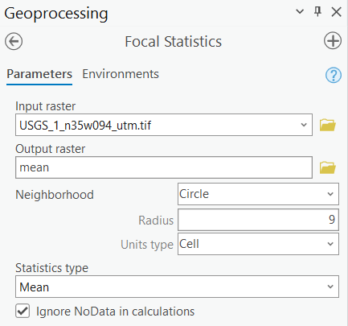
You now want to compare the original elevation at the cell to the mean value calculated above to determine if the elevation is higher or lower than the mean of the neighborhood. You will do this using the Raster Calculator Tool.
- Navigate to Spatial Analyst Tools followed by the Map Algebra subtoolbox.
- Click on the Raster Calculator Tool.
- Define the syntax as follows: "USGS_1_n35w094_utm" - "mean".
- Name the Output Raster sp.
- You do not need to change any additional settings.
- Click Run to execute the tool. The output should automatically be added to your map.
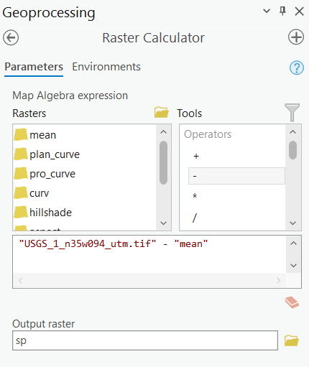

Questions 3. Compare the sp layer and the background World Topographic Map and World Hillshade, are the slope positions in your expectations? Why? (3 Points) (Hint, you want to turn off all other layers)
The focal mean raster represents the average elevation of the surrounding terrain and serves as a reference surface describing the general landform trend. Subtracting the mean surface from the original DEM removes broad-scale elevation patterns and highlights local topographic variation. The resulting raster expresses relative elevation, indicating whether each location is higher or lower than its neighborhood. This allows identification of slope positions such as ridges, hillslopes, and valleys, which cannot be distinguished using slope or elevation alone.

Step 6. Create a Terrain Roughness Raster Grid
You will now create a terrain roughness raster, which provides a measure of how variable or rugged the terrain is based on how variable the elevation measurements are in a given window size. Note that this measure is dependent on the window size specified.
You will begin by calculating the standard deviation in a circular radius of 9 cells around each cell.
- Navigate to Spatial Analyst Tools followed by the Neighborhood subtoolbox.
- Click on the Focal Statistics Tool.
- Set the Input Raster to the USGS_1_n35w094_utm layer.
- Name the Output Raster sd.
- Define the Neighborhood using a “Circle” with a radius of 9 cells.
- Make sure the Statistic Type is set to “Standard deviation.”
- You do not need to change any additional settings.
- Click Run to execute the tool. The output should automatically be added to your map.
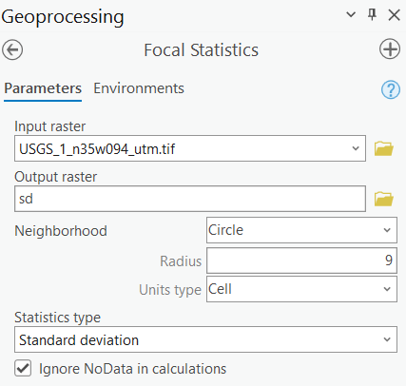
You will now use raster math to calculate the square root of the standard deviation surface produced above.
- Navigate to Spatial Analyst Tools followed by the Map Algebra subtoolbox.
- Click on the Raster Calculator Tool.
- Define the syntax as follows: SquareRoot("sd"). Note that the square root operator is available from the Tools list.
- Name the Output Raster roughness.
- You do not need to change any additional settings.
- Click Run to execute the tool. The output should automatically be added to your map.
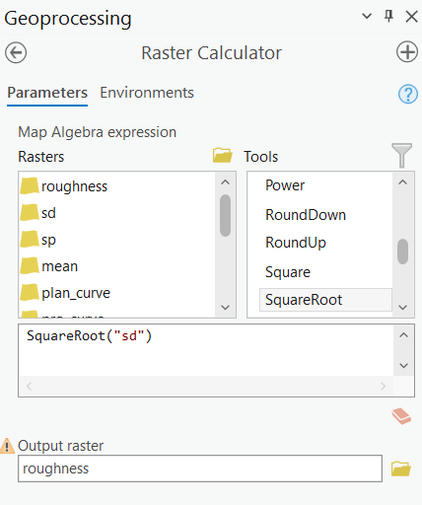

The higher value represents more roughness, and the lower value indicates less roughness. Based on the roughness layer, answer the following questions.

Question 4. Which regions’ surface is relatively rough? (3 Points)
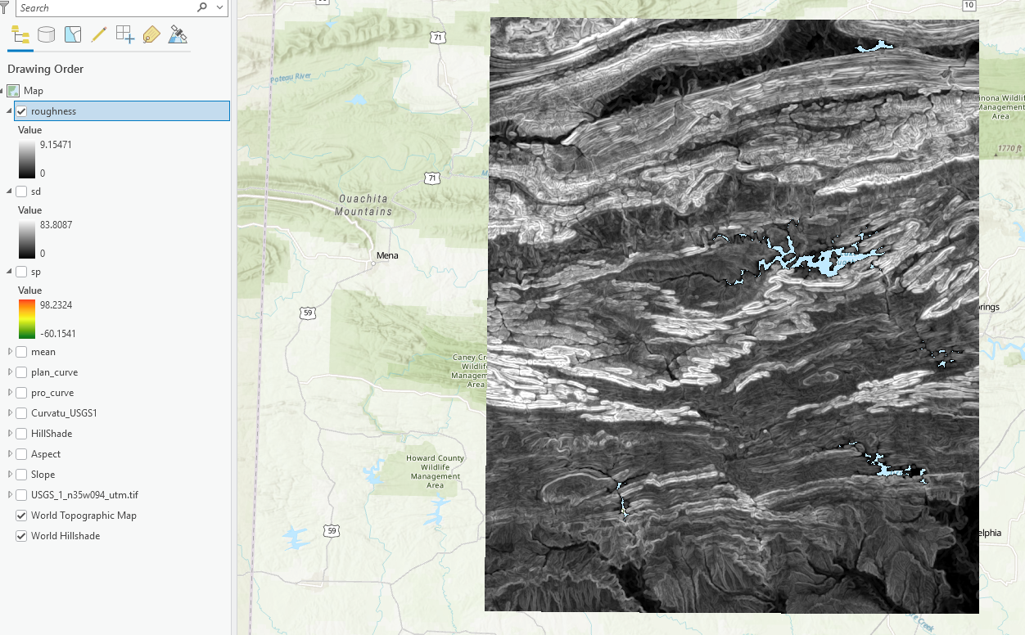

Step 7. Create a Terrain Dissection Raster Grid
Now, you will create a terrain dissection grid. Terrain dissection is a measure of how incised the landscape is at the cell location. This will involve multiple steps. Note that this measure is dependent on the window size specified.
First, you will need to find the maximum elevation value in a circular radius of 9 cells around each cell.
- Navigate to Spatial Analyst Tools followed by the Neighborhood subtoolbox.
- Click on the Focal Statistics Tool.
- Set the Input Raster to the USGS_1_n35w094_utm layer.
- Name the Output Raster max.
- Define the Neighborhood using a “Circle” with a radius of 9 cells.
- Make sure the Statistic Type is set to “Maximum.”
- You do not need to change any additional settings.
- Click Run to execute the tool. The output should automatically be added to your map.
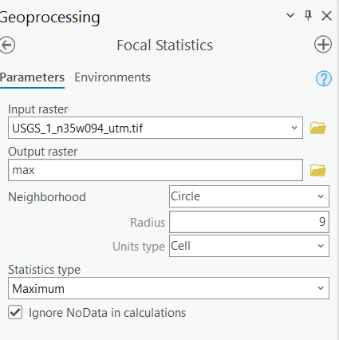
You will now need to find the minimum elevation value in a circular radius of 9 cells around each cell.
- Use the methods outlined above to calculate the minimum elevation value in a circular window with a radius of 9 cells. Make sure to use the minimum statistic. Name the output min.

Now, you will calculate dissection with the following equation using the Raster Calculator Tool:
(dem- min)/(max – min)
- Navigate to Spatial Analyst Tools followed by the Map Algebra subtoolbox.
- Click on the Raster Calculator Tool.
- Define the syntax as follows: ("USGS_1_n35w094_utm" - "min")/("max" - "min").
- Name the Output Raster diss1.
- You do not need to change any additional settings.
- Click Run to execute the tool. The output should automatically be added to your map.

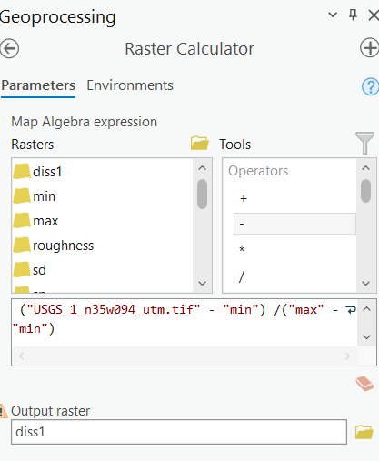

Just in case one of the cells had a denominator of zero in this calculation, you will need to execute one more step using a conditional statement:
Con(("max" - "min") == 0, 0, "diss1")
Here is an interpretation of this conditional statement. If the difference between the max and min raster grids is zero, then code the result as zero. If it is not, then use the value from the diss1 grid.
- Navigate to Spatial Analyst Tools followed by the Map Algebra subtoolbox.
- Click on the Raster Calculator Tool.
- Define the syntax as follows: Con(("max" - "min") == 0, 0, "diss1"). The Con function is available in the tools list.
- Name the Output Raster diss2.
- You do not need to change any additional settings.
- Click Run to execute the tool. The output should automatically be added to your map.
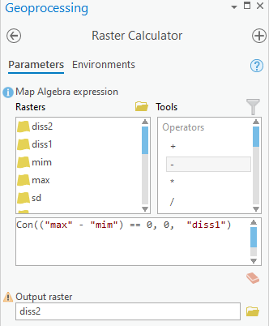

Deliverable 3. Screenshot the map showing the dissection of the study area. (3 Points).
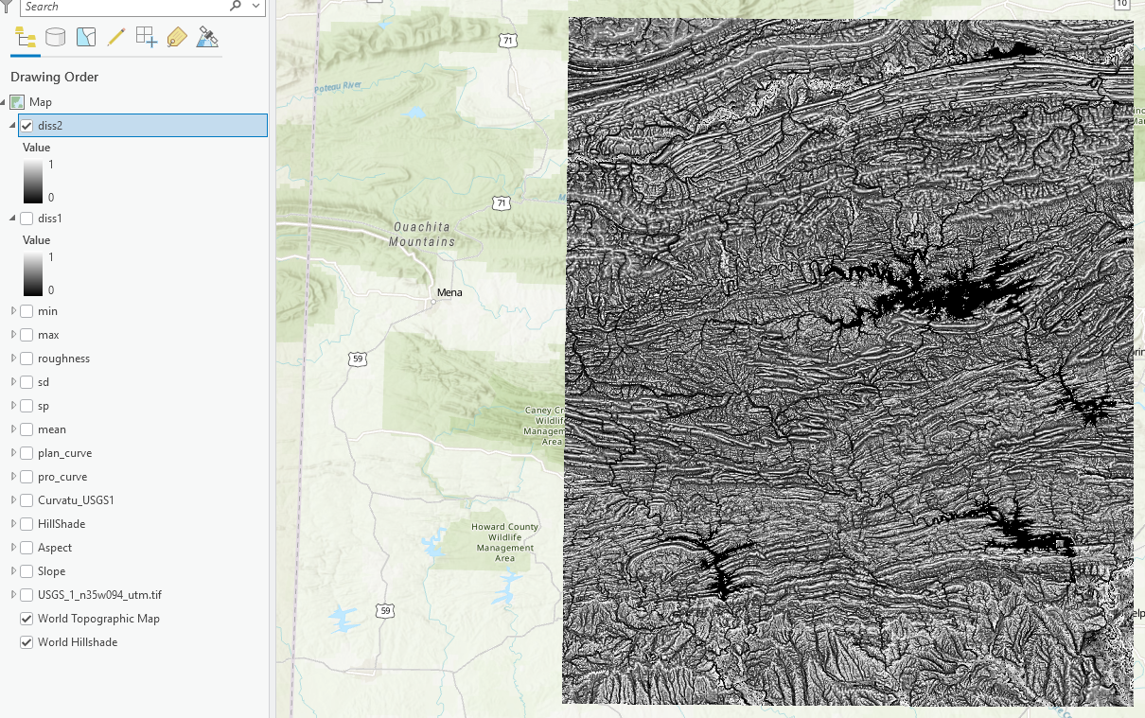

Step 8. Surface Hydrologic Analysis
You have learned a variety of raster analysis tools based on DEMs. In the following, you will learn to use the hydrological tool to derive watershed boundaries. This analysis assumes that water flows downhill and models this downhill motion using a DEM. First, you will need to create a filled DEM so that water can travel downhill without getting caught in a local sink. This kind of sink may be due to errors in DEM data. Sometimes, the DEM may already fill the sinks, so there is no need to do this step. Second, you will calculate flow direction and flow accumulation. Flow direction indicates which neighboring cell water will migrate to while flow accumulation counts the number of cells that will drain into a specific cell. Third, you will set a flow accumulation threshold in order to define streams. In this exercise, we will use 150 acres. Fourth, you will determine the stream linkages based on the ‘stream/not stream’ map and the flow direction grid. Finally, you will produce watersheds as a raster using the stream linkage and flow direction data.
You will now fill the DEM. Note, this operation can take a while to complete on a large DEM.
- Navigate to Spatial Analyst Tools followed by the Hydrology subtoolbox.
- Click on the Fill tool.
- Set the Input Surface Raster to the USGS_1_n35w094_utm layer.
- Name the Output Surface Raster as filled.
- You do not need to change any of the other settings.
- Click Run to execute the tool. The output should automatically be added to your map.
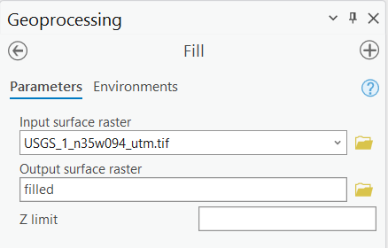

Deliverable 4. Screenshot the map showing the filled DEM of the study area. (3 Points)
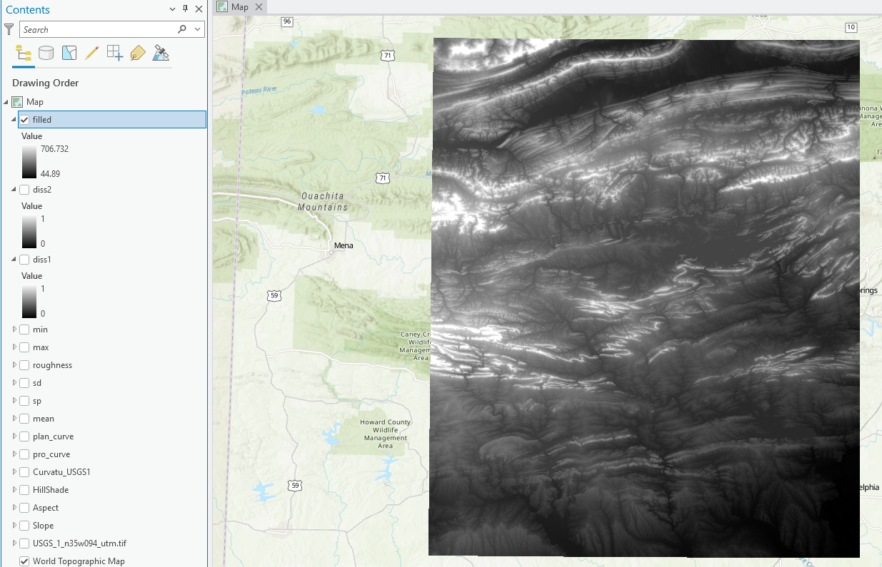
Next, you will create a flow direction grid.
- Navigate to Spatial Analyst Tools followed by the Hydrology subtoolbox.
- Click on the Flow Direction tool.
- Set the Input Surface Raster to the filled layer.
- Name the Output Flow Direction Raster as dir.
- You do not need to change any of the other settings.
- Click Run to execute the tool. The output should automatically be added to your map.
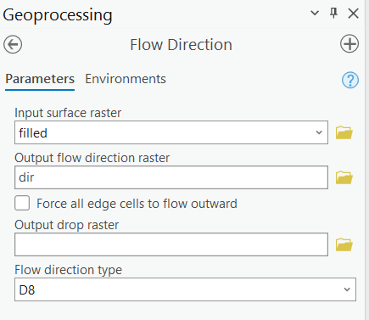
Now, you will create a flow accumulation grid from the flow direction surface.
- Navigate to Spatial Analyst Tools followed by the Hydrology subtoolbox.
- Click on the Flow Accumulation tool.
- Set the Input Flow Direction Raster to the dir layer.
- Name the Output Accumulation Raster as acc.
- Make sure the Output Data Type is set to float.
- You do not need to change any of the other settings.
- Click Run to execute the tool. The output should automatically be added to your map.
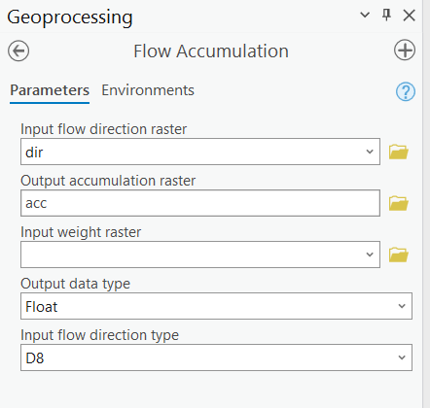

Deliverable 5. Screenshot the map showing the flow accumulation of the study area. (3 Points)
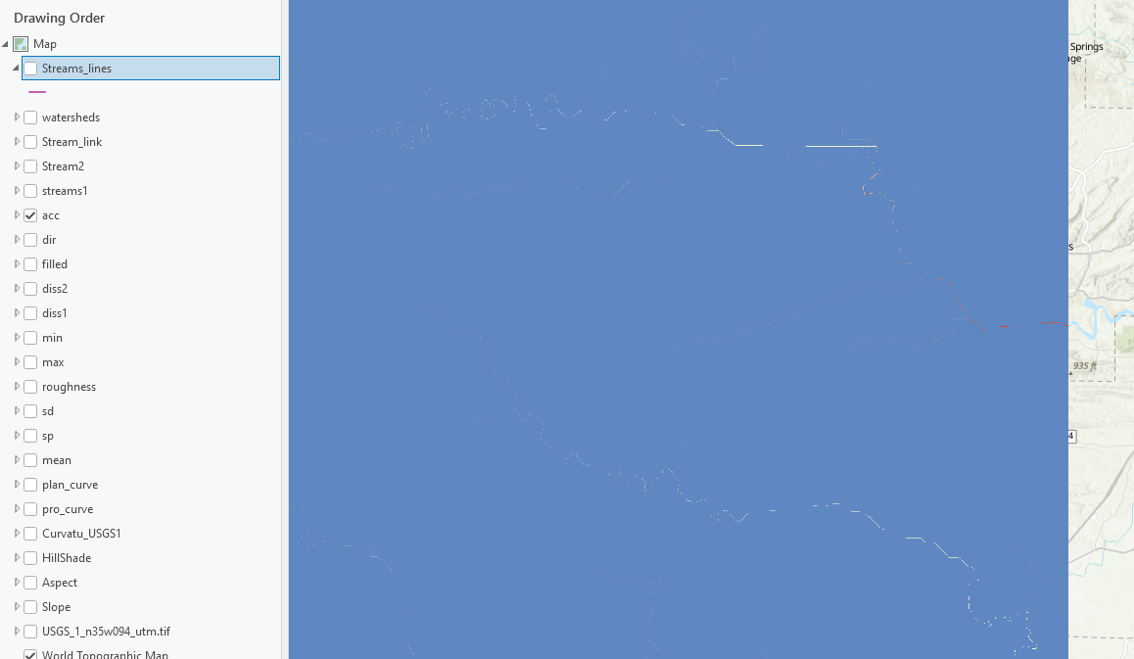
We will now extract streams using a threshold of 150 acres. The flow accumulation grid represents a count of pixels. So you will need to determine the number of pixels that are roughly equivalent to 150 acres (~607,028 square meters). Note, the cell size of your flow accumulation grid is 28.2 x 28.2 meters.

Question 5. Calculate the number of pixels in the flow accumulation grid that would correspond to the 150 acres. (6 points) (Hint, number of pixels = total area/ area of a pixel)
763.326
Once you have calculated the number of pixels, you will need to use the Raster Calculator Tool to select the raster cells that have a flow accumulation larger than this number.
- Navigate to Spatial Analyst Tools followed by the Map Algebra subtoolbox.
- Click on the Raster Calculator Tool.
- Define the syntax as follows: “Acc” > You Threshold calculated from Question 5.
- Name the Output Raster streams1.
- You do not need to change any additional settings.
- Click Run to execute the tool. The output should automatically be added to your map.
This calculation will produce a binary raster in which 1 represents pixels that were selected as streams and 0 represents non-stream pixels. Zoom in to your streams1 layer, and you should be able to see the streams, like the map on the below. Note, your stream color maybe different from mine.
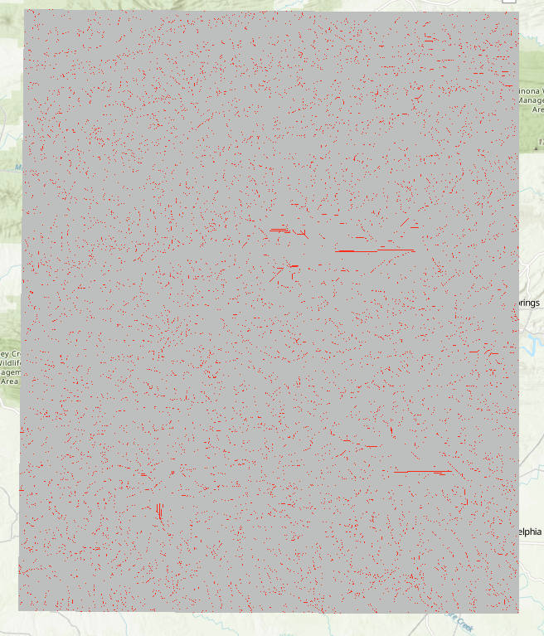

Deliverable 6. Screenshot the map showing the streams and non-streams of the entire study area. (6 Points)

You will now need to reclassify the 0 pixels to NoData using the Reclassify Tool.
- Navigate to Spatial Analyst Tools followed by the Reclass subtoolbox.
- Click on the Reclassify Tool.
- Set the Input Raster to the streams1 layer.
- Make sure the Reclass Field is set to “Value”.
- In the New column in the table, make sure the first column is set to NODATA, the middle to 2, and the last to NODATA. So, the stream cells will have a value of 2 and all other cells will be NODATA.
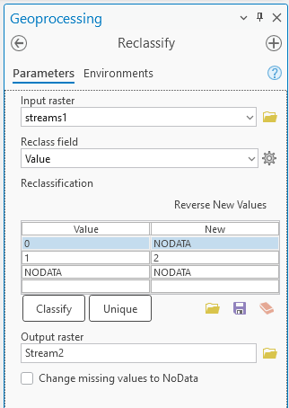
- Name the Output Raster streams2.
- You do not need to change any additional settings.
- Click Run to execute the tool. The output should automatically be added to your map.

Before you can create watersheds, you will need to create a stream link grid that assigns a unique raster grid value to each stream segment.
- Navigate to Spatial Analyst Tools followed by the Hydrology subtoolbox.
- Click on the Stream Link tool.
- Set the Input Raster to the stream2 layer.
- Set the Input Flow Direction Raster to the dir layer.
- Name the Output Raster as strm_link.
- You do not need to change any of the other settings.
- Click Run to execute the tool. The output should automatically be added to your map.
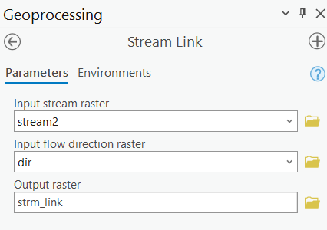
Now, you can create watershed boundaries using the raster grids created above.
- Navigate to Spatial Analyst Tools followed by the Hydrology subtoolbox.
- Click on the Watershed tool.
- Set the Input D8 Flow Direction Raster to the dir layer.
- Set the Input Raster or Feature Pour Point Data to the strm_link layer.
- Make sure the Pour Point Field is set to “Value”.
- Name the Output Raster as watershelds.
- You do not need to change any of the other settings.
- Click Run to execute the tool. The output should automatically be added to your map.
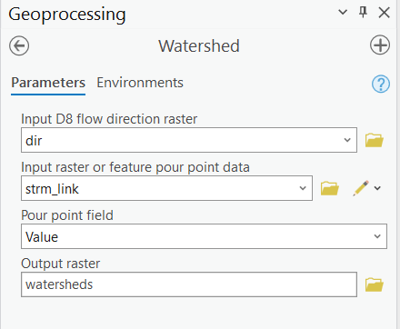

To better identify the watersheds, you can change the symbology.
- Right-click on the watersheds layer, in the drop-down menu, select Symbology.
- In the Symbology window, set Primary Symbology as “Unique Values”.
- Set Field 1 as “Value”.
- Choose your preferred Color scheme.
- You do not need to change others.
Each watershed is now symbolized by different colors. They are thousands of watersheds in this region.

Deliverable 7. Screenshot the map showing the watersheds of the study area. (6 Points)
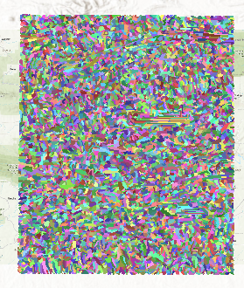
Finally, you will convert your streams to vector line features.

- Navigate to Spatial Analyst Tools followed by the Hydrology subtoolbox.
- Click on the Streams to Features tool.
- Set the Input Stream Raster to the stream2 layer.
- Set the Input Flow Direction Raster to the dir layer.
- Name the Output Polyline Features as streams_lines.
- Check the Simplify Polylines option.
- Click Run to execute the tool. The output should automatically be added to your map.
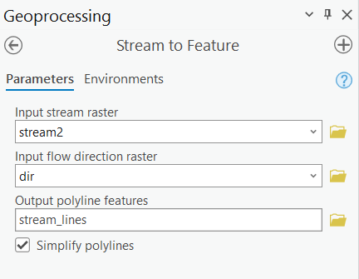
This should generate a line vector. Note that the streams were smoothed or simplified since the Simplify Polylines options was selected.

Question 6. How many unique stream segments were created? (5 points) (You want to open the attribute table of the stream_lines layer and find the maximum value of OBJECTID field.)
9050
Homework
Please submit a word file with answers for 6 questions, together with the 7 deliverables.

END OF EXERCISE

