Exercise 08: Spatial Interpolation
This exercise explores spatial interpolation methods. These methods allow you to estimate a continuous surface from discrete measurements. You will be asked to create a kernel density surface from disease data simulated from the famous 1854 Broad Street Cholera Outbreak in London. You will also create interpolated raster surfaces using inverse distance weighting (IDW), spline, and Thiessen (Voronoi) polygons for temperature and precipitation data for Ontario.

Topics covered in this exercise include:
- Create and interpret a density map using kernel density.
- Interpolate a surface using inverse distance weighting (IDW), spline, and Thiessen polygons

Step 1. Open a Map Project
First, we need to download and open the Exercise_8.aprx file.
- Download the Exercise_8.zip file. You will need to extract the compressed files and save it to the location of your choosing.
- Open ArcGIS Pro. This can be done by navigating to All Apps followed by the ArcGIS Folder. Within the ArcGIS Folder, select ArcGIS Pro. Note that you can also use a Task Bar or Desktop shortcut if they are available on your machine.
- After ArcGIS Pro launches, select “Open another project.”
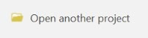
- Navigate to the directory that houses the material for this course. The project files are in the Exercise_8 folder where it was saved on your local machine.
- Select Exercise_8.aprx. Click OK to open the project.
Note: If you’d prefer, you can also just click on the Exercise_8.aprx file within the uncompressed folder directly to launch ArcGIS Pro.
This project contains two maps. The John Snow map contains the data required to complete the kernel density portion of the lab. The following data layers are included:
Water_Pumps: point features representing historic locations of water pumps, including the Broad Street water pump
Death_Addresses: point locations with recorded cholera deaths
buildings: polygon building footprints
Study_Area: a rectangular study area extent
John_Snow_Map: a georeferenced historic street map
Note that these data were created by Dr. Robin Wilson of the School of Geography at the University of Southampton, United Kingdom.
The Ontario map will be used to perform spatial interpolation. The following layers are included:
clim_points: point locations where climate data are collected, including temperature and precipitation.
ontario: boundary of the province of Ontario
canada: Canadian provinces boundaries

Step 2. Kernel Density
You will start this exercise by investigating kernel density.
- Navigate to the John Now Map.
You will need to set some environment settings before you begin.
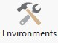
- Navigate to the Analysis Tab and click the Environments button in the Geoprocessing area.
- Under Workspace, change the Current Workspace and Scratch Workspace to the Exercise_9.gdb geodatabase in the Exercise_9 folder.
- Under Output Coordinates, set the Output Coordinate System to be the same as the Death_Addresses layer. This should be WGS 1984 UTM Zone 30 North.
- Under Processing Extent, set the Extent to be the same as the Study_Area layer.
- Under Raster Analysis set the Cell Size to 3, meaning 3 meters. Also, set the Mask to the Study_Area layer. You do not need to set a Snap Raster.
- Click OK to save the Environment settings.
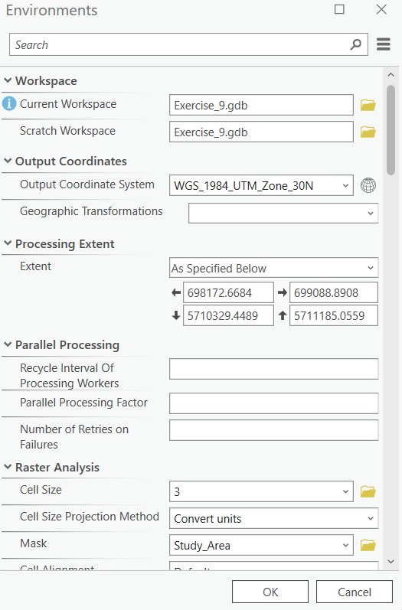
You are now ready to create the kernel density surface. You will do this using the Kernel Density Tool.
- Navigate to Spatial Analyst Tools followed by the Density subtoolbox. Click on the Kernel Density Tool.
- Set the Input Point or Polyline Features to the Death_Addresses layer.
- Set the Population field to “Num_Cases” (this represents the number of cholera cases at that address).
- Name the output cholera_kd. This will save to the workspace defined in the Environment settings: the Exercise_9.gdb geodatabase in your downloaded Exercise_9 folder.
- The Output Cell Size should already be set to 3, as specified in the environments.
- Set the Search Radius to 200 (meaning 200 meters).
- Make sure the Area Units is set to Square kilometers, the Output Cell Value is set to Densities, and the Method is set to Planar. These should be the defaults.
- You do not need to change others.
- Click Run to execute the tool. The result should be added to the map automatically.
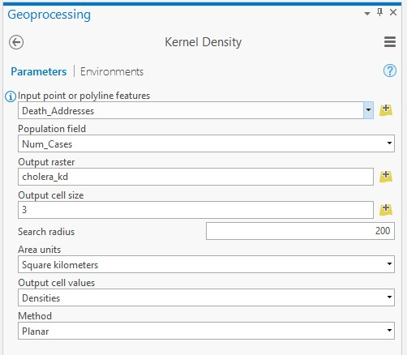
Note: The defined search radius can have a large impact on the resulting kernel density surface and estimates. Larger values indicate a larger search radius and will produce a more generalized pattern. In contrast, smaller values indicate a smaller search radius and will produce a less generalized pattern that shows more local variability. If you are unsure what search radius to use, we would recommend experimenting with different settings.
Question 1. Using early spatial analysis techniques, Dr. John Snow attributed the cholera outbreak to a specific well on Broad Street. Does your kernel density analysis confirm Dr. Snow’s earlier work? (5 Points) (Hint, turn on the Water_Pumps layer and put it above the cholera_kd. You may also want to turn off other layers in order to see the results clearly)
Yes
Question 2. What is the unit of measurement in your output kernel density grid? (5 Points).
Meter
A similar analysis could be completed using point density as opposed to kernel density. For comparison, you will now create this surface using the Point Density Tool.
- Navigate to Spatial Analyst Tools followed by the Density subtoolbox. Click on the Point Density Tool.
- Set the Input Point Features to the Death_Addresses layer. Set the Population field to “Num_Cases.” Name the output cholera_pd.
- The Output Cell Size should already be set to 3, as specified in the environments.
- Define the Neighborhood as a Circle.
- Set the Search Radius to 200 (meaning 200 meters) using the Map units.
- Make sure the Area Units is set to Square kilometers.
- Click Run to execute the tool. The result should be added to the map automatically.
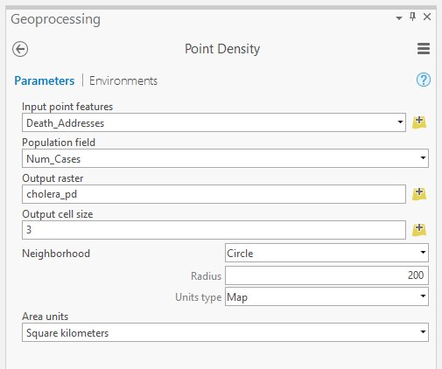
Question 3. Does the point density result support Dr. Snow’s prior results and your prior kernel density analysis? (5 Points) (Hint, turn on the Water_Pumps layer and put it above the cholera_pd. Again, you may want to turn off other layers in order to see the results clearly)
yes

Step 3. Spatial Interpolation with IDW and Spline
You are now done analyzing the cholera data. You will now work with the Ontario climate data.
- Navigate to the Ontario map.
You will now interpolate surfaces from the climate data. The clim_points layer contains two climate variables for November 2016. The “Tm” field represents mean temperature for the month in Celsius while the “P” field represents the total precipitation in millimeters (mm) for the month. These data were obtained from the Canadian government: http://climate.weather.gc.ca/.
Before you can begin creating interpolated surfaces, you will need to change the Environments settings again.
- Right click John Snow map in left content, select properties, coordinate system, select NAD 1983 CRSR Candas Atlas Lambert as coordinate system for your map
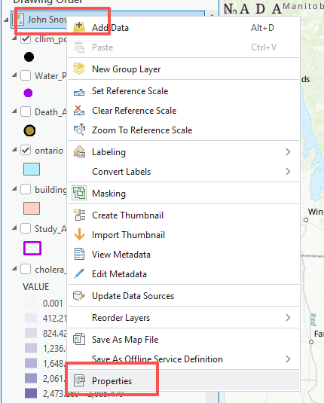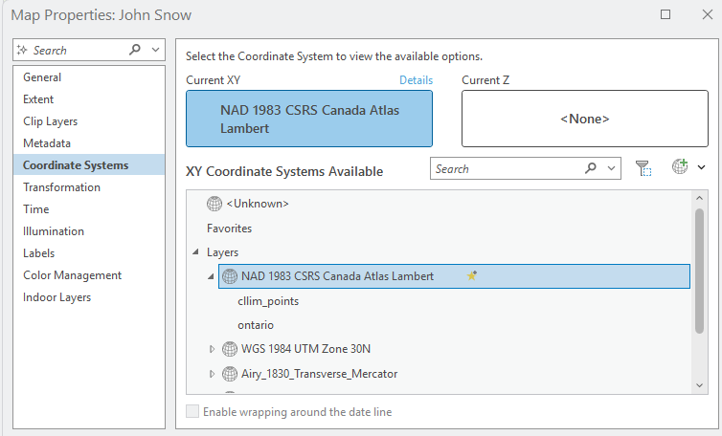
- Navigate to the Analysis Tab and click the Environments button in the Geoprocesing area.
- Under Workspace, leave the Current Workspace and Scratch Workspace set to the Exercise_9.gdb geodatabase in your downloaded Exercise_9 folder.
- Under Output Coordinates, set the Output Coordinate System to be the same as the clim_points layer. This should be NAD 1983 CSRS Canada Atlas Lambert.
- Under Processing Extent, set the Extent to be the same as the ontario layer.
- Under Raster Analysis set the Cell Size to 500, meaning 500 meters. Also, set the Mask to the ontario layer. You do not need to set a Snap Raster.
- Click OK to save the Environment settings.
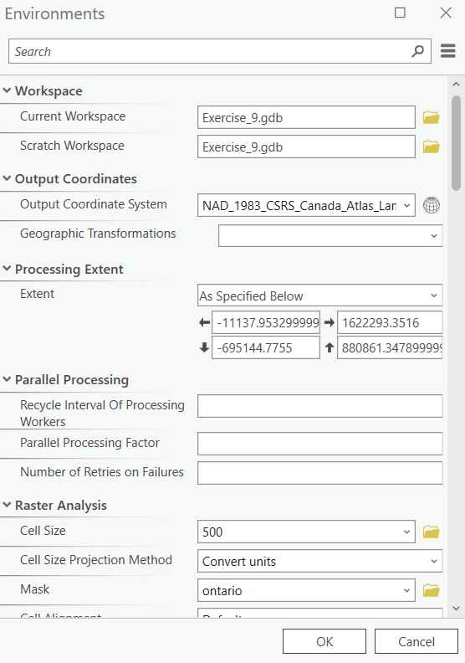
You are now ready to interpolate a raster surface. You will begin by interpolating the temperature data using IDW.
- Navigate to Spatial Analyst Tools followed by the Interpolation subtoolbox.
- Click on the IDW Tool.
- Set the Input Point Features to the clim_points layer.
- Set the Z Value Field to the “Tm” field.
- Name the Output Raster tm_idw.
- The Output Cell Size should already be set to 500, as specified in the Environment settings.
- Leave the Power set to 2, the Search Radius set to Variable, and the Number of Points set to 12.
- You do not need to change any additional settings.
- Click Run to execute the tool. The result should be added to the map automatically.
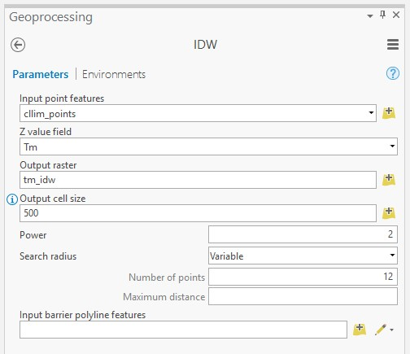

Note: Because you specified the extent and mask in the Environments relative to the ontario layer, the interpolated surface fills the extent of the province and is also masked to its boundary. This highlights one of the benefits of defining environment settings. Note that the cell size is also 500, as specified in the Environments. Again, we highly recommend specifying the environments before undertaking an analysis.
Answer the following questions relating to the IDW interpolation map.
Question 4. What is the temperature pattern looks like in Ontario? (5 Points) (Hint, refer to the legend of tm_idw)
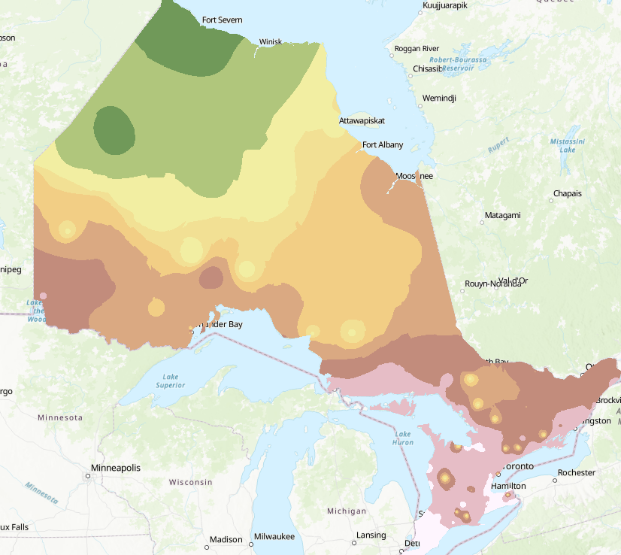
Now, you will perform a spline interpolation for the same data using the Spline Tool.
- Navigate to Spatial Analyst Tools followed by the Interpolation subtoolbox.
- Click on the Spline Tool.
- Set the Input Point Features to the clim_points layer.
- Set the Z Value Field to the “Tm” field.
- Name the Output Raster tm_spline.
- The Output Cell Size should already be set to 500, as specified in the Environment settings.
- You do not need to change any additional settings.
- Click Run to execute the tool. The result should be added to the map automatically.
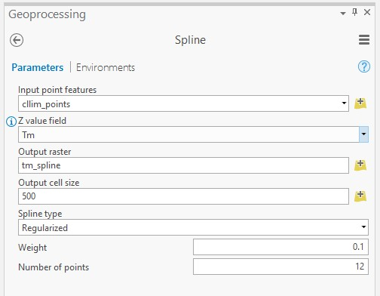

Answer the following question relating to the spline interpolation map.
Question 5. What are the two options for the spline type? (5 Points) (Hint, click on the exclamation mark before Spline type
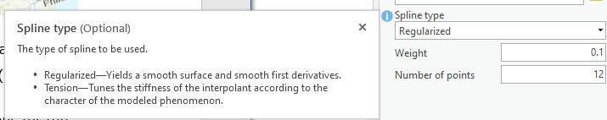
Now, compare the results of the IDW and spline interpolations for the temperature data.
Regularized and tension
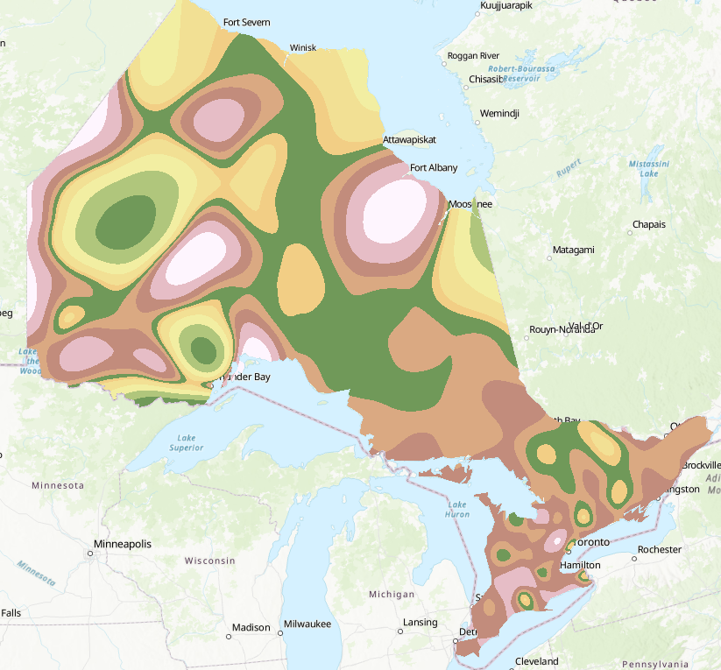
Question 6. Which method do you think is most appropriate to interpolate the temperature data? Please explain your reasoning. (5 Points) (Hint, pay attention to the legend of the two results)
idw
- Perform the IDW and spline interpolations for the total monthly precipitation using the “P” field. Use the same settings as those used to interpolate the temperature data.

Deliverable 1: Provide the screenshot showing IDW interpolation for P. (5 points)
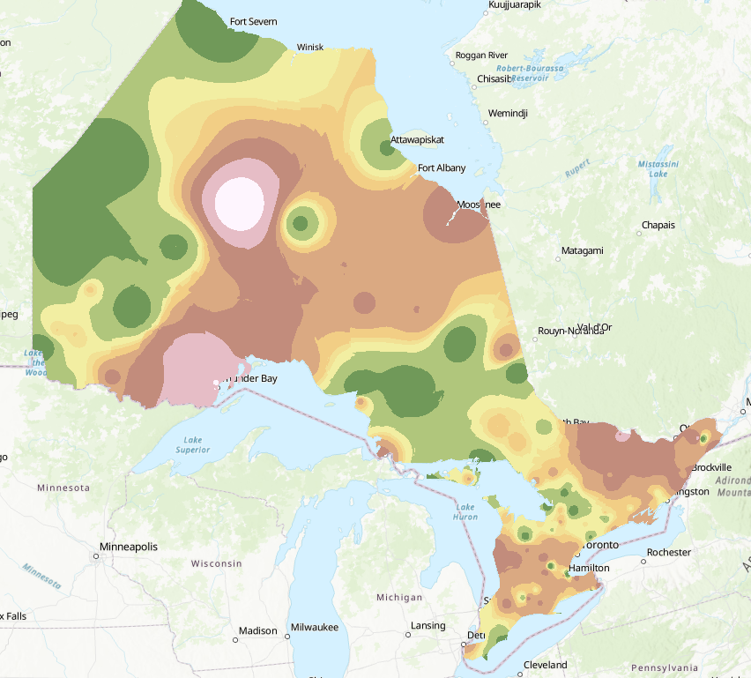
Deliverable 2: Provide the screenshot showing spline interpolation for P. (5 points)
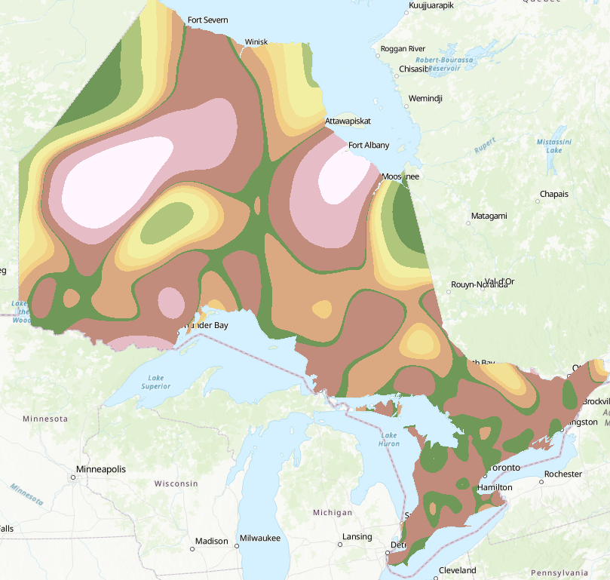
Question 7. Which method do you think is most appropriate to interpolate the precipitation data? Please explain your reasoning. (5 Points) (Hint, pay attention to the legend of the two results)
Idw，

Step 4. Spatial Interpolation with Thiessen (Voronoi) Polygons
Thiessen (Voronoi) polygons offer another means to interpolate data.
This method can be applied using the Create Thiessen Polygons Tool.
- Navigate to Analysis Tools followed by the Proximity subtoolbox.
- Click on the Create Thiessen Polygons Tool.
- Set the Input Features to the clim_points layer.
- Name the Output Feature Class thiessen_polys_tm.
- Set the Output Fields to All Fields.
- Click Run to execute the tool. The result should be added to the map automatically.

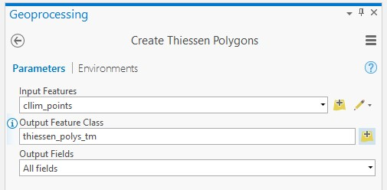
The polygons are not clipped to the extent of the province. To do this, you can use the Clip Tool. The mask setting in the environments is not honored here since this is not a raster output.
- Navigate to Analysis Tools followed by the Extract subtoolbox.
- Click on the Clip Tool.
- Set the Input Features to the thiessen_polys_tm layer.
- Set the Clip Features to the ontario layer.
- Name the Output Feature Class thiessen_polys_tm_clip.
- Click Run to execute the tool. The result should be added to the map automatically.
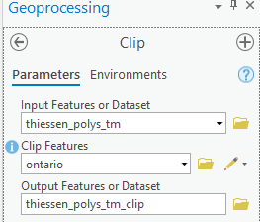
You will now want to symbolize the output using the “Tm” field.
- Symbolize the “Tm” field and graduated colors by clicking on thiessen_polys_tm_clip and selecting symbology. In the Primary symbology window, select Graduated Colors for Primary symbology, Tm for Filed, Natural Breaks (Jenks) for Method, 5 for Classes. Choose your preferred color.
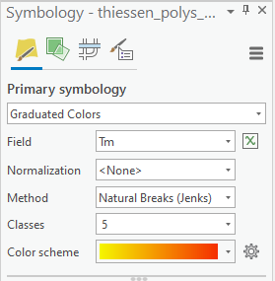

Note: In contrast to IDW and spline, the output here is a vector polygon layer as opposed to a raster grid. If you would like to convert this surface to a raster, you can use the Polygon to Raster Tool. You do not need to perform the conversion here.
Question 8. For Interpreting the temperature data, which method do you think is best: IDW, spline, or Thiessen (Voronoi) polygons? Explain your reasoning. (5 Points)

Note: These are not the only interpolation methods available. For example, Kriging is a geostatistical interpolation method that takes into account spatial autocorrelation.

Homework
Please submit 8 questions and 2 deliverables.

END OF EXERCISE

