Exercise 7: Spatial Pattern Analysis
This exercise will explore a variety of spatial statistical analysis methods made available in ArcGIS Pro. These tools allow you to measure spatial central tendency, spatial variability, and spatial autocorrelation. This lab is simply an introduction, as there are a variety of statistical analysis techniques that can be applied to spatial data. Here, we will make use of data for the city of Pittsburgh and also county-level data for the western United States. The data for Pittsburgh can be obtained here: http://pittsburghpa.gov/dcp/gis/data-maps.html. The county-level data for the western United States is from the 2010 United States Census.

Topics covered in this exercise include:
- Measure spatial central tendency and dispersion
- Analyze point patterns
- Analyze global spatial autocorrelation
- Find local hot spots and cold spots

Step 1. Open a Map Project
First, we need to download and open the Exercise_7.aprx file.
- Download the Exercise_7.zip file. You will need to extract the compressed files and save it to the location of your choosing.
- Open ArcGIS Pro. This can be done by navigating to All Apps followed by the ArcGIS Folder. Within the ArcGIS Folder, select ArcGIS Pro. Note that you can also use a Task Bar or Desktop shortcut if they are available on your machine.
- After ArcGIS Pro launches, select “Open another project.”

- Navigate to the directory that houses the material for this course. The project files are in the Exercise_7 folder where it was saved on your local machine.
- Select Exercise_7.aprx. Click OK to open the project.
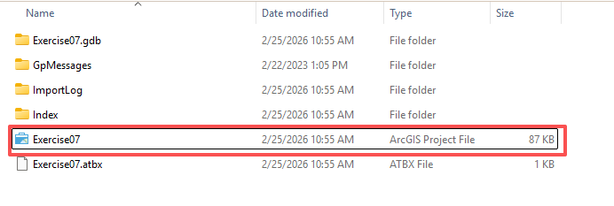
Note: If you’d prefer, you can also just click on the Exercise_7.aprx file within the uncompressed folder directly to launch ArcGIS Pro.
This project contains two maps. The Pittsburgh map contains the following layers.
universities: point locations of universities
trees: point location of trees
schools: point locations of schools
PAT_stops: point locations of bus stops along the Port Authority of Allegheny County transit routes
hospitals: point locations of hospitals
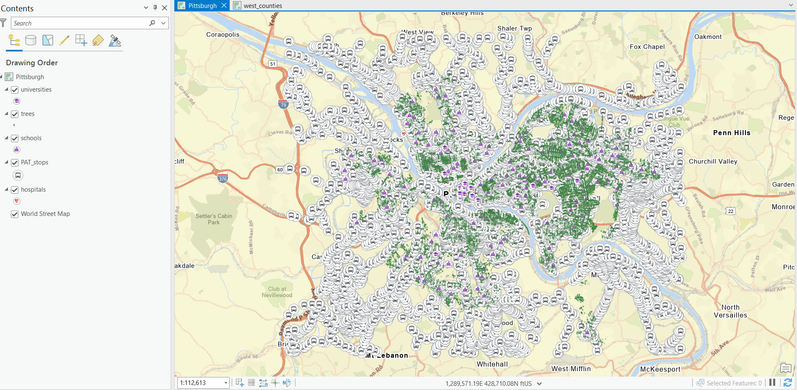
The west_counties map only contains one layer: west_counties. This is a polygon layer that provides all of the county boundaries in the western United States. You can load west counties data from database
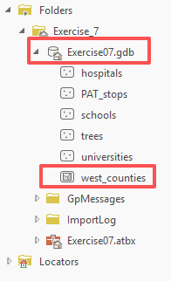

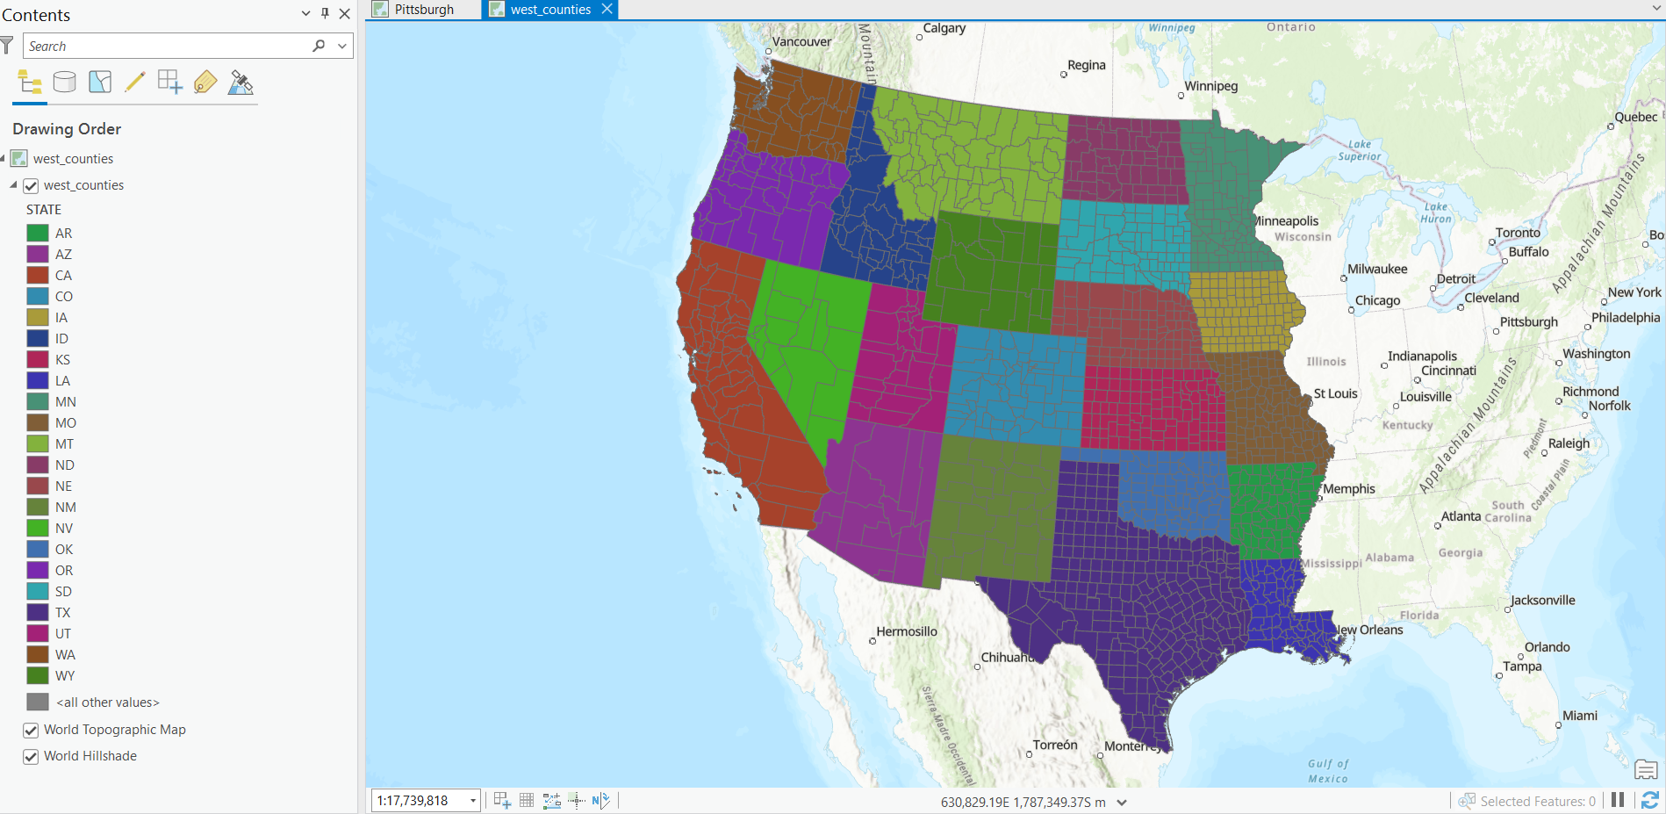
You will start the analysis with the Pittsburgh data.
- Navigate to the Pittsburgh map.

Step 2. Set Environment Settings
Before you start performing analyses, you will set some environment settings.
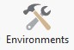
- Click on the Environments button in the Geoprocessing area of the Analysis Tab.
- Under Workspace, set the Current Workspace and Scratch Workspace to the Exercise_7.gdb geodatabase in the Exercise_7 folder.
- You do not need to change any other settings. Click OK to save the Environment changes.
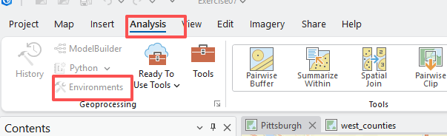
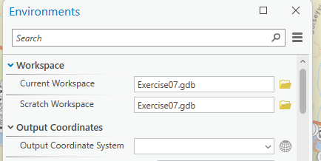

Step 3. Measuring Spatial Central Tendency
You will begin your analysis by finding the most centrally located university in Pittsburgh. This can be accomplished using the Central Feature Tool.
Using this tool, the most central feature is defined as the feature with the smallest accumulated distance to all other features in the dataset.
Note: In this lab, we will access tools from ArcToolbox. However, there are many ways to access tools in ArcGIS Pro. For example, some of the more common tools are provided in the Tools list in the Analysis Tab.
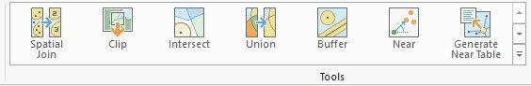
Once you open the Geoprocessing Pane, you can access favorite tools or search for Tools.
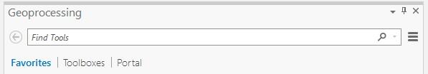


We have decided to demonstrate ArcToolbox here so that you get a sense of where the tools are located in the Toolbox directory.
- In the Analysis Tab, select Tools from the Geoprocessing Area. This should open the Geoprocessing Pane.
- In the Geoprocessing Pane, navigate to the Toolboxes.
Note: We will not provide these directions for accessing other tools. We will just tell you where to find them within ArcToolbox.
- Navigate to Spatial Statistic Tools followed by the Measuring Geographic Distributions subtoolbox.
- Click on the Central Feature Tool.
- Set the Input Feature Class to the universities layer.
- Name the Output Feature Class central_university. Note that the output will automatically save to the location specified in the environment settings: Exercise_7.gdb.
- You do not need to change any of the other settings.
- Click Run to execute the tool.
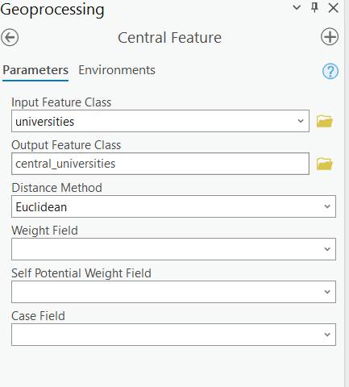
This analysis will produce a new vector layer containing one point: the university that was calculated to be most central. Use the attribute table of your output to answer the following question. Note that the name of the university is in the “NAME” field.
Question 1. What is the most central university in Pittsburgh? (3 Points)
- Conduct a similar analysis for the hospitals. Find the most central hospital.
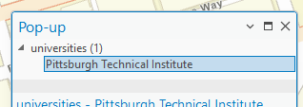

Deliverable 1. Screenshot the map showing the central hospital (3 points) （Note, turn off other layers to show your results clearly）
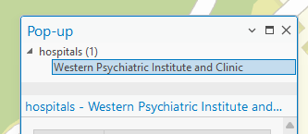
Instead of finding the most central feature, you can also find the spatial mean or median of the data. This is defined as the geographic center of the data. This is calculated from the average X and Y coordinates of the input features. If the input features are polygons, the average X and Y values of the centroids are used. This geographic center can be defined as a mean or as a median. You will first calculate the mean using the Mean Center Tool.
- Navigate to Spatial Statistic Tools followed by the Measuring Geographic Distributions subtoolbox.
- Click on the Mean Center Tool.
- Set the Input Feature Class to the schools layer.
- Name the Output Feature Class mean_center_schools.
- You do not need to change any of the other settings.
- Click Run to execute the tool. 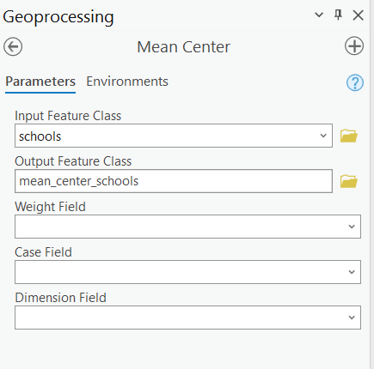

Now, you will calculate the median center using the Median Center Tool.
- Navigate to Spatial Statistic Tools followed by the Measuring Geographic Distributions subtoolbox.
- Click on the Median Center Tool.
- Set the Input Feature Class to the schools layer.
- Name the Output Feature Class median_center_schools.
- You do not need to change any of the other settings.
- Click Run to execute the tool.
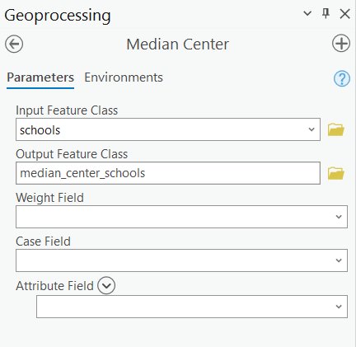
You will notice that the mean and median center are not at the same location. Also, they are not at the location of one of the schools, in contrast to the central feature.

It is also possible to apply a weight to the calculations. As an example, we will find the mean center for the schools using the number of students as a weight. So, schools with more students will have a higher weight in the calculation of the mean. These numbers are stored in the “students” field. Note that these are synthetic data and are not the real school population sizes. The results will not represent a true measure. Note that these coordinates are relative to the map projection: NAD 1983 State Plane Pennsylvania South Feet.
- Navigate to Spatial Statistic Tools followed by the Measuring Geographic Distributions subtoolbox.
- Click on the Mean Center Tool.
- Set the Input Feature Class to the schools layer.
- Name the Output Feature Class mean_center_schools_weighted.
- Set the Weight Field to the “students” field.
- You do not need to change any of the other settings.
- Click Run to execute the tool.

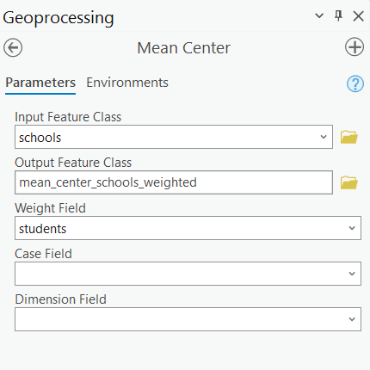

Deliverable 2. Screenshot the map showing mean_center_schools, median_center_schools, and mean_center_schools_weighted (9 Points) (Note, you want to turn off other layers to show your results clearly)
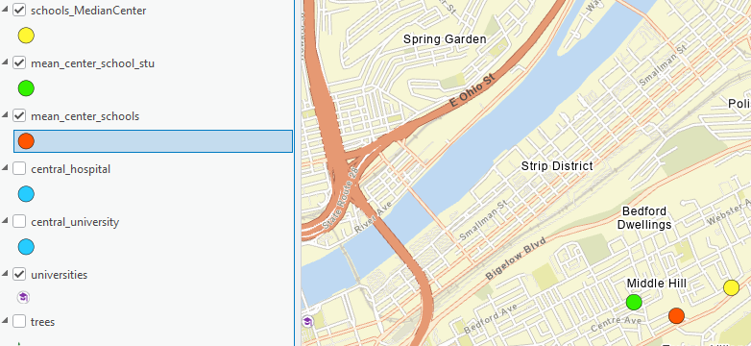

Step 4. Measures of Spatial Variance and Directional Trends
The measures investigated above provide estimates of spatial central tendency. You will now investigate measures of spatial variability or dispersion. First, you will calculate a standard distance for the hospitals layer using the Standard Distance Tool. The standard distance is a measure of spatial standard deviation. The larger the circle, the more spatially dispersed the data. The center of the circle will be the mean center.
- Navigate to Spatial Statistic Tools followed by the Measuring Geographic Distributions subtoolbox.
- Click on the Standard Distance Tool.
- Set the Input Feature Class to the hospitals layer.
- Name the Output Standard Distance Feature Class hospitals_sd.
- Set the Circle Size to “1 standard deviation.”
- You do not need to change any of the other settings.
- Click Run to execute the tool.

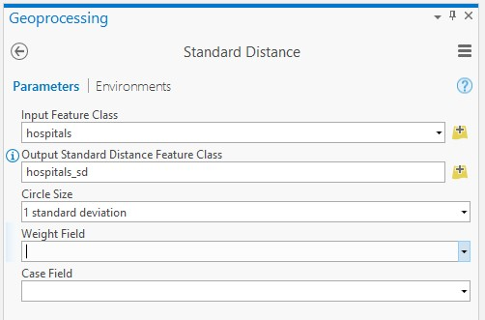

The spatial standard deviation (in the map units, in this case feet) is noted in the attribute table of the output.

Question 2. What is the spatial standard deviation value for the hospitals?

(3 Points) (note, the standard deviation is stored in ‘StdDist’ in the attribute table. The unit is feet)
11143.183156585708
- Complete a similar analysis to find the spatial standard deviation for the universities. Open the attribute table to answer the following question

Question 3. What is the spatial standard deviation value for the universities? (3 Points) (note, the standard deviation is stored in ‘StdDist’. The unit is feet)
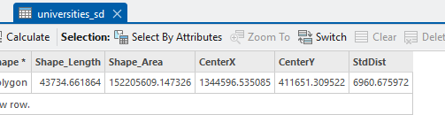
You will now experiment with the Directional Distribution (Standard Deviational Ellipse) Tool. This tool is used to describe the spatial central tendency, spatial dispersion, and directional trends. The created ellipse will be centered on the mean center. The larger the ellipse, the more dispersed the data. The long access of the ellipse will be aligned with the direction in which the data are most dispersed. You will now calculate this for the universities layer.
- Navigate to Spatial Statistic Tools followed by the Measuring Geographic Distributions subtoolbox.
- Click on the Directional Distribution (Standard Deviational Ellipse) Tool.
- Set the Input Feature Class to the universities layer.
- Name the Output Ellipse Feature Class universities_dd.
- Set the Ellipse Size to “1 standard deviation.”
- You do not need to change any of the other settings.
- Click Run to execute the tool.
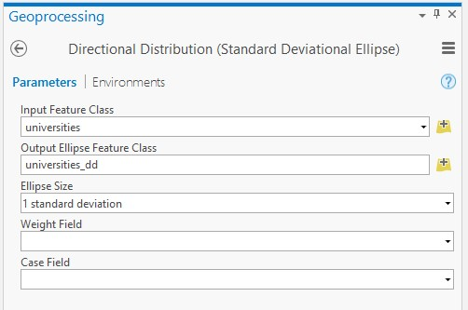

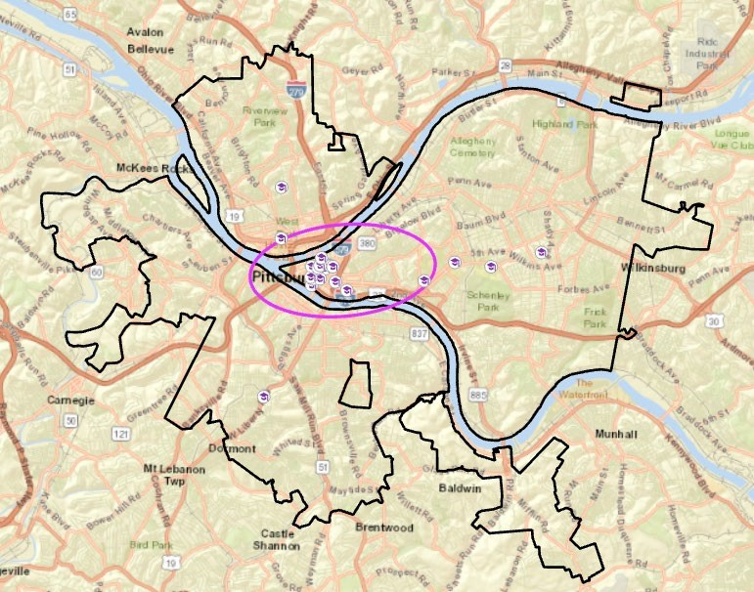
Open the attribute table to answer the following question.

Question 4. What is standard deviation value for x and y direction? And Which direction is more dispersed? (6 Points) (Note, the standard deviation value for x and y direction is stored in ‘XStdDist’ and ‘YStdDist’’, respectively. The unit is feet)

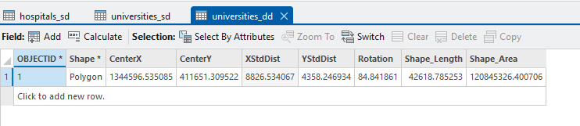

Y direction

Step 5. Analyzing Point Patterns
You will now analyze spatial patterns using the Average Nearest Neighbor Tool. This tool provides a statistical test of dispersion, randomness, or clustering based on the average distance from each feature to its nearest neighbors. It does not look at the attribute data associated with the points. It only looks at the point distribution. It is a statistical test that produces a z-score and a p-value. You will run this tool on the trees layer to determine if the spatial pattern of the trees is dispersed, random, or clustered.
- Navigate to Spatial Statistic Tools followed by the Analyzing Patterns subtoolbox.
- Click on the Average Nearest Neighbor Tool.
- Set the Input Feature Class to the trees layer.
- Leave the Distance Method set to Euclidean.
- Make sure Generate Report is selected.
- You do not need to change any of the other settings.
- Click Run to execute the tool.
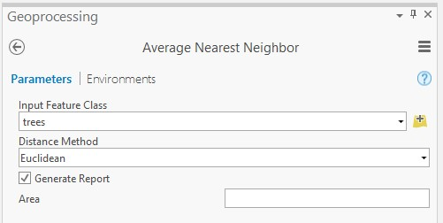
This tool does not produce a new layer. It generates a report.
- In the result pop-up click on the Report File.
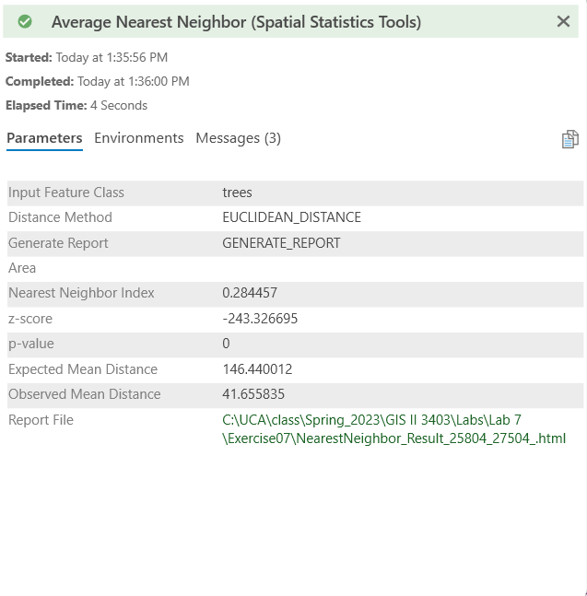

- This will open in a web browser as an HTML report.
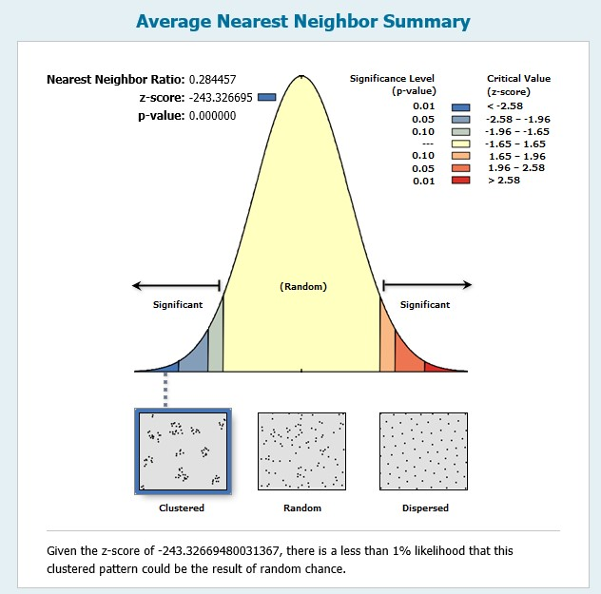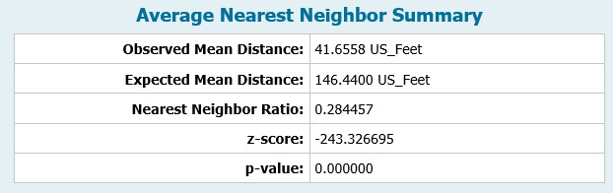

The nearest neighbor ratio is 0.284457, z-score is -243.33. The p-value for this test was 0. Note that this result suggests that the trees are clustered as opposed to spatially random or dispersed, as indicated in the above screenshot.
- Complete a similar analysis using the PAT_stops layer. Use Euclidean for the Distance Method.

Question 5. What is the nearest neighbor ratio? (3 Points)

0.284457

Question 6. What is the z-value? (3 Points)

-243.326695

Question 7. What is the p-value? Is it statistically significant? Why? (3 Points)

0, yes, less than 0.01

Question 8. According to this analysis, are the stops dispersed, random, or clustered? (3 Points)

clustered

Step 6. Analyzing Global Spatial Autocorrelation
The average nearest neighbor statistic looks at spatial patterns, not the attributes associated with the features. Exploring the correlation of feature attributes across space is known as spatial autocorrelation. The question here is whether or not the attributes or values associated with features are spatially clustered (near features tend to have more similar values), spatially dispersed (near features tend to have more dissimilar values or distant features tend to have more similar values), or spatially random (there is no pattern in the distribution of the values). The Global Moran’s I Test can be used to assess global spatial autocorrelation.
- You are done using the Pittsburgh map. Switch to the west_counties map.
You will explore whether median income aggregated at the county level in the western United States shows spatial randomness, dispersion, or clustering. You will do this using the Spatial Autocorrelation (Global Moran’s I) Tool.
- Navigate to Spatial Statistic Tools followed by the Analyzing Patterns subtoolbox.
- Click on the Spatial Autocorrelation (Global Moran’s I) Tool.
- Set the Input Feature Class to the west_counties layer.
- Set the Input Field to “med_income.”
- Make sure to select Generate Report.
- Set the Conceptualization of Spatial Relationships to “Contiguity edges only.”
- Set the Standardization as None.
- Click Run to execute the tool.
- Similar to the Average Nearest Neighbor Tool, a new output is not generated. Instead, an HTML report is produced.
- Open the HTML report (Note, if you encounter a warning, it is ok).
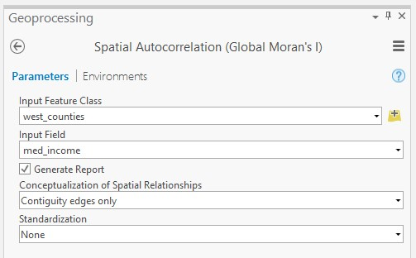
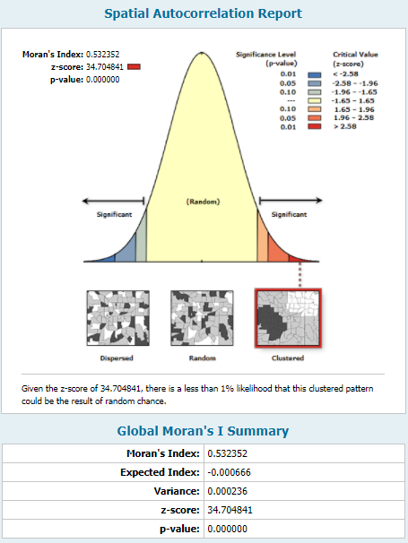
Note that this test suggests that median income shows a clustered pattern when evaluated globally. A positive Moran’s I index suggests clustering whereas a negative result suggests dispersion. Values near zero indicate randomness.

Question 9. What is value of Moran’s I? (3 Points)
0.532352

Question 10. The median income is random, clustered, or dispersed? Is the pattern statistically significant? (3 Points)
Clustered, significant

Step 7. Analyzing Local Spatial Autocorrelation
Lastly, you will analyze local spatial autocorrelation, as opposed to assessing autocorrelation globally as investigated above. Here, you will specifically investigate hot spot analysis. The goal of this tool is to identify local clusters of high values (hot spots) and local clusters of low values (cold spots) using the Getis-Ord GI* statistic. This analysis can be completed using the Hot Spot Analysis (Getis-Ord Gi*) Tool. You will start by performing this analysis for median income.
- Navigate to Spatial Statistic Tools followed by the Mapping Clusters subtoolbox.
- Click on the Hot Spot Analysis (Getis-Ord Gi*) Tool.
- Set the Input Feature Class to the west_counties layer.
- Set the Input Field to “med_income.”
- Name the Output Feature Class med_income_hot_spots.
- Set the Conceptualization of Spatial Relationships to “Contiguity edges only.”
- You do not need to change any additional settings.
- Click Run to execute the tool.
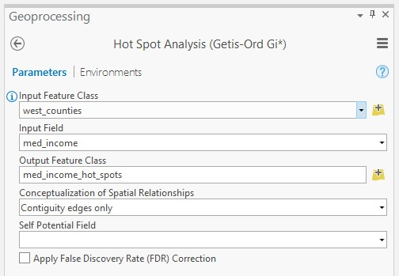
In contrast to the global statistics, a new spatial output will be generated and added to your map. The output is shown below.
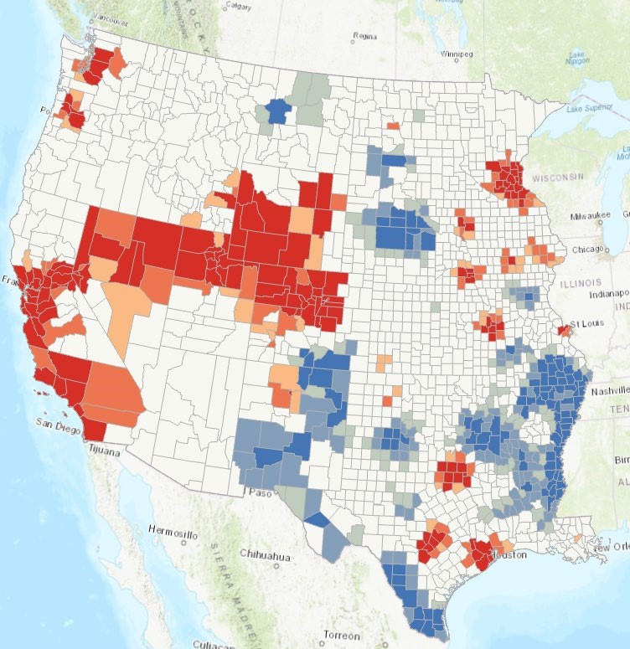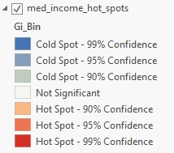

Areas in red indicate hot spots, or clusters of counties with a high median income. Blue areas indicate cold spots, or clusters of counties with low median incomes. White areas suggest randomness or patterns that are not statistically significant. Darker shades of red or blue indicate increasing statistical significance at the 90%, 95%, and 99% confidence intervals. Note that no global measure is produced since this is not a global statistical test. If you open the attribute table, you will see that different p-values were generated for each county. Again, this is a local test.
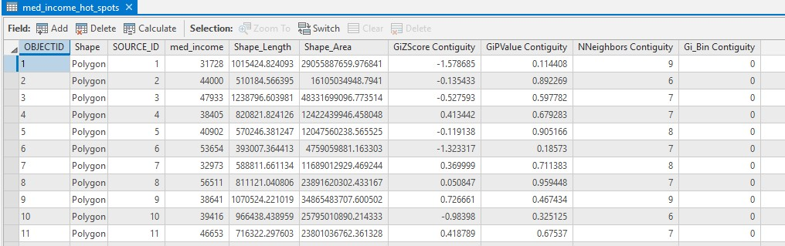
To finish the lab, you will conduct a hot spot analysis to look for local hot spots and cold spots of counties based on the percentage of the population that is older than 55. You will then generate a map of your output and describe the results.
- Use the Hot Spot Analysis (Getis-Ord Gi*) Tool to investigate local hot spots and cold spots relative to the percentage of the population in each county that is older than 55. Reminder that this information is in the “per_gt55” field. Make sure to use the “Contiguity edges only” method as the conceptualization of spatial relationships.

Deliverable 3: Screenshot your map showing hot spot analysis for the percentage of the population that is older than 55. Describe the map patterns (5 points)
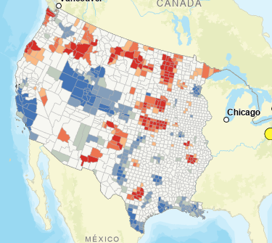
As a final note, this is simply an introduction to spatial statistics, and there are many methods that were not discussed here. This is a field of study in its own right. If you are interested in this, I would recommend exploring further. Other than just exploring global and local patterns, spatial statistical methods, such as geographically weighted regression (GWR), can be used to make predictions over a map space, which we will learn next class.

END OF EXERCISE

Homework
Submit the 10 questions & answers and 3 deliverables to blackboard.

