Lab 09
Custom geoprocessing tool provide higher flexibility to support user in processing geospatial data. During the lecture, we develop a tool to calculate the NDVI and NDWI using Landsat 8 imagery.
Once completed, submit this word file to Canvas by midnight (11:29 PM) on April 25.
- This lab is worth a total of 105 points and contributes 10.5% toward the final grade.

For this lab, you task is to extend the tool to include the Normalized Difference Built-Up index to assist users in analyzing built-up areas.
$$NDBI=\frac{SWIR 1-NIR}{SWIR 1+NIR}$$
Result 1: Provide a screenshot of your code showing how you added the NDBI calculation into the function. (45 pts)
Result 2: Provide a screenshot of the tool’s dropdown menu, demonstrating the new NDBI option added to your custom geoprocessing tool. (See example below for reference). (30 pts)
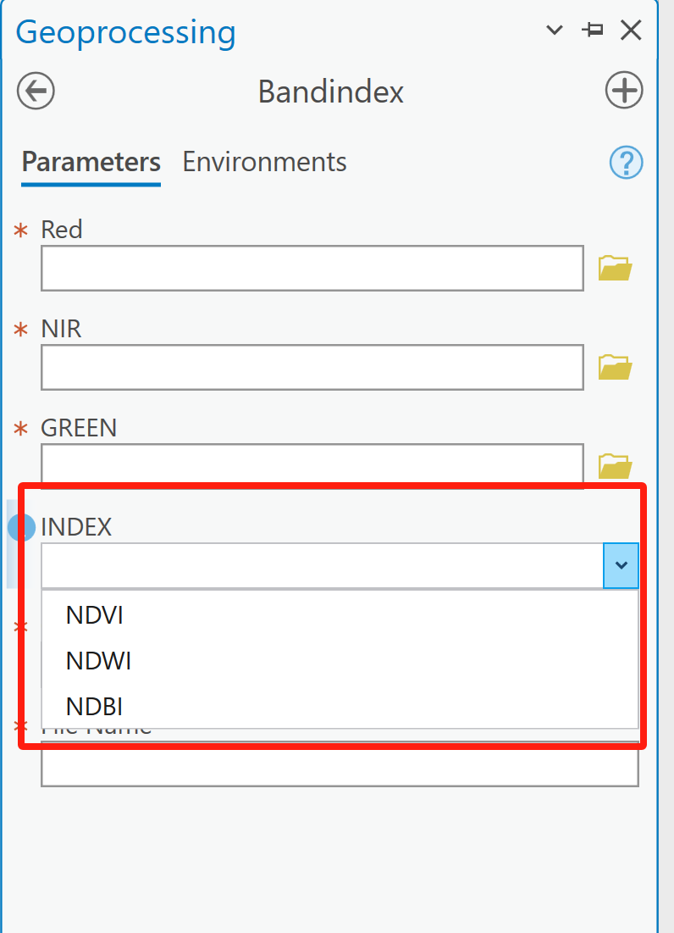
Result 3:
Use an appropriate color symbology to visualize the resulting NDBI raster. Include a screenshot of the final output. (30 pts)

